COMET Local HVD Oracle DB Setup
ITS-TP063L, Ver 1.1


Sharda Centre, Off Karve Road, Erandwane,
Pune, Maharashtra, India 411004

www.techmahindra.com

Table of Contents

1. Introduction 2
1.1. Purpose 2
1.2. Scope 2
1.3. Definitions 2
1.4. Acronyms 2
1.5. References 2
1.6. Overview 2
2. Process details 2
2.1. Admin rights on HVD 2
2.2. Download oracle setup 3
2.3. Oracle installation guide 4
2.4. Create oracle schema 7
2.5. Download SQL developer setup 10
2.6. SQL Developer installation guide 10
2.7. Oracle schema copy 11
3. DOCUMENT HISTORY 15
4. Annexure 15
5. Template DOCUMENT HISTORY 15

Introduction

Purpose

Purpose of this document is to setup Oracle locally on HVD so that development can be done with faster pace and network latency can be minimized.

Scope

Scope of this document remains till local development. Once code is committed to Git repository application should point to respective environment database. Developers should not commit local database related information in any configuration files.

Definitions

Acronyms

COMET | Customer Order Management and Engagement Tool

References

Include any documents referenced in the text of the document. Include a reference to this guideline.

Overview

This section identifies the sub-system and the processor where the program resides. This section also identifies the feature and program version for which the unit test is being performed. Briefly identify the functions of the program that are modified and/or added and are being tested in the unit test described by this document.

Process details

Oracle database installation will be done once as a part of environment setup activity. For development we will be using Oracle 11g xe version.

Admin rights on HVD

If you already have admin access please skip this step. If not then follow below instructions.

Steps:
- Go to https://intra.att.com/cops2/aws/index.cfm
- Click on Temporary admin rights link.

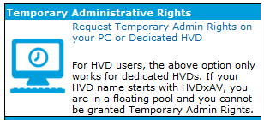
- You will be redirected to another page
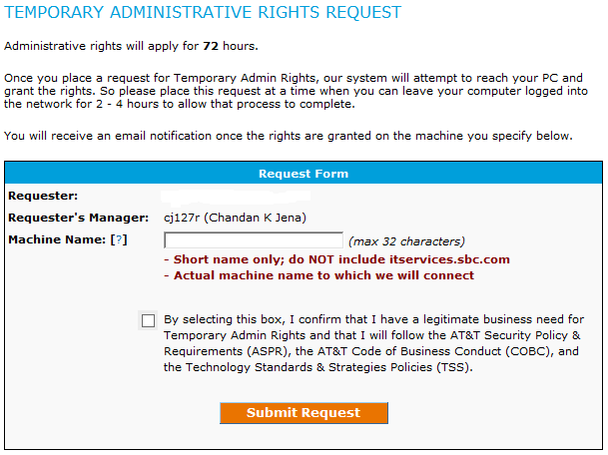
- Go to Run -> cmd. Type hostname and enter
- Copy and paste hostname in Machine name textbox. Select below check box and click on Submit Request button.
- After some time you will receive auto generated mail with admin right confirmation. Once mail is received log off and login back to HVD.

Download oracle setup
After admin rights are received download oracle database. Please follow below steps.
Steps:
- Go to https://www.oracle.com/database/technologies/xe-prior-releases.html
- Download Oracle Database 11gR2 Express Edition for Windows x64 and follow onscreen instruction.
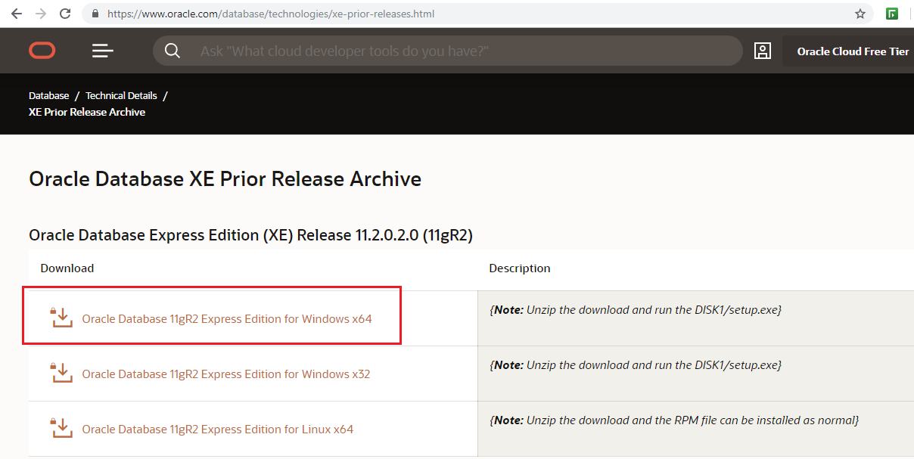

Oracle installation guide
After oracle database setup is downloaded. Please follow below steps.
Steps:
- Extract OracleXE112_Win64 zip file.
- Run setup.exe
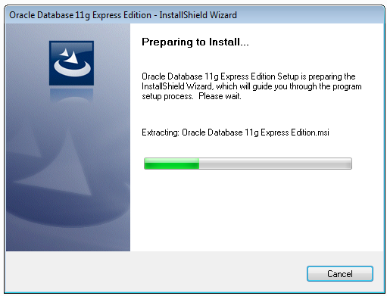
- Click on Next

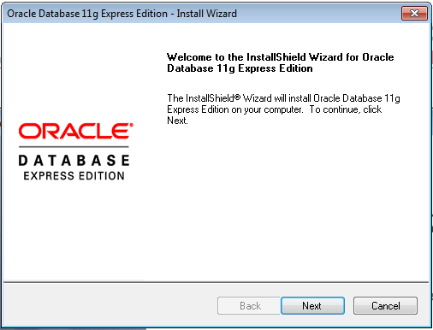
- Select I agree radio button and click on next.
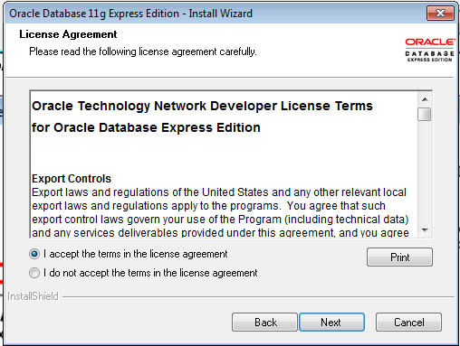
- Recommended to do installation on c drive if there is a space else do it on shared drive. Click on next.
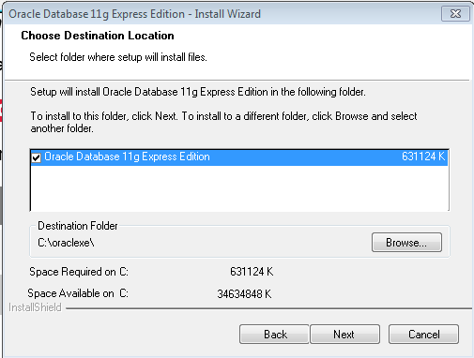
- Enter password as admin and click on next.
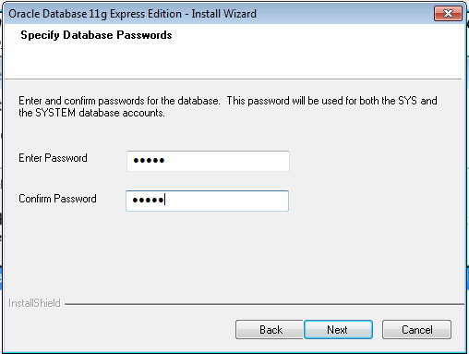
- Click on Install
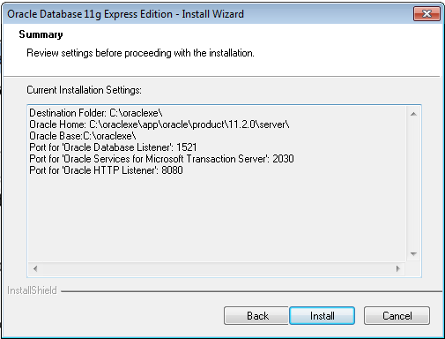
- Click on Finish.

Create oracle schema
After oracle is installed. Please follow below steps to create schema on local db.
Steps:
- Go to Start -> All programs -> Oracle Database 11g Express Edition -> Run SQL command line
- Execute below command to connect as DBA and enter system/admin as credentials
conn as sysdba
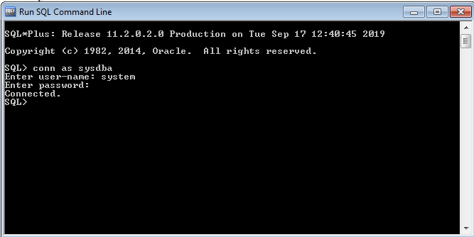
- Execute below command to create table space. Please change table space file path as per your machine.
create tablespace comet_ccs_tbs datafile 'C:/Users/<ATT Uid>/comet-tablespace/COMET_CCS.dbf' size 3g;
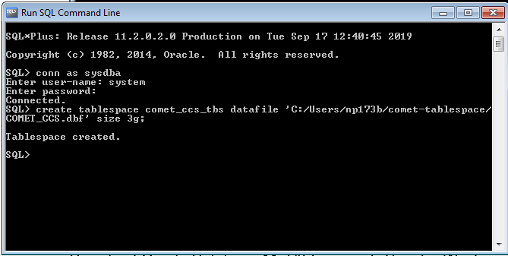
- Execute below command to create user(Schema)
create user ccs_local identified by sept2019 default tablespace comet_ccs_tbs;
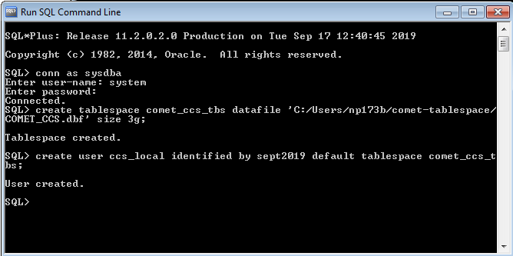
- Execute below command to provide access to use full tablespace
alter user ccs_local quota unlimited on comet_ccs_tbs;
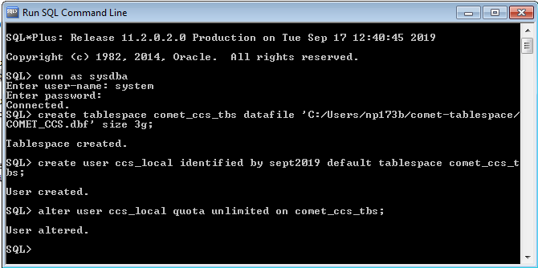
- Execute below commands to provide grants to user(schema)
grant connect, resource to ccs_local;
GRANT CREATE ANY VIEW to ccs_local;
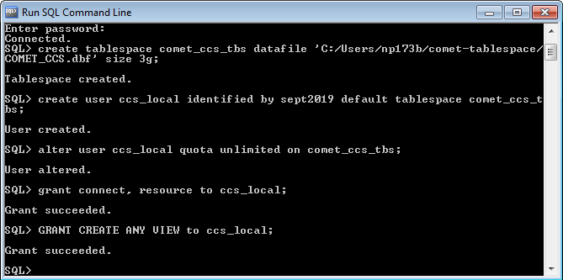
- Execute below commands
alter system set processes = 300 scope = spfile;
alter system set sessions = 300 scope = spfile;
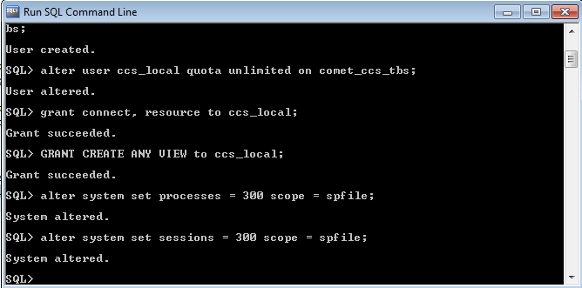

Download SQL developer setup
After oracle schema is created download SQL Developer. Please follow below steps.
Steps:
- Go to
https://www.oracle.com/technetwork/developer-tools/sql-developer/downloads/sqldev-downloads-184-5458710.html
- Download SQL Developer 18.4 for Windows x64 and follow onscreen instruction.
If you don’t have JDK 8 installed on your machine choose installer containing JDK.
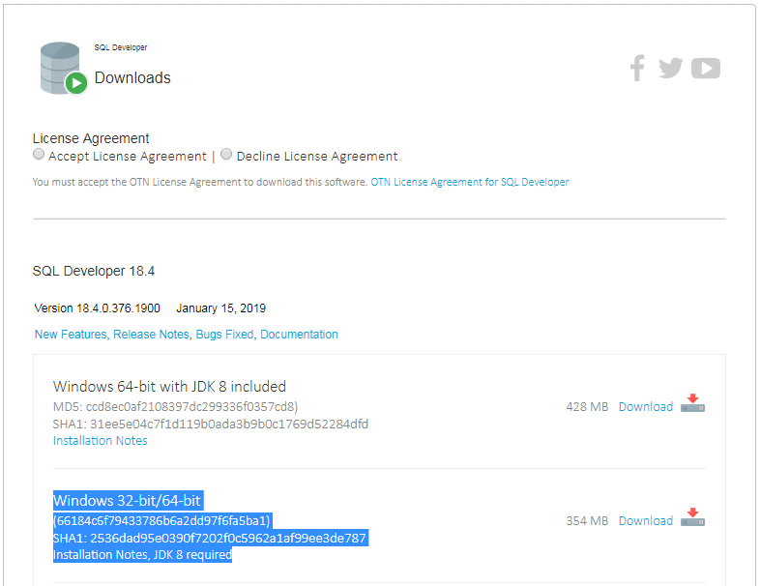

SQL Developer installation guide
After SQL developer setup is downloaded. Please follow below steps.
Steps:
- Extract sqldeveloper-18.4.0-376.1900-no-jre.zip.
- Copy folder in shared drive or as per your convenience.
- To open SQL developer run sqldeveloper.exe

Oracle schema copy
After SQL developer is setup. Please follow below steps.
Steps:
- Open SQL developer.
- Add Local and Stage connections in tool. For local use below credentials.
COMET Local :
Host : localhost
Port :1521
SID : xe
Username : ccs_local
Password : sept2019

COMET Stage :
Host : s1com1d1.vci.att.com
Port :1524
SID : s1com1d1
Username : ccs_stage

For Stage credentials please get in touch with ADBA or team lead
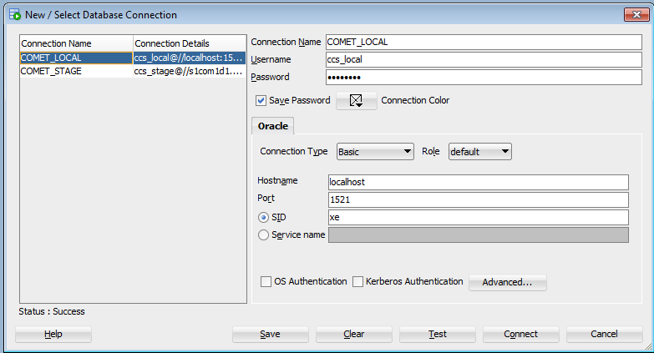
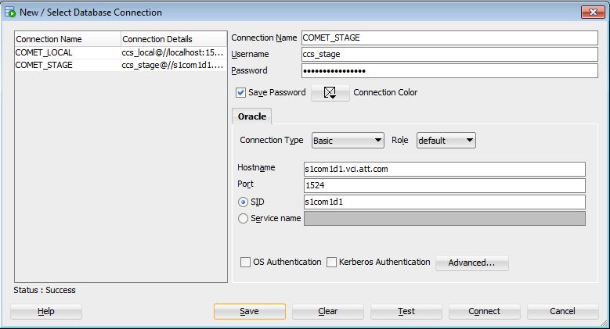
- Connect to both database.
- Go to Tools -> Database copy
- Select source as Stage and destination as local

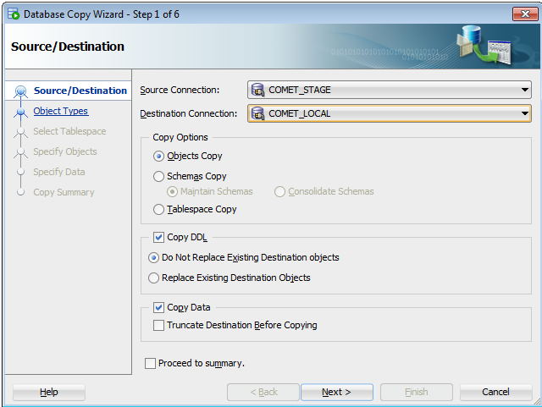
- Click on next. You will get one pop up about version warning. Click Yes and proceed.
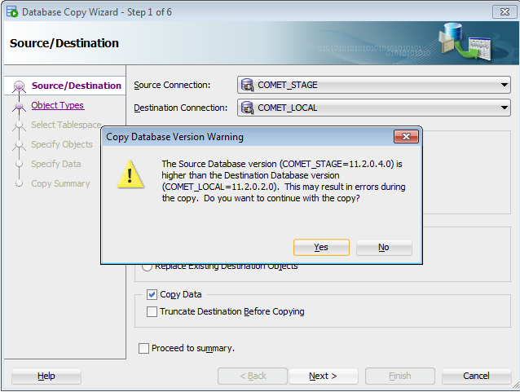
- Click on next.
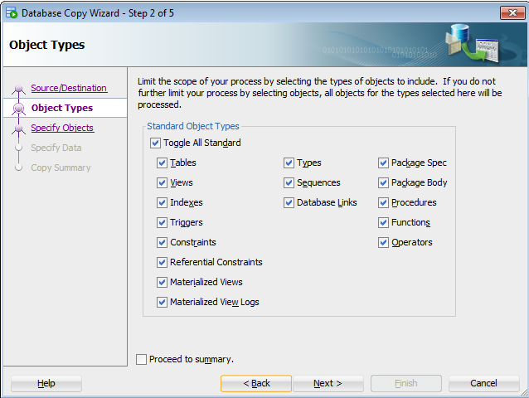
- Click on next
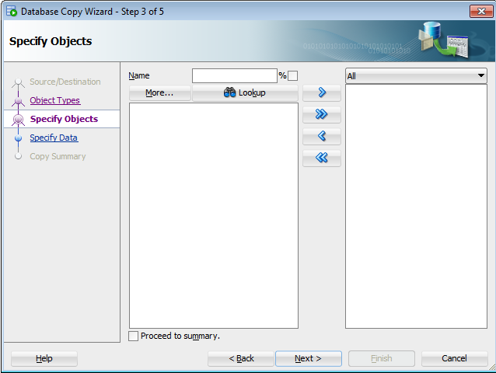
- Click on next
- Click on Finish
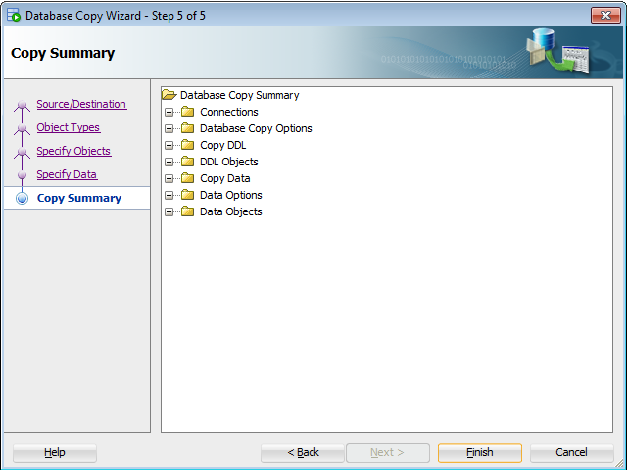
- SQL Developer will copy all database objects in your local database.
- This finished local database installation guide.

DOCUMENT HISTORY

Version | Date | Author (function) | Reviewed by | Approved by | Nature of changes
1.0 | 17-Sep-2019 | Sulekh Gharat | Prasanjit Deka | Prasanjit Deka | Baseline document

Annexure

Template DOCUMENT HISTORY

Version | Date | Author | Reviewed by | Approved by | Nature of changes
1.0 | Sulekh Gharat | Prasanjit Deka | Prasanjit Deka | Sulekh Gharat

