KWOC END EVALUATION REPORT



**Sakshi Gaur**

Github account-@gaursakshi

Indira gandhi Delhi Technical University For Women

# 

# **ABOUT KWOC**

Kharagpur Winter of Code is a 5-week long online programme for students who are new to open source software development. The programme not only helps students to get involved in open source, but also prepares them for many open source summer programmes; Google Summer of Code being one of them.

# **SELECTION OF PROJECTS**

There were variety and interesting projects provided by KWOC this year .My main focus was to enhance on my coding skills and therefore I choosed two projects which were

1.Competitive Programming data Structure and Algorithm mentored by Rishabh Garg

2.Interview Preparation Kit mentored by Sundaram Dubey

# **PROJECT DESCRIPTION**

**First project**

**Interview Preparation Kit**

https://www.hackerrank.com/interview/interview-preparation-kitnGive Solvution of all hacker-rank Interview preparation kit problems in c++ , java and python . And also add Competitive-programing algorithms .

**Second Project**

**Competitive Programming data Structure and Algorithm**

This project contains some useful codes, techniques, algorithms and problem solutions helpful in Competitive Coding.

# **Contributing towards the Project**

Interview Preparation Kit(Project 1)

I started the project by understanding the given problem on the Hackerrank Portal .I analysed the whole problem and try to decode the given problem by practising with pen and paper.I created pseudocode for the given problem and then I tried to upload my code on Hackerrank Platform and my solution was accepted.

Program chosen:-Birthday Cake Candle.cpp

**Contribution 1**

**PULL REQUEST 1**

|  |  |  |
| --- | --- | --- |
| int birthdayCakeCandles(vector<int> ar) |  |  |
| int largest=ar[0]; |  |  |
| int count=0; |  |  |
| for(int i=1;i<ar.size();i++)  { |  |  |
| if(ar[i]>largest) |  |  |
| { |  |  |
| largest=ar[i]; |  |  |
| } |  |  |
| } |  |  |
| for(int i=0;i<ar.size();i++) |  |  |
| { |  |  |
| if(ar[i]==largest) |  |  |
| { |  |  |
| count++; |  |  |
| } |  |  |
| } |  |  |
| return count; |  |  |
| } |  |  |

**MERGED PR1**

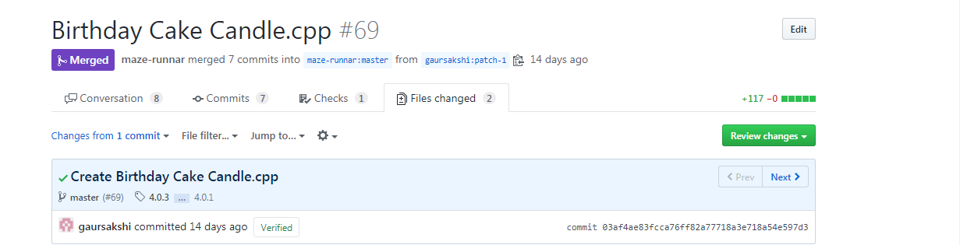

**Contribution 2**

In second project First I have to create an issue on the program -sort array of 0,1,2s

And then my mentor approved my issue and I was ready to work on it.

First I understood the logic of my current program using Dutch National flag algorithm .

Then I coded my algorithm for my program using c++ and my coding platform was Visual Studio code and then created my pull request..

**PULL REQUEST 2**

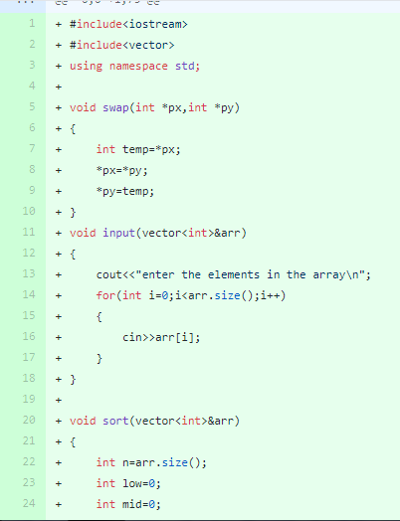

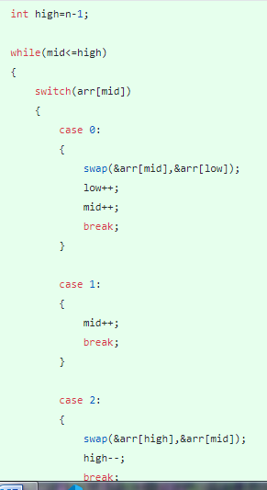

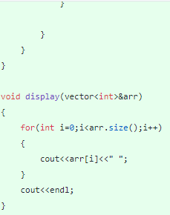

**MERGED PR2**

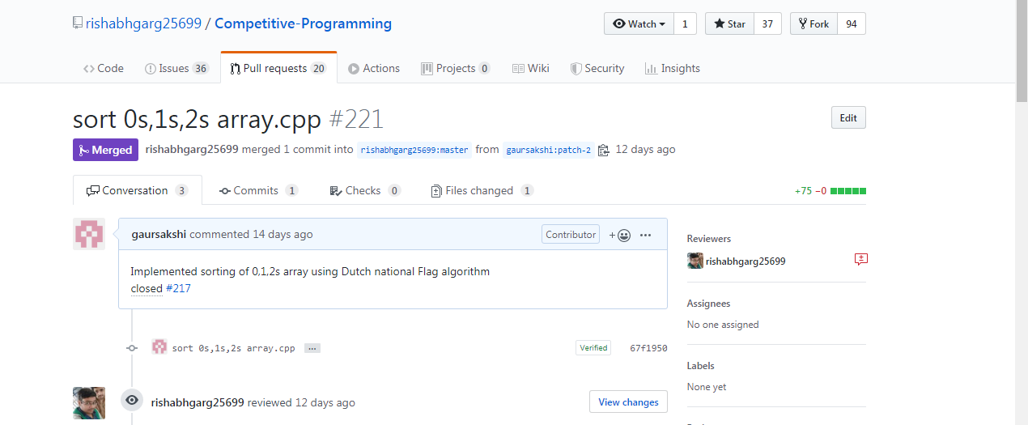

**MY KWOC EXPERIENCE**

My experience with Kharagpur Winter of Code has been beneficial as the level of contribution is very much appropriate, considering for the beginners, and testing out all the aspects of Open Source Development. I also had the privilege of interacting some of the highly motivated and enthusiastic people through my project and identify my shortcoming

# SUMMARY OF THE WORK

|  |  |
| --- | --- |
| Project name | Pull request-(topic) |
| 1.Interview Preparation Kit | Program created on BirthdayCake Candle.cpp on Hackerrank platform |
| 2.Competitive Programming data Structure and Algorithm | Program created on sort of array of0s,1s,2s using Dutch national flag algorithm |