**Devi Ahilya Vishwavidyalaya, Indore.**

**School Of Data Science and Forecasting**

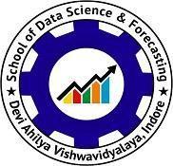

ASSIGNMENT ON

ANALYSIS OF SOCIAL MEDIA POSTS USING DATA MINING MODEL

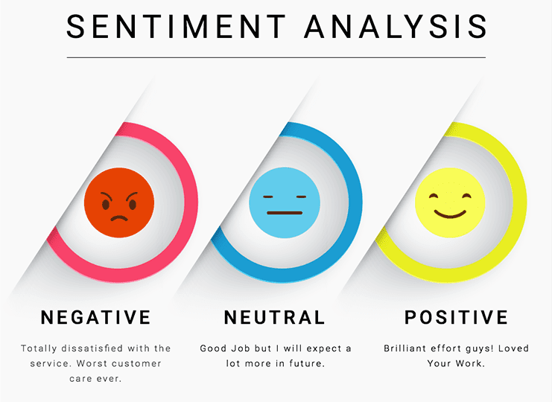

GUIDED BY: SUBMITTED BY:

PROF. KAPIL SHARMA AYUSHI JAIN (DS7B-2006)

GAUTAM KUMAR (DS7B-2008)

NISHITA JAIN (DS7B-2010)

PARITOSH LAHRI (DS7B-2011)

M-Tech (BDA)