FLASK AND MONGODB ASSIGNMENT
Name: Gautam Dawar
Course: DevOps
Assignment: Docker

1. Frontend (Node.js with Express)
- Create a frontend using Express and Node.js.
- Include a form similar to the one from the Flask Assignment 2.
- Configure the form to send a request to the Flask backend.
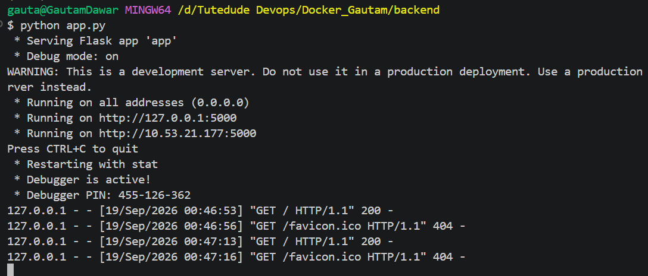
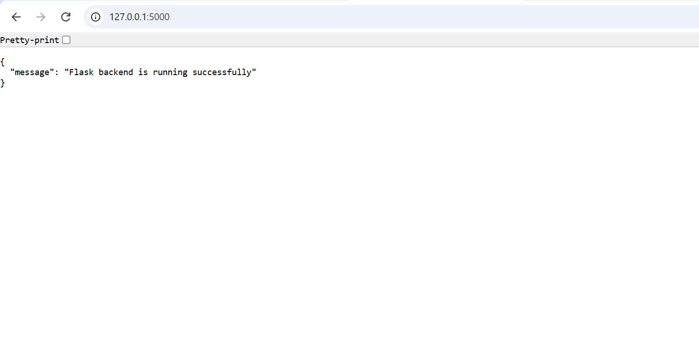
2. Backend (Flask)
- Use the Flask backend to handle the form submission and process the data.
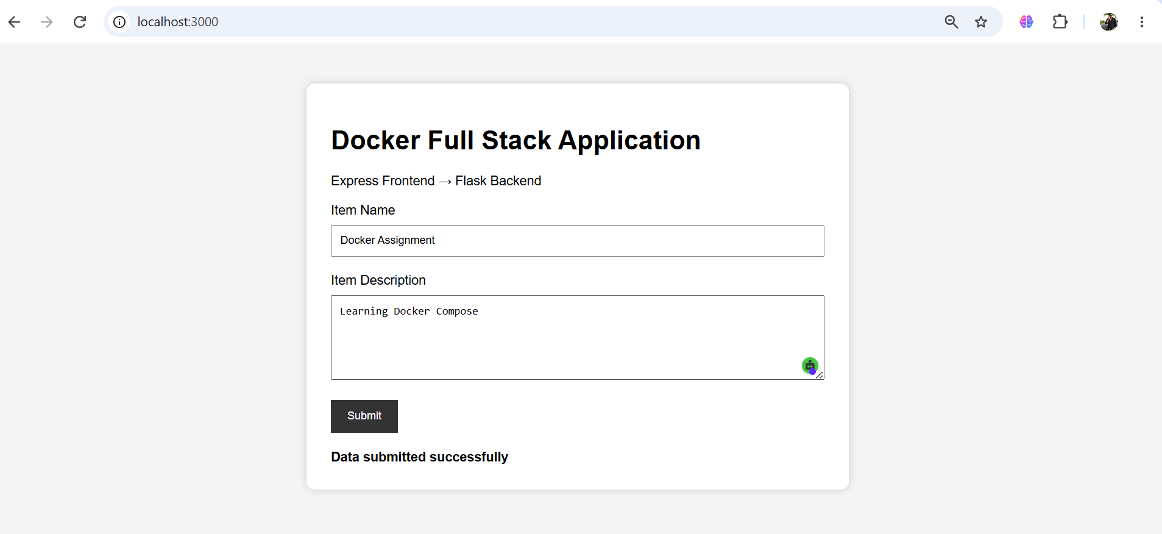
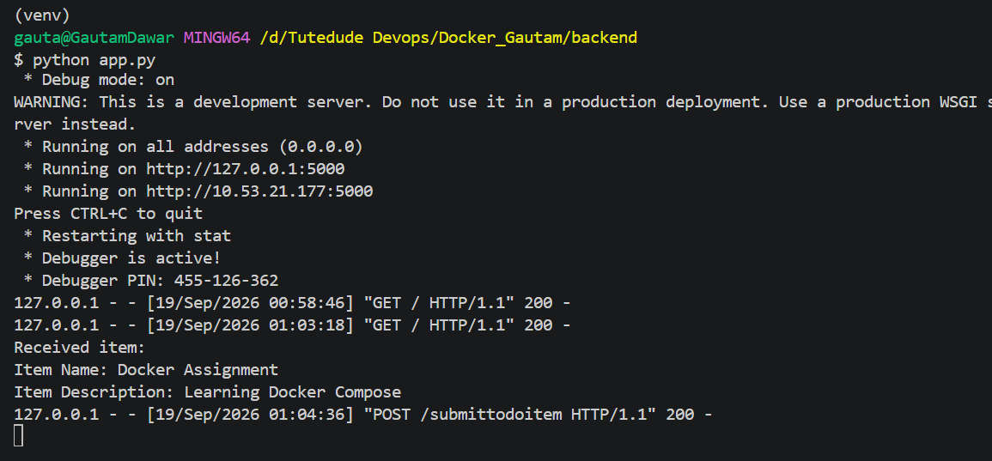
3. Folder Structure
- Organize the project with separate folders for the frontend and backend.
4. Docker Configuration
- Create a Dockerfile for both the frontend and backend.
- Write a .yaml file (Docker Compose) to connect both services in the same network.
- Upload both images to Docker Hub, and push your whole code to GitHub. Add node_modules and other non-required files (e.g., .vscode) to .gitignore.
Docker compose commands:
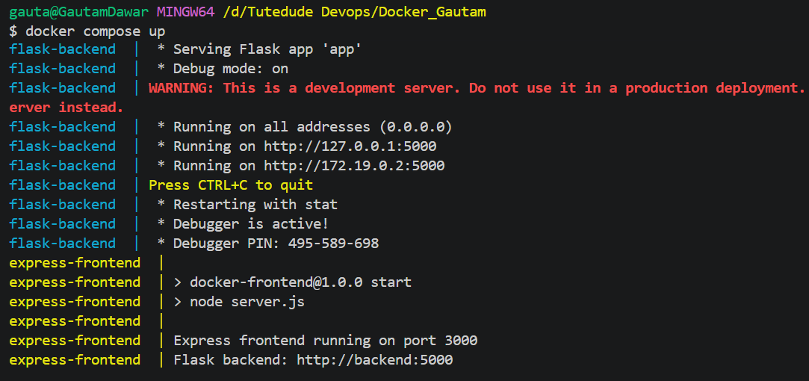
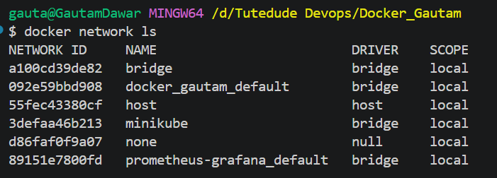
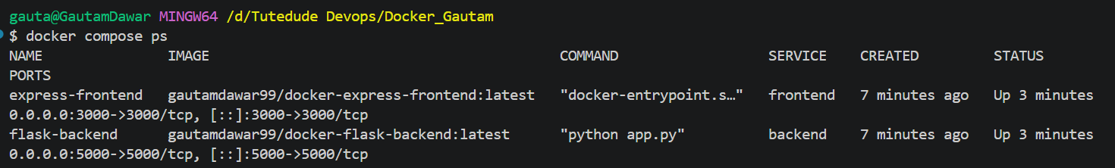
DockerHub Commands and repositories:
