Vehicle Service Center Management System
Introduction
The Vehicle Service Center Management System is a web-based application developed to simplify and digitalize the process of vehicle servicing. In traditional systems, users need to visit service centers physically or make bookings through calls, which can be time-consuming and inefficient. This website provides a convenient online platform where users can access services anytime, select their vehicle, choose a service center, and book a suitable time slot.
The system is designed with a structured and user-friendly web interface, allowing smooth navigation across different pages such as registration, login, service selection, and booking. It connects customers with authorized service centers and local garages, making it easier to compare options and schedule services without hassle. Additionally, service center owners and administrators can manage services, availability, and bookings through the system.
Overall, the website improves efficiency, reduces manual effort, and provides a reliable and accessible solution for managing vehicle servicing online.
Project Scope
The Vehicle Service Center Management System is a web-based platform developed to simplify and modernize the process of vehicle servicing. It enables users to connect with nearby authorized service centers and local garages through an online interface. The system allows users to easily register, explore service options, and book appointments without the need for physical visits, saving both time and effort.
Scope of the Project
This project focuses on creating a user-friendly and efficient system where vehicle owners can manage their servicing needs digitally. Users can create an account, select their vehicle type (two-wheeler or four-wheeler), choose a preferred brand or local service center, and book an available time slot.

Functionalities / Modules
Main Module: Vehicle Service Booking & Management
1. User Authentication – Users can securely register and log in to access the system.
2. Vehicle & Service Selection – Users can choose vehicle type and preferred service center.
3. Service Center Support – View nearby centers and contact them.

Main Module: Service Center Owner Management
1. Service Center Registration – Register and manage service center.
2. Service & Slot Management – Add/update services and time slots.
3. Booking Management – Manage bookings efficiently.

Main Module: Admin Management
1. User & Service Center Management – Manage users and service centers.
2. Booking Management – Monitor all bookings.
3. System Monitoring – Monitor system performance.

Roles and Their Interactions
- Customer/User
- Register and log in
- Select vehicle and service center
- Book slots

- Service Center Owner
- Manage profile
- Manage services and slots
- Handle bookings

- Admin
- Manage users and centers
- Monitor bookings
- Oversee system

Functional Scope
Includes user login, vehicle selection, service center listing, slot booking, and booking management.

Technical Scope
Frontend: HTML, CSS, JavaScript, Node Js.
Database: MySQL

Analysis and Design
Entity Relationship Diagram (ERD):
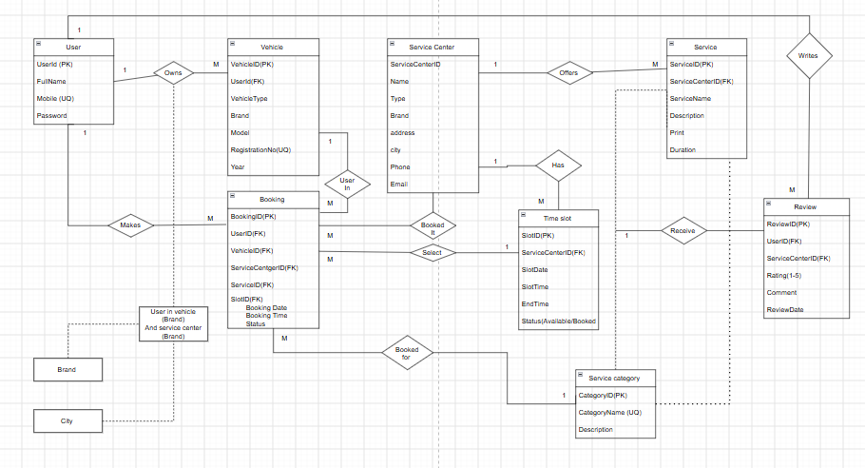

Use Case Diagram :
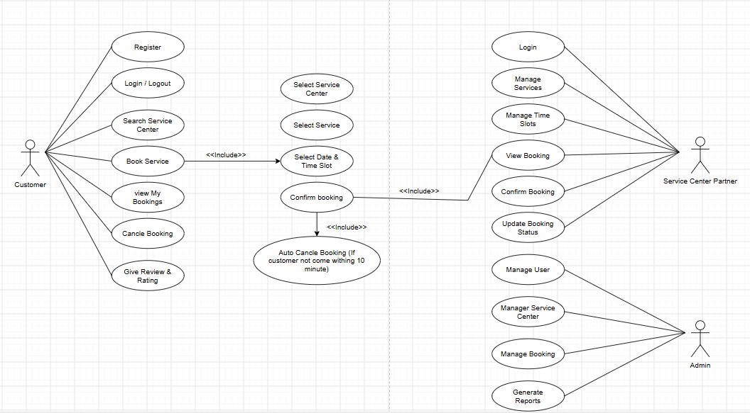

Table Structure / Data Dictionary :
Table :

Table Structure / Data Dictionary

User Table

Field | Type | Key | Description
UserID | INT | PK | Unique user ID
FullName | VARCHAR(100) |  | Customer name
Mobile | VARCHAR(15) | UQ | Mobile
Email | VARCHAR(100) | UQ | Email
Password | VARCHAR(255) |  | Password
UserType | ENUM |  | Customer/Admin/ServiceCenter
CreatedAt | DATETIME |  | Created date

Vehicle Table

Field | Type | Key | Description
VehicleID | INT | PK | Vehicle ID
UserID | INT | FK | Owner
VehicleType | ENUM |  | 2W/4W
Brand | VARCHAR(50) |  | Brand
Model | VARCHAR(50) |  | Model
RegistrationNo | VARCHAR(20) | UQ | Registration
Year | YEAR |  | Manufacture year

Service Center Table

Field | Type | Key | Description
ServiceCenterID | INT | PK | Center
Name | VARCHAR(100) |  | Name
Type | ENUM |  | Branded/Non
Address | TEXT |  | Address
Phone | VARCHAR(15) |  | Phone
OpenStatus | BOOLEAN |  | Open/Busy

Service Table

Field | Type | Key | Description
ServiceID | INT | PK | Service
ServiceCenterID | INT | FK | Center
ServiceName | VARCHAR(100) |  | Name
Price | DECIMAL |  | Price
Duration | INT |  | Minutes

Booking Table

Field | Type | Key | Description
BookingID | INT | PK | Booking
UserID | INT | FK | User
VehicleID | INT | FK | Vehicle
ServiceCenterID | INT | FK | Center
ServiceID | INT | FK | Service
BookingDate | DATE |  | Date
TimeSlot | TIME |  | Time
Status | ENUM |  | Status
TotalAmount | DECIMAL |  | Bill

Time Slot Table

Field | Type | Key | Description
SlotID | INT | PK | Slot
ServiceCenterID | INT | FK | Center
SlotDate | DATE |  | Date
StartTime | TIME |  | Start
EndTime | TIME |  | End
Status | ENUM |  | Available/Booked

Review Table

Field | Type | Key | Description
ReviewID | INT | PK | Review
UserID | INT | FK | User
ServiceCenterID | INT | FK | Center
Rating | INT |  | 1-5
Comment | TEXT |  | Feedback
ReviewDate | DATETIME |  | Date

