Right Business Decisions

* High Revenue
* Reduce expenses
* Customer experience

Walmart :

Beer and diaper case study

Stages of data science project :

* Understand the problem statement .
* Data gathering .
* Data Engineering :
* EDA : Exploratory data analysis .
* Data Cleaning :
* Data preparation :
* Data models .
* Test the model created above .
* Deploy the model in production .

https://cran.r-project.org/bin/windows/base/

<https://rstudio.com/products/rstudio/>

SAS

Dplyr : handling data .

Ggplot2 : visualization .

Links to learn R

<https://www.tutorialspoint.com/r/index.htm>

<https://www.rdocumentation.org/packages/base/versions/3.6.2>

<https://www.datacamp.com/>

<https://towardsdatascience.com/>

<https://statistics.berkeley.edu/computing/r-dates-times>

Link for data sets and explore further in the world of data science

<https://www.kaggle.com/>

<http://www.z-table.com/>

<http://www.ttable.org/>

Statistics :

H0 -> Null Hypothesis

H1 -> Alternate Hypothesis

Population data -> total data

Sample data -> subset of population data

µ - Mean of population data

σ – Standard deviation.

$\underline{X}$– Mean of the sample data.

n – number of records in sample data.

N – number of records in population data.

**Central Limit Theorems :**



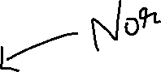

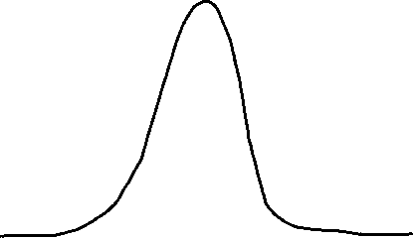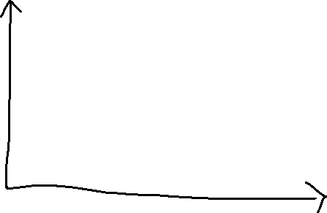





1 - When the population data is normally distributed then the sample means also follow a normal distribution.



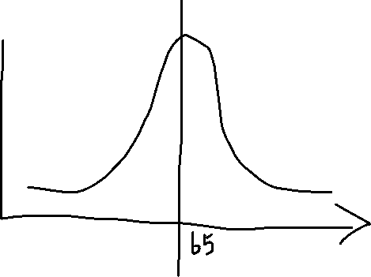



2 – When the sample size is large , the sample mean follows a normal distribution irrespective of the distribution of the population data

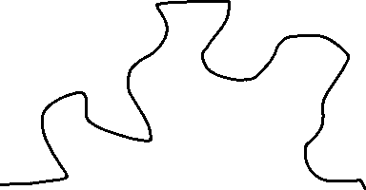





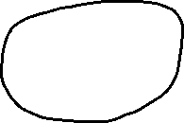

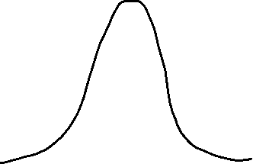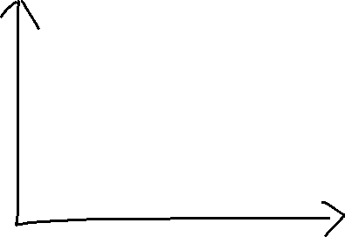

3 –

X ~ N (µ , σ ) - > Population data

$\underline{X}$ ~ N ( µ , $\frac{σ}{√n}$) -> Sample data

H0 - > My friend sells 350 toffees everyday .

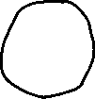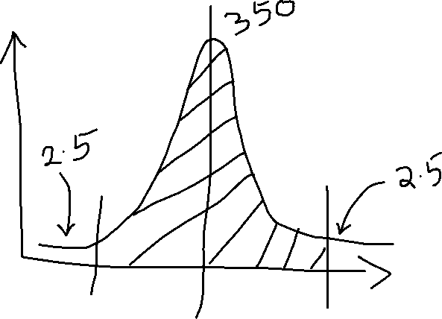

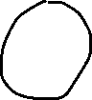



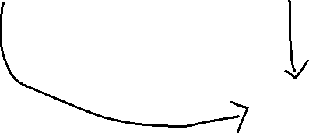

Critical region

n = 100

standard deviation of the population = 18

Z test :

$±$ Z = $\frac{\underline{X}- µ}{\frac{σ}{√n}}$

$\underline{X}$ = $µ ±$ Z ($\frac{σ}{√n}$)

= 350 $±$ 1.96 ( 18 / $√$ 100 )

= 350 $±$ 1.96 * 1.8

UL : 350 + 3.5 , LL : 350 – 3.5

T test :

t = $\frac{\underline{X}- µ}{\frac{s}{√n}}$

School of 1000 students .

Average IQ : 100

N = 1000

$µ$ = 100

H0 -> IQ of the students will remain the same.

n = 25

$\underline{X}$ = 140

S = 18 -> std dev of sample data .

Level of significance = 0.05

t = $\frac{140 - 100}{\frac{18}{√25}}$

= 11.11

Degree of Freedom: n -1 = 24

-2.064 < t < 2.064 -> accept null hypothesis.

Which means I will reject the null hypothesis and the medicine has a positive impact .

ANOVA TEST :

Analysis of Variance

5 Ponds . polluted .

20 samples from each pond . 

H0 -> P1 = P2 = P3 = P4 = P5 ( all ponds have same pollution)









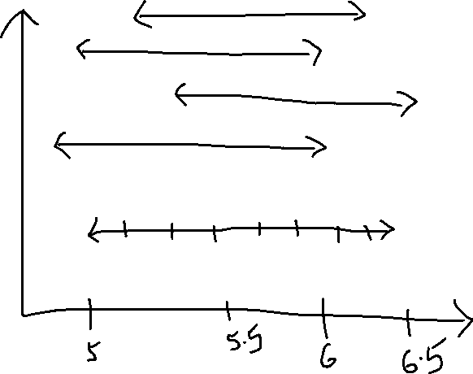



Fstats = 

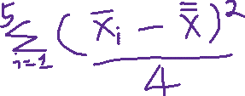



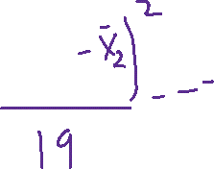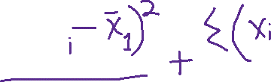



Parametric tests

Non parametric tests :

Chi square

CHI SQUARE:

|  |  |  |  |  |
| --- | --- | --- | --- | --- |
|  | Salary | | | |
| Service | Low | Medium | High | Total |
| Excellent | 9 E11 | 10 E12 | 7 E13 | 26 |
| Good | 11 E21 | 9 E22 | 31 E23 | 51 |
| Poor | 12 E31 | 8 E32 | 3 E33 | 23 |
| Total | 32 | 27 | 41 | 100 |

E11 = (26 * 32) / 100

E12 = (26 * 27) / 100

E13 = (26 * 41 )/ 100

.

.

.

.

.

.

E33 = 23 * 41 /100

Xsq = 18.658