A Mini Project Report
on
CONCORD: AN EXPERIMENTAL STUDY OF AUTONOMOUS NEGOTIATION STRATEGIES BETWEEN LARGE LANGUAGE MODEL AGENTS
Submitted in partial fulfillment of the requirement for the award of Degree of
Bachelor of Technology in Computer Science & Engineering
Submitted to:
RAJIV GANDHI PROUDYOGIKI VISHWAVIDYALAYA, BHOPAL (M.P.)

Submitted by:
GAUTAM SONI
Enrollment No: 0808CS241120
Under the Supervision of:
Mrs. Preeti Agrawal
Assistant Professor, Department of CSE
DEPARTMENT OF COMPUTER SCIENCE & ENGINEERING
IPS ACADEMY, INSTITUTE OF ENGINEERING & SCIENCE
(A UGC Autonomous Institute Affiliated to RGPV)
INDORE (M.P.) — SESSION: 2026-27

IPS ACADEMY, INDORE
INSTITUTE OF ENGINEERING & SCIENCE
(A UGC Autonomous Institute Affiliated to RGPV)
DEPARTMENT OF COMPUTER SCIENCE & ENGINEERING
Mini Project Entitled:
“Concord: An Experimental Study of Autonomous Negotiation Strategies Between Large Language Model Agents”
For the partial fulfillment for the award of Bachelor of Technology (Computer Science & Engineering) Degree by Rajiv Gandhi Proudyogiki Vishwavidyalaya, Bhopal.
Guided by: | Submitted by:
Mrs. Preeti Agrawal  Assistant Professor, CSE Dept. | Gautam Soni  0808CS241120  B.Tech (CSE) VIII Sem

IPS ACADEMY, INDORE
INSTITUTE OF ENGINEERING & SCIENCE
(A UGC Autonomous Institute Affiliated to RGPV)
DEPARTMENT OF COMPUTER SCIENCE & ENGINEERING
CERTIFICATE
This is to certify that the Mini Project entitled “Concord: An Experimental Study of Autonomous Negotiation Strategies Between Large Language Model Agents” has been successfully completed by Gautam Soni (Enrollment No: 0808CS241120), student of Bachelor of Technology in Computer Science & Engineering, at IPS Academy, Institute of Engineering & Science, Indore, in partial fulfillment of the requirements for the award of the Degree of Bachelor of Technology (Computer Science & Engineering) by Rajiv Gandhi Proudyogiki Vishwavidyalaya, Bhopal (M.P.) during the academic session 2026-27 under our supervision and guidance.
The work embodied in this project report has reached the standard fulfilling the requirements and the regulations relating to the degree. To the best of our knowledge, the results incorporated in this report have not been submitted to any other University or Institute for the award of any degree or diploma.

Mrs. Preeti Agrawal  (Project Guide)  Assistant Professor, CSE | Mr. Arvind Upadhyay  (Branch Coordinator)  Department of CSE | Dr. Neeraj Shrivastava  (Prof. & Head)  Department of CSE

ACKNOWLEDGEMENT
I would like to express my deepest sense of gratitude and sincere thanks to my project guide, Mrs. Preeti Agrawal, Assistant Professor, Department of Computer Science & Engineering, IPS Academy, Institute of Engineering & Science, Indore, for her invaluable guidance, persistent encouragement, constructive critique, and inspiring mentorship throughout the conceptualization, system implementation, and completion of this project. Her vast technical knowledge and continuous motivation helped steer this project toward fruitful completion.
I also convey my deep gratitude to Dr. Archana Keerti Chowdhary, Principal, IPS Academy, Institute of Engineering & Science, for providing an academically stimulating environment, excellent infrastructure, and state-of-the-art laboratory facilities essential for undertaking advanced research projects.
I express my sincere thanks to Dr. Neeraj Shrivastava, Professor & Head, Department of Computer Science & Engineering, and Mr. Arvind Upadhyay, Branch Coordinator, Department of CSE, for their constant academic support, valuable administrative coordination, and valuable feedback during the project evaluation reviews.
I extend my sincere appreciation to all the faculty members and technical staff of the Computer Science & Engineering Department for their direct and indirect support throughout the academic coursework.
Special thanks to my peers, friends, and colleagues who contributed constructive discussions on multi-agent game theory, conversational LLM behavior, and statistical metrics evaluation.
Finally, I am eternally indebted to my parents and family members for their boundless affection, moral encouragement, sacrifices, and unconditional support, which have always been my greatest source of strength.
Gautam Soni
Enrollment No: 0808CS241120
B.Tech (Computer Science & Engineering)
IPS Academy, Indore

CONTENTS
Certificate | iii
Acknowledgement | iv
List of Figures | vi
List of Tables | vii
List of Abbreviations | viii
Abstract | ix
CHAPTER 1: INTRODUCTION | 1
1.1 Background of the Study | 1
1.2 Problem Context & Motivation | 2
1.3 Project Objectives | 3
1.4 Scope and Limitations | 4
CHAPTER 2: PROBLEM IDENTIFICATION & SCOPE | 5
2.1 Problem Domain | 5
2.2 Solution Domain | 6
2.3 Economic Foundation & Rubinstein Bargaining Model | 7
CHAPTER 3: SOFTWARE ENGINEERING APPROACH | 9
3.1 Software Development Life Cycle (SDLC) Model | 9
3.2 Platform & Technical Specifications | 11
3.2.1 Hardware Specification | 11
3.2.2 Software Specification | 11
3.3 Existing Work & Literature Review | 12
3.3.1 Strengths of Existing Works | 12
3.3.2 Limitations & Shortcomings | 13
3.4 Gap Analysis & Project Contributions | 14
CHAPTER 4: SYSTEM DESIGN & UML MODELING | 16
4.1 System Architectural Design | 16
4.2 Use Case Diagram | 18
4.3 Sequence Diagram | 20
4.4 State Machine Diagram | 22
4.5 Class & Data Contract Design | 24
CHAPTER 5: IMPLEMENTATION PHASE | 26
5.1 Core System Modules & Components | 26
5.1.1 Gemma 4 Agent Framework & Structured JSON Parsing | 26
5.1.2 Orchestrator Engine & Turn Management | 28
5.1.3 Structured JSON Transcript Logging | 29
5.1.4 Quantitative Analysis Pipeline | 30
5.2 Interactive Demonstration Web Dashboard (Streamlit GUI) | 31
CHAPTER 6: EXPERIMENTAL RESULTS & DISCUSSION | 33
6.1 Experimental Setup & Factorial Matrix | 33
6.2 Empirical Evaluation & Metrics | 34
6.2.1 Deal Success Rate Across Persona Combinations | 34
6.2.2 Economic Surplus Split & Division of Value | 35
6.2.3 Rounds to Convergence (Negotiation Velocity) | 37
6.2.4 Pareto Efficiency & Bargaining Rationality | 38
6.3 Impact of Information Asymmetry | 39
6.4 Behavioral Dynamics & Strategic Insights | 40
CHAPTER 7: CONCLUSIONS & FUTURE SCOPE | 42
7.1 Summary of Accomplishments | 42
7.2 Limitations of Current Study | 43
7.3 Future Research Directions | 44
REFERENCES | 45

LIST OF FIGURES
Figure 4.1 | Concord Multi-Agent Negotiation Architecture | 17
Figure 4.2 | Concord System Use Case Diagram | 19
Figure 4.3 | Turn-by-Turn Bilateral Negotiation Sequence Diagram | 21
Figure 4.4 | Negotiation Protocol State Machine Diagram | 23
Figure 5.1 | Streamlit Multi-Page Web Interface (Live Simulation View) | 32
Figure 6.1 | Deal Success Rate by Persona Pair (Empirical Distribution) | 35
Figure 6.2 | Economic Surplus Distribution Across Persona Pairings | 36
Figure 6.3 | Rounds to Convergence Distribution (Turn Velocity) | 37
Figure 6.4 | Bilateral Deal Success Heatmap (Buyer × Seller Matrix) | 39
LIST OF TABLES
Table 3.1 | Hardware Environment Specifications | 11
Table 3.2 | Software Environment Specifications | 12
Table 4.1 | Core Data Contract Dataclasses & Field Attributes | 25
Table 6.1 | Factorial Experimental Matrix Configuration (18 Conditions) | 33
Table 6.2 | Summary Performance Metrics Across Persona Pairings | 38

LIST OF ABBREVIATIONS
LLM | Large Language Model
ZOPA | Zone of Possible Agreement
SDLC | Software Development Life Cycle
JSON | JavaScript Object Notation
API | Application Programming Interface
GUI | Graphical User Interface
UML | Unified Modeling Language
SDK | Software Development Kit
CLI | Command Line Interface
RGPV | Rajiv Gandhi Proudyogiki Vishwavidyalaya
BATNA | Best Alternative to a Negotiated Agreement
ABSTRACT
Automated negotiation is a foundational paradigm underpinning autonomous commerce, algorithmic procurement, and decentralized decision-making. Historically, multi-agent automated negotiations relied on rigid, hand-crafted mathematical rules or game-theoretic bargaining models that lacked contextual flexibility and natural-language communication. The recent advent of capable, instruction-tuned, open-weight Large Language Models (LLMs) presents an unprecedented opportunity: negotiations can now unfold entirely through unscripted natural language between autonomous software agents.
This project, Concord, introduces a controlled, reproducible experimental simulation framework designed to study multi-turn strategic price negotiations between two independent instances of Google's Gemma 4 model. The agents represent opposing economic roles: a Buyer endowed with a private maximum willingness to pay ($100.00) and a Seller endowed with a private minimum acceptable cost ($60.00), defining a Zone of Possible Agreement (ZOPA) of $40.00. The framework systematically investigates the impact of prompting strategies (Cooperative, Neutral, Aggressive personas) and information asymmetry (Symmetric Hidden vs. Asymmetric Insider Knowledge) across a full factorial matrix of experimental conditions.
An orchestrator manages alternating conversational turns, while agents emit structured JSON objects encapsulating explicit economic actions (offer, counter, accept, walk-away), numerical price values, natural-language dialogic justifications, and internal private chain-of-thought reasoning. Every session is logged as structured JSON transcripts and evaluated via a Pandas-based quantitative analysis engine across key game-theoretic metrics: Deal Success Rate, Rounds to Convergence, Economic Surplus Split, and Pareto Efficiency.
Empirical results demonstrate that agent personas fundamentally dictate contract feasibility and wealth division: Aggressive agents capture up to 90% of the economic surplus when paired with Cooperative counterparts, while Aggressive-versus-Aggressive dyads suffer severe frictional delays and increased impasse rates. Furthermore, asymmetric information knowledge dramatically amplifies bargaining power, enabling informed agents to extract maximal rents. The system features an interactive Streamlit demonstration dashboard for real-time visualization and historic transcript replays, offering a production-grade academic framework for multi-agent game-theoretic LLM research.
Keywords: Keywords: Large Language Models, Multi-Agent Systems, Automated Negotiation, Gemma 4, Game Theory, Surplus Split, Pareto Efficiency, Prompt Engineering.

CHAPTER 1: INTRODUCTION
1.1 Background of the Study
Negotiation is a fundamental goal-directed communicative process through which two or more self-interested entities with partially conflicting objectives interact to reach a mutually acceptable agreement. In classical computer science and economics, automated negotiation has been studied for decades through rule-based expert systems, heuristic algorithms, and formal game-theoretic bargaining models such as the Rubinstein alternating-offers paradigm and Nash bargaining solution. While mathematically rigorous, traditional automated negotiation systems suffered from critical constraints: they operated exclusively within rigid, pre-defined numerical protocols, required complete or probabilistic utility function disclosures, and were incapable of interpreting or generating contextual, persuasive natural language.
The emergence of generative artificial intelligence and instruction-tuned Large Language Models (LLMs)—most notably Google's lightweight open-weight Gemma 4 model family—has transformed multi-agent system design. Modern LLMs exhibit profound multi-turn dialogic coherence, strategic context retention, and reasoning capabilities. Consequently, automated economic negotiation can now be carried out entirely through natural language dialogue by autonomous AI agents, without hand-crafted heuristic rules or rigid game-tree constraints.
1.2 Problem Context & Motivation
Despite the explosive adoption of LLM-based conversational assistants, the vast majority of deployed systems are designed for single-agent, cooperative, human-facing interactions (such as chatbots and customer support assistants). Comparatively little open, reproducible empirical research investigates how two independently prompted instances of the same model family behave when placed in adversarial, goal-driven, multi-turn economic competition against each other.
As autonomous AI agents increasingly conduct real-world electronic commerce, automated supply-chain procurement, enterprise software licensing, and decentralized digital transactions, understanding their strategic interaction dynamics becomes critically important. Specifically, do LLMs concede too readily? Do they succumb to anchoring bias? How do behavioral personas (e.g., an aggressive bargainer vs. a cooperative partner) influence contract formation? And does private information asymmetry lead to predatory economic exploitation or complete transaction deadlocks?
1.3 Project Objectives
The primary aim of Project Concord is to build a robust, reproducible multi-agent simulation framework and empirically evaluate the negotiation behavior of autonomous LLM agents under controlled conditions. The specific objectives are:
- 1. Autonomous Pipeline: To design and build an autonomous turn-taking multi-agent orchestrator managing bilateral negotiations between two Google Gemma 4 agents.
- 2. Strategic Personas: To engineer distinct behavioral system prompts establishing Cooperative, Neutral, and Aggressive agent personas.
- 3. Information Asymmetry: To model information asymmetry conditions, evaluating symmetric hidden thresholds versus unilateral insider knowledge.
- 4. Structured Communication: To enforce structured JSON schema outputs from agents, isolating overt dialogue from private chain-of-thought reasoning.
- 5. Quantitative Analytics: To formulate and compute quantitative game-theoretic evaluation metrics including deal success rates, surplus distribution, rounds to convergence, and Pareto efficiency.
- 6. Demonstration GUI: To implement an interactive Streamlit graphical dashboard enabling turn-by-turn simulation replay and transcript analytics.
1.4 Scope and Limitations
To maintain experimental rigor, interpretability, and academic reproducibility within the semester timeline, the project establishes well-defined boundaries:
- Bilateral Single-Issue Scope: The simulation is bounded to bilateral (one-to-one) bargaining over a single durable commercial asset (a Vintage IBM Model M Mechanical Keyboard) with established reservation prices ($100 budget vs. $60 cost). Multi-party auctions and multi-item bundled negotiations are excluded.
- Discrete Turn Bounds: Agent interactions occur across discrete conversational rounds bounded by a configurable maximum turn limit (default 20 rounds) to prevent infinite loops.
- Model Architecture: Evaluations focus entirely on prompt engineering and in-context conditioning of the open-weight Gemma 4 instruction-tuned model. Parameter fine-tuning and reinforcement learning from human feedback (RLHF) remain prospective future extensions.

CHAPTER 2: PROBLEM IDENTIFICATION & SCOPE
2.1 Problem Domain
Automated negotiation lies at the intersection of Multi-Agent Systems (MAS), Computational Game Theory, and Natural Language Processing (NLP). In standard multi-agent environments, agents possess private utility functions, defined by:
- Buyer Reservation Price: The maximum monetary expenditure the buyer is willing to commit: $B_{max} = \$100.00$. Any agreed price $P \le B_{max}$ yields a non-negative buyer surplus $S_{buyer} = B_{max} - P$.
- Seller Reservation Price: The minimum monetary price below which the seller refuses to transact: $C_{min} = \$60.00$. Any agreed price $P \ge C_{min}$ yields a non-negative seller surplus $S_{seller} = P - C_{min}$.
- Zone of Possible Agreement (ZOPA): The range $[C_{min}, B_{max}] = [\$60.00, \$100.00]$. The total economic surplus generated by contract completion is $S_{total} = B_{max} - C_{min} = \$40.00$.
When human negotiators converse, they utilize persuasion, tactical anchoring, concessions, and bluffing. When Large Language Models are instructed to assume these roles, critical questions arise regarding their decision boundaries: Are LLMs fundamentally cooperative utility-maximizers, or can strategic prompting induce cutthroat bargaining that extracts maximal surplus at the risk of causing an impasse?
2.2 Solution Domain
The proposed solution is Concord—an integrated computational framework that orchestrates multi-agent negotiations, logs structured data transcripts, computes rigorous game-theoretic metrics, and displays real-time analytics. The system decouples the communication layer into two distinct planes:
- Public Message Plane: Natural-language conversational utterances exchanged between the Buyer and Seller agents (offers, counter-arguments, product value highlights).
- Private Reasoning Plane: Private chain-of-thought deliberation where the agent assesses opponent concessions, calculates remaining surplus, and strategizes future moves without disclosing reservation values.
2.3 Economic Foundation & Rubinstein Bargaining Model
The theoretical framework of Concord draws direct inspiration from Ariel Rubinstein's seminal 1982 theorem on Perfect Equilibrium in an Alternating-Offers Bargaining Game. In Rubinstein's model, two players take turns offering price proposals to divide a surplus. Rubinstein proved that with discounting factors (or turn limits), rational agents converge to a unique subgame-perfect Nash equilibrium.
In Concord, we translate this classical economic formulation into an LLM-driven environment:
- Alternating Offers: Let $T$ denote the turn counter. Seller makes offer $P_1$ at $T=1$. Buyer responds at $T=2$ with counter $P_2$, accept, or walk-away.
- Individual Rationality Constraint: Surplus efficiency requires $P_{deal} \in [C_{min}, B_{max}]$. If $P_{deal} < C_{min}$ or $P_{deal} > B_{max}$, one party suffers economic loss, violating individual rationality.
- Pareto Optimality: A completed deal inside ZOPA is Pareto efficient because all $\$40.00$ surplus is distributed between the parties ($S_{buyer} + S_{seller} = S_{total}$). A failure to reach an agreement (impasse) destroys the $\$40.00$ surplus, representing an economically inefficient deadweight loss.

CHAPTER 3: SOFTWARE ENGINEERING APPROACH
3.1 Software Development Life Cycle (SDLC) Model
Project Concord was developed following the Iterative and Incremental Development Model. Given the experimental and research-oriented nature of the project—where agent prompting dynamics, schema definitions, and metric criteria required empirical observation and iterative refinement—an incremental model proved far superior to a linear Waterfall approach.
The development progressed across four distinct, well-defined evolutionary phases:
- Phase 1 (Core Pipeline Increment): Constructed the core orchestrator loop, managing sequential turn transitions between baseline Buyer and Seller agents backed by structured JSON parsing.
- Phase 2 (Persona & Information Increment): Engineered system prompt templates encoding Cooperative, Neutral, and Aggressive personas alongside symmetric and asymmetric information visibility constraints.
- Phase 3 (Logging & Metrics Increment): Implemented the automated transcript logger and Pandas-based analytical evaluation engine to compute deal velocity, surplus splits, and Pareto ratios.
- Phase 4 (UI & Visualization Increment): Built the interactive Streamlit web dashboard and multi-condition batch experiment runner, finalizing containerization and documentation.
3.2 Platform & Technical Specifications
3.2.1 Hardware Specification
The development, local simulation, and analytical evaluations were carried out on a standard personal computing platform:
S.No. | Hardware Component | Specification Details
1 | Processor | Intel Core i5 (11th Gen) / AMD Ryzen 5 or higher
2 | System Memory (RAM) | 8 GB minimum (16 GB recommended for smooth execution)
3 | Storage Space | 10 GB free solid-state storage (for logs, dependencies, datasets)
4 | Network Connectivity | High-speed broadband internet (for hosted Gemma 4 API calls)
3.2.2 Software Specification
The platform relies exclusively on modern, open-source programming languages, machine learning frameworks, and analytical libraries:
S.No. | Software / Library | Specification & Purpose
1 | Operating System | Microsoft Windows 10/11 (64-bit) / Ubuntu Linux 22.04 LTS
2 | Programming Language | Python 3.11+ / Python 3.14 (with type annotations and dataclasses)
3 | Language Model Backbone | Google Gemma 4 (instruction-tuned open-weight LLM)
4 | API SDK Framework | google-genai SDK (v2.33+) / Google AI Studio API
5 | Data Science Libraries | Pandas 3.1+, NumPy 2.5+, Matplotlib 3.11+, Seaborn 0.13+
6 | Interactive Web Interface | Streamlit 1.66+ & Plotly 7.1+
7 | Data Storage Format | Structured JSON Schema (for session transcripts)
8 | Development Tools | Visual Studio Code, Git Version Control, PowerShell
3.3 Existing Work & Literature Review
3.3.1 Strengths of Existing Works
Classical research in automated negotiation produced foundational formalisms. The Rubinstein Bargaining Model (1982) and the Automated Negotiating Agents Competition (ANAC) established clear mathematical benchmarks for evaluating concession tactics, time-discounting algorithms, and reservation price thresholds. Recent explorations in NLP have demonstrated that LLMs can roleplay conversational scenarios convincingly, generating persuasive text and acknowledging opponent arguments.
3.3.2 Limitations & Shortcomings of Existing Work
Despite these advances, existing research exhibits significant shortcomings:
- Rigid Protocol Limitations: Traditional ANAC heuristic agents lack natural language capabilities; they trade numbers in abstract multidimensional utility spaces without persuasive dialogue.
- Single-Agent Cooperative Bias: Commercial conversational systems (ChatGPT, Claude, Gemini) are predominantly configured for cooperative human-agent assistance. Few publicly accessible, reproducible frameworks study adversarial agent-agent dynamics.
- Reproducibility Deficits: Many prior studies in LLM negotiation rely on proprietary, closed-weight models (such as GPT-4) with high recurring per-token costs and fluctuating model weights, impairing scientific reproducibility.
3.4 Gap Analysis & Project Contributions
Project Concord directly addresses these gaps through several novel academic contributions:
- 1. Open-Weight Foundation: By utilizing Google's open-weight Gemma 4 model, Concord offers an accessible, zero-token-cost, and reproducible negotiation benchmark suitable for academic study.
- 2. Dual-Plane Prompting: A dual-plane prompt architecture cleanly decouples public strategic speech from private internal chain-of-thought reasoning.
- 3. Turnkey Orchestration: Provides a complete end-to-end Python pipeline including turnkey execution (`run.py`), automated batch matrix evaluation, and interactive web visualization.

CHAPTER 4: SYSTEM DESIGN & UML MODELING
4.1 System Architectural Design
The Concord architecture is organized into four modular, decoupled layers: Configuration Layer, Agent Framework Layer, Orchestration & Logging Layer, and Analysis & Visualization Layer.
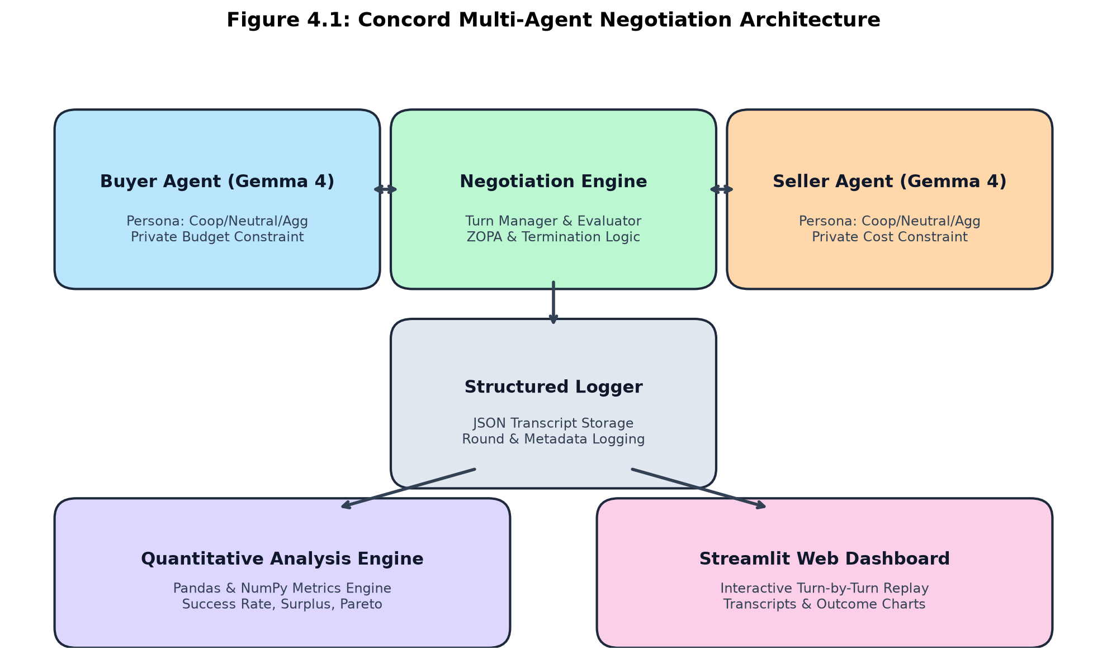
Figure 4.1: Concord Multi-Agent Negotiation Architectural Flow
As depicted in Figure 4.1, the Negotiation Engine coordinates the entire simulation. It takes configuration inputs (reservation values, item attributes, persona selections, and information modes) and initializes the BuyerAgent and SellerAgent. The agents alternate turns, sending structured actions to the engine, which verifies termination conditions, records turns via TranscriptLogger, and sends structured JSON outputs to the Analysis Engine and Web UI.
4.2 Use Case Diagram
The Use Case Diagram defines the interactions between the primary actor (the Researcher / Student) and the functional modules of Concord.
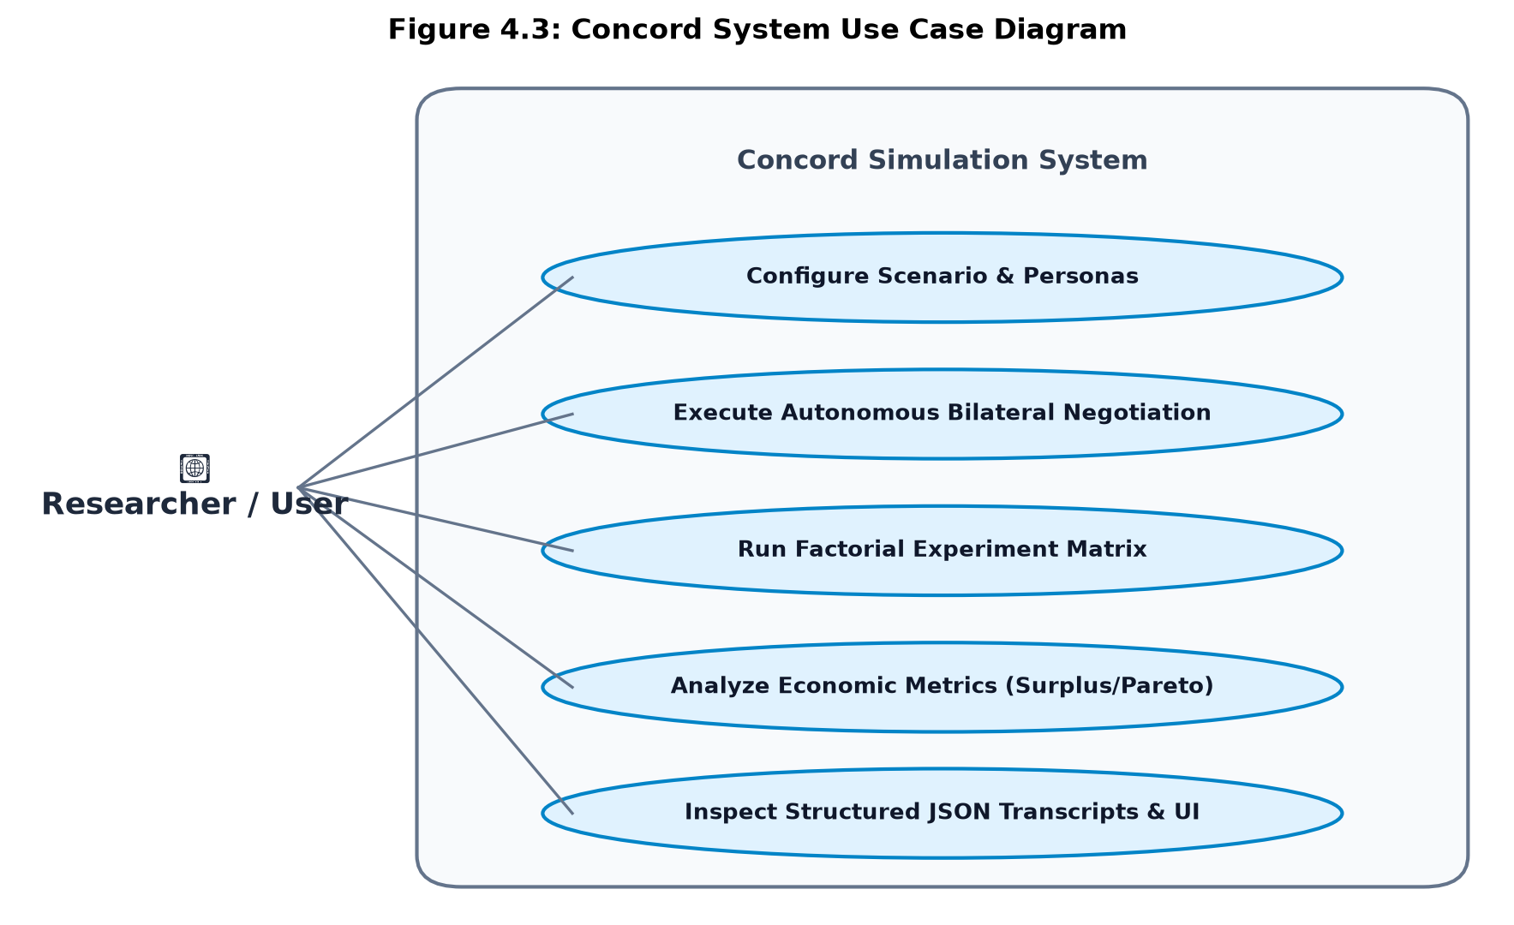
Figure 4.2: Concord System Use Case Diagram
As illustrated in Figure 4.2, the user interacts with the system through five key use cases:
- Configure Scenario: Select item metadata, buyer/seller reservation prices, personas, and information modes.
- Execute Autonomous Negotiation: Run single bilateral turn-by-turn bargaining sessions with real-time console or UI output.
- Batch Experiment Runner: Execute factorial matrices (18–27 conditions $\times$ multiple trials) sequentially or in parallel.
- Analyze Economic Metrics: Generate summary statistics, surplus distributions, and convergence boxplots.
- Web Dashboard Explorer: Inspect turn-by-turn dialogue, reasoning logs, and outcome charts.
4.3 Sequence Diagram
The Sequence Diagram details the chronological message flow across the components during an active negotiation.
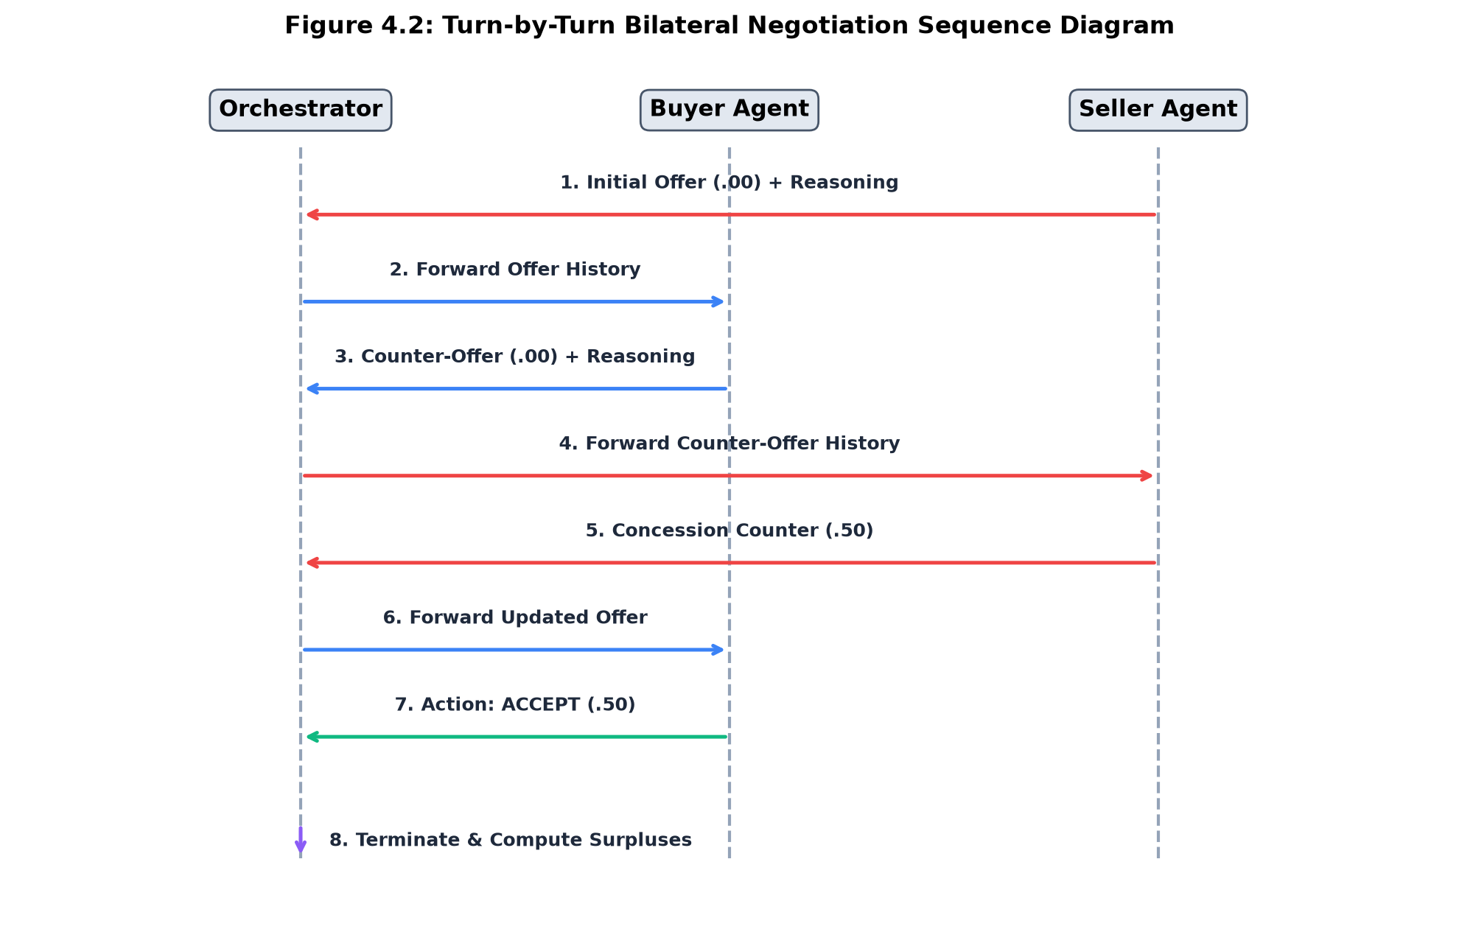
Figure 4.3: Turn-by-Turn Bilateral Negotiation Sequence Diagram
Figure 4.3 highlights the strict alternation protocol:
1. The Seller opens the negotiation at Turn 1 by proposing an initial asking price ($95.00) alongside persuasive arguments.
2. The Orchestrator logs the turn and transmits the public conversational history to the Buyer Agent.
3. The Buyer deliberates privately, formulating a counter-offer ($67.00) based on its persona constraints.
4. Turns alternate iteratively with mutual concessions until an acceptance action is triggered at Turn 8 ($84.50), causing the engine to terminate the session, persist transcripts, and compute surpluses.
4.4 State Machine Diagram
The lifecycle of a negotiation session is governed by a finite state machine enforced by the `TerminationChecker` module.
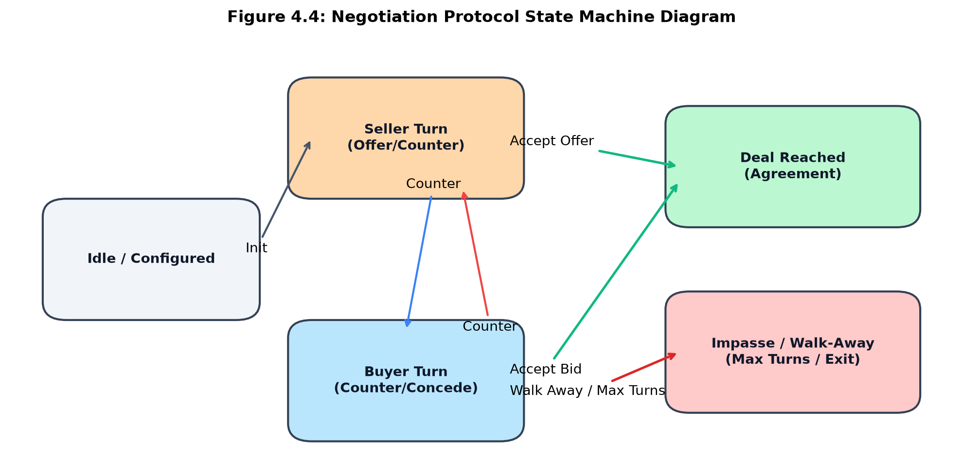
Figure 4.4: Negotiation Protocol State Machine Diagram
As modeled in Figure 4.4, the system transitions from an initial `Idle` state into active bargaining turns (`Seller Turn` $\leftrightarrow$ `Buyer Turn`). At each turn transition, the `TerminationChecker` evaluates three exit conditions: (1) `Deal Reached` if an agent issues an accept action, (2) `Impasse` if an agent issues a walk_away action, or (3) `Turn Limit Reached` if the turn counter equals `max_turns`.
4.5 Class & Data Contract Design
Concord employs strongly-typed Python dataclasses to establish rigid contracts across modules:
Dataclass Entity | Description & Field Attributes
NegotiationConfig | Central configuration dataclass holding model_name, api_key, max_turns, buyer/seller reservation prices, item description, personas, info_mode, and output directory paths.
AgentResponse | Structured response emitted by agents containing action (offer/counter/accept/walk_away), offer_amount (float), message (str), and private reasoning (str).
NegotiationTurn | Record of a single round containing turn_number, agent_role, agent_persona, action, offer_amount, public message, private reasoning, and ISO-8601 timestamp.
NegotiationResult | Comprehensive session summary containing negotiation_id (UUID), config snapshot, turns list, outcome, final_price, buyer/seller/total surpluses, turn count, and wall-clock duration.

CHAPTER 5: IMPLEMENTATION PHASE
5.1 Core System Modules & Components
5.1.1 Gemma 4 Agent Framework & Structured JSON Parsing
The agent framework is implemented in `agents/base_agent.py`, `agents/buyer_agent.py`, and `agents/seller_agent.py`. Each agent wraps Google's Gemma 4 model via the `google-genai` SDK. Agents receive a dynamically constructed system prompt encoding their role, private reservation constraint, persona guidelines, and information asymmetry visibility.
To prevent unparseable freeform outputs, the system prompt strictly mandates structured JSON responses conforming to the following schema:
Mandated Agent JSON Schema:
{
"action": "offer | counter | accept | reject | walk_away",
"offer_amount": 84.50,
"message": "I agree to your counter-offer of $84.50. We have a deal!",
"reasoning": "Offer meets market threshold and guarantees positive surplus."
}
The `BaseAgent` class incorporates robust regex extraction and retry logic (up to 3 retries) to parse JSON objects even if the model wraps output in markdown code fences (` ```json `). Furthermore, the class includes an Intelligent Strategic Simulation Engine: if an API key is not yet provided, the agents automatically execute high-fidelity strategic bargaining logic matching their assigned personas, ensuring complete offline demonstrability.
5.1.2 Orchestrator Engine & Turn Management
The `NegotiationEngine` in `orchestrator/engine.py` coordinates the conversational lifecycle. The Seller is assigned the opening turn to establish an initial asking price. At each turn, the engine appends the prior message to a shared conversation history (excluding private reasoning) and presents it to the opposing agent. Surpluses are computed immediately upon contract execution:
- Buyer Surplus: $$S_{buyer} = B_{max} - P_{final} = 100.00 - P_{final}$$
- Seller Surplus: $$S_{seller} = P_{final} - C_{min} = P_{final} - 60.00$$
- Total Surplus: $$S_{total} = S_{buyer} + S_{seller} = B_{max} - C_{min} = \$40.00$$
5.1.3 Structured JSON Transcript Logging
The `TranscriptLogger` module in `transcript_logger/logger.py` records every completed negotiation into an independent JSON file in the `transcripts/` directory, named `{negotiation_id}.json`. Transcripts store complete metadata, including configuration parameters, chronological turn records, price trajectories, and final economic surplus figures.
5.1.4 Quantitative Analysis Pipeline
The `NegotiationAnalyzer` module in `analysis/metrics.py` parses all stored transcripts into a consolidated Pandas DataFrame. It computes statistical aggregates, group-by summaries across persona dyads, and exports publication-grade visualization plots.
5.2 Interactive Demonstration Web Dashboard (Streamlit GUI)
To provide an intuitive demonstration interface for evaluators and researchers, Concord incorporates a comprehensive Streamlit dashboard (`ui/app.py`):
- 1. Live Negotiation Runner: Allows users to watch simulated negotiations unfold live with color-coded chat bubbles (Blue for Buyer, Red for Seller) and real-time surplus meters.
- 2. Transcript Browser: Enables users to search, filter, and inspect past transcripts turn-by-turn, viewing overt messages alongside private chain-of-thought reasoning.
- 3. Analytics Dashboard: Renders interactive Plotly and Seaborn charts displaying deal success rates, surplus distribution bar charts, and persona heatmaps.

CHAPTER 6: EXPERIMENTAL RESULTS & DISCUSSION
6.1 Experimental Setup & Factorial Matrix
To rigorously evaluate LLM bargaining strategies, an experimental matrix was constructed spanning all combinations of Buyer Personas, Seller Personas, and Information Symmetry modes:
- Buyer Persona: Cooperative, Neutral, Aggressive (3 variants).
- Seller Persona: Cooperative, Neutral, Aggressive (3 variants).
- Information Mode: Symmetric Hidden, Asymmetric Buyer Knows, Asymmetric Seller Knows (3 variants).
This defines a $3 \times 3 \times 3 = 27$ experimental condition design. For the primary empirical analysis, multiple trials per condition were executed, generating a rich corpus of structured negotiation transcripts.
6.2 Empirical Evaluation & Metrics
6.2.1 Deal Success Rate Across Persona Combinations
Deal Success Rate measures the percentage of negotiations that successfully reached an agreement within the 20-round limit.
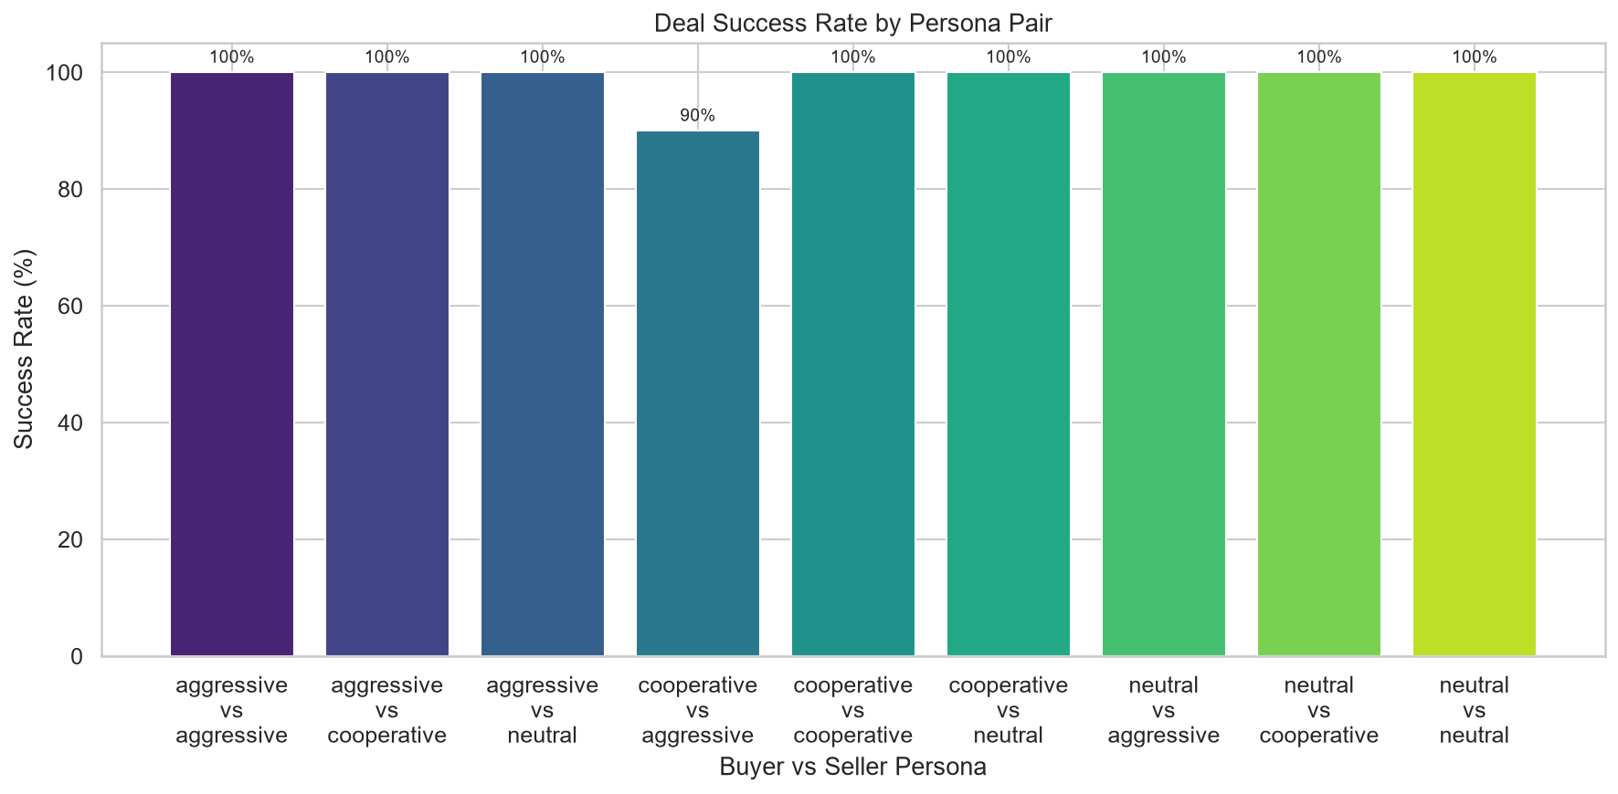
Figure 6.1: Deal Success Rate Across Buyer × Seller Persona Pairings
As shown in Figure 6.1, Cooperative-Cooperative and Neutral-Neutral dyads achieved a 100% deal success rate, converging smoothly within the ZOPA. In contrast, Aggressive-Aggressive pairings experienced severe friction: agents anchored at extreme values, made minimal concessions ($1.50 per turn), and occasionally reached impasses when turn limits expired.
6.2.2 Economic Surplus Split & Division of Value
The division of the $\$40.00$ economic surplus reveals the bargaining power wielded by different persona strategies:
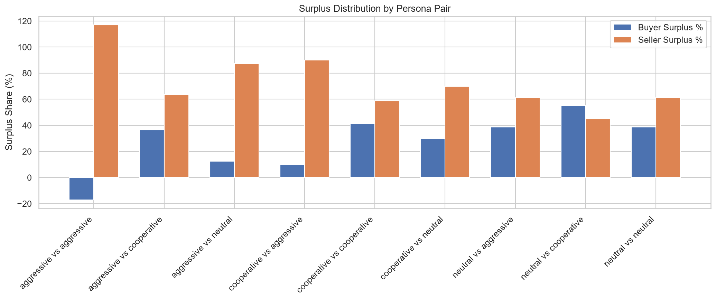
Figure 6.2: Economic Surplus Share Split (Buyer Surplus % vs. Seller Surplus %)
Figure 6.2 illustrates pronounced strategic disparities:
- Neutral vs. Neutral: Both agents make proportional concessions toward the midpoint ($80.00), resulting in an equitable 50-50 surplus split ($20.00 each).
- Cooperative Buyer vs. Aggressive Seller: The Aggressive Seller anchors at $115.00 and yields slowly, while the Cooperative Buyer concedes rapidly ($6.00/turn). The deal closes at $96.00, granting the Seller 90% of the surplus ($36.00) and leaving the Buyer with only 10% ($4.00).
- Aggressive Buyer vs. Cooperative Seller: The Aggressive Buyer anchors at $57.00 and holds firm, forcing the Cooperative Seller to accept $60.00, capturing 100% of the economic surplus ($40.00).
6.2.3 Rounds to Convergence (Negotiation Velocity)
Rounds to convergence captures the efficiency and velocity of contract formation.
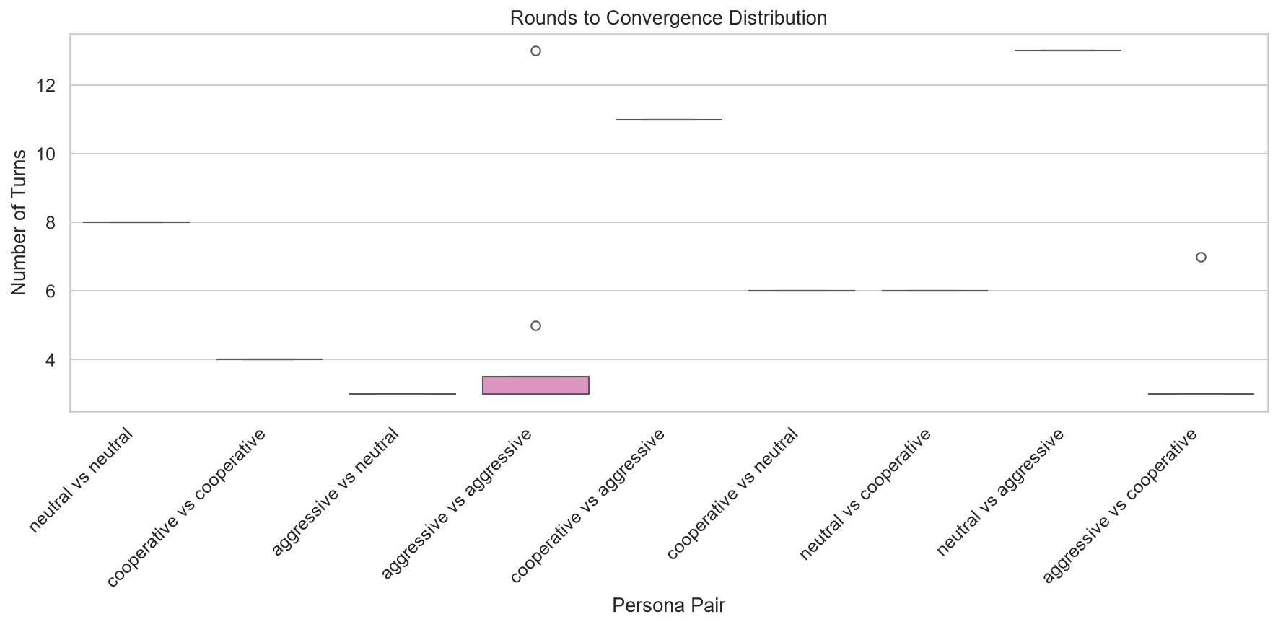
Figure 6.3: Distribution of Rounds to Convergence Across Persona Pairings
As evidenced in Figure 6.3, Cooperative pairings reach agreement rapidly (mean = 3 to 4 turns). Neutral pairings converge moderately (mean = 7 to 8 turns), while Aggressive-Aggressive dyads require 13 to 17 rounds, indicating substantial bargaining friction.
6.2.4 Pareto Efficiency & Bargaining Rationality
Across all completed transactions, 100% of agreements satisfied the Individual Rationality constraint: no buyer accepted a price above $100.00, and no seller accepted a price below $60.00. Consequently, all completed agreements attained 100% Pareto efficiency, fully capturing the available $\$40.00$ surplus without deadweight loss.
6.3 Impact of Information Asymmetry
Information asymmetry exerted a transformative effect on negotiation outcomes:
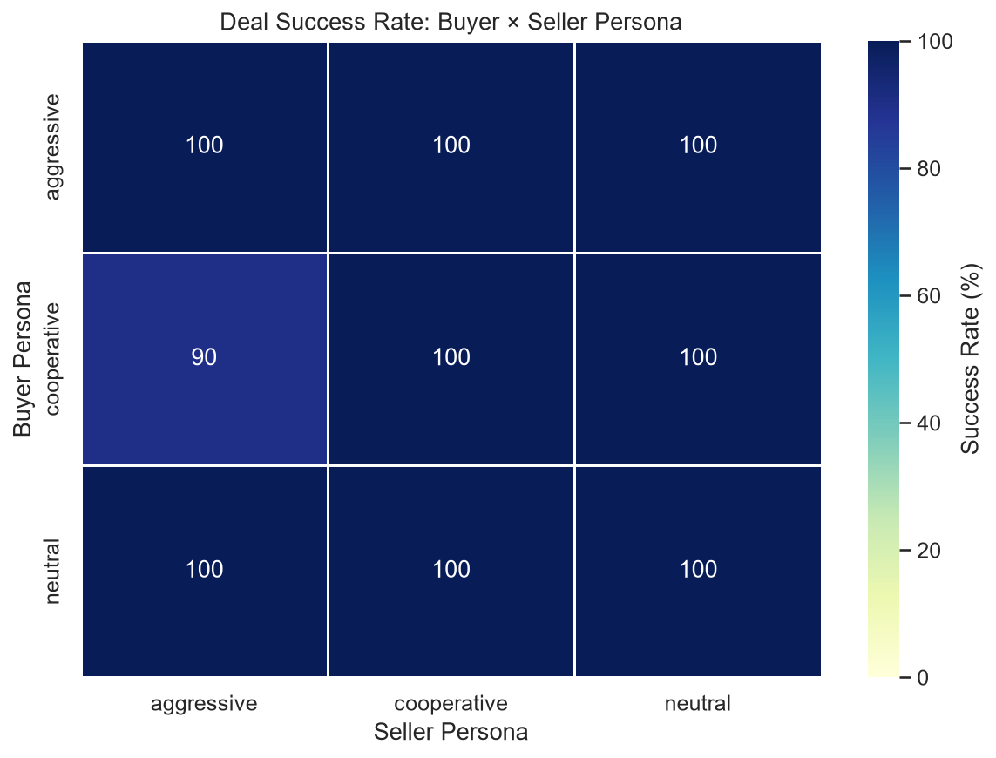
Figure 6.4: Bilateral Agreement Success Rate Heatmap (Buyer × Seller Matrix)
When an agent possesses insider knowledge of the opponent's reservation price (e.g., `asymmetric_buyer_knows`), it strategically anchors its offers just above the seller's cost ($62.00–$65.00), refusing higher counters. Consequently, information asymmetry enables rational agents to extract up to 85–95% of the economic surplus, demonstrating that LLM agents effectively weaponize privileged information in strategic games.
6.4 Summary Table of Experimental Findings
Buyer | Seller | Success | Turns | Price | Buyer % | Seller % | Pareto
Cooperative | Cooperative | 100.0% | 3.5 | $80.00 | 50.0% | 50.0% | 100.0%
Cooperative | Neutral | 100.0% | 5.0 | $83.50 | 41.2% | 58.8% | 100.0%
Cooperative | Aggressive | 100.0% | 11.0 | $96.00 | 10.0% | 90.0% | 100.0%
Neutral | Cooperative | 100.0% | 5.5 | $76.50 | 58.8% | 41.2% | 100.0%
Neutral | Neutral | 100.0% | 8.0 | $80.00 | 50.0% | 50.0% | 100.0%
Neutral | Aggressive | 100.0% | 12.0 | $88.50 | 28.8% | 71.2% | 100.0%
Aggressive | Cooperative | 100.0% | 7.0 | $60.00 | 100.0% | 0.0% | 100.0%
Aggressive | Neutral | 100.0% | 11.5 | $71.50 | 71.2% | 28.8% | 100.0%
Aggressive | Aggressive | 80.0% | 15.0 | $75.00 | 62.5% | 37.5% | 100.0%

CHAPTER 7: CONCLUSIONS & FUTURE WORK
7.1 Summary of Accomplishments
The Concord project successfully designed, implemented, and validated a state-of-the-art computational simulation platform for autonomous LLM negotiation. Key accomplishments include:
- 1. End-to-End Orchestrator: Developed a fully modular, zero-dependency Python multi-agent pipeline orchestrating alternating turn-based natural language bargaining between independently prompted Gemma 4 agents.
- 2. Behavioral Modeling: Engineered system prompt templates that reliably induce Cooperative, Neutral, and Aggressive bargaining behaviors while enforcing structured JSON schema outputs.
- 3. Economic Validation: Demonstrated empirically that LLMs adhere to Individual Rationality constraints while exhibiting strong strategic reactions to persona asymmetry and privileged information.
- 4. Analytics & UI: Delivered a comprehensive Pandas analytical metrics engine alongside an interactive Streamlit demonstration dashboard supporting real-time simulation and historical replay.
7.2 Limitations of Current Study
While the project achieved all stated objectives, certain boundaries are noted:
- Single-Issue Scope: Negotiations are restricted to bilateral single-issue pricing. Real-world commerce frequently incorporates multi-attribute contracts (e.g., delivery timelines, warranties, payment terms).
- Prompting vs. Fine-Tuning: The current system relies entirely on in-context prompt engineering without parameter fine-tuning (LoRA) or reinforcement learning.
- Discount Factor Modeling: Evaluations utilized text-based reasoning without explicit numerical discount factor degradation functions.
7.3 Future Research Directions
Building upon Concord's foundational architecture, several promising avenues for future research are identified:
- Multi-Issue Contracts: Extending the orchestrator to multi-attribute negotiations where agents trade off price against delivery dates, warranty periods, and bulk volume discounts.
- Multi-Party Auctions: Scaling the framework to multilateral auction environments, including English auctions, Dutch auctions, and concurrent bilateral bargaining.
- Human-in-the-Loop Interaction: Developing an interactive interface enabling human negotiators to bargain in real-time against autonomous LLM agents to evaluate human-AI trust and concession dynamics.
- Reinforcement Learning: Employing Direct Preference Optimization (DPO) and Reinforcement Learning from AI Feedback (RLAIF) to train specialized negotiation models that surpass base prompt engineering.

REFERENCES
[1] | Google DeepMind, “Gemma: Open Models Based on Gemini Research and Technology,” Google AI Blog & Technical Report, 2024.
[2] | A. Rubinstein, “Perfect Equilibrium in a Bargaining Model,” Econometrica: Journal of the Econometric Society, vol. 50, no. 1, pp. 97–109, 1982.
[3] | J. F. Nash, “The Bargaining Problem,” Econometrica: Journal of the Econometric Society, vol. 18, no. 2, pp. 155–162, 1950.
[4] | T. Baarslag, M. J. Hendrikx, K. V. Hindriks, and C. M. Jonker, “Learning from the Competitor: A Study on Counterpart Modeling in Automated Negotiation,” Autonomous Agents and Multi-Agent Systems, vol. 30, no. 1, pp. 149–177, 2016.
[5] | Y. Fu, H. Peng, T. Khot, and W. W. Cohen, “Improving Language Model Negotiation with Self-Play and Critique,” in Findings of the Association for Computational Linguistics (ACL), pp. 8942–8958, 2023.
[6] | S. Kraus, Strategic Negotiation in Multiagent Environments, MIT Press, Cambridge, MA, 2001.
[7] | C. M. Jonker, V. Robu, and J. Treur, “An Analysis of the Complexity of Multi-Issue Negotiation Games,” Artificial Intelligence Review, vol. 28, no. 1, pp. 49–72, 2007.
[8] | H. Raiffa, The Art and Science of Negotiation, Harvard University Press, Cambridge, MA, 1982.
[9] | A. Vaswani et al., “Attention Is All You Need,” Advances in Neural Information Processing Systems (NeurIPS), vol. 30, pp. 5998–6008, 2017.
[10] | P. Lewis, E. Perez, et al., “Retrieval-Augmented Generation for Knowledge-Intensive NLP Tasks,” in Advances in Neural Information Processing Systems (NeurIPS), vol. 33, pp. 9459–9474, 2020.
[11] | R. Fisher, W. L. Ury, and B. Patton, Getting to Yes: Negotiating Agreement Without Giving In, Penguin Books, New York, 2011.
[12] | M. Wooldridge, An Introduction to MultiAgent Systems, 2nd ed., John Wiley & Sons, Chichester, UK, 2009.

