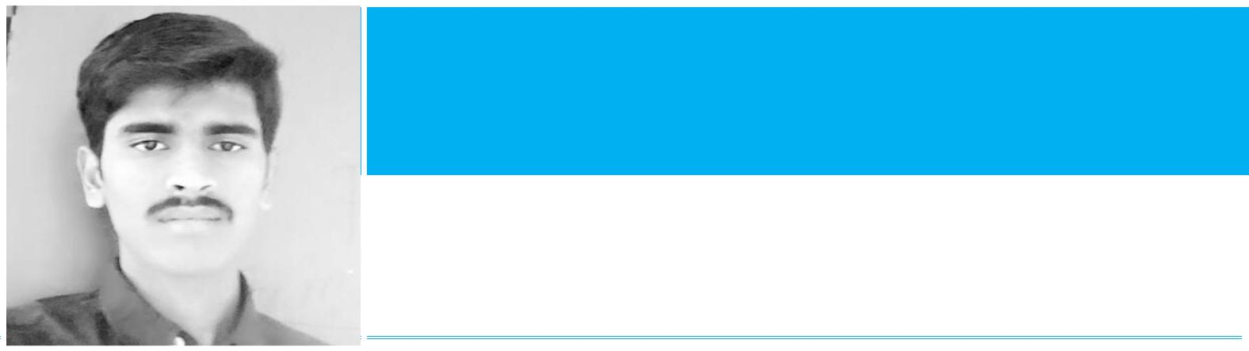

**SHIVA KUMAR KANNEBOINA**

Mobile Number: +91-9963808956, Email ID: [shiva2035.iiit@gmail.com,](mailto:shiva2035.iiit@gmail.com)

Skype ID: shivakumar.iiit

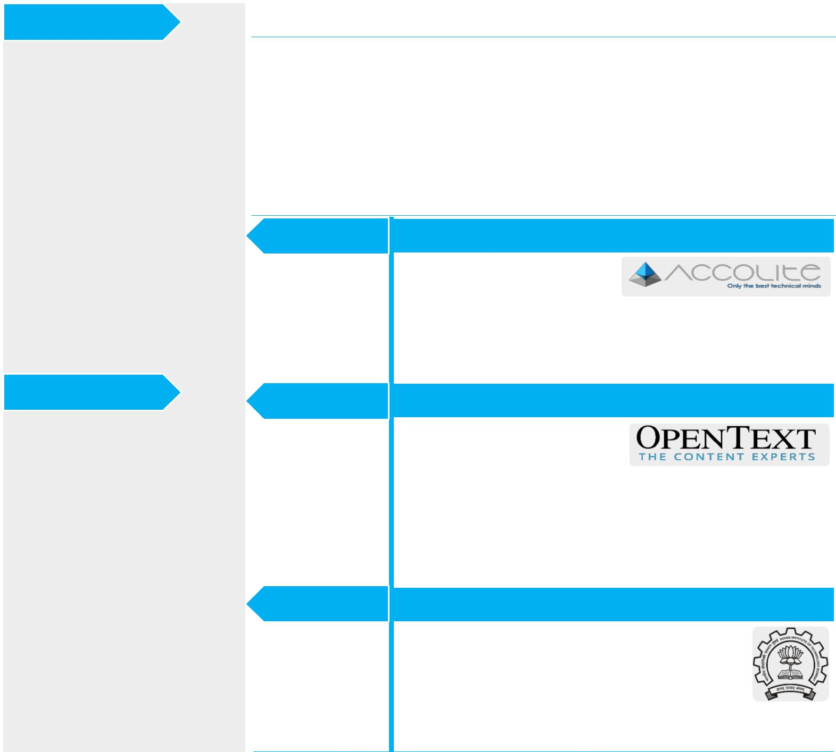

Skillset

|  |  |
| --- | --- |
| - | JavaScript |
| - | TypeScript |
| - | AngularJS (1,2) |
| - | Java EE |
| - | Spring MVC |
| - | Oracle, MySQL |
| - | Apache Lucene |
| - | PhoneGap |

Summary

Having 2+ years of experience in owning and delivering enterprise software solutions to airline industry end-to-end (from requirements gathering to delivery). Expertise in conceptualizing, designing and coding technical solutions using Java/J2EE and AngularJs technology stacks. Excellent communication skills to coordinate with mid-sized technical team, and business leadership including direct interaction with client. Apart from the work, Tech-Meetups, Bike-Riding, Travelling, Music attracts me more.

Professional Experience

|  |  |
| --- | --- |
| - | Apache Cordova |
| - | Bootstrap, CSS |
| - | HTML |
| - | RESTful Services |
| - | Design Patterns |
| - | Algorithms & Data |
|  | Structures |
|  |  |

Tools

* Eclipse IDE
* Jenkins
* Maven
* SonarQube
* Subversion (SVN)
* Pencil (UI Wireframe Designing tool)
* Putty
* WINSCP

Feb2015 - Present

July2014-Dec2014

May2013 -July2013

**Accolite Labs India Pvt. Ltd.**

***Sr. Software Engineer:*** As a

**Full Stack** Developer atAccolite, I have helped the

client succeed in their product implementation using various technologies including AngularJS, Spring MVC, Oracle, MySQL, PhoneGap, Apache Lucene, etc.…

**OpenText Corporation India Pvt. Ltd.**

As a ***Professional*** ***Services***

***Consultant-Intern*** atOPENTEXT, I have worked

on the following products of Enterprise Content Management (ECM) Suite. OpenText Content Server, Content Server Work Flows, Live Reports, Livelink Administration, Email Integration, Directory Services, Document Management.

**Indian Institute of Technology(IIT) – Bombay**

As a ***Summer Research Intern*** at IIT-Bombay my responsibilities include developing Swing UI and dumbo model using Blender for the project ‘*Graphical Interpreter* *–* *Buddhuram Dumbo in*

*Action*’and integration of all the modules. And alsoresponsible for making the cross platform application.

http://github.com/shiva2035 <http://in.linkedin.com/in/shiva2035>



Publication



* Naveen Kumar Ch, **Shiva Kumar K**, Harish Y, Vikram K, Chakravarthi J, *NaVaSH-Examination Software for*

*ICT based Institutes*,**6th****IEEE International Conference on Technology for Education (T4E)**, AmritaUniversity, Kerala, India, December 18-21, 2014.

Certification



* ‘[*Introduction to Machine Learning’* Course by Andrew NG, Coursera, License: KETGYEGNZSS7](https://www.coursera.org/account/accomplishments/certificate/KETGYEGNZSS7)

Education



* **Bachelor of Technology, IIIT-Basar**

*Computer Science and Engineering, Class of 2014, CGPA:* ***8.16***

* **Pre-University Course(PUC)/ Intermediate, IIIT-Basar**

*M.Bi.P.C, 2010, CGPA:* ***8.45***

* **Matriculation, ZPHS Nagaram**

*Board of Secondary Education AP (BSEAP), Score:* ***82.66%,*** *School* ***1st*** *and Mandal* ***2nd*** *Rank. Got admission into IIIT-Basar for the 6 years Integrated Course.*

Projects



**Sept 2015-May 2017**

**Technologies:**

* Java Spring
* JUnit
* Mockito
* AngularJS
* MySQL
* Oracle
* NVD3.js
* Plotly.js
* XML

**Client:**

**Fatigue Data Management(FDM)**

**Project Description:** Pilot/Crew member fatigue is now acknowledged as a core safetyissue. It predictably degrades various types of *human performance* and can contribute to aviation accidents and incidents. Fatigue is inevitable in 24/7 operations because human brain and body function optimally with unrestricted sleep at night. Therefore, fatigue cannot be eliminated, it must be managed. FDM System manages the crew fatigue data and helps scientists understand and analyze the various parameters like alertness, workload, sleepiness, etc. FDM System helps the Fatigue Review Management System(FRMS) experts to collect the data from various sources like Altigraph Device, Psychometric Vigilance Test Device, Electroencephalogram Device, etc., and sends collected data to various models (WSU Model, TPM Model, etc...) and presents results as output. Some of the major modules of FDM include, Subjective Fatigue Logging (e-Logging), Data Preparation, Models, Study Comparison, Study Merge, Probability distributions, schedule analyzer, etc.

**Roles & Responsibilities:**

* Took the *ownership* on the complete application and managed to maintain it single-handed by accepting the changes/new features from client on *ad-hoc basis* by working directly with client.
* Stretched in the night hours to deliver the items that 'Previous Team was supposed to deliver’ and delivered successfully within less time (to make sure client demos for his customers is not disturbed), and in parallel worked for POR application as well.
* Designing wire-frames for new features, get it approved by client and implementing it in modular way.
* Implemented some complex functionalities like *‘e-Logging (Subjective Fatigue*

*Logging)’, ‘Study Merge’, ’Study Compare’, ‘Email Notifications’, ‘MSAccessDataMigration Tool’, ‘Bunch of File Parsers for reading information*

http://github.com/shiva2035 <http://in.linkedin.com/in/shiva2035>





**Oct 2015 – Aug 2016**

**Technologies:**

* Java Spring
* JUnit, Mockito
* AngularJS
* Oracle
* Apache Lucene

**Client:**

*from various sources of raw data including ActigraphParser, PVTFileParser, MindMetricsFile Reader, CSVFileReader, XLSFileReader, etc.’, ’Customizing angular-gantt.js library to achieve client requirement’, ’Minification of JavaScript Code to reduce the load on server’, ‘Theme Manager’, ‘PFC Login (SSO Mechanism)’,’Merging MySQL and Oracle codebases into single code base using spring profiles’, etc.* and client was very happy for the quality of the deliveryand delivering within stipulated time. These components add a lot of value to the application in its entirety.

* Writing Unit test cases to make sure each feature is resulting in expected behavior using *JUnit* and *Mockito*.
* Responsible for Managing Builds and Deployments on various environments like (dev, testing, staging, production, etc.). And following the code quality standards as per the metrics specified by *SonarQube* quality profile.
* Successful installation & setup of the application on desired environment for customers of the client(confidential).
* Setting up Continuous Integration and Delivery mechanism(*Jenkins*) and writing custom triggers on *SVN* to send code metrics to Business Unit Head via email.
* Responsible for the complete product from requirement gathering to delivery and Front-end to Back-end, DB, etc.



**Pilot Operations Reporting (POR)/Insite**

**Project Description:** Pilot Operations Reporting(POR)/Insite Application tracksvarious requests/activities raised by pilot. It acts as issue tracking or ticketing system for its users. It has the strong capabilities like categorizing the tickets, assigning it to relevant user in a user group, grouping similar tickets and perform bulk action, automatically assigning ticket to its resolver based on issue type, escalation hierarchy, and many more..

**Roles & Responsibilities:**

* Delivered the complex modules like *Auto-assignment, User group and Category* *filters, Auto Merge (using Apache Lucene), Merge Tickets, Split Tickets, Auto Resolve, All kinds of Emailing in POR, Custom pagination directive, Help page, Data migration tool (for loading data from old system to new system)*, and manyother minor features...
* Working closely with QA team to make sure all the issues raised by them are resolved before the UAT. Responsible for Build and Deployment on various environments like (dev, test, stage, prod, L1, L2, L3)
* Learned and trained co-workers on JUnit & Mockito frameworks for writing unit test cases and implemented it in FDM application.
* Getting my code reviewed by peers and making sure the changes suggested by them were implemented. And reviewing other team members code and providing suggestions.
* Following the code quality standards suggested by sonarqube quality profile.
* Worked as an individual contributor and acted as a key team player in developing POR application as matured product.

http://github.com/shiva2035 <http://in.linkedin.com/in/shiva2035>





**July 2015 – Sept 2015**

**Technologies:**

* Java Spring
* JavaScript
* AngularJS
* Ionic
* HTML, CSS
* PhoneGap, Cordova
* MySQL

**Client:**

**Aug 2012 – May 2014**

**Technologies:**

* Core Java
* PHP
* MySQL

**Users/Client:**

**May 2013 – July 2013**

**Technologies:**

* Core Java
* LibGDX
* Blender Tool

**Project Guide:**

Prof.Dr. DB Phatak, Dept. of CSE, IIT - Bombay

**Jumpseat – Proof of Concept**



**Project Description:** Jumpseat provides tremendous business value and cost savings byallowing Fedex to fly its employees to meet business needs drastically minimizing the need for commercial flights. Recent trends in technology coupled with the convenience the mobile solutions offer presents an incredible opportunity to move towards a modern platform that encourages a self-service model which minimizes the cost of ownership of the product and the overheads involved in managing the overall program

**Roles & Responsibilities:**

* Implemented the Hybrid mobile app for the jumpseat as a proof of concept
* Research on the existing system which is written in mainframe
* Creating the UML diagrams and breaking down the workflow diagrams into tasks
* Creating the business requirement document from the study performed on the existing system. Also helped in creating High Level Design(HLD) document.
* Implemented the web application in POC mode for the new system proposed.
* Guided summer interns – 2015 by giving them some UI screens to implement from the proposed system.



**NaVaSH: Examination software for ICT Based Institutions**

**Project Description:** A software application used to conduct examinations in **ICT** basedinstitutes (like RGUKT) where bulk number of students is present. Aims at reducing the technical mass copying. NaVaSH software application is to reform and redefine the existing Online Examination System, by making use of ICT to provide strict and flawless System. It is designed to make the Online Examination System autonomous, adaptable and secured from the instance question paper preparation to the announcement of the results by considering each part of the system. Majorly NaVaSH has four modules - *ExamMaker,* *ExamBrowser, Exam Server, and ExamEvaluator.* Using the NaVaSH exam model, afaculty prepares test paper in a pre-defined template by using any standard word processor (ex: MS-Word) and saves this template based test paper. Then he uses ***ExamMaker***, which converts this question paper into an encrypted exam file, and uploads it to ***ExamServer***. Student on the day of exam, logs into ***ExamServer***, downloads exam files, and starts writing exam. After completion of the exam, answer files are sent to ***ExamServer*** and a copy is saved on local hard drive for student reference and eventually the exam administrator using ***ExamEvaluator*** evaluates exam files and announces the results. This ***ExamEvaluator*** is combined with ***ExamServer*** to make auto evaluations to announceresults quick.



**Graphical Interpreter – Buddhuram Dumbo in Action**

**Project Description:** Graphical Interpreter is a*Ministry of Human Resources &**Development(MHRD) India* sponsored project**,**which is intended as an educationalcross platform tool that helps students to best understand basic computer architecture. In order to become better programmers, every programmer must have an overall understanding of the machine’s internals and how programming instructions are executed inside the machine to produce the desired results. Experimentation/ interaction leads to a much fuller understanding of any subject.

We attempted to build a full-scale graphics interpreter for **‘C’** which will allow learners to understand how their code maps gets executed on machine internals.

http://github.com/shiva2035 <http://in.linkedin.com/in/shiva2035>



This application is intended to initially execute **‘C’** commands. The architecture of the system is intended to be neutral in order for the application to be extensible. The application is intended to be a stand-alone application that will function without the use of a server. It consists following modules: Intermediate Command Set (**ICS**), **Parser** module, Graphical Virtual Machine (**GVM**), Import/Export and other miscellaneous UI functions.

Appreciations/Awards



* Got appreciation memento from client for the successful delivery of the POR Application.
* Got an award from Business Unit Head and appreciation from client for the work done on FDM application and successful delivery.
* Jumpseat application Proof of Concept model which is designed by me has been approved by the client and we were able to implement and deliver it successfully.
* Got an award for the successful completion of the course ‘Mobility Practices - iOS’ offered by Accolite.
* Guided and Helped Summer Interns of Accolite for the years 2015 and 2016 as well.

Participations



* Participated in Participated in **Yahoo Hack India -**2013.
* Active contributor to **EkShiksha Portal (IIT-Bombay, Dept. of CSE).** All contributions are released in open source.
* Participated and presented the **NaVaSH:** Examination Software to conduct exams in ICT based institutes in **“Science** **and Technology Fair–2013” conducted at RGU IIIT Basar.**
* Participated in **“Oracle** **ThinkQuest Competition-2012”** (*by Oracle Education Foundation*) under application development category with project titled **“e-Medicare”.**
* Volunteered in AP state Bye-Elections at Banswada (Nizamabad Dist.) constituency in 2011, Nagar Karnool (Mahaboob Nagar Dist.) constituency in 2011, Parakal (Warangal Dist.) constituency in 2012 as **“Live Web Casting**

**Engineer”.**

http://github.com/shiva2035 <http://in.linkedin.com/in/shiva2035>

