E Centric Solutions Private Limited
(Formerly known as Paradigm InfoTech (India) Pvt. Ltd.,)



Computerization of
National Cyclone Risk Mitigation Project
System Requirement Specification
Version No. 1.4
Release date: 09-20-2010

Prepared by
E-Centric Solution Pvt. Ltd.
U & I, F-41, South Extension Part-I, New Delhi

Document Change Control
ISSUE RECORD
Issue No. | 1 | 2 | 3 | 4 | 5 | 6
Date (MM/DD/YYYY): | 07/06/2010
Prepared By | Prashanth P
Reviewed By  (PM) | Naveen G
Approved By | Naveen G

AMENDMENT RECORD (for current issue only)
Sl. No. | Date(MMDD/YYYY) | Current Revision # | Section  # | Brief details on changes made | PM’s/PL’s Signature
1 | 08/07/2010 | 1.0 | All | All Sections | Naveen Gudapudi
2 | 07/12/2010 | 1.1 | 3. Master | Removed codes in the all master section. | Naveen Gudapudi
 |  |  | 4.2.10 Taluka usecase | Removed from previous version
 |  |  | 4.2.7 Vendor Usecase | Removed from previous version
 |  |  | 3.2.1.5 Procurement Planning | Removed from previous version
 |  |  | 4.2.6 Division use case | Added sub module
 |  |  | 4.2.9 Implementing Agency Usecase | Added Sub module
 |  |  | 4.2.12 Secutiry Type Use case | Added sub module
 |  |  | 3.2.1.5 Tender | Added some more fields for this module
3 | 08/06/2010 | 1.2 | Sector Area Proforma | Modified sector area proforma list fields | Naveen Gudapudi
 |  |  | Packages(Tasks) | Added priority drop down
 |  |  | 4.2.12 Security Type from the Masters | Removed from the previous version
 |  |  | 3.3.1 Raising Demands from the Finance module | Removed from the previous version
 |  |  | 4.9 Grievance Module | Removed From the Previous version
 |  |  | 4.11Practices Module | Removed from the previous version
 |  |  | 4.10 HR modules | Removed from the previous version
 |  |  | 3.5 Environment & social | Modifications in fields
 |  |  | 3.2.5 Agreement details | Added
 |  |  | 3.2.2 Projects | Name changed to Sector Area
 |  |  | 3.2.3 Tasks | Name changed to Packages
 |  |  | 3.2.4 Tender | Name changed to Work Award
 |  |  | 3.3 Monitoring & Evaluation | Monitoring renamed as Physical Progress
 |  |  | 3.1 Masters | Modifications in masters
 |  |  | 6.5 Procurement Process Diagram | Added Procurement Process diagram
4 | 08/20/2010 | 1.3 | 4.2.6Division Usecase section | Removed from previous version | Naveen Gudapudi
 |  |  | division relation dependies | Removed
 |  |  | 3.2.2.4 Site | Re designed in current version
 |  |  | 3.3.2Work Award(Physical progress) | Added one more filed, bid process is completed or not, in current version
 |  |  | 3.2.2.3 Agreement details | Added two new fileds.in current version
 |  |  | Sector Area | Added field for component drop down
 |  |  | 4.4.2 Site Physical Progress | Modifications in current version
 |  |  | 4.4.1 Work Award Progress | modifications
 |  |  | 3.6.1 Financial reports | Added
5 | 09/20/2010 | 1.4 | 4.2.12 Sector Area(use case) | State dropdown is removed. And added sector category & sector type . | Naveen Gudapudi
 |  |  | Procurment Plan (3.2.1, 3.2.10, 3.2.14) | Added Procrurement Plan for Component A, Component C, Component D
 |  |  | 3.4 Finance Module | Functionality of Finance Modules is Changed and new modules are Finance Management and Cheque

TABLE OF CONTENTS
1. Background & Area of Operation 9
1.1 Definitions, Acronyms, and Abbreviations 10
2. Document Scope 11
2.1 Purpose of This Document 11
2.2 Nature and future of This Document 11
3. Project Overview 12
3.1 Creation of Masters 12
3.2 Procurement Planning 13
3.2.1 Component A 13
3.2.2 Package Details 13
3.2.3 Work Award Details 14
3.2.4 Agreement Details 14
3.2.5 Component B 14
3.2.6 Package Details 15
3.2.7 Work Award Details 15
3.2.8 Agreement Details 15
3.2.9 Site Management 16
3.2.10 Component C 16
3.2.11 Package Details 16
3.2.12 Work Award Details 16
3.2.13 Agreement Details 17
3.2.14 Component D 17
3.2.15 Package Details 18
3.2.16 Work Award Details 18
3.2.17 Agreement Details 19
3.3 Physical Progress 19
3.3.1. Site Physical Progress 19
3.3.2 Work Award Physical Progress 19
3.4 Financial 19
3.4.1 Financial Plan Management 20
3.4.2 Cheque Issue 20
3.5 Environmental & Social 20
3.6 Reports 20
3.6.1 Financial Reporting 20
3.6.2 The Following reports need to generate 21
3.7 Project Documents 22
4. Use Case 23
4.1 Use Cases Descriptions 23
4.2 Masters 26
4.2.1 Login 26
4.2.2 Manage Roles 28
4.2.3 Manage User 29
4.2.4 Manage State 30
4.2.5 Manage District 31
4.2.6 Manage Block/ Mandal 32
4.2.7 Manage Gram Panchayat 33
4.2.8 Manage Implementing Agency 35
4.2.9 Manage Contractor 37
4.2.10 Manage Component 38
4.2.11 Manage Sector Type 39
4.2.12 Manage Sector Area 41
4.3 Procurement Plan for Component A 42
4.3.1 Packages Management 42
4.3.2 Work Award Details Management 44
4.3.3 Agreement Details Management 46
4.4 Procurement Plan for Component B 48
4.4.1 Packages Management 48
4.4.2 Site Management 50
4.4.3 Work Award Details Management 52
4.4.4 Agreement Details Management 55
4.5 Procurement Plan for Component C 57
4.5.1 Packages Management 57
4.5.2 Work Award Details Management 59
4.5.3 Agreement Details Management 61
4.6 Procurement Plan for Component D 63
4.6.1 Packages Management 63
4.6.2 Work Award Details Management 65
4.6.3 Agreement Details Management 68
4.7 Physical Progress 70
4.7.1 WorkAward Physical progress 70
4.7.2 Site Physical progress 71
4.8 Finance 73
4.8.1 Finance Management 73
4.8.2 Cheque Issue Management 75
4.9 Environment / Social Screening 76
4.9.1 Data creation for Environment / Social Screening 76
4.10 Uploading Documents 78
5. Proposed System 80
5.1 Advantages of the Proposed System 80
5.2 Feature of Proposed system 80
5.3 User Interface 82
5.4 Application Architecture 82
5.4.1 The presentation tier 82
5.4.2 The data tier 82
5.4.3 The business tier 83
5.4.4 Software 83
5.4.5 Hardware 83
5.4.6 Software interfaces 83
5.4.7 Hardware interfaces 84
5.5 Non Functional Requirement 84
6. NCRMP Process Diagrams 85
6.1 Project Process Diagram 85
6.1 Creation of New Project 85
6.2 Project Process Diagram 86
6.3 Execution of a Project 87
6.4 Master Process Diagram 88
6.5 Procurement Process Diagram 88
6.6 Environment & Social Process Diagram 89
7. Strategy 90
7.1 Development 91
7.2 Implementation 91
8. Acceptance Test Criteria 92
9. Delivery Specification 93
9.1 Packaging 93
9.2 Installation 93
9.3 Documentation 93
10. Annexure 94
10.1 Environment / Social Screening Form 94
10.1.1 Part A: General Information 94
10.1.2 Part B (1): Environment Screening 95
10.1.3 Part C (1): Social Screening 98
10.1.4 Part C (2): Result/Outcome of Social Screening Exercise 99
10.2 Environmental & Social 100
10.2.1 Results of ESMF screening 100
10.2.2 B. Results of social screening and management 100
10.3 Instances of sites with deviations from EMP 101
10.4 Progress of the state in environmental matters 101
10.6 Events and Critical date’s 102
10.7 Exceptions to the planned events and activities are as follows 103
10.8 Comparison of actual expenditure with planned expenditure 103

Background & Area of Operation

The Government of India has initiated National Cyclone Risk Mitigation Project (‘NCRMP’), with a view to address cyclone risks in the country. National Disaster Management Authority (‘NDMA’ or ‘The Authority’) under the aegis of Ministry of Home Affairs (MHA) shall implement the project in coordination with participating States/UTs. Thirteen coastal States/UTs have been identified as vulnerable to cyclone risks in the country. Further, these 13 States/UTs have been divided into two categories based on their vulnerability to cyclone risks.

Category I: Higher vulnerability coastal States/UTs i.e. Andhra Pradesh, Gujarat, Orissa, Tamil Nadu and West Bengal
Category II: Lower vulnerability coastal States/UTs i.e. Maharashtra, Goa, Karnataka, Kerala, Daman & Diu, Pondicherry, Lakshadweep and Andaman & Nicobar Islands

The Development for project is belongs to component B:
Component B - Construction of physical infrastructure for cyclone risk mitigation. This Component will be implemented by the States/UTs

For implementing NCRMP, the participating States/UTs will set up a Project Implementation Units (PIU) which will coordinate with various line departments of State Government. The Line Departments will be responsible for execution of project work. A Central Project Management Unit (PMU) shall be responsible for monitoring and oversight over the NCRMP.

Definitions, Acronyms, and Abbreviations

NDMA - National Disaster Management Authority
NCRMP - National Cyclone Risk Mitigation Project
UT - Union Territories
MHA - Ministry of Home Affairs
NIDM - National Institute of Disaster Management
PIU - Project Implementation Units
PMU - Central Project Management Unit
COA - Chart of Accounts
PO - Purchase Order
FAR - Fixed asset register
VO - Variation Order
ESMF - Environment and Social Management Framework
RFP - Request for Proposal
PIP - Project Implementation Plans
PPR - Project Preliminary report
SLNA - State Level Nodal Agency
WB - World Bank
IFB - Invitation for Bid
LOA - Letter of Authorization
NTP - Notice to Proceed
WB - World Bank
TOR - Terms Of Reference
EOI - Expression Of Interest
GRN - Goods Received Note
SRN - Service Request Number
EMP - Environmental Monitoring Plan
DPR - Detailed Project Report
GL - General Ledger
WO - Work Order
SO - Special Order

Document Scope

Scope of the document covers all the general and detailed requirements for the NCRMP Tool.

2.1 Purpose of This Document

The Primary purposes of the document are:
- Record and consolidate conclusions and agreements between NDMA and E Centric.
- Provide the project management team of E Centric a way to review and agree on the requirements for NDMA.
- Provide the development team of E Centric a baseline for conducting the Detailed Design Phase of NCRMP Tool.

Nature and future of This Document

- Original Source Code (except in cases where it has been explicitly superseded by agreement between NCRMP and E Centric)
- E Centric develop design documents (SRS, detailed design document)
In the event of a conflict between any design documents and the source code, the source code shall always take precedence, unless that difference has been discussed and agreed to by NDMA and E Centric. In the event of an omission of any requirement in any design document, the existence of any functionality in the PHP Portal shall be considered sufficient to impose that requirement.

Project Overview
Following are the detailed functional descriptions for NCRMP System

Summary
Project Components Summary
Planning & Implementation
Planning and Procurement
Environmental & Social
Financial Management
Monitoring
Monitoring and Evaluation
Key Action Status
Support
Project Documents
Administration

3.1 Creation of Masters
- The program me management tool must provide the options to create requisite masters for procurement such as, but not limited to
- Component master (that captures 4 type of components with their name and description)
- State master
- District Master
- Block Master
- Gram Panchayat Master
- Implementing agency(Line Department)
- Sector Type
- Sector Area
And should capture name, description and other details for all the masters
- The tool must provide for the comprehensive form to capture all the pertinent details under different masters along with the mandatory fields (such as unique IDs) to be completed so as to avoid duplicity. With a facility to link same fields under different masters, it must also generate abbreviated unique codes.

3.2 Procurement Planning
- The project management tool should facilitate to capture the packages details belonging to Component A

3.2.1 Component A

Sector Category | Sector Type | Sector Area
Goods | Procurement | Mobile Phone
Goods | Procurement | Sat Phone
Goods | Procurement | RPAC System
Goods | Procurement | Siren/loudspeaker
Goods | Procurement | TETRA
Goods | Procurement | Plant & Machinery
Goods | Procurement | Office Equipment
Goods | Procurement | Vehicles
Goods | Procurement | Office Furniture
Works | Minor Civil Works | Minor Civil Works
Services |  | Network Service
Services |  | Community Training
Services |  | PCCU applications

This should capture the following details
- Package Details
- Work Award Details
- Agreement Details

3.2.2 Package Details
Package is a set of works. Package may belong to any of sector area which is belongs to component B. One package may implement in one location or in more locations. Each location represents one site. Line department(Implementing Agency) implements packages. Package details consists Sector Area, Package Number, Type of Work, State name, District Name, Block Name, Package Description, Quantity( number of implementing sites), Method of selection, Estimated Cost, State name which the package implementing, Selection Authority, Package Status, Officer details, Remarks details. Added one more filed priority.

3.2.3 Work Award Details
Work Award details consists details of the package work awarded dates.
Which consists following date’s information for a particular package.
- Package No.
- Estimate Prepared And sanctioned
- Finalization Of TOR
- Approval Of RFP By Bank
- Preparation Of Short List
- Receipt Of Proposals
- Approval Of Technical Proposals By Bank
- Opening Of Financial Proposals

3.2.4 Agreement Details
Agreement details consists contractor agreement details. which consist of the following information.
- Package No.
- Actual cost
- Contractor Name
- Bank no objection to contract award
- LOA Date
- Signing Date
- Publication Of Contract Award
- Target completion date

- The project management tool should facilitate to capture the packages details belonging to Component B

3.2.5 Component B
Component B belongs to Cyclone Shelters, Road to Habitation, Approach Roads to Cyclone Shelters, Bridges & Saline Embankments Sector areas which are coming under shelters, Roads, Bridges, Embankments sector Type.
This should capture the following details
- Package Details
- Work Award Details
- Agreement Details
- Site Management

3.2.6 Package Details
Package is a set of works. Package may belong to any of sector area which is belongs to component B. One package may implement in one location or in more locations. Each location represents one site. Line department(Implementing Agency) implements packages.
Package details consists Sector Area, Package Number, Type of Work, State name, District Name, Block Name, Package Description, Quantity( number of implementing sites), Method of selection, Estimated Cost, State name which the package implementing, Selection Authority, Package Status, Officer details, Remarks details. Added one more filed priority.

3.2.7 Work Award Details
Work Award details consists details of the package work awarded dates.
Which consists following date’s information for a particular package.
Initiate preparation of Specification and Bid Document, Preparation of IFB and submission to the Bank/Govt, Approval of IFB and Bid documents by the Bank/Govt, Publication of IFB in Newspapers and UNDB, Beginning of Sale of Bid document, Opening of Bid Document, Submission of BER to Bank/Govt. for Preparation of BER, Approval of BER.

3.2.8 Agreement Details
Agreement details consists contractor agreement details. which consist of the following information.
Actual cost of the agreement for package, Letter of Acceptance, Date of Signing of Contract, Letter of Acceptance, Last Date of Validity of Bid Security, Last Date of Completion of Work, contractor Information.

3.2.9 Site Management
Each Package consists number of site One Package consists more than one site.
Site consists of the following information.
Package name, Location Name, Stage dates.
Physical Stage is implemented in it and the older fields like site cost, site priority, end_date, start date, actual end date , remarks is removed from the add site input sheet.

The project management tool should facilitate to capture the packages details belonging to Component C

Consultancy Services Type: Internal Auditor, Preparing long term training and Capacity building, Third party quality auditing, external auditing, Damage and loss assessment, Risk analysis.

3.2.10 Component C
For Component C Sector Areas are Technical Assistance for Hazard Risk Analysis, Capacity Building, and Damage & Loss assessment.
This should capture the following details
- Package Details
- Work Award Details
- Agreement Details

3.2.11 Package Details
Package is a set of works. Package may belong to any of sector area which is belongs to component B. One package may implement in one location or in more locations. Each location represents one site. Line department(Implementing Agency) implements packages.
Package details consists Sector Area, Package Number, Type of Work, State name, District Name, Block Name, Package Description, Quantity( number of implementing sites), Method of selection, Estimated Cost, State name which the package implementing, Selection Authority, Package Status, Officer details, Remarks details. Added one more filed priority.

3.2.12 Work Award Details
Work Award details consists details of the package work awarded dates.
Which consists following date’s information for a particular package.
- Estimate Prepared And sanctioned
- Finalization Of TOR
- Approval Of RFP By Bank
- Preparation Of Short List
- Receipt Of Proposals
- Approval Of Technical Proposals By Bank
- Opening Of Financial Proposals
- Signing Of Contract

3.2.13 Agreement Details
Agreement details consists contractor agreement details. which consist of the following information.
- Package No.
- Actual cost
- Contractor Name
- Bank no objection to contract award
- LOA Date
- Signing Date
- Publication Of Contract Award
- Target completion date
The project management tool should facilitate to capture the packages details belonging to ComponentD

3.2.14 Component D

Sector Category | Sector Type | Sector Area
Consultancy | Technical Assistance – Payments to consultants | Third Party Quality Auditor
Consultancy | Technical Assistance – Payments to consultants | Project Management
Consultancy | Technical Assistance – Payments to consultants | Environment/Engineering Consultants
Consultancy | Technical Assistance – Payments to consultants | Internal Auditor
Consultancy | Technical Assistance – Payments to consultants | External Auditor
Consultancy | Technical Assistance – Payments to consultants | Benefit Monitoring consultants
Consultancy | Technical Assistance – Payments to consultants | Consultancy Services at NDMA
Incremental operating costs | Operating Cost | Salaries
Incremental operating costs | Operating Cost | Rent
Incremental operating costs | Operating Cost | Travel Expenses
Incremental operating costs | Operating Cost | Repairs & Maintenance – Office equipment
Incremental operating costs | Operating Cost | Communication Expenses
Incremental operating costs | Operating Cost | Hiring of vehicles
Incremental operating costs | Operating Cost | Hiring of Equipments
Incremental operating costs | Operating Cost | Office Expenses
Incremental operating costs | Operating Cost | Printing & Stationery
Incremental operating costs | Operating Cost | Books & Periodicals
Incremental operating costs | Operating Cost | Advertising Expenses
This should capture the following details
- Package Details
- Work Award Details
- Agreement Details

3.2.15 Package Details
Package is a set of works. Package may belong to any of sector area which is belongs to component B. One package may implement in one location or in more locations. Each location represents one site. Line department(Implementing Agency) implements packages.
Package details consists Sector Area, Package Number, Type of Work, State name, District Name, Block Name, Package Description, Quantity( number of implementing sites), Method of selection, Estimated Cost, State name which the package implementing, Selection Authority, Package Status, Officer details, Remarks details. Added one more filed priority.

3.2.16 Work Award Details
Work Award details consists details of the package work awarded dates.
Which consists following date’s information for a particular package.
- Estimate Prepared And sanctioned
- Finalization Of TOR
- Approval Of RFP By Bank
- Preparation Of Short List
- Receipt Of Proposals
- Approval Of Technical Proposals By Bank
- Opening Of Financial Proposals

3.2.17 Agreement Details
Agreement details consists contractor agreement details. which consist of the following information.
- Package No.
- Actual cost
- Contractor Name
- Bank no objection to contract award
- LOA Date
- Signing Date
- Publication Of Contract Award
- Target completion date

3.3 Physical Progress

3.3.1. Site Physical Progress
Monitoring of packages at site level. It should take progress of the work and date at the progress. And also need to give option to upload the images of the work.

3.3.2 Work Award Physical Progress
Physical Progress of the work award at package level it consists of the below fields.
Initiate preparation of Specification and Bid Document, Preparation of IFB and submission to the Bank/Govt, Approval of IFB and Bid documents by the Bank/Govt, Publication of IFB in Newspapers and UNDB, Beginning of Sale of Bid document, Opening Of Bid Document, Submission of BER to Bank/Govt, Approval of BER.and Newly added field Tick If Bid Is completed..

3.4 Financial
The IT tool shall act as a repository for accounting and financial reporting. The finance module shall be an integrated module.
The Project has a central Project Management Unit (PMU) that oversees the deployment of the different components across different Project Implementing Units (‘PIUs’). For certain components, the PIUs are supported by implementing agencies while for other components, the PIU is itself the implementing unit. Accordingly, financial information would need to be captured for:
- Overall project (consolidation at the level of the PMU)
- For each PIU (and within it for each implementing agency)

3.4.1 Financial Plan Management
This module consists the financial management plan for the quarters for each year

3.4.2 Cheque Issue
This module consists the Cheque issue details, like date of Issuance of cheque, Name of the party, Voucher No. etc

3.5 Environmental & Social
Environmental and social screening is considered in both procurement planning and Implementation section.
- Environmental screening like whether the subproject located in whole or part in/near environmentally sensitive areas?
- Is the sub-project located within 500 meters from rivers, streams, estuaries or deltaic mouths?
- Social screening like Does the sub-project activity requires acquisition of private land?
- Does the proposed Project activity result in loss of crops/trees?
- Does the proposed Project activity affect schedule tribe/caste communities?
The result/outcome should be generated from the above questions.
The PIU should take adequate steps to ensure that there are no adverse impacts on the environment within 1 km radius of the listed protected areas during sub-project implementation. The Environmental Officers at the PIU/PMU need to ensure that the required avoidance, minimization and mitigation measures are taken care of during site selection, DPR preparation and implementation/construction stages of a sub-project. This will help facilitate project supervision and monitoring during the implementation stage as well. (Refer 12.18 for screening forms)

3.6 Reports

3.6.1 Financial Reporting
- The IT tool shall facilitate the participating agencies to generate periodical Financial Statements
- These financial statements can be generated at the level of:
  - Consolidated statements for the project
  - Project Implementing Units
  - Project Component (consolidated across the different units)

3.6.2 The Following reports need to generate
1) Status of Funds received and utilized.
- Project information
- Financial utilization summary
- Financial progress of the project
- Indicative Chart of Accounts (COA)
- Interim Un – Audited Financial Report (IUFRs)
- Procurement data fields
- Procurement Summary
- Exceptions to procurement plan
- Deviation from the schedule
- Procurement schedule – Component A, B and D
- Procurement schedule – Component C
- Physical progress of the project
- Status of Ongoing Projects
- List of completed packages
- List of Dropped / Rescinded / Closed Packages
- Constraints and unresolved issues
- Environment / Social Screening Form
- Results of ESMF screening & Results of social screening and management
- Instances of sites with deviations from EMP
- List of key non-compliances
- Progress of the state in environmental matters
- Grievance Redressal Tracker
- Events and Critical dates calendar
- Exceptions to the planned events and activities are as follows
- Comparison of actual expenditure with planned expenditure
- Comparison of actual expenditure with planned expenditure

3.7 Project Documents
Document vault which will act as a data store that facilitates uploading all type of documents like .pdf, spreadsheet, .doc, .xml files
- The tool should have provision to generate and assign unique number to the documents uploaded and shall maintain complete audit trail of the changes made and access to the important documents
- Uploading of bank statements

4. Use Case

Use Cases Descriptions

Actor | Module Referenced | Description | Use Case(s)
Master | Login | The main purpose of the use case is to Login/Forgot Password into the system. | 4.2.1 Login
Master | Manage Role | The main purpose of the use case is to Create roles. | 4.2.2 Manage Role
Master | Manage User | The main purpose of the use case is to create/update/delete User on the role basis. | 4.2.3 Manage User
Master | Manage State | The main purpose of the use case is to create/update/delete of state details. | 4.2.4 Manage State
Master | Manage District | The main purpose of the use case is  Creating District  Updating District  Deleting District | 4.2.5 Manage District
Master | Manage Block | The main purpose of the use case is  Creating Block  Updating Block  Deleting Block | 4.2.6 Manage Block
Master | Manage Gram Panchayat | The main purpose of the use case is  Creating Gram Panchayat  Updating Gram Panchayat  Deleting Gram Panchayat | 4.2.7 Manage Gram Panchayat
Master | Mange Implementing Agency | The main purpose of the use case is  Creating /Updating /Deleting Implementing Agency | 4.2.8 Manage Implementing Agency
Master | Manage Contractor | The main purpose of the use case is to create/ update /delete Contractor information | 4.2.9 Manage Contractor
Master | Manage Component | The main purpose of the use case is  Creating Component  Updating Component  Deleting Component | 4.2.10 Manage Component
 | Mange Sector Type | The main purpose of the use case is to create/ update /delete Sector Type | 4.2.11 Manage Sector Type
 | Sectors Area Management | The main purpose of the use case is  Add / Updating / Delete  Sector area. | 4.2.12 Manage Sector Area
Procurement Plan For A | Packages Management | The main purpose of the use case is  Add / Updating / Delete  Package by sector wise. | 4.3.1 Package Management
Procurement Plan For A | Work Award Details | The main purpose of the use case is  Add / Updating / Delete  Work Award to package. | - Work Award Management
Procurement Plan For A | Agreement Details | The main purpose of the use case is  Add / Updating / Delete  Agreement details to package. | - Agreement Details management
Procurement Plan For B | Packages Management | The main purpose of the use case is  Add / Updating / Delete  Package by sector wise. | 4.4.1 Package Management
Procurement Plan For B | Site Management | The main purpose of the use case is  Add / Updating / Delete  Sites for particular package. | 4.4.2 Site Management
Procurement Plan For B | Work Award Details | The main purpose of the use case is  Add / Updating / Delete  Work Award to package. | 4.4.3 Work Award Management
Procurement Plan For B | Agreement Details | The main purpose of the use case is  Add / Updating / Delete  Agreement details to package. | - Agreement Details Management
Procurement Plan For C | Packages Management | The main purpose of the use case is  Add / Updating / Delete  Package by sector wise. | 4.5.1 Package Management
Procurement Plan For C | Work Award Details | The main purpose of the use case is  Add / Updating / Delete  Work Award to package. | 4.5.2 Work Award Management
Procurement Plan For C | Agreement Details | The main purpose of the use case is  Add / Updating / Delete  Agreement details to package. | 4.5.3 Agreement Details Management
Procurement Plan For C | Packages Management | The main purpose of the use case is  Add / Updating / Delete  Package by sector wise. | 4.6.1 Package Management
Procurement Plan For C | Work Award Details | The main purpose of the use case is  Add / Updating / Delete  Work Award to package. | 4.6.2 Work Award Management
Procurement Plan For C | Agreement Details | The main purpose of the use case is  Add / Updating / Delete  Agreement details to package. | 4.6.3 Agreement Details Management
Physical Progress | Site Physical Progerss | The main purpose of the use case is Physical Progress of Site | 4.7.2 Site Physical progress
Physical Progress | WorkAward Physical progress | The main purpose of the use case is Physical Progress of Workaward | 4.7.1 Workaward physical progress
Finance | Financial Management Plan | The main purpose of the use case is Financial management plan for the all years defined by quarterly wise | 4.8.1Financial Management
Finance | Cheque Issue | The main purpose of the usecase is manage the cheque issue details | 4.8.2 Cheque Issue Management
Environment / Social Screening | Data creation for Environment / Social Screening | The main purpose of the use case is for Environment / Social Screening form- Data Creation  Creation of general Information  Delete Records  Modify  Report | 4.9 Data creation for Environment / Social Screening
Document Vault | Document Vault | The main purpose of the use case is  Add / Updating / Delete  Documents. | 4.10 Uploading documents

4.2 Masters

4.2.1 Login

Use Case No | 4.2.1
Use Case Name | Login
Purpose | The main purpose of the use case is to Login/Forgot Password into the system.
Primary Actor | NCRMP User
Secondary Actor | None
Triggers | The use case starts when the actor clicks on Login button.
Pre Condition | User must be validated by the system whether it is a valid user or not.
Flow of Events | Case 1: Login details  - Enter the User Id in the relevant input field.  - Enter the password in the relevant input field.  - Press the Login button.  - After the click of Login button the systems navigates the user to activity screen as per the login.  - If any mandatory field is left empty, the Login operation will not be completed. An alert message will pop up.  - Feed the relevant data in the mandatory fields identified in the above message and CLICK on Login button again.  Case 2: Change Password details  - User clicks on the Change Password button.  - User will be navigated to the Changed Password screen.  - Enter the Old Password in the relevant input field.  - Enter the New Password in the relevant input field.  - Enter the Confirm Password in the relevant input field.  - Press the submit button the user password will be changed.  - The user will be taken back to the Login screen.  - If any mandatory field is left empty, the Change password operation will not be completed. An alert message will pop up.  - Feed the relevant data in the mandatory fields identified in the above message and CLICK on Change Password button again.  Case 3: Forgot Password details  - User clicks on the Forgot Password button.  - User will be navigated to the Forgot Password screen.  - Enter the User Id in the relevant input field.  - Press the submit button the user will get his password through mail.  - The user will be taken back to the Login screen.  - If any mandatory field is left empty, the Login operation will not be completed. An alert message will pop up.  - Feed the relevant data in the mandatory fields identified in the above message and CLICK on Login button again.
Special Requirements | None
Post Conditions | - If the user logins successfully then the activity screen will come based on the user.  - If any validation fails at the time of submitting/saving, appropriate error message will be displayed and control will remain in the same screen.
Priority
Measurable Result | None
Sub Use Case | None
Audit Trail | Yes
Security | Only a registered/validated user shall be allowed to perform.

4.2.2 Manage Roles

Use Case No | 4.2.2
Use Case Name | Manage Roles
Purpose | The main purpose of the use case is to Create roles.
Primary Actor | Admin
Secondary Actor | None
Triggers | The use case starts when the actor clicks on Create Role.
Pre Condition | User must be validated by the system whether it is a valid user or not.
Flow of Events | Create Roles  - Enter the Role in the relevant input field.  - Validate if the user already exists or not.  - After the submit button the system creates a new Role.  - If any mandatory field is left empty, the Create Role operation will not be completed. An alert message will pop up.  - Feed the relevant data in the mandatory fields identified in the above message and CLICK on Submit button again.
Special Requirements | None
Post Conditions | - If any validation fails at the time of submitting/saving, appropriate error message will be displayed and control will remain in the same screen.
Priority
Measurable Result | None
Sub Use Case | None
Audit Trail | Yes
Security | Only a registered/validated user shall be allowed to perform.

4.2.3 Manage User

Use Case No | 4.2.3
Use Case Name | Manage User
Purpose | The main purpose of the use case is to Create User on the role basis. There are different types of roles i.e. /NDMA/PMU/PIU/ District
Primary Actor | Admin
Secondary Actor | None
Triggers | The use case starts when the actor clicks on Create User.
Pre Condition | User must be validated by the system whether it is a valid user or not.
Flow of Events | Create Roles  - Enter the User Id in the relevant input field.  - Select the role from the dropdown. The dropdown contains NCRMP, MPU, District and PIU.  - The newly added role will be reflected in the role list while creating the new user.  - After the submit button the system creates a new User.  - If any mandatory field is left empty, the Create User operation will not be completed. An alert message will pop up.  - Feed the relevant data in the mandatory fields identified in the above message and CLICK on Submit button again.
Special Requirements | None
Post Conditions | Successful addition of the role will be reflected in the database.
Priority
Measurable Result | None
Sub Use Case | None
Audit Trail | Yes
Security | Only a registered/validated user shall be allowed to perform.

4.2.4 Manage State

Use Case No | 4.2.4
Use Case Name | Manage State
Purpose | The main purpose of the use case is  Creating State  Updating State  Deleting State
Primary Actor | Admin
Secondary Actor | None
Triggers | The use case starts when the actor clicks on Manage States.
Pre Condition | User must be validated by the system whether it is a valid user or not.
Flow of Events | Create State  - Enter the State name in the relevant input field.  - Click the save button the system creates a new State  - If any mandatory field is left empty, the Create State operation will not be completed. An alert message will pop up.  - Feed the relevant data in the mandatory fields identified in the above message and CLICK on Save button again.  Update State  - Enter the State name in the relevant input field  - Click on the update button, the system updates the state field information.  Delete State  - Click the delete button of the respective row of the state from the grid display  - The system generates the alert message whether you really want to delete.  - Click the Ok button in the alert box to confirm the deletion.
Special Requirements | None
Post Conditions | Successful addition/updating/deletion of the state will be reflected in the database.
Priority
Measurable Result | None
Sub Use Case | None
Audit Trail | Yes
Security | Only a registered/validated user shall be allowed to perform.

4.2.5 Manage District

Use Case No | 4.2.5
Use Case Name | Manage District
Purpose | The main purpose of the use case is  Creating District  Updating District  Deleting District
Primary Actor | Admin
Secondary Actor | None
Triggers | The use case starts when the actor clicks on Manage District.
Pre Condition | User must be validated by the system whether it is a valid user or not.
Flow of Events | Create District  - Select the state from the list box.  - Enter the District name in the relevant input field.  - After the Save button the system creates a new District  - If any mandatory field is left empty, the Create District operation will not be completed. An alert message will pop up.  - Feed the relevant data in the mandatory fields identified in the above message and CLICK on Submit button again.  Update District  - Select the State Name from the State drop down list  - Enter the District name in the given input field  - Click on the update button, the system updates the District field information.  Delete District  - Click the delete button of the respective row of the district from the grid display.  - The system generates the alert message whether you really want to delete.  - Click the Ok button in the alert box to confirm the deletion.
Special Requirements | None
Post Conditions | Successful addition/updating/deletion of the District will be reflected in the database.
Priority
Measurable Result | None
Sub Use Case | None
Audit Trail | Yes
Security | Only a registered/validated user shall be allowed to perform.

4.2.6 Manage Block/ Mandal

Use Case No | 4.2.6
Use Case Name | Manage Block/ Mandal
Purpose | The main purpose of the use case is  Creating Block/ Mandal  Updating Block/ Mandal  Deleting Block/Mandal
Primary Actor | Admin
Secondary Actor | None
Triggers | The use case starts when the actor clicks on Block/Mandal tab
Pre Condition | User must be validated by the system whether it is a valid user or not.
Flow of Events | Create Block/Mandal  - Select the state from the state drop down list  - Select the District from the district drop down list  - Enter the Block/Mandal name in the relevant input field.  - Click the Save button, the system creates a new Block/Mandal  - If any mandatory field is left empty, the Create Block/Mandal operation will not be completed. An alert message will pop up.  - Feed the relevant data in the mandatory fields identified in the above message and CLICK on Submit button again.  Update Block/Mandal  - Select the state from the state drop down list  - Select the District from the district drop down list  - Enter the Block/Mandal name in the relevant input field.  - Click the Save button, the system creates a new Block/Mandal  - If any mandatory field is left empty, the Create Block/Mandal operation will not be completed. An alert message will pop up.  - Click on the update button, the system updates the Block/Mandal field information.  Delete Block/Mandal  - Click the delete button of the respective row of the Block/Mandal from the grid display.  - The system generates the alert message whether you really want to delete.  - Click the Ok button in the alert box to confirm the deletion.
Special Requirements | None
Post Conditions | Successful addition/updating/deletion of the Block/Mandal will be reflected in the database.
Priority
Measurable Result | None
Sub Use Case | None
Audit Trail | Yes
Security | Only a registered/validated user shall be allowed to perform.

4.2.7 Manage Gram Panchayat

Use Case No | 4.2.7
Use Case Name | Manage Gram Panchayat
Purpose | The main purpose of the use case is  Creating Gram Panchayat  Updating Gram Panchayat  Deleting Gram Panchayat
Primary Actor | Admin
Secondary Actor | None
Triggers | The use case starts when the actor clicks on Manage District.
Pre Condition | User must be validated by the system whether it is a valid user or not.
Flow of Events | Create Gram Panchayat  - Select the state from the state drop down list  - Select the District from the district drop down list  - Select the Block/Mandal from block/mandal drop down list  - Enter the Gram Panchayat name in the relevant input field.  - After the submit button the system creates a new Gram Panchayat  - If any mandatory field is left empty, the Create Gram Panchayat operation will not be completed. An alert message will pop up.  - Feed the relevant data in the mandatory fields identified in the above message and CLICK on Submit button again.  Update Gram Panchayat  - Select the state from the state drop down list  - Select the District from the district drop down list  - Select the Block/Mandal from block/mandal drop down list  - Enter the Gram Panchayat name in the relevant input field.  - After the submit button the system creates a new Gram Panchayat  - If any mandatory field is left empty, the Update Gram Panchayat operation will not be completed. An alert message will pop up.  - Click on the update button, the system updates the Gram Panchayat field information.  Delete Gram Panchayat  - Click the delete button of the respective row of the Gram Panchayat from the grid display.  - The system generates the alert message whether you really want to delete.  - Click the Ok button in the alert box to confirm the deletion.
Special Requirements | None
Post Conditions | Successful addition/updating/deletion of the Gram Panchayat will be reflected in the database.
Priority
Measurable Result | None
Sub Use Case | None
Audit Trail | Yes
Security | Only a registered/validated user shall be allowed to perform.

4.2.8 Manage Implementing Agency

Use Case No | 4.2.8
Use Case Name | Manage Implementing Agency
Purpose | The main purpose of the use case is  - Creating Implementing Agency  - Updating Implementing Agency  - Deleting Implementing Agency
Primary Actor | Admin
Secondary Actor | None
Triggers | The use case starts when the actor clicks on Manage Implementing Agency tab.
Pre Condition | User must be validated by the system whether it is a valid user or not.
Flow of Events | Create Implementing Agency  - Enter the Implementing Agency name in the relevant input field  - Select state from the state drop down list  - Enter the contact person name in the given input field  - Enter designation the given input field  - Enter mobile number in the given input field  - Enter email in the given input field  - Enter address in the given text area field  - Click the Save button to create New Implementing Agency  - If any mandatory field is left empty, the Create Implementing Agency operation will not be completed. An alert message will pop up.  - Feed the relevant data in the mandatory fields identified in the above message and CLICK on Save button again.  Update Implementing Agency  - Enter the Implementing Agency name in the relevant input field  - Select state from the state drop down list  - Enter the contact person name in the given input field  - Enter designation the given input field  - Enter mobile number in the given input field  - Enter email in the given input field  - Enter address in the given text area field  - Click the Save button to create New Implementing Agency  - If any mandatory field is left empty, the Update Implementing Agency operation will not be completed. An alert message will pop up.  - Feed the relevant data in the mandatory fields identified in the above message and CLICK on Save button again.  Delete Implementing Agency  - Click the delete button of the respective row of Implementing Agency from the grid display  - The system generates the alert message whether you really want to delete.  - Click the Ok button in the alert box to confirm the deletion.
Special Requirements | None
Post Conditions | Successful addition/updating/deletion of the Implementing Agency will be reflected in the database.
Priority
Measurable Result | None
Sub Use Case | None
Audit Trail | Yes
Security | Only a registered/validated user shall be allowed to perform.

4.2.9 Manage Contractor

Use Case No | 4.2.9
Use Case Name | Manage Contractor
Purpose | The main purpose of the use case is  - Creating Contractor  - Updating Contractor  - Deleting Contractor
Primary Actor | Admin
Secondary Actor | None
Triggers | The use case starts when the actor clicks on Manage Contractor.
Pre Condition | User must be validated by the system whether it is a valid user or not.
Flow of Events | Create Contractor  - Enter the Contractor name in the relevant input field  - Select contractor type from the contractor type drop down list  - Select state from the state drop down list  - Select district from the district dropdown list  - Enter mobile in the given input field  - Click the Save button to create New contractor.  - If any mandatory field is left empty, the Create Contractor operation will not be completed. An alert message will pop up.  - Feed the relevant data in the mandatory fields identified in the above message and CLICK on Save button again.  Update Contractor  - Enter the Contractor name in the relevant input field  - Select contractor type from the contractor type drop down list  - Select state from the state drop down list  - Select district from the district dropdown list  - Enter mobile in the given input field  - Click on the update button, the system updates the Contractor information.  - If any mandatory field is left empty, the Update Contractor operation will not be completed. An alert message will pop up.  - Feed the relevant data in the mandatory fields identified in the above message and CLICK on Save button again.  Delete Contractor  - Click the delete button of the respective row of contractor from the grid display  - The system generates the alert message whether you really want to delete.  - Click the Ok button in the alert box to confirm the deletion.
Special Requirements | None
Post Conditions | Successful addition/updating/deletion of the Contractor will be reflected in the database.
Priority
Measurable Result | None
Sub Use Case | None
Audit Trail | Yes
Security | Only a registered/validated user shall be allowed to perform.

4.2.10 Manage Component

Use Case No | 4.2.10
Use Case Name | Manage Component
Purpose | The main purpose of the use case is  Creating Component  Updating Component  Deleting Component
Primary Actor | Admin
Secondary Actor | None
Triggers | The use case starts when the actor clicks on Manage District.
Pre Condition | User must be validated by the system whether it is a valid user or not.
Flow of Events | Create Component  - Enter the Component name in the relevant input field.  - Enter the Component description in the given text area field  - After the save button the system creates a Component  - If any mandatory field is left empty, the Create Component operation will not be completed. An alert message will pop up.  - Feed the relevant data in the mandatory fields identified in the above message and CLICK on Save button again.  Update Component  - Enter the Component name in the relevant input field.  - Enter the Component description in the given text area field  - After the save button the system creates a Component Click on the update button, the system updates the Component field information  - . If any mandatory field is left empty, the Update Component operation will not be completed. An alert message will pop up.  - Click on the update button, the system updates the Component field information.  Delete Component  - Click the delete button of the respective row of the Component from the grid display.  - The system generates the alert message whether you really want to delete.  - Click the Ok button in the alert box to confirm the deletion.
Special Requirements | None
Post Conditions | Successful addition/updating/deletion of the Component will be reflected in the database.
Priority
Measurable Result | None
Sub Use Case | None
Audit Trail | Yes
Security | Only a registered/validated user shall be allowed to perform.

4.2.11 Manage Sector Type

Use Case No | 4.2.11
Use Case Name | Sector Type Management
Purpose | The main purpose of the use case is to create/update and delete Sector Type
Primary Actor | Admin
Secondary Actor | None
Triggers | The use case starts when the actor clicks on Sectors Type Mgmt Tab.
Pre Condition | User must be validated by the system.
Flow of Events | Case 1: Creating Sector Type  NCRMP user creates Sector Type along with the following details  - Select Component from the Component Dropdown list  - Select Category from the Category dropdown list  - Enter Sector Type in the relevant input field  - Click the Save button to create new sector Type  Case 2: Updating Sector Type  - Select Component from the Component Dropdown list  - Select Category from the Category dropdown list  - Enter Sector Type in the relevant input field  - Click the Update button to Update sector Type  Case 3: Deleting Sector Type  - Click the delete button of the respective row of the sector Type from the grid  - It will prompt an alert message confirming “are you sure you want to delete” .click the ok button to confirm the deletion
Special Requirements | None
Post Conditions | - If the details are added successfully, a message to that effect will be displayed.  - If any validation fails at the time of submitting/saving, appropriate error message will be displayed and control will remain in the same screen.
Priority
Measurable Result | A record containing the sector Type information is saved to the database.
Audit Trail | Yes
Security | Only a registered/validated user shall be allowed to perform.

4.2.12 Manage Sector Area

Use Case No | 4.2.12
Use Case Name | Sector Area Management
Purpose | The main purpose of the use case is to create/update and delete Sector Area
Primary Actor | Admin
Secondary Actor | None
Triggers | The use case starts when the actor clicks on Sectors Area Mgmt Tab.
Pre Condition | User must be validated by the system.
Flow of Events | Case 1: Creating Sector Area  NCRMP user creates Sector Area along with the following details  - Select Component from the Component Dropdown list  - Select Category from the Category dropdown list  - Select Sector Type from the Sector Type Drop Down list  - Enter Sector Area in the relevant input field  - Click the Save button to create new sector Area  Case 2: Updating Sector Area  - Select Component from the Component Dropdown list  - Select Category from the Category dropdown list  - Select Sector Type from the Sector Type Drop Down list  - Enter Sector Area in the relevant input field  - Click the Update button to Update sector Area  Case 3: Deleting Sector Area  - Click the delete button of the respective row of the sector Area from the grid  - It will prompt an alert message confirming “are you sure you want to delete” .click the ok button to confirm the deletion
Special Requirements | None
Post Conditions | - If the details are added successfully, a message to that effect will be displayed.  - If any validation fails at the time of submitting/saving, appropriate error message will be displayed and control will remain in the same screen.
Priority
Measurable Result | A record containing the sector Area information is saved to the database.
Audit Trail | Yes
Security | Only a registered/validated user shall be allowed to perform.

4.3 Procurement Plan for Component A

4.3.1 Packages Management

Use Case No | 4.3.1
Use Case Name | Packages Management
Purpose | The main purpose of the use case is to create/update and delete Packages
Primary Actor | Admin
Secondary Actor | None
Triggers | The use case starts when the actor clicks on Packages Mgmt Tab.
Pre Condition | User must be validated by the system.
Flow of Events | Case 1: View Packages  - Select Sector Area from the Sector Area Dropdown list  It will displays the grid with the following packages information  - Action having the buttons for edit and delete  - S.no  - Package No.  - Method of Selection  - Selection Authority  - Estimated cost(Rs.in lakhs)  Case 2: Creating Packages  NCRMP user creates Packages along with the following details  - Select Sector Name from the Sector Name Dropdown list  - Enter Package No. in the given input field  - Select Type of work from the Type of work Dropdown list  - Enter No. of works in the given input field  - Enter Work Detail in the given text area  - Select Method of Selection from the Method of procurement Dropdown list  - Select Selection authority from the procurement authority Dropdown list  - Enter Estimated cost(Rs. in lakhs) in the given input field  - Enter officer details in the given text area  - Select Priority from the Priority Dropdown list  - Select state from the state Dropdown list  - Select district from the district Dropdown list  - Select block/mandal from the block/mandal Dropdown list  - Enter Remarks in the given textarea  - Click the Save button to create the New package with the details entered.  Case 3: Updating Packages  - Select Sector Name from the Sector Name Dropdown list  - Enter Package No. in the given input field  - Select Type of work from the Type of work Dropdown list  - Enter No. of works in the given input field  - Enter Work Detail in the given text area  - Select Method of selection from the Method of procurement Dropdown list  - Select selection authority from the procurement authority Dropdown list  - Enter Estimated cost(Rs. in lakhs) in the given input field  - Enter officer details in the given text area  - Select Priority from the Priority Dropdown list  - Select state from the state Dropdown list  - Select district from the district Dropdown list  - Select block/mandal from the block/mandal Dropdown list  - Enter Remarks in the given textarea  - Click the Update button to Update the package with the details entered.  Case 4: Deleting Packages  - Click the delete button of the respective row of the Packages from the grid  - It will prompt an alert message confirming “are you sure you want to delete” .click the ok button to confirm the deletion
Special Requirements | None
Post Conditions | - If the details are added successfully, a message to that effect will be displayed.  - If any validation fails at the time of submitting/saving, appropriate error message will be displayed and control will remain in the same screen.
Priority
Measurable Result | A record containing the Packages information is saved to the database.
Audit Trail | Yes
Security | Only a registered/validated user shall be allowed to perform.

4.3.2 Work Award Details Management

Use Case No | 4.3.2
Use Case Name | Work Award details Management
Purpose | The main purpose of the use case is to view/create/update and delete work award details
Primary Actor | Admin
Secondary Actor | None
Triggers | The use case starts when the actor clicks on Work Award details Tab.
Pre Condition | User must be validated by the system.
Flow of Events | Case 1: View Work Award details  - Select Sector Area from the Sector Area Dropdown list  It will displays the grid with the following Work Award details  - Action having the buttons for edit and delete  - S.no  - Package No.  - Estimate Prepared And sanctioned  - Finalization Of TOR  - Approval Of RFP By Bank  - Preparation Of Short List  - Receipt Of Proposals  - Approval Of Technical Proposals By Bank  - Opening Of Financial Proposals  Case 2: Creating Work Award Details  NCRMP user creates Work Award details along with the following details  - Select Sector Area from the Sector Area Dropdown list  - Select Package No. From the Package No. Dropdown list  - Enter Estimate Prepared And sanctioned in the given input field using date picker control  - Enter Finalization Of TOR in the given input field using date picker control  - Enter Approval Of RFP By Bank in the given input field using date picker control  - Enter Preparation Of Short List in the given input field using date picker control  - Enter Receipt Of Proposals in the given input field using date picker control  - Enter Approval Of Technical Proposals By Bank in the given input field using date picker control  - Enter Opening Of Financial Proposals in the given input field using date picker control  - Click the Save button to save the new work award details.  Case 3: Updating Work Award Details  - Select Sector Area from the Sector Area Dropdown list  - Select Package No. From the Package No. Dropdown list  - Enter Estimate Prepared And sanctioned in the given input field using date picker control  - Enter Finalization Of TOR in the given input field using date picker control  - Enter Approval Of RFP By Bank in the given input field using date picker control  - Enter Preparation Of Short List in the given input field using date picker control  - Enter Receipt Of Proposals in the given input field using date picker control  - Enter Approval Of Technical Proposals By Bank in the given input field using date picker control  - Enter Opening Of Financial Proposals in the given input field using date picker control  - Click the Update button to update the work award details with the details entered.  Case 4: Deleting Work Award Details  - Click the delete button of the respective row of the Work Award details from the grid  - It will prompt an alert message confirming “are you sure you want to delete” .click the ok button to confirm the deletion
Special Requirements | None
Post Conditions | - If the details are added successfully, a message to that effect will be displayed.  - If any validation fails at the time of submitting/saving, appropriate error message will be displayed and control will remain in the same screen.
Priority
Measurable Result | A record containing the Work award details information is saved to the database.
Audit Trail | Yes
Security | Only a registered/validated user shall be allowed to perform.

4.3.3 Agreement Details Management

Use Case No | 4.3.3
Use Case Name | Agreement details Management
Purpose | The main purpose of the use case is to view/create/update and delete agreement details
Primary Actor | Admin
Secondary Actor | None
Triggers | The use case starts when the actor clicks on Agreement details Tab.
Pre Condition | User must be validated by the system.
Flow of Events | Case 1: View Agreement details  - Select Sector Area from the Sector Area Dropdown list  It will displays the grid with the following Agreent details  - Action having the buttons for edit and delete  - S.No  - Package No.  - Actual cost  - Contractor Name  - Bank no objection to contract award  - LOA Date  - Signing Date  - Publication Of Contract Award  - Target completion date  Case 2: Creating Agreement Details  NCRMP user creates Agreement details along with the following details  - Select Sector Area from the Sector Area Dropdown list  - Select Package No. From the Package No. Dropdown list  - Enter Actual cost in the given input field  - Select contractor from the contractor drop down list  - Enter Bank no objection to contract award in the given input field using date picker control  - Enter LOA Date in the given input field using date picker control  - Enter Signing Date in the given input field using date picker control  - Enter Publication Of Contract Award in the given input field using date picker control  - Enter Target completion date in the given input field using date picker control  Case 3: Updating Agreement Details  - Select Sector Area from the Sector Area Dropdown list  - Select Package No. From the Package No. Dropdown list  - Enter Actual cost in the given input field  - Select contractor from the contractor drop down list  - Enter Bank no objection to contract award in the given input field using date picker control  - Enter LOA Date in the given input field using date picker control  - Enter Signing Date in the given input field using date picker control  - Enter Publication Of Contract Award in the given input field using date picker control  - Enter Target completion date in the given input field using date picker control  - Click the Update button to update the agreement details with the details entered.  Case 4: Deleting Agreement Details  - Click the delete button of the respective row of the Agreement details from the grid  - It will prompt an alert message confirming “are you sure you want to delete” .click the ok button to confirm the deletion
Special Requirements | None
Post Conditions | - If the details are added successfully, a message to that effect will be displayed.  - If any validation fails at the time of submitting/saving, appropriate error message will be displayed and control will remain in the same screen.
Priority
Measurable Result | A record containing the Agreement details information is saved to the database.
Audit Trail | Yes
Security | Only a registered/validated user shall be allowed to perform.

4.4 Procurement Plan for Component B

4.4.1 Packages Management

Use Case No | 4.4.1
Use Case Name | Packages Management
Purpose | The main purpose of the use case is to create/update and delete Packages
Primary Actor | Admin
Secondary Actor | None
Triggers | The use case starts when the actor clicks on Packages Mgmt Tab.
Pre Condition | User must be validated by the system.
Flow of Events | Case 1: View Packages  - Select Sector Area from the Sector Area Dropdown list  It will displays the grid with the following packages information  - Action having the buttons for edit and delete  - S.no  - Package No.  - Method of procurement  - Procurement Authority  - Estimated cost(Rs.in lakhs)  Case 2: Creating Packages  NCRMP user creates Packages along with the following details  - Select Sector Name from the Sector Name Dropdown list  - Enter Package No. in the given input field  - Select Type of work from the Type of work Dropdown list  - Enter No. of works in the given input field  - Enter Work Detail in the given text area  - Select Method of procurement from the Method of procurement Dropdown list  - Select procurement authority from the procurement authority Dropdown list  - Enter Estimated cost(Rs. in lakhs) in the given input field  - Enter officer details in the given text area  - Select Priority from the Priority Dropdown list  - Select state from the state Dropdown list  - Select district from the district Dropdown list  - Select block/mandal from the block/mandal Dropdown list  - Enter Remarks in the given textarea  - Click the Save button to create the New package with the details entered.  Case 3: Updating Packages  - Select Sector Name from the Sector Name Dropdown list  - Enter Package No. in the given input field  - Select Type of work from the Type of work Dropdown list  - Enter No. of works in the given input field  - Enter Work Detail in the given text area  - Select Method of procurement from the Method of procurement Dropdown list  - Select procurement authority from the procurement authority Dropdown list  - Enter Estimated cost(Rs. in lakhs) in the given input field  - Enter officer details in the given text area  - Select Priority from the Priority Dropdown list  - Select state from the state Dropdown list  - Select district from the district Dropdown list  - Select block/mandal from the block/mandal Dropdown list  - Enter Remarks in the given textarea  - Click the Update button to Update the package with the details entered.  Case 4: Deleting Packages  - Click the delete button of the respective row of the Packages from the grid  - It will prompt an alert message confirming “are you sure you want to delete” .click the ok button to confirm the deletion
Special Requirements | None
Post Conditions | - If the details are added successfully, a message to that effect will be displayed.  - If any validation fails at the time of submitting/saving, appropriate error message will be displayed and control will remain in the same screen.
Priority
Measurable Result | A record containing the Packages information is saved to the database.
Audit Trail | Yes
Security | Only a registered/validated user shall be allowed to perform.

4.4.2 Site Management

Use Case No | 4.4.2
Use Case Name | Site Management
Purpose | The main purpose of the use case is to View/Create Site information
Primary Actor | Admin
Secondary Actor | None
Triggers | The use case starts when the actor clicks on Site Mgmt Tab.
Pre Condition | User must be validated by the system.
Flow of Events | Case 1: View Site Information  - Select State Name from the State Name Dropdown list  - Select Sector Area from the Sector Area Dropdown list  - Select Package No from the Package No Dropdown list  It Will displays the Grid with The following Site Details  - Site Location  - Earth Work Formation  - CD Work(CD- Cross Drainage)  - GSB(GSB- Granular Sub Base)  - WBM Grade II(WBM- Water Bound Macadam)  - WBM Grade III  - WMM(WMM- Wet Mix Macadam)  - BT(Bitumen)  - Completed  Case 2: Create Site  - Select State Name from the State Name Dropdown list  - Select Sector Area from the Sector Area Dropdown list  - Select Package No from the Package No Dropdown list  - Select GramPanchayat Name from the GramPanchayat dropdown list  - It will displays the total number of sites Exist for that package  - Enter the site location in the given input field  Entering Plan Dates of Site  - Enter Date of Earth work Formation in the given input field using the date picker control  - Enter Date of CD Work in the given input field using the date picker control  - Enter Date of GSB in the given input field using the date picker control  - Enter Date of WBM Grade II in the given input field using the date picker control  - Enter Date of WBM Grade III in the given input field using the date picker control  - Enter Date of WMM in the given input field using the date picker control  - Enter Date of BT in the given input field using the date picker control  - Enter Date of Completed in the given input field using the date picker control  - Click the save button to create the site details in the database.  Note: The above details have to be entered for each site
Special Requirements | None
Post Conditions | - If the details are added successfully, a message to that effect will be displayed.  - If any validation fails at the time of submitting/saving, appropriate error message will be displayed and control will remain in the same screen.
Priority
Measurable Result | A record containing the Site information is saved to the database.
Audit Trail | Yes
Security | Only a registered/validated user shall be allowed to perform.

4.4.3 Work Award Details Management

Use Case No | 4.4.3
Use Case Name | Work Award details Management
Purpose | The main purpose of the use case is to view/create/update and delete work award details
Primary Actor | Admin
Secondary Actor | None
Triggers | The use case starts when the actor clicks on Work Award details Tab.
Pre Condition | User must be validated by the system.
Flow of Events | Case 1: View Work Award details  - Select Sector Area from the Sector Area Dropdown list  It will displays the grid with the following Work Award details  - Action having the buttons for edit and delete  - S.no  - Package No.  - Preparation of IFB  - Preparation of specification  - Publication of IFB  - Approval of IFB  - Beginning of sale  - Opening of bid document  - Submission of BER  - Approval of BER  Case 2: Creating Work Award Details  NCRMP user creates Work Award details along with the following details  - Select Sector Area from the Sector Area Dropdown list  - Select Package No. From the Package No. Dropdown list  - Enter Initiate preparation of Specification and Bid Document in the given input field using date picker control  - Enter Preparation of IFB and submission to the Bank/Govt in the given input field using date picker control  - Enter Approval of IFB and Bid documents by the Bank/Govt in the given input field using date picker control  - Enter Publication of IFB in Newspapers and UNDB in the given input field using date picker control  - Enter Beginning of Sale of Bid document in the given input field using date picker control  - Enter Opening Of Bid Document in the given input field using date picker control  - Enter Submission of BER to Bank/Govt. for Preparation of BER in the given input field using date picker control  - Enter Approval of BER in the given input field using date picker control  - If all the above mandatory fields are entered then only check box for Tick if Bid is completed will enabled  - Click the Save button to save the new work award details.  Case 3: Updating Work Award Details  - Select Sector Area from the Sector Area Dropdown list  - Select Package No. From the Package No. Dropdown list  - Enter Initiate preparation of Specification and Bid Document in the given input field using date picker control  - Enter Preparation of IFB and submission to the Bank/Govt in the given input field using date picker control  - Enter Approval of IFB and Bid documents by the Bank/Govt in the given input field using date picker control  - Enter Publication of IFB in Newspapers and UNDB in the given input field using date picker control  - Enter Beginning of Sale of Bid document in the given input field using date picker control  - Enter Opening Of Bid Document in the given input field using date picker control  - Enter Submission of BER to Bank/Govt. for Preparation of BER in the given input field using date picker control  - Enter Approval of BER in the given input field using date picker control  - If all the above mandatory fields are entered then only check box for Tick if Bid is completed will enabled  - Click the Update button to update the work award details with the details entered.  Case 4: Deleting Work Award Details  - Click the delete button of the respective row of the Work Award details from the grid  - It will prompt an alert message confirming “are you sure you want to delete” .click the ok button to confirm the deletion
Special Requirements | None
Post Conditions | - If the details are added successfully, a message to that effect will be displayed.  - If any validation fails at the time of submitting/saving, appropriate error message will be displayed and control will remain in the same screen.
Priority
Measurable Result | A record containing the Work award details information is saved to the database.
Audit Trail | Yes
Security | Only a registered/validated user shall be allowed to perform.

4.4.4 Agreement Details Management

Use Case No | UC4.4.4
Use Case Name | Agreement details Management
Purpose | The main purpose of the use case is to view/create/update and delete agreement details
Primary Actor | Admin
Secondary Actor | None
Triggers | The use case starts when the actor clicks on Agreement details Tab.
Pre Condition | User must be validated by the system.
Flow of Events | Case 1: View Agreement details  - Select Sector Area from the Sector Area Dropdown list  It will displays the grid with the following Agreent details  - Action having the buttons for edit and delete  - S.No  - Package No.  - Actual cost  - Contractor Name  - Security Amount  - LOA Date  - Signing Date  - Validity of security  - Target completion date  Case 2: Creating Agreement Details  NCRMP user creates Agreement details along with the following details  - Select Sector Area from the Sector Area Dropdown list  - Select Package No. From the Package No. Dropdown list  - Enter Actual cost in the given input field  - Select contractor from the contractor drop down list  - Enter Amount of bid security in the given input field  - Enter Letter Of Acceptance in the given input field using date picker control  - Enter Date Of Signing Of Contract in the given input field using date picker control  - Enter Last Date Of Validity Of Bid Security in the given input field using date picker control  - Enter Last Date Of Completion Of Work in the given input field using date picker control  - Click the Save button to save the New agreement details  Case 3: Updating Agreement Details  - Select Sector Area from the Sector Area Dropdown list  - Select Package No. From the Package No. Dropdown list  - Enter Actual cost in the given input field  - Select contractor from the contractor drop down list  - Enter Amount of bid security in the given input field  - Enter Letter Of Acceptance in the given input field using date picker control  - Enter Date Of Signing Of Contract in the given input field using date picker control  - Enter Last Date Of Validity Of Bid Security in the given input field using date picker control  - Enter Last Date Of Completion Of Work in the given input field using date picker control  - Click the Save button to save the New agreement details  - Click the Update button to update the agreement details with the details entered.  Case 4: Deleting Agreement Details  - Click the delete button of the respective row of the Agreement details from the grid  - It will prompt an alert message confirming “are you sure you want to delete” .click the ok button to confirm the deletion
Special Requirements | None
Post Conditions | - If the details are added successfully, a message to that effect will be displayed.  - If any validation fails at the time of submitting/saving, appropriate error message will be displayed and control will remain in the same screen.
Priority
Measurable Result | A record containing the Agreement details information is saved to the database.
Audit Trail | Yes
Security | Only a registered/validated user shall be allowed to perform.

4.5 Procurement Plan for Component C

4.5.1 Packages Management

Use Case No | 4.5.1
Use Case Name | Packages Management
Purpose | The main purpose of the use case is to create/update and delete Packages
Primary Actor | Admin
Secondary Actor | None
Triggers | The use case starts when the actor clicks on Packages Mgmt Tab.
Pre Condition | User must be validated by the system.
Flow of Events | Case 1: View Packages  - Select Sector Area from the Sector Area Dropdown list  It will displays the grid with the following packages information  - Action having the buttons for edit and delete  - S.no  - Package No.  - Method of Selection  - Selection Authority  - Estimated cost(Rs.in lakhs)  Case 2: Creating Packages  NCRMP user creates Packages along with the following details  - Select Sector Name from the Sector Name Dropdown list  - Enter Package No. in the given input field  - Select Type of work from the Type of work Dropdown list  - Enter No. of works in the given input field  - Enter Work Detail in the given text area  - Select Method of Selection from the Method of procurement Dropdown list  - Select Selection authority from the procurement authority Dropdown list  - Enter Estimated cost(Rs. in lakhs) in the given input field  - Enter officer details in the given text area  - Select Priority from the Priority Dropdown list  - Select state from the state Dropdown list  - Select district from the district Dropdown list  - Select block/mandal from the block/mandal Dropdown list  - Enter Remarks in the given textarea  - Click the Save button to create the New package with the details entered.  Case 3: Updating Packages  - Select Sector Name from the Sector Name Dropdown list  - Enter Package No. in the given input field  - Select Type of work from the Type of work Dropdown list  - Enter No. of works in the given input field  - Enter Work Detail in the given text area  - Select Method of selection from the Method of procurement Dropdown list  - Select selection authority from the procurement authority Dropdown list  - Enter Estimated cost(Rs. in lakhs) in the given input field  - Enter officer details in the given text area  - Select Priority from the Priority Dropdown list  - Select state from the state Dropdown list  - Select district from the district Dropdown list  - Select block/mandal from the block/mandal Dropdown list  - Enter Remarks in the given textarea  - Click the Update button to Update the package with the details entered.  Case 4: Deleting Packages  - Click the delete button of the respective row of the Packages from the grid  - It will prompt an alert message confirming “are you sure you want to delete” .click the ok button to confirm the deletion
Special Requirements | None
Post Conditions | - If the details are added successfully, a message to that effect will be displayed.  - If any validation fails at the time of submitting/saving, appropriate error message will be displayed and control will remain in the same screen.
Priority
Measurable Result | A record containing the Packages information is saved to the database.
Audit Trail | Yes
Security | Only a registered/validated user shall be allowed to perform.

4.5.2 Work Award Details Management

Use Case No | 4.5.2
Use Case Name | Work Award details Management
Purpose | The main purpose of the use case is to view/create/update and delete work award details
Primary Actor | Admin
Secondary Actor | None
Triggers | The use case starts when the actor clicks on Work Award details Tab.
Pre Condition | User must be validated by the system.
Flow of Events | Case 1: View Work Award details  - Select Sector Area from the Sector Area Dropdown list  It will displays the grid with the following Work Award details  - Action having the buttons for edit and delete  - S.no  - Package No.  - Estimate Prepared And sanctioned  - Finalization Of TOR  - Approval Of RFP By Bank  - Preparation Of Short List  - Receipt Of Proposals  - Approval Of Technical Proposals By Bank  - Opening Of Financial Proposals  - Signing Of Contract  Case 2: Creating Work Award Details  NCRMP user creates Work Award details along with the following details  - Select Sector Area from the Sector Area Dropdown list  - Select Package No. From the Package No. Dropdown list  - Enter Estimate Prepared And sanctioned in the given input field using date picker control  - Enter Finalization Of TOR in the given input field using date picker control  - Enter Approval Of RFP By Bank in the given input field using date picker control  - Enter Preparation Of Short List in the given input field using date picker control  - Enter Receipt Of Proposals in the given input field using date picker control  - Enter Approval Of Technical Proposals By Bank in the given input field using date picker control  - Enter Opening Of Financial Proposals in the given input field using date picker control  - Enter Signing Of Contract in the given input field using date picker control  - Click the Save button to save the new work award details.  Case 3: Updating Work Award Details  - Select Sector Area from the Sector Area Dropdown list  - Select Package No. From the Package No. Dropdown list  - Enter Estimate Prepared And sanctioned in the given input field using date picker control  - Enter Finalization Of TOR in the given input field using date picker control  - Enter Approval Of RFP By Bank in the given input field using date picker control  - Enter Preparation Of Short List in the given input field using date picker control  - Enter Receipt Of Proposals in the given input field using date picker control  - Enter Approval Of Technical Proposals By Bank in the given input field using date picker control  - Enter Opening Of Financial Proposals in the given input field using date picker control  - Enter Signing Of Contract in the given input field using date picker control  - Click the Update button to update the work award details with the details entered.  Case 4: Deleting Work Award Details  - Click the delete button of the respective row of the Work Award details from the grid  - It will prompt an alert message confirming “are you sure you want to delete” .click the ok button to confirm the deletion
Special Requirements | None
Post Conditions | - If the details are added successfully, a message to that effect will be displayed.  - If any validation fails at the time of submitting/saving, appropriate error message will be displayed and control will remain in the same screen.
Priority
Measurable Result | A record containing the Work award details information is saved to the database.
Audit Trail | Yes
Security | Only a registered/validated user shall be allowed to perform.

4.5.3 Agreement Details Management

Use Case No | 4.5.3
Use Case Name | Agreement details Management
Purpose | The main purpose of the use case is to view/create/update and delete agreement details
Primary Actor | Admin
Secondary Actor | None
Triggers | The use case starts when the actor clicks on Agreement details Tab.
Pre Condition | User must be validated by the system.
Flow of Events | Case 1: View Agreement details  - Select Sector Area from the Sector Area Dropdown list  It will displays the grid with the following Agreent details  - Action having the buttons for edit and delete  - S.No  - Package No.  - Actual cost  - Contractor Name  - Bank no objection to contract award  - LOA Date  - Signing Date  - Publication Of Contract Award  - Target completion date  Case 2: Creating Agreement Details  NCRMP user creates Agreement details along with the following details  - Select Sector Area from the Sector Area Dropdown list  - Select Package No. From the Package No. Dropdown list  - Enter Actual cost in the given input field  - Select contractor from the contractor drop down list  - Enter Bank no objection to contract award in the given input field using date picker control  - Enter LOA Date in the given input field using date picker control  - Enter Signing Date in the given input field using date picker control  - Enter Publication Of Contract Award in the given input field using date picker control  - Enter Target completion date in the given input field using date picker control  Case 3: Updating Agreement Details  - Select Sector Area from the Sector Area Dropdown list  - Select Package No. From the Package No. Dropdown list  - Enter Actual cost in the given input field  - Select contractor from the contractor drop down list  - Enter Bank no objection to contract award in the given input field using date picker control  - Enter LOA Date in the given input field using date picker control  - Enter Signing Date in the given input field using date picker control  - Enter Publication Of Contract Award in the given input field using date picker control  - Enter Target completion date in the given input field using date picker control  - Click the Update button to update the agreement details with the details entered.  Case 4: Deleting Agreement Details  - Click the delete button of the respective row of the Agreement details from the grid  - It will prompt an alert message confirming “are you sure you want to delete” .click the ok button to confirm the deletion
Special Requirements | None
Post Conditions | - If the details are added successfully, a message to that effect will be displayed.  - If any validation fails at the time of submitting/saving, appropriate error message will be displayed and control will remain in the same screen.
Priority
Measurable Result | A record containing the Agreement details information is saved to the database.
Audit Trail | Yes
Security | Only a registered/validated user shall be allowed to perform.

4.6 Procurement Plan for Component D

4.6.1 Packages Management

Use Case No | 4.6.1
Use Case Name | Packages Management
Purpose | The main purpose of the use case is to create/update and delete Packages
Primary Actor | Admin
Secondary Actor | None
Triggers | The use case starts when the actor clicks on Packages Mgmt Tab.
Pre Condition | User must be validated by the system.
Flow of Events | Case 1: View Packages  - Select Sector Area from the Sector Area Dropdown list  It will displays the grid with the following packages information  - Action having the buttons for edit and delete  - S.no  - Package No.  - Method of Selection  - Selection Authority  - Estimated cost(Rs.in lakhs)  Case 2: Creating Packages  NCRMP user creates Packages along with the following details  - Select Sector Name from the Sector Name Dropdown list  - Enter Package No. in the given input field  - Select Type of work from the Type of work Dropdown list  - Enter No. of works in the given input field  - Enter Work Detail in the given text area  - Select Method of Selection from the Method of procurement Dropdown list  - Select Selection authority from the procurement authority Dropdown list  - Enter Estimated cost(Rs. in lakhs) in the given input field  - Enter officer details in the given text area  - Select Priority from the Priority Dropdown list  - Select state from the state Dropdown list  - Select district from the district Dropdown list  - Select block/mandal from the block/mandal Dropdown list  - Enter Remarks in the given textarea  - Click the Save button to create the New package with the details entered.  Case 3: Updating Packages  - Select Sector Name from the Sector Name Dropdown list  - Enter Package No. in the given input field  - Select Type of work from the Type of work Dropdown list  - Enter No. of works in the given input field  - Enter Work Detail in the given text area  - Select Method of selection from the Method of procurement Dropdown list  - Select selection authority from the procurement authority Dropdown list  - Enter Estimated cost(Rs. in lakhs) in the given input field  - Enter officer details in the given text area  - Select Priority from the Priority Dropdown list  - Select state from the state Dropdown list  - Select district from the district Dropdown list  - Select block/mandal from the block/mandal Dropdown list  - Enter Remarks in the given textarea  - Click the Update button to Update the package with the details entered.  Case 4: Deleting Packages  - Click the delete button of the respective row of the Packages from the grid  - It will prompt an alert message confirming “are you sure you want to delete” .click the ok button to confirm the deletion
Special Requirements | None
Post Conditions | - If the details are added successfully, a message to that effect will be displayed.  - If any validation fails at the time of submitting/saving, appropriate error message will be displayed and control will remain in the same screen.
Priority
Measurable Result | A record containing the Packages information is saved to the database.
Audit Trail | Yes
Security | Only a registered/validated user shall be allowed to perform.

4.6.2 Work Award Details Management

Use Case No | 4.6.2
Use Case Name | Work Award details Management
Purpose | The main purpose of the use case is to view/create/update and delete work award details
Primary Actor | Admin
Secondary Actor | None
Triggers | The use case starts when the actor clicks on Work Award details Tab.
Pre Condition | User must be validated by the system.
Flow of Events | Case 1: View Work Award details  - Select Sector Area from the Sector Area Dropdown list  It will displays the grid with the following Work Award details  - Action having the buttons for edit and delete  - S.no  - Package No.  - Estimate Prepared And sanctioned  - Finalization Of TOR  - Approval Of RFP By Bank  - Preparation Of Short List  - Receipt Of Proposals  - Approval Of Technical Proposals By Bank  - Opening Of Financial Proposals  Case 2: Creating Work Award Details  NCRMP user creates Work Award details along with the following details  - Select Sector Area from the Sector Area Dropdown list  - Select Package No. From the Package No. Dropdown list  - Enter Estimate Prepared And sanctioned in the given input field using date picker control  - Enter Finalization Of TOR in the given input field using date picker control  - Enter Approval Of RFP By Bank in the given input field using date picker control  - Enter Preparation Of Short List in the given input field using date picker control  - Enter Receipt Of Proposals in the given input field using date picker control  - Enter Approval Of Technical Proposals By Bank in the given input field using date picker control  - Enter Opening Of Financial Proposals in the given input field using date picker control  - Click the Save button to save the new work award details.  Case 3: Updating Work Award Details  - Select Sector Area from the Sector Area Dropdown list  - Select Package No. From the Package No. Dropdown list  - Enter Estimate Prepared And sanctioned in the given input field using date picker control  - Enter Finalization Of TOR in the given input field using date picker control  - Enter Approval Of RFP By Bank in the given input field using date picker control  - Enter Preparation Of Short List in the given input field using date picker control  - Enter Receipt Of Proposals in the given input field using date picker control  - Enter Approval Of Technical Proposals By Bank in the given input field using date picker control  - Enter Opening Of Financial Proposals in the given input field using date picker control  - Click the Update button to update the work award details with the details entered.  Case 4: Deleting Work Award Details  - Click the delete button of the respective row of the Work Award details from the grid  - It will prompt an alert message confirming “are you sure you want to delete” .click the ok button to confirm the deletion
Special Requirements | None
Post Conditions | - If the details are added successfully, a message to that effect will be displayed.  - If any validation fails at the time of submitting/saving, appropriate error message will be displayed and control will remain in the same screen.
Priority
Measurable Result | A record containing the Work award details information is saved to the database.
Audit Trail | Yes
Security | Only a registered/validated user shall be allowed to perform.

4.6.3 Agreement Details Management

Use Case No | 4.6.3
Use Case Name | Agreement details Management
Purpose | The main purpose of the use case is to view/create/update and delete agreement details
Primary Actor | Admin
Secondary Actor | None
Triggers | The use case starts when the actor clicks on Agreement details Tab.
Pre Condition | User must be validated by the system.
Flow of Events | Case 1: View Agreement details  - Select Sector Area from the Sector Area Dropdown list  It will displays the grid with the following Agreent details  - Action having the buttons for edit and delete  - S.No  - Package No.  - Actual cost  - Contractor Name  - Bank no objection to contract award  - LOA Date  - Signing Date  - Publication Of Contract Award  - Target completion date  Case 2: Creating Agreement Details  NCRMP user creates Agreement details along with the following details  - Select Sector Area from the Sector Area Dropdown list  - Select Package No. From the Package No. Dropdown list  - Enter Actual cost in the given input field  - Select contractor from the contractor drop down list  - Enter Bank no objection to contract award in the given input field using date picker control  - Enter LOA Date in the given input field using date picker control  - Enter Signing Date in the given input field using date picker control  - Enter Publication Of Contract Award in the given input field using date picker control  - Enter Target completion date in the given input field using date picker control  Case 3: Updating Agreement Details  - Select Sector Area from the Sector Area Dropdown list  - Select Package No. From the Package No. Dropdown list  - Enter Actual cost in the given input field  - Select contractor from the contractor drop down list  - Enter Bank no objection to contract award in the given input field using date picker control  - Enter LOA Date in the given input field using date picker control  - Enter Signing Date in the given input field using date picker control  - Enter Publication Of Contract Award in the given input field using date picker control  - Enter Target completion date in the given input field using date picker control  - Click the Update button to update the agreement details with the details entered.  Case 4: Deleting Agreement Details  - Click the delete button of the respective row of the Agreement details from the grid  - It will prompt an alert message confirming “are you sure you want to delete” .click the ok button to confirm the deletion
Special Requirements | None
Post Conditions | - If the details are added successfully, a message to that effect will be displayed.  - If any validation fails at the time of submitting/saving, appropriate error message will be displayed and control will remain in the same screen.
Priority
Measurable Result | A record containing the Agreement details information is saved to the database.
Audit Trail | Yes
Security | Only a registered/validated user shall be allowed to perform.

4.7 Physical Progress

4.7.1 WorkAward Physical progress

Use Case No | UC4.7.1
Use Case Name | Work Award Physical Progress
Purpose | The main purpose of the use case is to View/Add Physical progress for Work Award
Primary Actor | Admin
Secondary Actor | None
Triggers | The use case starts when the actor clicks on Work Award Tab.
Pre Condition | User must be validated by the system.
Flow of Events | Case 1: View Work Award Progress List  - Select State from the State Dropdown list  - Select Sector Area from the Sector Area Dropdown list  It will displays the grid with the following Work Award physical Progress List  - Package No.  - Preparation of IFB  - Preparation of specification  - Publication of IFB  - Approval of IFB  - Beginning of sale  - Opening of bid document  - Submission of BER  - Approval of BER  Case 2: Adding Work Award Progress  NCRMP user Add physical progress for Work award along with the following details  - Select State from the State drop down list  - Select Sector Area from the Sector Area Dropdown list  - Select Package No. From the Package No. Dropdown list  It will automatically fill the below fields with the initial dates entered in while creation of the work award details  - Initiate preparation of Specification and Bid Document  - Preparation of IFB and submission to the Bank/Govt.  - Approval of IFB and Bid documents by the Bank/Govt  - Publication of IFB in Newspapers and UNDB  - Beginning of Sale of Bid document  - Opening Of Bid Document  - Submission of BER to Bank/Govt.  - Approval of BER  Change the dates according to the physical progress of work award with the below additional details.  - Tick If completed  - Reason for revision  Click the Save button to save the physical progress of work award.
Special Requirements | None
Post Conditions | - If the details are added successfully, a message to that effect will be displayed.  - If any validation fails at the time of submitting/saving, appropriate error message will be displayed and control will remain in the same screen.
Priority
Measurable Result | A record containing the Physical Progress of Work Award information is saved to the database.
Audit Trail | Yes
Security | Only a registered/validated user shall be allowed to perform.

4.7.2 Site Physical progress

Use Case No | UC4.7.2
Use Case Name | Site Physical Progress
Purpose | The main purpose of the use case is to View/Add Physical progress for Site
Primary Actor | Admin
Secondary Actor | None
Triggers | The use case starts when the actor clicks on Work Award Tab.
Pre Condition | User must be validated by the system.
Flow of Events | Case 1: View site Progress List  - Select State from the State Dropdown list  - Select Sector Area from the Sector Area Dropdown list  - Select Package No. from the Package No. Dropdown list  It will displays the grid with the following Site physical Progress List  - Site  - Stage  - Schedule Date  - % Of Work Done  - Actual Date  Case 2: Adding Site Physical Progress  NCRMP user Add physical progress for Site along with the following details  - Select State from the State drop down list  - Select Sector Area from the Sector Area Dropdown list  - Select Package No. From the Package No. Dropdown list  - Select Site from the Site drop down list  - Select Stage from the Stage drop down list  - Enter Date in the given input field by using date picker control  - Enter Remarks in the given text area field  - Click the Save button to save the physical progress of site
Special Requirements | None
Post Conditions | - If the details are added successfully, a message to that effect will be displayed.  - If any validation fails at the time of submitting/saving, appropriate error message will be displayed and control will remain in the same screen.
Priority
Measurable Result | A record containing the Physical Progress of Site information is saved to the database.
Audit Trail | Yes
Security | Only a registered/validated user shall be allowed to perform.

4.8 Finance

4.8.1 Finance Management

Use Case No | 4.8.1
Use Case Name | Finance Management
Purpose | The main purpose of the use case is to create/update and delete Financial Mgmt Plan
Primary Actor | Admin
Secondary Actor | None
Triggers | The use case starts when the actor clicks on Financial Mgmt Tab.
Pre Condition | User must be validated by the system.
Flow of Events | Case 1: View Financial Management Plan list  - Select Component from the Component Dropdown list  - It will populates the sector categories in the sector category dropdown list  - Select the Sector category from the sector category drop down list  - It will populates the sector Areas in the sector Areas dropdown list  - Select the Sector Area from the sector area drop down list  It will display the grid with the following financial details  - Financial Year  - Quarter  - Amount for each quarter  Case 2: Creating Financial Mgmt plan details  NCRMP user creates Financial Mgmt plan along with the following details  - Select Component from the Component Dropdown list  - It will populates the sector categories in the sector category dropdown list  - Select the Sector category from the sector category drop down list  - It will populates the sector Areas in the sector Areas dropdown list  - Select the Sector Area from the sector area drop down list  - Select Type of work from the Type of work Dropdown list  - Enter the Amount for Each Quarter(Quarter-1,2,3,4)  - Click the Save & Add New year button to create the New Financial mgmt plan details for the next subsequent year  - Click Save & Exit button to save the details for the Entered Year and Exit from the form.  Case 3: Updating Financial Mgmt Plan details  - Select the Row from the Grid and click on Edit button  - It will display the Update form  - Select Component from the Component Dropdown list  - It will populates the sector categories in the sector category dropdown list  - Select the Sector category from the sector category drop down list  - It will populates the sector Areas in the sector Areas dropdown list  - Select the Sector Area from the sector area drop down list  - Select Type of work from the Type of work Dropdown list  - Enter the Amount for Each Quarter(Quarter-1,2,3,4)  - Click the Update button to Update Financial mgmt plan details with the details entered  Case 4: Deleting Packages  - Click the delete button of the respective row of the Financial Mgmt plan from the grid  - It will prompt an alert message confirming “are you sure you want to delete” .click the ok button to confirm the deletion
Special Requirements | None
Post Conditions | - If the details are added successfully, a message to that effect will be displayed.  - If any validation fails at the time of submitting/saving, appropriate error message will be displayed and control will remain in the same screen.
Priority
Measurable Result | A record containing the Financial information is saved to the database.
Audit Trail | Yes
Security | Only a registered/validated user shall be allowed to perform.

4.8.2 Cheque Issue Management

Use Case No | 4.8.2
Use Case Name | Cheque Issue Management
Purpose | The main purpose of the use case is to create/update and delete Cheque Issue
Primary Actor | Admin
Secondary Actor | None
Triggers | The use case starts when the actor clicks on Cheque Issue Tab.
Pre Condition | User must be validated by the system.
Flow of Events | Case 1: View Cheque Issue Details  It will display the grid with the following Cheque Issue details  - Date Of Issuance Of Cheque  - Name Of The Party  - Voucher No.  - Account Head  - Amount  Case 2: Creating New Cheque Issue details  NCRMP user creates New Cheque Issue along with the following details  - Enter the Date Of Issuance Of Cheque in the given input field using date picker control  - Enter the Name Of The Party in the given input field  - Enter the Bill/Voucher No in the given input field  - Enter the Account Head in the given input field  - Enter the Amount in INR in the given input field  - Click the Save button to create the New Cheque Issue details  - Click Cancel button to Exit from the form  Case 3: Updating Cheque Issue details  - Select the Row from the Grid and click on Edit button  - It will display the Update form  - Enter the Date Of Issuance Of Cheque in the given input field using date picker control  - Enter the Name Of The Party in the given input field  - Enter the Bill/Voucher No in the given input field  - Enter the Account Head in the given input field  - Enter the Amount in INR in the given input field  - Click the Update button to Update Cheque Issue details with the details entered  Case 4: Deleting Cheque Issue Details  - Click the delete button of the respective row of the cheque Issue from the grid  - It will prompt an alert message confirming “are you sure you want to delete” .click the ok button to confirm the deletion
Special Requirements | None
Post Conditions | - If the details are added successfully, a message to that effect will be displayed.  - If any validation fails at the time of submitting/saving, appropriate error message will be displayed and control will remain in the same screen.
Priority
Measurable Result | A record containing the Cheque Issue details is saved to the database.
Audit Trail | Yes
Security | Only a registered/validated user shall be allowed to perform.

4.9 Environment / Social Screening

4.9.1 Data creation for Environment / Social Screening

Use Case No | 4.9.1
Use Case Name | Data creation for Environment / Social Screening
Purpose | The main purpose of the use case is for Environment / Social Screening form- Data Creation  - Creation of general Information  - Delete Records  - Modify  - Report
Primary Actor | NCRMP User
Secondary Actor | None
Triggers | The use case starts when the actor clicks on Environment / Social Screening form
Pre Condition | User must be validated by the system whether it is a valid user or not.
Creation of general Information
- Click the create button
- Leads to the General Information data entry page
- Enter the State name
- Enter the type of proposed sub-project activity
- Enter the location of the sub project
- Enter the size of the sub project
- Enter the Land requirement
- Enter the Implementing Agency Detail
- Enter the Details about the screening exercise
- Click Submit
- If not, click Cancel button
Delete
- Select the Delete button
- Leads to the Project information’s page
- Select the desired project no, which is a hyperlink
- View the complete details of the screening information
- Select delete
- OR Click Cancel
Modify
- Select Modify button
- Leads to the Project information’s page
- Select the desired project no, which is a hyperlink
- View the complete details of the screening information
- Select the deserted field to modify
- Click Submit
- OR Click Cancel

Reports
- Click the Report button
- Leads to the user screen where the parameters of the report generation can be set
- Select the appropriate project no.
- Click submit
- If not, click Reset button
- Select the appropriate fields
- On submitting, the PDF report will be generated

Special Requirements | None
Post Conditions | Successful Data creation / deletion/ modification will be reflected in the database.
Priority
Measurable Result | None
Sub Use Case | None
Audit Trail | Yes
Security | Only a registered/validated user shall be allowed to perform.

4.10 Uploading Documents

Use Case No | 4.10
Use Case Name | Uploading Documents
Purpose | Uploading the documents to project folder
Primary Actor | NCRMP user
Secondary Actor | None
Triggers
Pre Condition | User must be validated by the system
Flow of Events | - NCRMP user logins to the system.  - User will get access to related project folder permissions.  - Select the project folder from the list.  - User will upload the required documents to the project folders.  - Once the user deletes a selected document the status of the document will be changed instead of deleting it physically.
Special Requirements
Post Conditions | - If the documents upload successfully, the system will shows the details of documents uploaded to the folder.  - If any validation fails at the time of submitting/saving, appropriate error message will be displayed and control will remain in the same screen.
Priority
Measurable Result
Security | Only a registered/validated user shall be allowed to perform the action.

5. Proposed System

5.1 Advantages of the Proposed System

- Better monitoring system
- There will be saving of the time for each level.
- We can have better vision of physical and financial work progress.
- Much transparent system. Actual amount of work physical and financial work progress can be monitor as every level.
- Resource management will be efficient as the resources will be further utilized for better services to citizens.
- Reduced efforts.
- Effective and easy monitoring of the information.
- Easy and effective analysis and compilation of data.
- Instantaneous report generation.
- Easy access to information.

5.2 Feature of Proposed system

In order to improve the efficiency and effectiveness of projecting monitoring of NCRMP, it is important that information processing timelines are to be reduced by usage of computerized systems. It is proposed that Web based application tool shall be developed. This will provide broad range of capabilities to support all office functions with features/modules for financial management, procurement management, project monitoring and control, and environment & social management (ESMF) compliances. The remote users shall access the system through VPN service.

The proposed system will be a web application using Project Management Software (Dot Project), PHP and My SQL and the software shall be hosted at Lakshmi Nagar Data Centre. The application tool can be accessed by the PMU and all PIUs of 13 costal States/UTs through VPN service.
All the information that is required for monitoring and controlling the project shall be collated based on the data and information uploaded on the tool by the different executing agencies, line departments and implementing agencies.
The project management tool would be a web – enabled fully integrated system that provides (24 X 7) real time access to the authenticated, reliable and accurate information with clearly mapped roles and rights of responsible agencies.
The Project Management Tool will serve to streamline and standardize key processes associated with various functional aspects of the project. The tool shall cover the following activities:
- Track financial progress of the project
- Track physical progress against targets
- Identify and report on key deviations and exceptions to the project. Report on constraints or bottlenecks being faced in the execution of the project & suitable action for the same
- Provide status of compliance with environmental and social management framework
- Provide real time status of the projects from Line Department level to Program Level
- Facilitate procurement activities including preparing the procurement plan, raising indents / requisitions, placing orders, awarding contracts, processing bills and managing contractors, consultants and suppliers / vendors
- Monitor assets / equipment and site inventories
- Provide a document vault for uploading and managing important documents including POs, SOs, contracts, agreements, bank guarantees, loan agreements, audit reports, checklists, etc.
- The tool should provide broad range of capabilities to support all critical back – office functions with features / modules for procurement management, financial management, project management, etc. The expectations from the tool have been summarized under the following heads:
- Accounting and financial management
- Procurement and inventory
- Project management
- Compliances
- MIS reports & Documentation

This system will ensure accuracy of the data by imposing various validation checks in the data entry forms. The authenticity of data will also be ensured by restricting unauthenticated access to the system. The roles and responsibilities as well as the duties assigned to each one can also be fixed by the system to work in a workflow manner.

5.3 User Interface

User Interface would be Web Browser (Internet Explorer, Netscape and Firefox etc). For GUI, standard template is maintained for the uniform look, feel and functioning of the modules.

5.4 Application Architecture
In the classic three tier design, applications break down into three major areas of functionality:
- The data layer manages the physical storage and retrieval of data
- The business layer maintains business rules and logic
- The presentation layer houses the user interface and related presentation code.
Inside each of these tiers there may also exist a series of sub-layers that provide an even more granular break up the functional areas of the application.

5.4.1 The presentation tier
In the presentation layer, the code-behind mechanism for PHP pages and user controls is a prominent example of a layered design. The mark-up file defines the look and layout of the web form and the code behind file contains the presentation logic.

5.4.2 The data tier
There are sub-layers in the data tier with database systems. Tables define the physical storage of data in a database, but stored procedures and views allow you to manipulate data as it goes into and out of those tables

5.4.3 The business tier
A business object is a component that encapsulates the data and business processing logic for a particular business entity. It is not, however, a persistent storage mechanism. Since business objects cannot store data indefinitely, the business tier relies on the data tier for long term data storage and retrieval. Thus, your business tier contains logic for retrieving persistent data from the data-tier and placing it into business objects and, conversely, logic that persists data from business objects into the data tier. This is called data access logic.

5.4.4 Software
As per Project requirement the software will be developed in the PHP framework as front end and MYSQL as a back end. Flow charts are prepared using Microsoft Visio 2010 and Use Cases using IBM Rational Rose. All the forms (Prototype) of the application will be designed in Dream Viewer 8.0. Internet Explorer or Mozilla Firefox is required as a web browser.
Operating System (O/S): Windows XP or higher for viewing the application and Windows 2000 server for deployment on the server.
The proposed system would use the following third party software components.
Operating System on Server: Windows 2000 advance server or Higher.
Operating System on Clients: Windows XP or Higher
Database: MY SQL
Platform: PHP

5.4.5 Hardware
Core 2 DUO E8200 / 4 GB / 19” TFT Colour Monitor / 250 GB Hard Disk, HP LaserJet 1505 printer is required for the printing purpose.

5.4.6 Software interfaces
The software interfaces are PHP forms. All these components are browser based which will support Mozilla Fire fox. All these are normal interpreted HTML pages. Every user will access the system through valid Login and password. Individual user needs to have an access permission to perform any activity of a module. This access permission will be defined and maintained by the system administrator or super user.

5.4.7 Hardware interfaces

Normal desktop personal computers will interact with client machines. Each Machine will be connected through Ethernet card in order to access server through LAN connectivity.

5.5 Non Functional Requirement

- Standardized system with Login ID and Password
- Elaborate Authorized Access to individuals for data / information access
- System should be scalable, flexible and parameterized
- Minimum manual interventions
- Low maintenance
- Response time in the proposed application should be maintained as per industry Standards
- System should be User Friendly

6. NCRMP Process Diagrams

6.1 Project Process Diagram

6.1 Creation of New Project
The below diagram depicts the process flow for the creation of new project
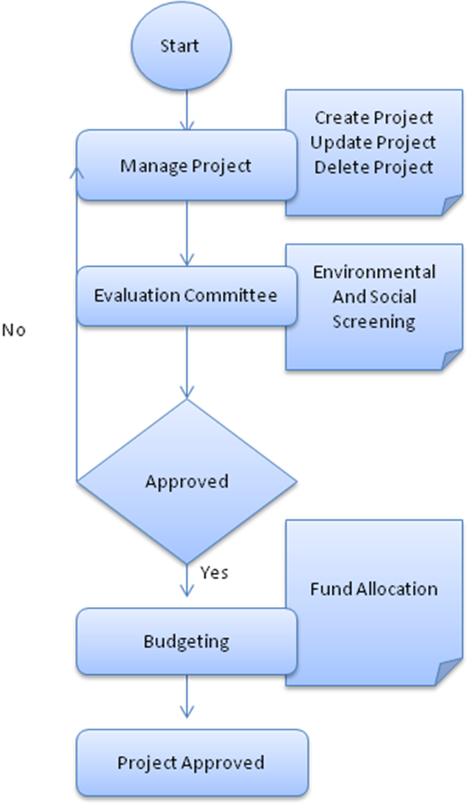

6.2 Project Process Diagram

The below diagram depicts the process flow identifying the each individual task.

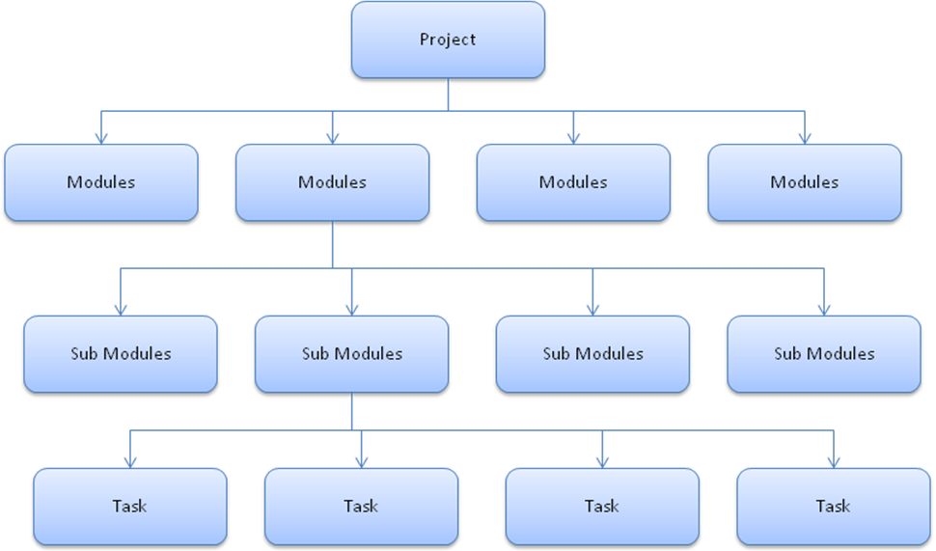

6.3 Execution of a Project

The below diagram depicts the process flow of the project execution from the start to the end of the project.

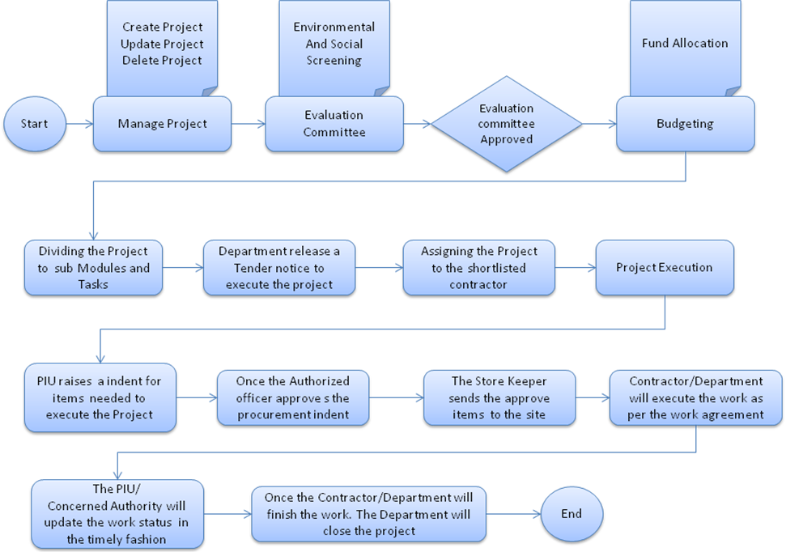

6.4 Master Process Diagram

The below diagram depicts the process flow for all the master data

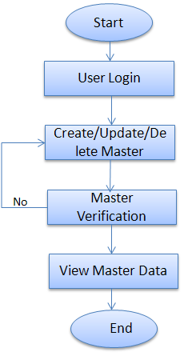

6.5 Procurement Process Diagram

The following diagram depicts the process flow of the procurement process
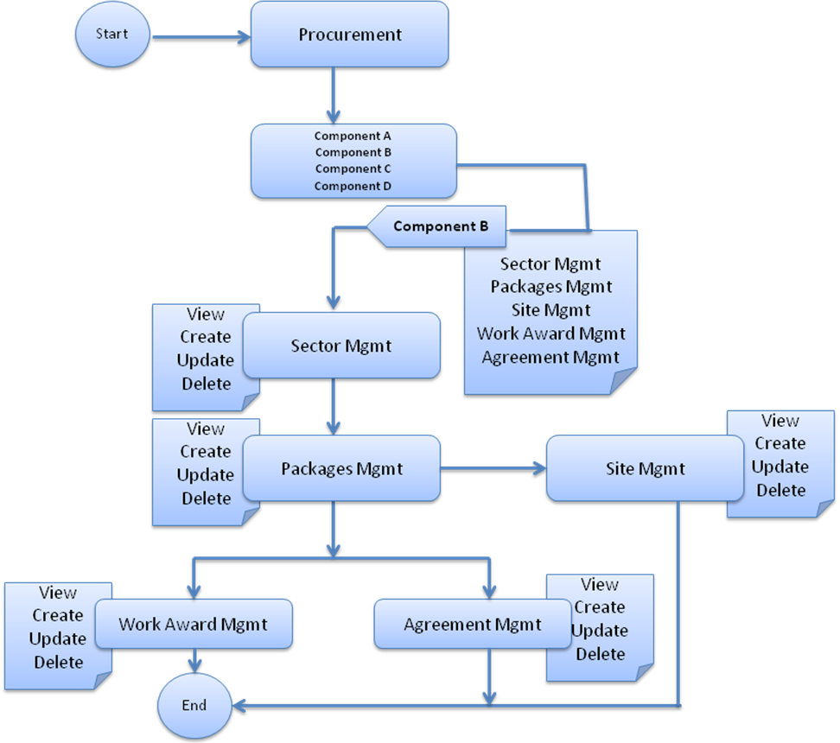

6.6 Environment & Social Process Diagram
The following diagram depicts the process flow of the Environment & social screening process
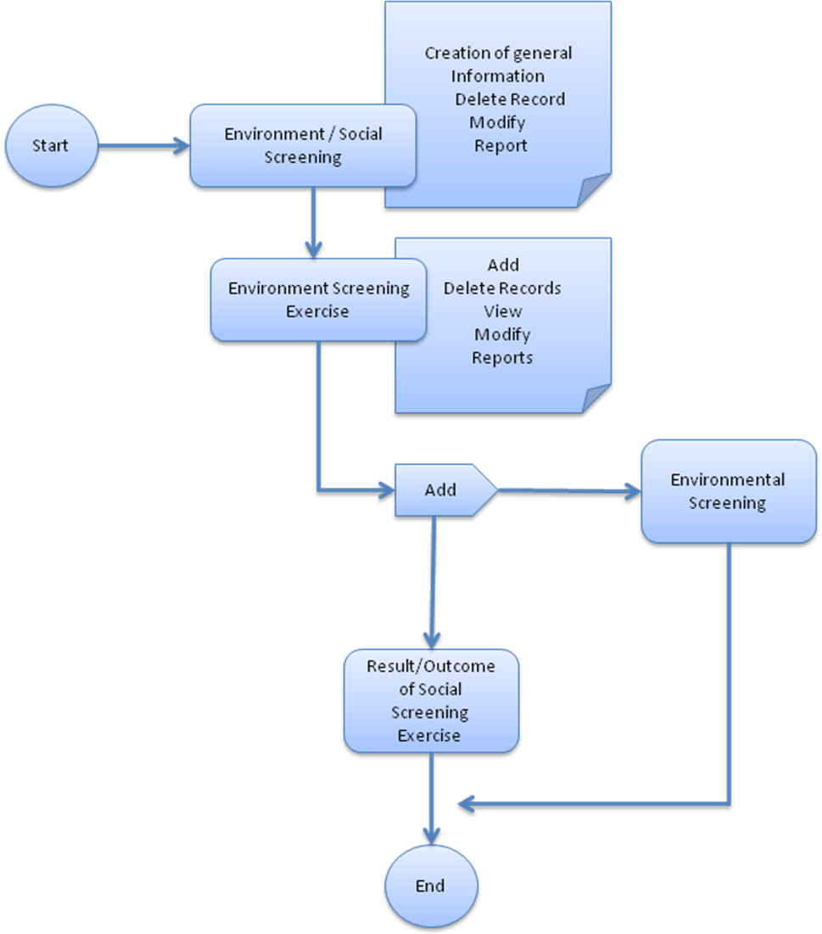

7. Strategy

7.1 Development

The complete development will be carried out in the following steps:

Preparation of SRS: This phase includes preparation of SRS document on the basis of user requirements, understanding of the activities that are to be automated and feedbacks received on URS Validation reports. It will contain specific details regarding integration with other NCRMP and other line departments systems and forms the basis for developing the application software...

Developer’s Training: This phase includes training provided to IT specialists of the NIC officials to ensure that they have a thorough knowledge of the application software design.

Development of Application Software, Coding including Prototype: This phase includes development of code of the Application Software and prototype. The development of the application software code will be in compliance with the SRS. The software coding will be done to cover front-end, business logic and backend.
Testing of Application Software: This phase includes

- Creation of test data
- Testing of the system at various levels for any errors in the transaction of data
- Validation checks at front end
- User interface design
- Performance

This phase also includes live pilot testing on the Application Software. These tests will be conducted at selected pilot sites. The live pilot tests would cover: all modules, sub-systems. The live pilot tests will be conducted in live conditions.

The development of the software will take place on the office location Delhi, Hyderabad or Vishakhapatnam any development centre defined by the company.

7.2 Implementation

The developed software will be implemented at the entire Category I: Higher vulnerability coastal States/UTs (Andhra Pradesh, Gujarat, Orissa, Tamil Nadu and West Bengal) and Category II: Lower vulnerability coastal States/UTs (Maharashtra, Goa, Karnataka, Kerala, Daman & Diu, Pondicherry, Lakshadweep and Andaman & Nicobar Islands)

Installation & Implementation: This phase includes installation, implementation, commissioning of the application software and integration testing for conducting parallel run on the specified number of machines (clients / servers) and at the specified locations. The parallel run will be conducted with the full participation of NIC personnel. During this phase, client will perform acceptance testing on the basis of test data to ensure that all the requirements given during the URS phase are captured in the system.

Training: This phase includes different trainings that will conduct for the users within the main offices and sub-offices of NCRMP and officials from line department. It includes training for system administrators and training for end-users.

8. Acceptance Test Criteria

- The acceptance of the application will be based on the successful testing of the System Test Cases. The client will approve these test cases and during the UAT (User acceptance testing). The following test will be carried over for the acceptance of the application.
1. System Test Cases

2. Integration Test Cases

3. Unit Test Cases

- NIC will prepare a detailed Software Test Plan and Acceptance Test Plan documents. Standard Entry, Input, and Exit criteria will be applicable.
- NIC would accept the various deliverables in accordance with the stipulated criteria in the Acceptance Test Plan.
- In order to manage the changes not covered by the SRS document, NIC discuss the issues and negotiate for a reasonable extension of project deadlines and cost escalations, if any.
- During the development stage, if there are new changes in the development, a change request (CR) will be prepared.
- The project will be treated as completed after the systems are tested and accepted. NIC will sign the Project Completion Document accordingly.

Delivery Specification

Packaging

- Tested software will be delivered with the source code to the client along with the documents on a CD / DVD.

9.2 Installation

- Application will be installed on Central server. Installation guidelines will be provided to the client in the form of an installation manual that will be provided at the time of delivery of system

Documentation

- All the documents submitted to the client at the end of various phases should be stored for future reference and maintenance purpose.
- These documents consist of:
- URS Validation report
- System Requirement Specification Document & System Design Document
- Training material
- Developer's manual
- System administrator's manual
- User Manual.

Following are the list of deliverable items.

- System Requirement Specification (SRS)
- Prototype
- Test cases/ Use cases
- Build Application
- User manual

10. Annexure

Environment / Social Screening Form

Part A: General Information

1. Name of the State
2. Type of proposed sub-project activity (tick the applicable option)
- Cyclone Shelter
- Cyclone Shelter with Access Road/Culverts
- Plantation of Mangroves
- Roads/Bridges/Culverts
- Shelter Belt Plantation
- Saline Embankment
- Coastal canal
- Any Other (Please Specify)
3. Location of the sub-project
- Village
- Taluka

- District
4. Size of the sub-project
(approx. area in sq. mt/hac or length in mt/km, as relevant)
5. Land Requirement (in hac. /sq. mt.)
- Total Requirement
- Private Land
- Govt. Land
- Forest Land
6. Implementing Agency Details (sub-project level)
- Name of the Department/Agency
- Name of the designated contact person
- Designation
- Contact Number
- E-mail Id
7. Details about the Screening Exercise
- Date
- Name of the Person
- Contact Number
- E-mail Id

Part B (1): Environment Screening

Question |  | Yes |  | No |  | Details
1. Is the sub-project located in whole or part within the Coastal Regulation Zone? |  |  |  |  |  | If yes, specify the zone.
2. Is the sub-project located in whole or part in/near any of the following environmentally sensitive areas?
Biosphere Reserve |  |  |  |  |  | If yes, mention name and distance.
National Park |  |  |  |  |  | If yes, mention name and distance.
Wildlife/Bird Sanctuary |  |  |  |  |  | If yes, mention name and distance.
Question |  | Yes |  | No |  | Details
Tiger Reserve/Elephant Reserve |  |  |  |  |  | If yes, mention name and distance.
Wetland |  |  |  |  |  | If yes, mention name and distance.
Important Bird Areas (IBAs) |  |  |  |  |  | If yes, mention name and distance.
Coastal area with corals |  |  |  |  |  | If yes, mention name and distance.
Mangrove area |  |  |  |  |  | If yes, mention name and distance.
Estuary with mangroves |  |  |  |  |  | If yes, mention name and distance.
Natural Lakes |  |  |  |  |  | If yes, mention name and distance.
Swamps/Mudflats |  |  |  |  |  | If yes, mention name and distance.
Habitat of migratory birds (outside protected areas) |  |  |  |  |  | If yes, mention name and distance.
Migratory Route of Wild Animals/Birds |  |  |  |  |  | If yes, mention name and distance.
Area with threatened/rare/endangered fauna (outside protected areas) |  |  |  |  |  | If yes, mention name and distance.
Area with threatened/rare/ endangered flora (outside protected areas) |  |  |  |  |  | If yes, mention name and distance.
Reserved/Protected Forest |  |  |  |  |  | If yes, mention name and distance.
Zoological Park /Botanical Garden |  |  |  |  |  | If yes, mention name and distance.
3. Is the sub-project located within 500 meters from rivers, streams, estuaries or deltaic mouths? |  |  |  |  |  | If yes, mention name/s and distance/s.
Question | Yes |  | No |  | Details
4. Is the sub-project located in whole or part near any of the following sensitive features?
- World Heritage Sites |  |  |  |  | If yes, mention name and distance.
- Archaeological monuments/sites (under ASI’s central/state list) ³ |  |  |  |  | If yes, mention name and distance.
- Historic Places (not listed under ASI – central or state list but regionally/locally important) |  |  |  |  | If yes, mention name and distance.
- Reservoirs/Dams |  |  |  |  | If yes, mention name and distance.
- Religious Places (Regionally or Locally Important) |  |  |  |  | If yes, mention name and distance.
- Public Water Supply Areas from Rivers/Surface Water Bodies/ Ground Water Sources |  |  |  |  | If yes, mention name and distance.

Part B (2) : Result/Outcome of Environmental Screening Exercise
No Environment Impact Assessment Required
Environment Impact Assessment Required
CRZ clearance required
Environmental Clearance Required
Forest Clearance Required
Note: Please refer to the relevant chapter of ESMF for information of regulatory framework and clearance requirements while Annexure No. --- provides guidance on conducting Environment Impact Assessment.

10.1.3 Part C (1): Social Screening
1. Does the sub-project activity require acquisition of private land?
Yes |  |  |  |  | No
Give the following details: |  | Private Land (sq mts/hac.)
 |  | Govt. Land (sq mts/hac.)
 |  | Forest Land (sq mts/hac.)
2. Does the proposed sub-project activity result in demolition/removal of existing structures?
Yes |  |  |  |  | No
If so, give the following details:
- Number of public structures/buildings
- Number of common property resources (such as religious/cultural/ drinking water/wells/etc)
- Number of private structures
(located on private or public land)
3. Does the proposed Project activity result in loss of crops/trees?
Yes |  |  |  |  | No
4. Does the proposed Project activity result in loss of direct livelihood/ employment?
Yes |  |  |  |  | No
5. Does the proposed activity result in loss of mangrove ecosystem/community forest on which nearby residents/local population are dependent for fuel wood/grazing etc.?
Yes |  |  | No
If yes, give the details of the extent of area to be lost (in acres/hac.).
6. Does the proposed Project activity affect schedule tribe/caste communities?
Yes |  |  |  | No

Part C (2): Result/Outcome of Social Screening Exercise

Part C (2) : Result/Outcome of Social Screening Exercise
 | Output | Outcome
 | Answer to all the question is ‘No’ and only forest land is being acquired | No SIA/RAP required
 | Answer to any question is ‘Yes’ and the sub-project does not affect more than 200 people (i.e. either complete or partial loss of assets and/or livelihood) | Abbreviated RAP is required
 | Answer to any question is ‘Yes’ and the sub-project affects more than 200 people (i.e. either complete or partial loss of assets and/or livelihood) | SIA/RAP Required

Environmental & Social

Results of ESMF screening
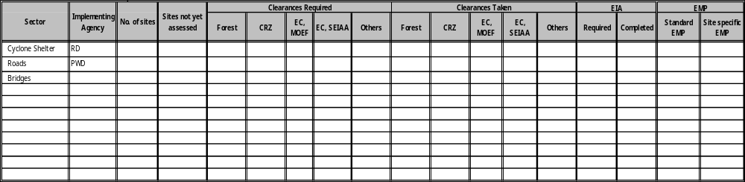

B. Results of social screening and management
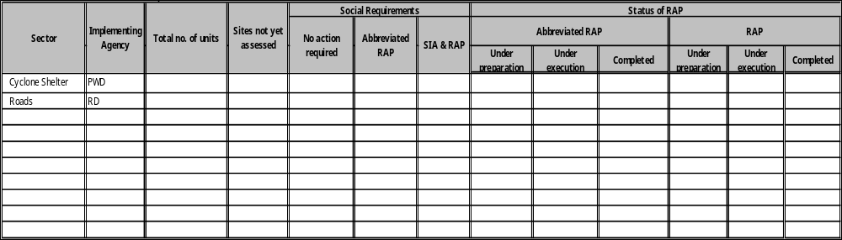

Instances of sites with deviations from EMP
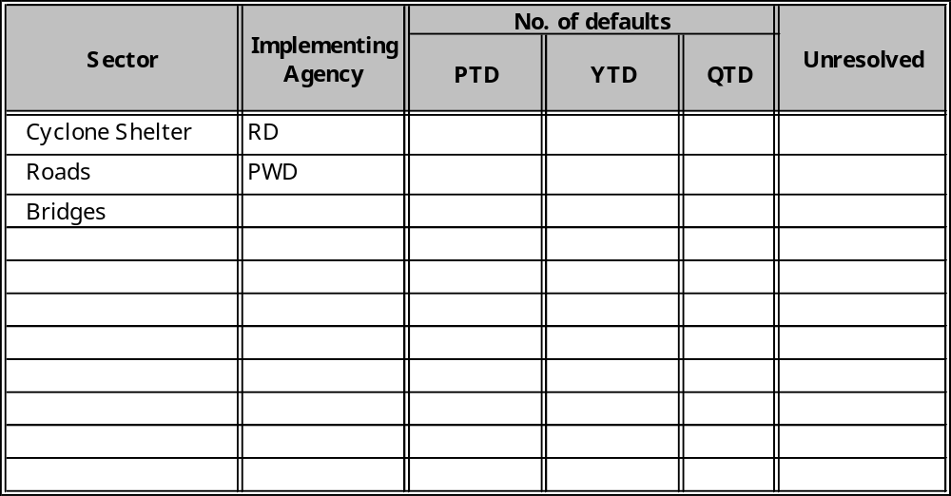

Progress of the state in environmental matters
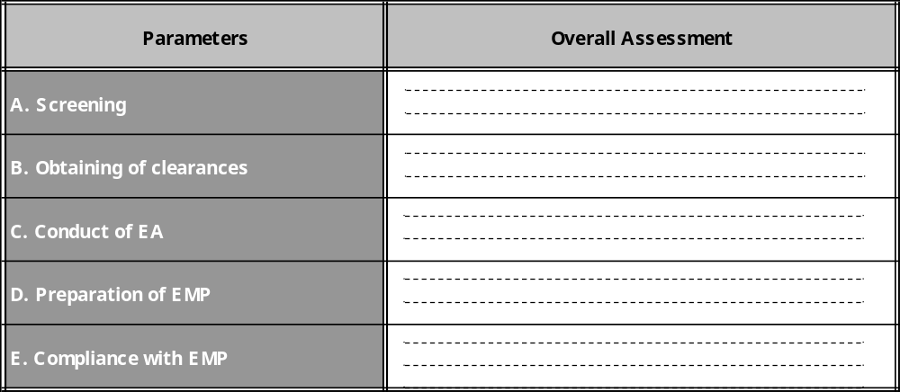

10.6 Events and Critical date’s calendar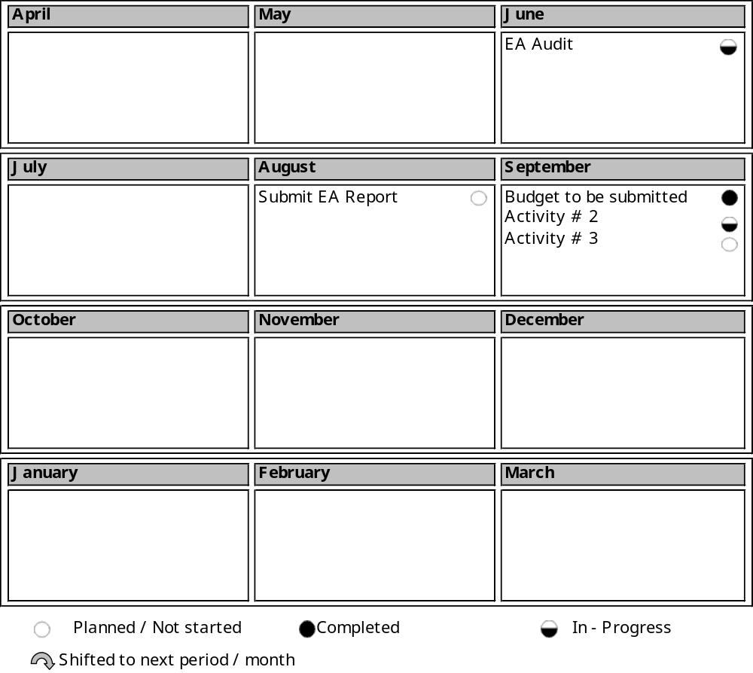

10.7 Exceptions to the planned events and activities are as follows
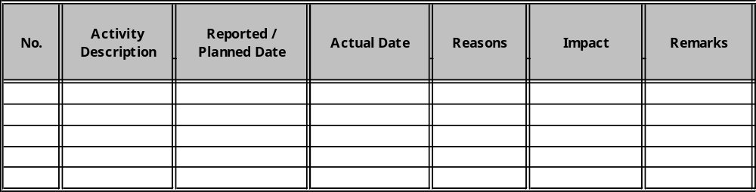

Comparison of actual expenditure with planned expenditure
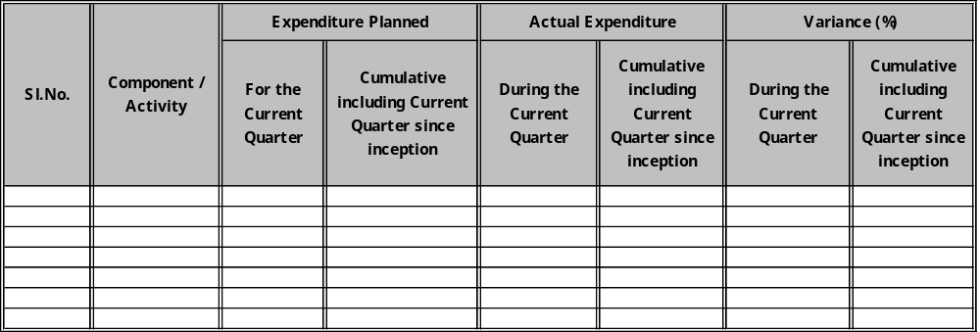

The PIU should take adequate steps to ensure that there are no adverse impacts on the environment within 1 km radius of the listed protected areas during sub-project implementation. The Environmental Officers at the PIU/PMU need to ensure that the required avoidance, minimization and mitigation measures are taken care of during site selection, DPR preparation and implementation/construction stages of a sub-project. This will help facilitate project supervision and monitoring during the implementation stage as well.

