Introduction_To_Programming
Session-6

Q1.Write a program that prints the numbers from 10 down to 1 using a for loop, similar to a countdown timer.

Ans=>
Code:
#include<stdio.h>
Int main()
{
for(int i=10;i>=1;i--)
{
printf(“Countdown is :%d\n",i”);
}
return 0;
}

Output:
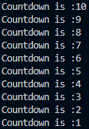

Q2.Create a menu-driven console app that lets the user: 1) View your favorite 3 IPL teams, 2) Add a new team, 3) Exit. Use a while loop to keep showing the menu until the user chooses Exit. Hint: Use input() (or Scanner in Java) to get the user's choice each time.

Ans=>
Code:
#include<stdio.h>
int main()
{
int choice;
char teams[10][30] = {"Mumbai Indians", "Chennai Super Kings", "Royal Challengers Bangalore"};
int team_count = 3;
while(1) {
printf("\nMenu:\n");
printf("1) View your favorite IPL teams\n");
printf("2) Add a new team\n");
printf("3) Exit\n");
printf("Enter your choice: ");
scanf("%d", &choice);
switch(choice) {
case 1:
printf("\nYour favorite IPL teams are:\n");
for(int i = 0; i < team_count; i++) {
printf("%d. %s\n", i + 1, teams[i]);
}
break;
case 2:
if(team_count < 10) {
printf("Enter the name of the new team: ");
scanf(" %[^\n]%*c", teams[team_count]); // Read string with spaces
team_count++;
printf("Team added successfully!\n");
} else {
printf("Cannot add more teams. Maximum limit reached.\n");
}
break;
case 3:
printf("Exiting the program. Goodbye!\n");
return 0;
default:
printf("Invalid choice. Please try again.\n");
}
}
}

Output:
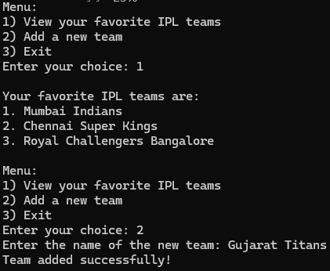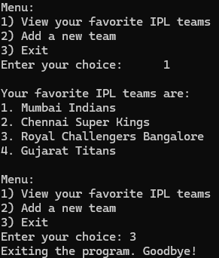

Q3.Build a 'Guess the Song' game like Spotify — the program randomly picks a song name from a list and asks the user to guess it. Use a do-while loop so the user can keep guessing until they get it right. Constraint: Use at least 3 song names of your choice.

Ans=>
Code:
#include <stdio.h>
int main() {
const char *songs[] = {"Shape of You", "Blinding Lights", "Levitating"};
const int num_songs = sizeof(songs) / sizeof(songs[0]);
int random_index = rand() % num_songs; // Randomly select a song
char guess[50];
int attempts = 0;
printf("Welcome to the 'Guess the Song' game!\n");
printf("Try to guess the song name. You can keep guessing until you get it right.\n");
do {
printf("Enter your guess: ");
scanf(" %[^\n]", guess); // Read string with spaces
attempts++;
if (strcmp(guess, songs[random_index]) == 0) {
printf("Congratulations! You've guessed the song correctly in %d attempts!\n", attempts);
break;
} else {
printf("Incorrect guess. Try again!\n");
}
} while (1);

return 0;
}

Output:
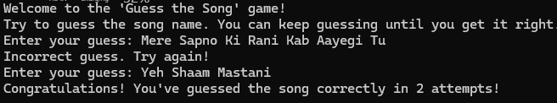

Q4.Explain with your own example the difference between entry-controlled and exit-controlled loops by writing a short code snippet for each (for/while vs do-while) and describing what happens if the loop condition is false at the start.

Ans=>
In programming, loops are used to execute a block of code repeatedly based on a condition. There are two main types of loops: entry-controlled loops and exit-controlled loops.

The difference between entry-controlled and exit-controlled loops lies in when the loop condition is evaluated.

In an entry-controlled loop (like the while loop), the condition is checked before the loop body is executed. If the condition is false at the start, the loop body will not execute at all.

In an exit-controlled loop (like the do-while loop), the loop body is executed at least once before the condition is checked. If the condition is false at the start, the loop body will still execute once before exiting the loop.

In summary, entry-controlled loops may not execute at all if the condition is false initially, while exit-controlled loops will always execute at least once regardless of the initial condition being false or true .

Code:
#include <stdio.h>
// Entry-Controlled Loop (while loop/for loop)
int main()
{
int count = 0;
printf("Entry-Controlled Loop Example:\n");
while (count < 5) ⇐ (Condition is checked before entering the loop)
{
printf("Count: %d\n", count);
count++;
}
return 0;
}

Output:

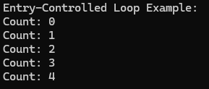

#include <stdio.h>
// Exit-Controlled Loop (do-while loop)
int main()
{
int count = 0;
printf("Exit-Controlled Loop Example:\n");
do
{
printf("Count: %d\n", count);
count++;
}
while (count < 5); ⇐ (Condition is checked after executing the loop body)
return 0;
}

Output:

