Introduction_To_Programming
Session-1

Q1.Write a short paragraph in your own words defining what a 'program' is and give one real-life example from any app you use daily (like Instagram, Zomato, or Paytm).

Ans=>
A program is a set of step-by-step instructions written by humans for a computer or mobile device to execute specific tasks automatically. It takes inputs from the user, processes that data behind the scenes using pre-defined logic, and delivers a specific output or result.
Example: In Paytm, when you scan a QR code and enter an amount to send money, the app's program takes your payment input, verifies your account details and UPI PIN, contacts the bank server to transfer the funds, and immediately displays a success receipt screen.

Q2.List three popular programming languages you have heard of, and for each, mention whether it is usually compiled, interpreted, or can be both. Hint: Think of languages like Java, Python, and JavaScript.
Ans=>

Programming Language | Execution Type | Description
Python | Interpreted | Executes code line-by-line using an interpreter, which makes debugging faster and easier.
Java | Compiled & Interpreted | First compiled into intermediate bytecode (.class file), which is then interpreted/executed by the Java Virtual Machine (JVM).
JavaScript | Both (Just-In-Time Compiled / Interpreted) | Traditionally interpreted in web browsers, but modern engines (like V8) use JIT (Just-In-Time) compilation to compile code directly to machine code at runtime for high performance.

Q3.Draw a flowchart (on paper or using any online tool) for the process of booking a movie ticket on BookMyShow, starting from opening the app to receiving the booking confirmation.

Ans=>
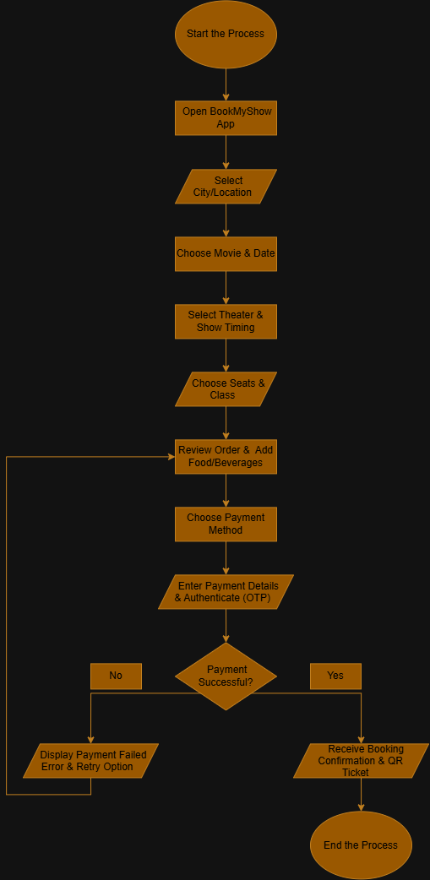

Q4.Write down the steps (as an algorithm, using simple numbered instructions) for ordering food on Swiggy — from opening the app to completing payment.

Ans=>
Step 1: Open App & Set Location:
Open the Swiggy app on your smartphone and ensure your delivery address/location is correctly selected.

Step 2: Search & Browse Restaurants:
Search for a specific dish, cuisine, or restaurant using the search bar, or browse through the available options on the home screen.

Step 3: Select Items & Add to Cart:
Choose your desired food items, select quantity/customizations (e.g.: add-ons, etc), and tap Add to Cart.

Step 4: Review Cart:
Tap on View Cart to review your ordered items, check the delivery fee, apply any applicable discount coupons, and verify your delivery address and contact number.

Step 5: Proceed to Pay:
Tap on Proceed to Pay to open the checkout/payment selection screen.

Step 6: Select Payment Method:
Choose your preferred payment method (UPI, Debit/Credit Card, Net Banking, Swiggy Money, or Cash on Delivery).

Step 7: Complete Transaction:
Enter your payment credentials or UPI PIN and authorize the payment. Once verified, the order confirmation screen will display your live order status and estimated delivery time.

