Introduction_To_Programming
Session-11

Q1.Declare an integer variable called likes and a pointer variable called ptrLikes; assign likes a value, point ptrLikes to likes, and print both the value and the address stored in ptrLikes.

Ans=>
Code:
#include<stdio.h>
int main() {
int Likes = 1000;
int *ptrLikes = &Likes;
printf("Value of likes: %d\n", *ptrLikes);
printf("Value of pointer p: %d\n", *ptrLikes);
printf("Address of pointer p: %x\n", ptrLikes);
return 0;
}

Output:
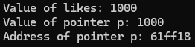

Q2.Write a function swapPlaylistCounts(int *a, int *b) that swaps the number of songs in two Spotify playlists using pointers, then call the function in main and print the swapped values.

Ans=>
Code:
#include <stdio.h>
void swapPlaylistCounts(int *a, int *b)
{
int x = *a;
*a = *b;
*b = x;
}
int main()
{
int playlist1 = 50;
int playlist2 = 80;
swapPlaylistCounts(&playlist1, &playlist2);
printf("Playlist 1 songs = %d\n", playlist1);
printf("Playlist 2 songs = %d\n", playlist2);
return 0;
}

Output:
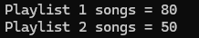

Q3.Given an array of 5 order amounts (e.g., Zomato orders), use a pointer to iterate through the array and print each amount along with its memory address. Hint: Use pointer arithmetic to move to the next element.

Ans=>
Code:
#include <stdio.h>
int main()
{
int orders[5] = {200, 350, 150, 500, 250};
int *ptr = orders;
for (int i = 0; i < 5; i++)
{
printf("Value = %d\n", *(ptr + i));
printf("Address = %p\n",(ptr + i));
}
return 0;
}

Output:
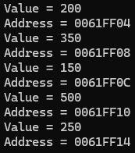

Q4.Create a function incrementFollowers(int *followers, int n) that increases each follower count in an array (representing Instagram followers for 5 friends) by 100 using pointer arithmetic, then print the updated counts.

Ans=>
Code:
#include <stdio.h>
void incrementFollowers(int *followers, int n)
{
for (int i = 0; i < n; i++)
{
*(followers + i) = *(followers + i) + 100;
}
}
int main()
{
int followers[5] = {500, 800, 1200, 1500, 2000};
incrementFollowers(followers, 5);
printf("Updated follower counts:\n");
for (int i = 0; i < 5; i++)
{
printf("%d\n", followers[i]);
}
return 0;
}

Output:
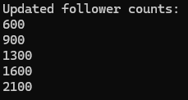

Q5.Draw a simple memory diagram (on paper or using any drawing tool) showing how a pointer references the address of a variable, using the variables from your likes and ptrLikes example; label the variable, pointer, and address.

Ans=>
