Introduction_To_Programming
Session-12

Q1.Declare a structure named Playlist to store details of a song: title (string), artist (string), and duration in seconds (integer). Initialize one Playlist variable with your favorite song's details and print each field.

Ans=>
Code:
#include <stdio.h>
struct Playlist
{
char title[50];
char artist[50];
int duration;
};
int main()
{
struct Playlist song = {"Aa Chal Ke Tujhe", "Kishore Kumar", 280};
printf("Song Title: %s\n", song.title);
printf("Artist: %s\n", song.artist);
printf("Duration: %d seconds\n", song.duration);
return 0;
}

Output:
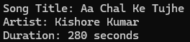

Q2.Create a structure called FoodItem to store Zomato-style menu data: itemName (string), price (float), and rating (float). Initialize an array of 3 FoodItem variables with real menu items and display their details using a loop.

Ans=>
Code:
#include <stdio.h>
struct FoodItem
{
char itemName[50];
float price;
float rating;
};
int main()
{
struct FoodItem menu[3] = {{"Corn Cheese Pizza", 150.0, 4.5}, {"Pari Pari Cheese Burger", 90.0, 4.2}, {"Double Cheese Pasta", 100.0, 4.3}};
for (int i = 0; i < 3; i++)
{
printf("Item Name: %s\n", menu[i].itemName);
printf("Price: Rs. %.2f\n", menu[i].price);
printf("Rating: %.1f\n\n", menu[i].rating);
}
return 0;
}

Output:
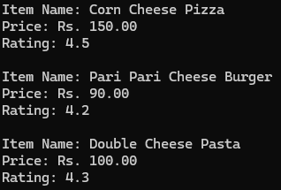

Q3.Define a nested structure called MovieShow for a BookMyShow-style app: Movie (string), Screen (integer), and a nested structure Time with hours and minutes (integers). Create and initialize a MovieShow variable for any movie and print its details in the format 'Movie: X, Screen: Y, Time: HH:MM'.

Ans=>
Code:
#include <stdio.h>
struct MovieShow
{
char movie[50];
int screen;
struct Time
{
int hr;
int min;
}
time;
};
int main()
{
struct MovieShow show = {"Jawan", 2, {18, 30}};
printf("Movie: %s \nScreen: %d \nTime: %02d:%02d\n",
show.movie, show.screen,
show.time.hr, show.time.min);
return 0;
}

Output:
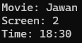

Q4.Build a structure called InstaProfile with fields: username (string), followers (integer), and a nested structure Bio with fields: description (string) and age (integer). Initialize an InstaProfile variable with your own details and display all fields.

Ans=>
Code:
#include <stdio.h>
struct InstaProfile
{
char username[50];
int followers;
struct Bio
{
char description[100];
int age;
}
bio;
};
int main()
{
struct InstaProfile user = {"Just.me.123", 3232,{"Hard Work Beats Talent If Talent Does Not Work Hard ", 23} };
printf("Username: %s\n", user.username);
printf("Followers: %d\n", user.followers);
printf("Description: %s\n", user.bio.description);
printf("Age: %d\n", user.bio.age);
return 0;
}

Output:
