Introduction_To_Programming
Session-13

Q1.Create a file called playlist.txt and write the names of your top 3 favorite songs from Spotify into it using write mode (w).

Ans=>
Code:
#include<stdio.h>
int main()
{
FILE *s;
s = fopen("playlist.txt","w");
fprintf(s,"O Mere Dil Ke Chain \n");
fprintf(s,"Pal Pal Dil Ke Paas \n");
fprintf(s,"Yeh Vaada Raha \n");
printf("File Written");
fclose(s);
return 0;
}

Output:
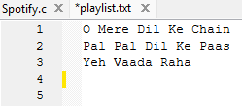

Q2.Open playlist.txt in read mode (r) and display each song name on a separate line in the console.

Ans=>
Code:
#include<stdio.h>
int main()
{
FILE *s;
char buff[255];
s = fopen("playlist.txt", "r");
while(fscanf(s,"%s", buff)!=EOF)
{
printf("%s \n", buff);
}
fclose(s);
}

Output:
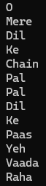

Q3.Add two more song names to playlist.txt without deleting the existing ones by opening the file in append mode (a).

Ans=>
Code:
#include<stdio.h>
int main()
{
FILE *f;
char song[20];
f=fopen("playlist.txt","a");
if(f == NULL)
{
printf("File does not exists");
return 0;
}
printf("Enter the song name :");
scanf("%19s",&song);
fprintf(f,"%s \n",song);

printf("Enter the song name :");
scanf("%19s",&song);
fprintf(f,"%s \n",song);
fclose(f);

return 0;
}

Output:
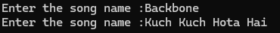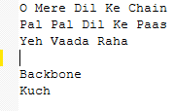
Q4.Write a program that reads all song names from playlist.txt and prints only those that contain the word 'love' (case-insensitive). Hint: Use the 'in' keyword or equivalent string method for filtering.

Ans=>
Code:
#include <stdio.h>
#include <string.h>
#include <ctype.h>
int main()
{
FILE *fp;
char song[100];
char lower[100];
int i;
fp = fopen("playlist.txt", "r");
if (fp == NULL)
{
printf("Unable to open file.\n");
return 1;
}
while (fgets(song, sizeof(song), fp) != NULL)
{
strcpy(lower, song);
for (i = 0; lower[i] != '\0'; i++)
{
lower[i] = tolower((unsigned char)lower[i]);
}
if (strstr(lower, "love") != NULL)
{
printf("%s", song);
}
}
fclose(fp);
return 0;
}

Output:
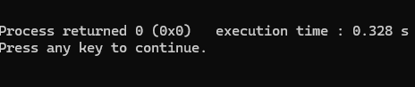

Because there is no song starting or containing love word.

