Introduction_To_Programming
Session-4

Q1.Create a simple C language function called calculateTotal that takes two numbers: itemPrice and quantity, and returns the total bill amount using arithmetic operators.

Ans=>
Code:
#include <stdio.h>
int main()
{
int itemPrice , quantity;

printf("Give price of the iteam:");
scanf("%d",&itemPrice);

printf("Give quantity of the iteam:");
scanf("%d",&quantity);
||---------- Arithmetic Operator(“Multiplication” )
v
int total = quantity * itemPrice;
printf("The total bill amount is %d",total);

return 0;
}

Output:
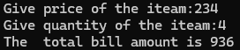

Q2.Build a Flipkart-style discount calculator: given product price, discount percentage, and a boolean is Member, use arithmetic and logical operators to calculate the final price (apply an extra 5% off if is Member is true).

Ans=>
Code:
#include <stdio.h>
int main()
{
float price, discount, finalPrice;
int isMember;

printf("Enter product price: ");
scanf("%f", &price);
printf("Enter discount percentage: ");
scanf("%f", &discount);
printf("Are you a member? (1 for Yes, 0 for No): ");
scanf("%d", &isMember);

finalPrice = price - (price * discount / 100);

if (isMember == 1)
{
finalPrice = finalPrice - (finalPrice * 5 / 100);
}
printf("Final price = %.2f", finalPrice);

return 0;
}

Output:
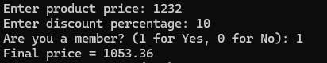

Q3.Write a function is Eligible For Offer that takes a user's age and total order value, and returns true if the user is 18 or older AND the order value is above 500, otherwise false. Hint: Use relational and logical operators together.

Ans=>
Code:
#include <stdio.h>

int isEligibleForOffer(int age, int orderValue)
{
if (age >= 18 && orderValue > 500)
{
return 1;
}
else
{
return 0;
}
}

int main()
{
int age, orderValue;
printf("Enter your age: ");
scanf("%d", &age);
printf("Enter total order value: ");
scanf("%d", &orderValue);
if (isEligibleForOffer(age, orderValue))
{
printf("Eligible for offer");
}
else
{
printf("Not eligible for offer");
}
return 0;
}

Output:
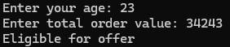

Q4.Given three variables: likes, comments, and shares (all numbers), write code to check if a post is 'trending' on Instagram (at least 1000 likes OR more than 200 comments AND at least 50 shares). Print the result.

Ans=>
Code:
#include <stdio.h>
int main()
{
int likes, comments, shares;
printf("Enter likes: ");
scanf("%d", &likes);
printf("Enter comments: ");
scanf("%d", &comments);
printf("Enter shares: ");
scanf("%d", &shares);
if (likes >= 1000 || (comments > 200 && shares >= 50))
{
printf("Post is trending");
}
else
{
printf("Post is not trending");
}
return 0;
}

Output:
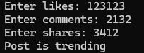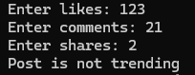

Q5.Write a code snippet that demonstrates the difference between pre-increment (++count) and post-increment (count++) by logging the values before and after using both on a follower Count variable.

Ans=>
Code:
#include <stdio.h>
int main()
{
int followerCount = 100;
printf("Before increment: %d\n", followerCount);
printf("Pre-increment: %d\n", ++followerCount);
printf("After pre-increment: %d\n", followerCount);
printf("Post-increment: %d\n", followerCount++);
printf("After post-increment: %d\n", followerCount);

return 0;
}

Output:
