Introduction_To_Programming
Session-9

Q1.Declare a 1D array called dailySteps with 7 elements to store your step count for each day of the week, assign sample values, and print each value using a loop.

Ans=>
Code:
#include <stdio.h>
int main()
{
int dailySteps[7] = {4500, 6000, 7500, 5000, 8000, 9000, 7000};
int i;
printf("Daily Steps:\n");
for (i = 0; i < 7; i++)
{
printf("Day %d: %d steps\n", i + 1, dailySteps[i]);
}
return 0;
}

Output:
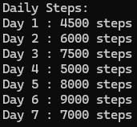

Q2.Create a 2D array called playlistRatings to store ratings for 3 Spotify playlists over 5 days (rows = playlists, columns = days). Fill it with sample numbers and print the ratings for the second playlist.

Ans=>
Code:
#include <stdio.h>
int main()
{
int playlistRatings[3][5] = { {5, 4, 5, 3, 4}, {4, 5, 3, 5, 5}, {3, 4, 4, 5, 4} };
int i;
printf("Ratings for the Second Playlist: \n");
for (i = 0; i < 5; i++)
{
printf("Day %d : %d stars\n", i + 1, playlistRatings[1][i]);
}
return 0;
}

Output:
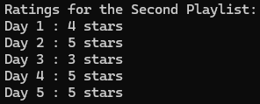

Q3.Build a function that takes a 1D array of 7 integers representing your daily Zomato order amounts and calculates the average spend for the week. Hint: Use a loop to sum the values, then divide by the array length.

Ans=>
Code:
#include <stdio.h>
float calculateAverage(int dailyOrders[], int size)
{
int i;
int total = 0;
float average;
for (i = 0; i < size; i++)
{
total = total + dailyOrders[i];
}
average = (float)total / size;
return average;
}
int main()
{
int dailyOrders[7] = {200, 350, 150, 400, 250, 300, 450};
float average;
average = calculateAverage(dailyOrders, 7);
printf("Last week's oders are\n");
for (int i = 0; i < 7; i++)
{
printf("Day %d : %d orders\n", i + 1, dailyOrders[i]);
}
printf("Average spending for the week is Rs. %.2f\n", average);
return 0;
}

Output:
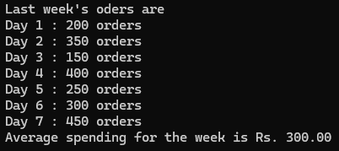

Q4.Given a 2D array called cricketScores where each row represents an IPL match and columns represent runs scored by each team, write code to print the highest score from each match.

Ans=>
Code:
#include <stdio.h>
int main()
{
int cricketScores[3][2] = { {185, 172}, {160, 190}, {210, 205} };
int i;
int highest;
for (i = 0; i < 3; i++)
{
if (cricketScores[i][0] > cricketScores[i][1])
{
highest = cricketScores[i][0];
}
else
{
highest = cricketScores[i][1];
}
printf("Highest score in Match %d: %d\n", i + 1, highest);
}
return 0;
}

Output:
