Introduction_To_Programming
Session-15

Q1.Create a console-based app called Music Listening Logger that allows users to enter the number of minutes they listened to music each day for a week and stores this data in an array.

Q2.Add a menu-driven interface to your Music Listening Logger so users can choose to log new listening minutes, view their weekly summary, or exit the app. Hint: Use a loop to repeatedly show the menu until the user selects exit.

Q3.Implement file handling in your Music Listening Logger so that when the user logs their daily listening minutes, the data is saved to a file named music_log.txt for persistence.

Q4.Add a feature to your app that reads the saved music_log.txt file and generates a weekly report showing the total, average, and highest listening minutes in the week.

Q5.Refactor your Music Listening Logger to allow users to reset their weekly data by clearing the array and deleting the contents of music_log.txt. Constraint: Make sure the reset option is available in the menu and asks for confirmation before deleting data.

Ans=>
Code:
#include <stdio.h>
void logListening();
void viewWeeklySummary();
void resetWeeklyData();
int main()
{
int choice = 0;
while (choice != 4)
{
printf("\n===== MUSIC LISTENING LOGGER =====\n");
printf("1. Log Daily Listening\n");
printf("2. View Weekly Summary\n");
printf("3. Reset Weekly Data\n");
printf("4. Exit\n");
printf("Enter your choice: ");
scanf("%d", &choice);
switch (choice)
{
case 1:
logListening();
break;
case 2:
viewWeeklySummary();
break;
case 3:
resetWeeklyData();
break;
case 4:
printf("Thank you for using Music Listening Logger!\n");
break;
default:
printf("Invalid choice!\n");
}
}
return 0;
}
void logListening() // Enter and save listening minutes
{
int minutes[7];
int i;
FILE *f;
printf("\n===== LOG DAILY LISTENING =====\n");
for (i = 0; i < 7; i++)
{
printf("Enter listening minutes for day %d: ", i + 1);
scanf("%d", &minutes[i]);
if (minutes[i] < 0)
{
printf("Minutes cannot be negative!\n");
return;
}
}
f = fopen("music_log.txt", "w");
if (f == NULL)
{
printf("Error opening file!\n");
return;
}
for (i = 0; i < 7; i++)
{
fprintf(f, "%d\n", minutes[i]);
}
fclose(f);
printf("Weekly data saved successfully!\n");
}
void viewWeeklySummary() // Read data and display weekly summary
{
int minutes[7];
int i;
int total = 0;
int highest = 0;
float average;
FILE *f;
f = fopen("music_log.txt", "r");
if (f == NULL)
{
printf("No weekly data available!\n");
return;
}
for (i = 0; i < 7; i++)
{
if (fscanf(f, "%d", &minutes[i]) != 1)
{
printf("Saved data is incomplete or invalid!\n");
fclose(f);
return;
}
}
fclose(f);
for (i = 0; i < 7; i++)
{
total = total + minutes[i];
if (minutes[i] > highest)
{
highest = minutes[i];
}
}
average = total / 7.0;
printf("\n===== WEEKLY SUMMARY =====\n");
for (i = 0; i < 7; i++)
{
printf("Day %d: %d minutes\n", i + 1, minutes[i]);
}
printf("Total: %d minutes\n", total);
printf("Average: %.2f minutes per day\n", average);
printf("Highest: %d minutes\n", highest);
}
void resetWeeklyData() // Reset saved weekly data
{
char confirm;
FILE *f;
printf("Are you sure you want to reset? (y/n): ");
scanf(" %c", &confirm);
if (confirm == 'y' || confirm == 'Y')
{
f = fopen("music_log.txt", "w");
if (f == NULL)
{
printf("Error opening file!\n");
return;
}
fclose(f);
printf("Weekly data reset successfully!\n");
}
else
{
printf("Reset cancelled.\n");
}
}

Output:
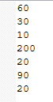
After selecting Log Daily Listening wee put he data it got send into music_log.txt
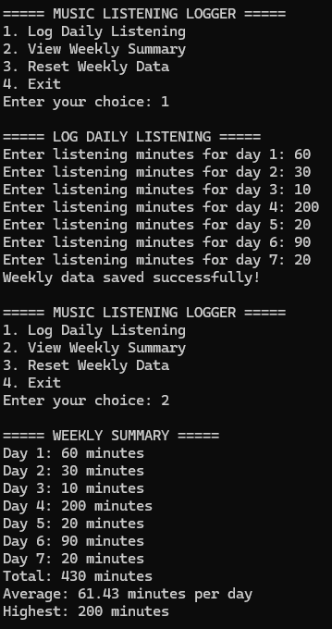
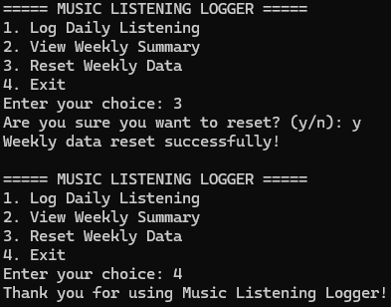

After selecting reset the while list will be deleted (means what ever data we added first will be wiped out the music_log.txt will be empty).

