Overview of IT Industries
Session-3

Q1.Write the full form and one-line use of: HTTP, HTTPS, FTP, SMTP.

Ans=>
Sort-Form | Full-Form | Use Case
HTTP | Hypertext Transfer Protocol | Transmits web pages across a network in unencrypted plaintext.
HTTPS | Hypertext Transfer Protocol Secure | Encrypts web data using SSL/TLS for secure communication.
FTP | File Transfer Protocol | Transfers files between a client and a server.
SMTP | Simple Mail Transfer Protocol | Sends and routes outgoing emails between mail servers.

Q2.What is the difference between IPv4 and IPv6? Answer in 2 lines.

Ans=>
IPv4 uses 32-bit numeric addresses (e.g., 192.168.1.1) with ~4.3 billion total addresses. And
IPv6 uses 128-bit hexadecimal addresses (e.g., 2001:db8::1) providing a virtually unlimited pool.

Q3.Run nslookup google.com on your system and write down the IP address you get.

Ans=>nslookup google.com Output
Running nslookup google.com returns the primary IPv4 address 192.178.24.110 and IPv6 2a00:1450:400e:811::200e
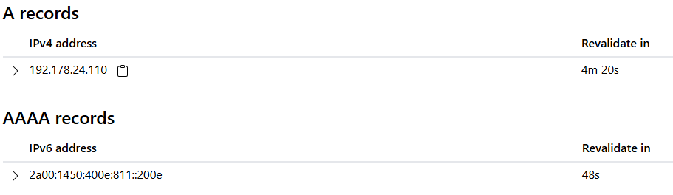

Q4.What do these HTTP status codes mean: 200, 301, 404, 500, 403?

Ans=>
HTTP Status Codes | Meaning | Explanation
200 | OK | The request succeeded, and the server successfully returned the requested resource.
301 | Moved Permanently | The requested URL has been permanently redirected to a new location.
404 | Not Found | The server cannot find the requested URL or resource.
500 | Internal Server Error | The server encountered an unexpected error and could not fulfill the request.
403 | Forbidden | The server understands the request, but the client does not have permission to access the resource.

Q5.Explain DNS hierarchy (root, TLD, domain, subdomain) with www.google.com as an example.

Ans=>
Root Zone (.):
The implicit root dot at the end ([www.google.com](https://www.google.com).) managed by root servers that direct the query to the correct TLD server.
Top-Level Domain / TLD (.com):
The broad extension is managed by the .com TLD registry, pointing queries toward Google's specific authoritative servers.
Domain (google):
The primary domain name registered by the organization, serving as the main authoritative entity.
Subdomain (www):
A specific sub-section or host name defined under the primary domain (often pointing to the primary web server).

