

Functional Safety Concept Lane Assistance

**Document Version: 1.0**



# Document history

|  |  |  |  |
| --- | --- | --- | --- |
| Date | Version | Editor | Description |
| 23-May-2018 | 1.0 | Gautam Sareen | First Attempt |
|  |  |  |  |
|  |  |  |  |
|  |  |  |  |
|  |  |  |  |

Table of Contents

Document history 2

Purpose of the Functional Safety Concept 4

Inputs to the Functional Safety Concept 4

Safety goals from the Hazard Analysis and Risk Assessment 4

Preliminary Architecture 4

Description of architecture elements 5

Functional Safety Concept 6

Functional Safety Analysis 6

Functional Safety Requirements 7

Refinement of the System Architecture 8

Allocation of Functional Safety Requirements to Architecture Elements 9

Warning and Degradation Concept 9

# Purpose of the Functional Safety Concept

Functional Safety looks at the system from a higher level without diving into the technical details of the system. It looks at general functionality of the item. Goal here is to reduce the risks below the acceptable levels.

# Inputs to the Functional Safety Concept

## Safety goals from the Hazard Analysis and Risk Assessment

|  |  |
| --- | --- |
| **ID** | **Safety Goal** |
| Safety_Goal_01 | Oscillating torque should be limited |
| Safety_Goal_02 | Lane assistance system should be time limited |

## Preliminary Architecture

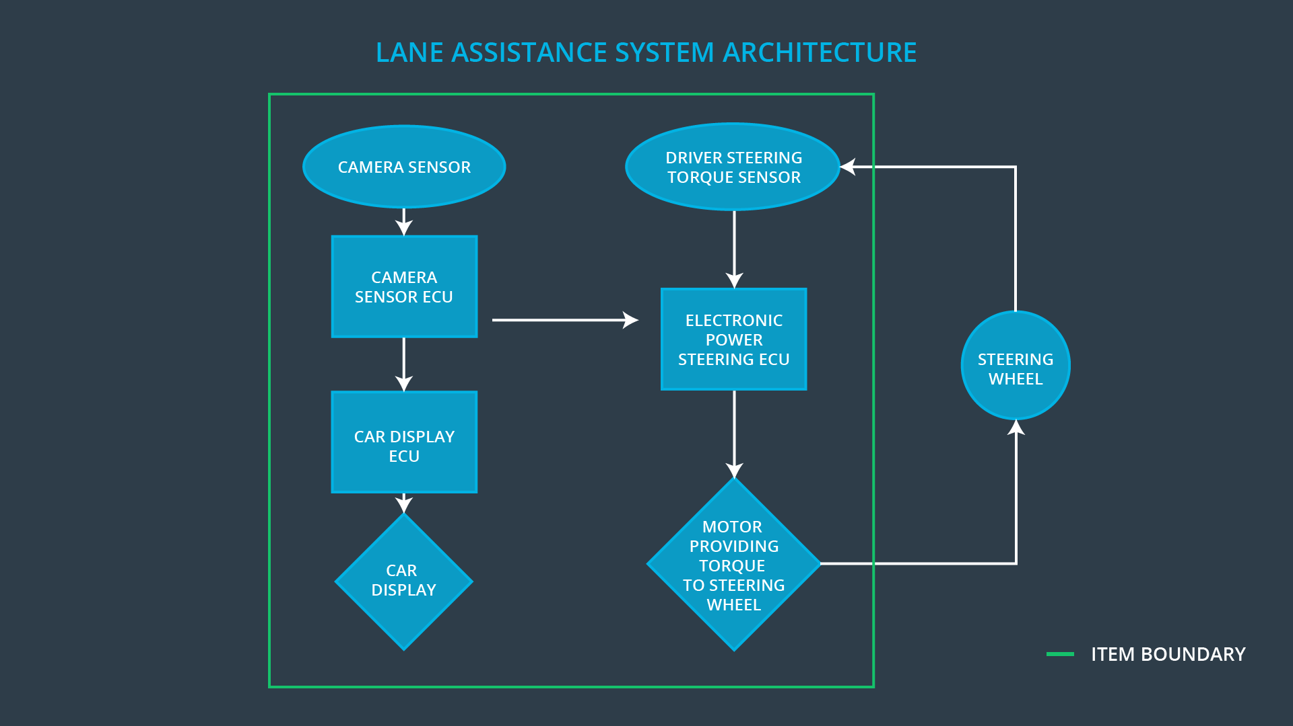

**Fig 1. Lane Assistance System Architecture   
[ image source Udacity course content]**

### Description of architecture elements

|  |  |
| --- | --- |
| **Element** | **Description** |
| Camera Sensor | Capture images and provide them to the camera sensor ECU continuously |
| Camera Sensor ECU | Detect Lane Lines and send the message when car has accidently departed the lane to Car display unit and Electronic Power Steering ECU |
| Car Display | Display the status of the systems and warnings when a system malfunction |
| Car Display ECU | It controls the things displayed on the car display in accordance with the inputs received from other systems. |
| Driver Steering Torque Sensor | It measures the torque applied to the steering wheel. |
| Electronic Power Steering ECU | It takes input from Driver Steering Torque Sensor and camera ECU and decides on the amount of torque needed to be applied on the steering wheel |
| Motor | The Motor is actuated by the input from Electronic Power Steering ECU. It applies the requisite torque to the steering wheel |

# Functional Safety Concept

The functional safety concept consists of:

* Functional safety analysis
* Functional safety requirements
* Functional safety architecture
* Warning and degradation concept

## Functional Safety Analysis

|  |  |  |  |
| --- | --- | --- | --- |
| **Malfunction ID** | **Main Function of the Item Related to Safety Goal Violations** | **Guidewords (NO, WRONG, EARLY, LATE, MORE, LESS)** | **Resulting Malfunction** |
| Malfunction_01 | Lane Departure Warning (LDW) function shall apply an oscillating steering torque to provide the driver a haptic feedback | MORE | The lane departure warning function applies an oscillating torque with very high torque amplitude (above limit) |
| Malfunction_02 | Lane Departure Warning (LDW) function shall apply an oscillating steering torque to provide the driver a haptic feedback | MORE | The lane departure warning function applies an oscillating torque with very high torque frequency (above limit) |
| Malfunction_03 | Lane Keeping Assistance (LKA) function shall apply the steering torque when active in order to stay in ego lane | NO | The lane keeping assistance function is not limited in time duration which leads to misuse as an autonomous driving function. |

## Functional Safety Requirements

Lane Departure Warning (LDW) Requirements:

|  |  |  |  |  |
| --- | --- | --- | --- | --- |
| **ID** | **Functional Safety Requirement** | **ASIL** | **Fault Tolerant Time Interval** | **Safe State** |
| Functional  Safety  Requirement  01-01 | The lane keeping item shall ensure that the lane departure oscillating torque amplitude is below Max_Torque_Amplitude. | C | 50 ms | Turn off  the LDW functionality |
| Functional  Safety  Requirement  01-02 | The lane keeping item shall ensure that the lane departure oscillating torque frequency is below Max_Torque_Frequency. | C | 50 ms | Turn off  the LDW functionality |

Lane Departure Warning (LDW) Verification and Validation Acceptance Criteria:

|  |  |  |
| --- | --- | --- |
| **ID** | **Validation Acceptance**  **Criteria and Method** | **Verification Acceptance**  **Criteria and Method** |
| Functional  Safety  Requirement  01-01 | Value of Max_Torque_Amplitude is chosen such that it is adequate enough to warn the driver and low enough to not cause steering loss. | Validate whether the system turns off when Max_Torque_Amplitude is exceeded. |
| Functional  Safety  Requirement  01-02 | Value of Max_Torque_Frequency is chosen such that it is adequate enough to warn the driver and low enough to not cause steering loss. | Validate whether the system turns off when Max_Torque_Frequency is exceeded. |

Lane Keeping Assistance (LKA) Requirements:

|  |  |  |  |  |
| --- | --- | --- | --- | --- |
| **ID** | **Functional Safety Requirement** | **ASIL** | **Fault Tolerant Time Interval** | **Safe State** |
| Functional  Safety  Requirement  02-01 | Lane keeping assistance Function will be time limited for a Max_Duration | B | 500ms | Set Lane Keeping Assistance torque to zero and shut off the system |

Lane Keeping Assistance (LKA) Verification and Validation Acceptance Criteria:

|  |  |  |
| --- | --- | --- |
| **ID** | **Validation Acceptance**  **Criteria and Method** | **Verification Acceptance**  **Criteria and Method** |
| Functional  Safety  Requirement  02-01 | Value for max_duration chosen is large enough to bring back the vehicle to the center of the lane and small enough to discourage driver taking hands off the steering wheel | Verify that the LKA function turns off when the Max_Duration is exceeded |

## Refinement of the System Architecture

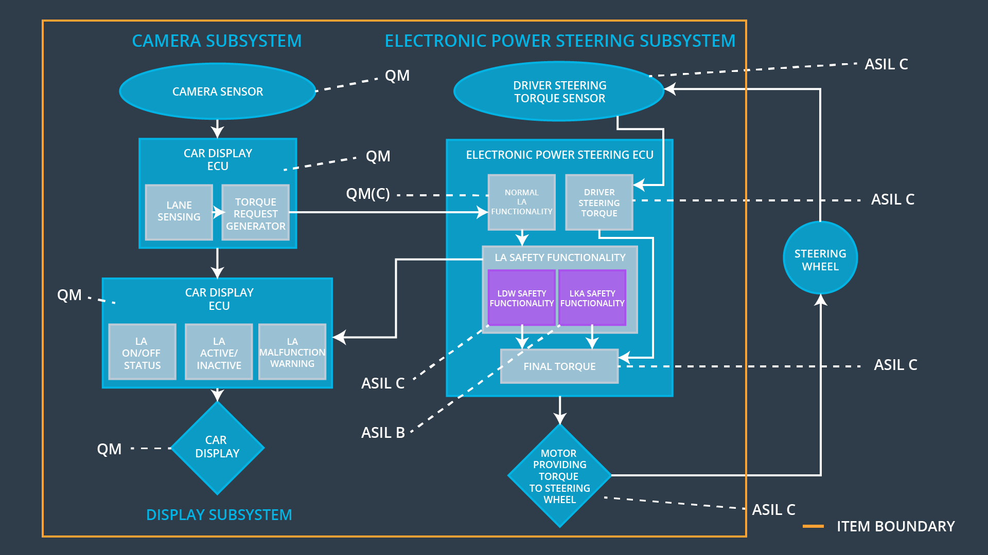

**Fig 1. Lane Assistance System Architecture   
[ image source Udacity course content]**

## Allocation of Functional Safety Requirements to Architecture Elements

|  |  |  |  |  |
| --- | --- | --- | --- | --- |
| **ID** | **Functional Safety Requirement** | **Electronic Power Steering ECU** | **Camera ECU** | **Car Display ECU** |
| Functional  Safety  Requirement  01-01 | The Electronic Power Steering ECU shall ensure that the amplitude of Lane Departure Warning oscillating torque is below Max_Torque_Amplitude | **Responsible** | **Not Responsible** | **Not Responsible** |
| Functional  Safety  Requirement  01-02 | The Electronic Power Steering ECU shall ensure that the Frequency of Lane Departure Warning oscillating torque is below Max_Torque_Frequency | **Responsible** | **Not Responsible** | **Not Responsible** |
| Functional  Safety  Requirement  02-01 | The Electronic Power Steering Shall ensure that the Lane Keeping Torque is applied for a maximum duration of Max_Duration | **Responsible** | **Not Responsible** | **Not Responsible** |

## Warning and Degradation Concept

|  |  |  |  |  |
| --- | --- | --- | --- | --- |
| **ID** | **Degradation Mode** | **Trigger for Degradation Mode** | **Safe State invoked?** | **Driver Warning** |
| WDC-01 | Turn OFF the Functionality | Malfunction_01  Malfunction_02 | Yes | Warning Light on Dashboard and warnings displayed on car display |
| WDC-02 | Turn OFF the Functionality | Malfunction_03 | Yes | Warning Light on Dashboard and warnings displayed on car display |