

Safety Plan Lane Assistance

**Document Version: 1.0**

**Template Version 1.0, Released on 2017-06-21**



# Document history

**[Instructions: Fill in the date, version and description fields. You can fill out the Editor field with your name if you want to do so. Keep track of your editing as if this were a real world project.**

**For example, if this were your first draft or first submission, you might say version 1.0. If this is a second submission attempt, then you'd add a second line with a new date and version 2.0]**

|  |  |  |  |
| --- | --- | --- | --- |
| Date | Version | Editor | Description |
| 23-May-2018 | 1.0 | Gautam Sareen | Initial Draft |
|  |  |  |  |
|  |  |  |  |
|  |  |  |  |
|  |  |  |  |

# 

# Table of Contents

**[Instructions: We have provided a table of contents. If the table of contents is not showing up correctly in your word processor of choice, please update it. The table of contents should show each section of the document and page numbers or links. Most word processors can do this for you. In** [**Google Docs**](https://support.google.com/docs/answer/116338?co=GENIE.Platform%3DDesktop&hl=en)**, you can use headings for each section and then go to Insert > Table of Contents.** [**Microsoft Word**](https://support.microsoft.com/en-us/help/285059/how-to-create-a-table-of-contents-by-marking-text-in-word) **has similar capabilities]**

Document history

Table of Contents

Introduction

Purpose of the Safety Plan

Scope of the Project

Deliverables of the Project

Item Definition

Goals and Measures

Goals

Measures

Safety Culture

Safety Lifecycle Tailoring

Roles

Development Interface Agreement

Confirmation Measures

# Introduction

## Purpose of the Safety Plan

**[Instructions: Answer what is the purpose of a safety plan?]**

Safety plan provides an overview of how to achieve a safe system. It helps us define roles for each task and outline the steps to be taken to achieve functional safety.

Purpose of safety plan is to manage and guide safety related activities such as safety culture, safety lifecycle, safety roles and responsibilities, coming up with DIA (development interface agreement) and confirmation measures.

## Scope of the Project

For the lane assistance project, the following safety lifecycle phases are in scope:

Concept phase

Product Development at the System Level

Product Development at the Software Level

The following phases are out of scope:

Product Development at the Hardware Level

Production and Operation

## Deliverables of the Project

The deliverables of the project are:

Safety Plan

Hazard Analysis and Risk Assessment

Functional Safety Concept

Technical Safety Concept

Software Safety Requirements and Architecture

# Item Definition

**What is the item in question, and what does the item do?**

The item being discussed is Lane assistance system. Lane assistance system warns the driver in case car is unintentionally straying out of the current lane and will try to steer back to the center of lane.

**What are its two main functions? How do they work?**

The two main functions of Lane Assistance Systems are:

1. Lane departure Warning: shall apply an oscillating steering torque to provide the driver a haptic feedback.
2. Lane keeping Assistance: shall apply the steering torque when active in order to stay in current lane.

**Which subsystems are responsible for each function?**

Camera subsystem, Car Display Subsystem and Electronic Power Steering system are all responsible for each of functions. This can be seen in below image.

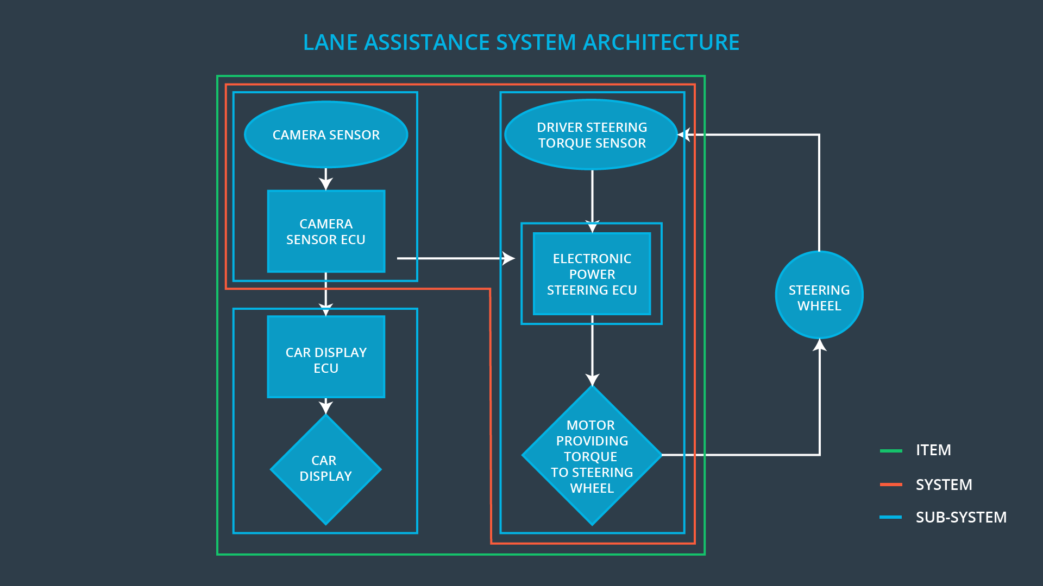

**Fig 1. Lane Assistance System Architecture  
[ image source Udacity course content]**

**What are the boundaries of the item? What subsystems are inside the item? What elements or subsystems are outside of the item?**

Item boundary for Lane Assistance System includes camera subsystem, electronic power subsystem and car display subsystem.

Steering wheel subsystem is outside of lane assistance system boundary.

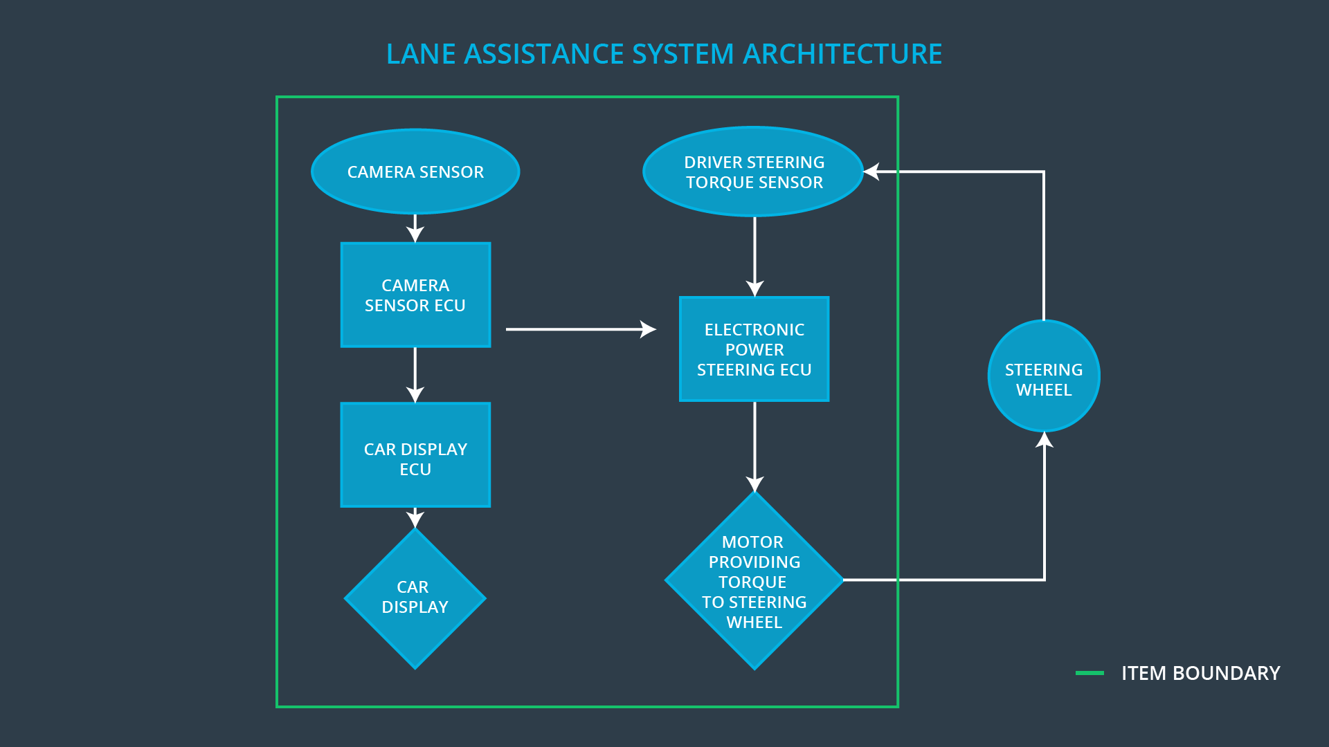

**Fig 2. Item boundary Lane Assistance System   
[ image source Udacity course content]**

# Goals and Measures

## Goals

**[Instructions:**

**Describe the major goal of this project; what are we trying to accomplish by analyzing the lane assistance functions with ISO 26262?]**

The main goal of this project to adhere to ISO 26262 standard for functional safety. This way we can understand the system and detect hazardous risk linked to lane assistance function and try to minimize to acceptable level.

## Measures

**[Instructions:**

**Fill in who will be responsible for each measure or activity. Hint: The lesson on Safety Management Roles and Responsibilities.**

**The options are:**

**All Team Members**

**Safety Manager**

**Project Manager**

**Safety Auditor**

**Safety Assessor**

**]**

|  |  |  |
| --- | --- | --- |
| Measures and Activities | Responsibility | Timeline |
| Follow safety processes | All Team Members | Constantly |
| Create and sustain a safety culture | All Team Members | Constantly |
| Coordinate and document the planned safety activities | Safety Manager | Constantly |
| Allocate resources with adequate functional safety competency | Project Manager | Within 2 weeks of start of project |
| Tailor the safety lifecycle | Safety Manager | Within 4 weeks of start of project |
| Plan the safety activities of the safety lifecycle | Safety Manager | Within 4 weeks of start of project |
| Perform regular functional safety audits | Safety Auditor | Once every 2 months |
| Perform functional safety pre-assessment prior to audit by external functional safety assessor | Safety Manager | 3 months prior to main assessment |
| Perform functional safety assessment | Safety Assessor | Conclusion of functional safety activities |

# Safety Culture

**[Instructions:**

**Describe the characteristics of your company's safety culture. How do these characteristics help maintain your safety culture. Hint: See the lesson about Safety Culture**

**]**

Below are some characteristics of our company safety culture.

* **High priority:** safety is placed at the highest priority among all other constraints such as cost, quality and productivity.
* **Accountability:** processes are enabled to ensure accountability of various tasks back to the people or teams who were involved in decision making or designing.
* **Rewards:** the organization motivates and supports the achievement of functional safety
* **Penalties:** the organization penalizes shortcuts that jeopardize safety or quality of the product.
* **Independence:** Its achieved by keeping separate teams for designing and auditing tasks.
* **Well defined processes:** company design and management processes should be clearly defined
* **Resources:** projects have necessary resources including people with appropriate skills
* **Diversity:** intellectual diversity is sought after, valued and integrated into processes
* **Communication:** communication channels encourage disclosure of problems

# Safety Lifecycle Tailoring

**[Instructions:**

**Describe which phases of the safety lifecycle are in scope and which are out of scope for this particular project. Hint: See the** **Intro section** **of this document**

**]**

For Lane Assistance System below phases are in-scope

* Product Development at the System Level
* Product Development at the Software Level

For Lane Assistance System below phases are out of scope

* Product Development at the Hardware Level
* Production and Operation

# Roles

**[Instructions:**

**This section is here for your reference. You do not need to do anything here. It is provided to help with filling out the development interface agreement section.**

**]**

|  |  |
| --- | --- |
| Role | Org |
| Functional Safety Manager- Item Level | OEM |
| Functional Safety Engineer- Item Level | OEM |
| Project Manager - Item Level | OEM |
| Functional Safety Manager- Component Level | Tier-1 |
| Functional Safety Engineer- Component Level | Tier-1 |
| Functional Safety Auditor | OEM or external |
| Functional Safety Assessor | OEM or external |

# Development Interface Agreement

**[Instructions:**

**Assume in this project that you work for the tier-1 organization as described in the above roles table. You are taking on the role of both the functional safety manager and functional safety engineer.**

**Please answer the following questions:**

1. **What is the purpose of a development interface agreement?**

A DIA (development interface agreement) defines the roles and responsibilities between companies involved in developing a product. All involved parties need to agree on the contents of the DIA before the project begins.

The DIA also specifies what evidence and work products each party will provide to prove that work was done according to the agreement.

The ultimate goal is to ensure that all parties are developing safe vehicles in compliance with ISO 26262.

1. **What will be the responsibilities of your company versus the responsibilities of the OEM? Hint: In this project, the OEM is supplying a functioning lane assistance system. Your company needs to analyze and modify the various sub-systems from a functional safety viewpoint.**

**]**

# Confirmation Measures

**[Instructions:**

**Please answer the following questions:**

1. **What is the main purpose of confirmation measures?**
2. **What is a confirmation review?**
3. **What is a functional safety audit?**
4. **What is a functional safety assessment?**

**]**

A safety plan could have other sections that we are not including here. For example, a safety plan would probably contain a complete project schedule.

There might also be a "Supporting Process Management" section that would cover "Part 8: Supporting Processes" of the ISO 26262 functional safety standard. This would include descriptions of how the company handles requirements management, change management, configuration management, documentation management, and software tool usage and confidence.

Similarly, a confirmation measures section would go into more detail about how each confirmation will be carried out.