# Digital Design

Combinational circuits

* + Output depends on current value of inputs only
  + No memory
* Sequential circuits
  + Output depends on past inputs, output
  + Have memory

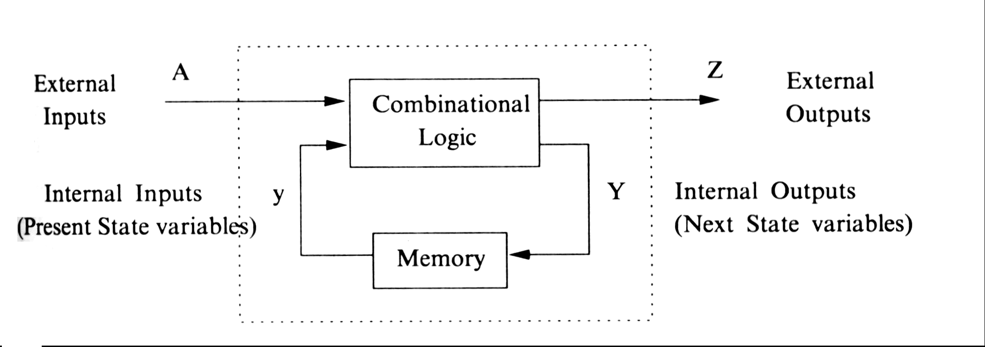

* **Carry Lookahead Adder (CLA)**
  + Propagation delay of n-bit ripple carry adder = O(n)
  + With CLA, time complexity = O(1)
  + HW complexity also rapidly increases
  + Define functions *carry generate* and *carry propagate*g_i = A_i & B_i  
    p_i = A_i ^ B_i  
      
    g_i = 1 => carry generated in stage independent of other stages  
    p_i = 1 => input carry c_i propagated to output carry c_i+1  
      
    therefore: c_i+1 = g_i | (p_i & c_i)  
    => all carry's can be got with 2 level and/or gates
  + 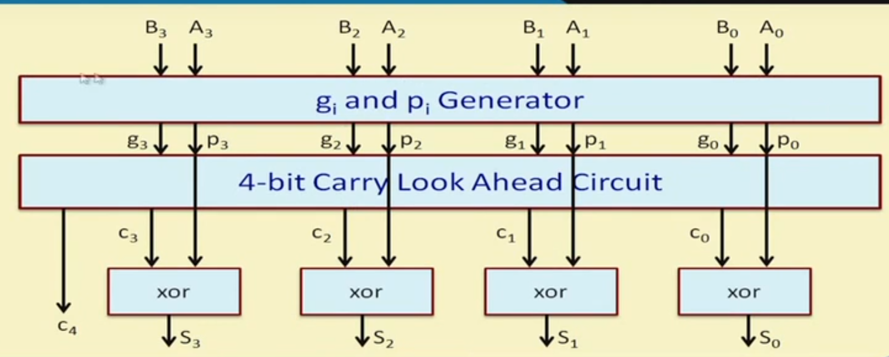

* 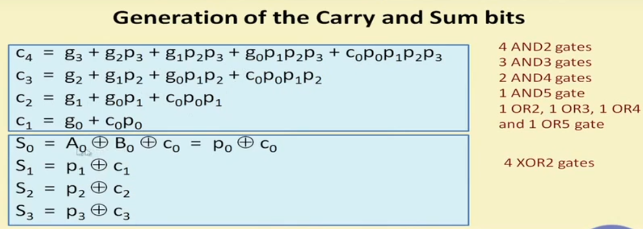

* **Priority Encoder**

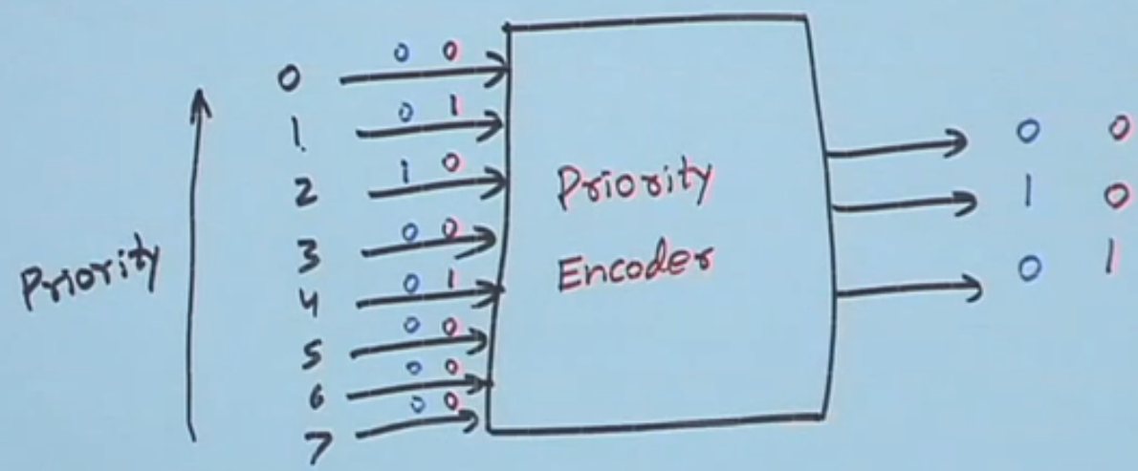

* **Ring Counter**
  + Shift register comprising of several D flip-flops
  + Eg: 4 bit ring counter:  
    Typically initialized to 1000

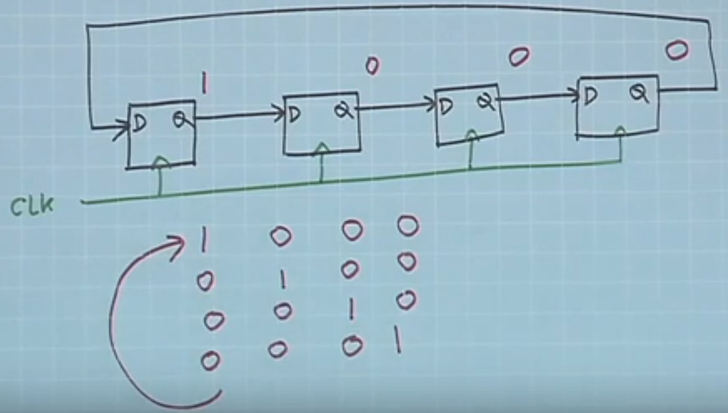

* JK FlipFLop