# Integrated Circuits

Aka IC, Chip, Microchip, Monolithic Integrated Circuit

* Large numbers of MOS transistors on a single silicon wafer
* Advantages over Discrete Circuits
  + Cost
    - Printed as a unit (not 1 transistor at a time) using photolithography - Mass production possible
    - Lesser material
  + Performance
    - Components switch quickly
    - Low power (small size, proximity)
* Disadvantage: High initial cost to design
* Usually refer to *monolithic integrated circuit*, often built on a single piece of silicon
* TTL ICs (Transistor-transistor Logic)
  + Developed in early 60's by James L Buie at TRW Inc
  + Dominant technology during 70's and 80's
* MOS (Metal-oxide-semiconductor) IC's
  + Nearly all modern IC's.
  + Built from MOSFETs
    - Ease of fabrication
    - Unlike BJTs, do not require multiple steps for p-n junction isolation of transistors
    - Easily isolated from each other
  + History
    - 1962 - Earliest experimental MOS IC (Fred Heiman & Steven Hofstein at RCA)
    - 1964 - First commercial MOS IC (General Microelectronics)
      * 120 transistor shift register (Robert Norman)
    - 1964 - MOS ICs reach higher density and lower cost than Bipolar ICs
    - Late 1960's: LSI (large scale integration) as per Moore's law - 100's of transistors on a single chip

* Pioneers  
            [Jack Kilby](https://en.wikipedia.org/wiki/Jack_Kilby) - developed the first IC (hybrid IC) in 1958, made from germanium at TI:
  + Awarded nobel prize in 2000 for his part in invention of IC

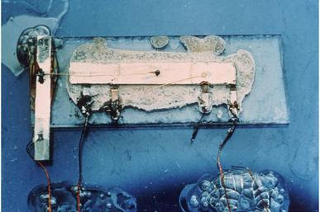

[Robert Noyce](https://en.wikipedia.org/wiki/Robert_Noyce) - invented the first true monolithic IC (Fairchild Semiconductors)

* Made of silicon,
* Fabricated using planar process
* Modern IC chips based on this version

[Jean Hoerni](https://en.wikipedia.org/wiki/Jean_Hoerni) - developed the planar process in 1959

[James L. Buie](https://en.wikipedia.org/wiki/James_L._Buie) - developed TTL IC's

[Fairchild Semiconductor](https://en.wikipedia.org/wiki/Fairchild_Semiconductor)

[Mohamed M. Atalla](https://en.wikipedia.org/wiki/Mohamed_M._Atalla) - co-inventor of MOSFET (Bell Labs)

[Dawon Kahng](https://en.wikipedia.org/wiki/Dawon_Kahng) - co-inventor of MOSFET (Bell Labs)

Bell Labs

[Kurt Lehovec](https://en.wikipedia.org/wiki/Kurt_Lehovec)

[Sprague Electric](https://en.wikipedia.org/wiki/Robert_C._Sprague_(inventor))

* 