DS745_NetworkingProjectAnalysis_BHOWMICK

Gautam

November 8, 2018

## R Markdown

This is an R Markdown document. Markdown is a simple formatting syntax for authoring HTML, PDF, and MS Word documents. For more details on using R Markdown see <http://rmarkdown.rstudio.com>.

When you click the **Knit** button a document will be generated that includes both content as well as the output of any embedded R code chunks within the document. You can embed an R code chunk like this:

## [1] FALSE

## [1] "igraph"

## IGRAPH 80f44a1 UN-- 93 323 --   
## + attr: group (v/c), name (v/c), sex (v/c), relationship_status  
## | (v/c), friend_count (v/c), mutual_friend_count (v/c), NewLabel  
## | (v/c)

## [1] 93

## [1] 0.07550257

## $membership  
## SE PH PD LN MB AP SM CB TB2 RBW NW AL DB CWB BS AC BW DZM   
## 1 1 1 1 1 2 2 3 3 3 3 1 1 1 1 1 1 1   
## KW VST TM CR AAE HRS LRS SL JJ TBC LE BCL SLL TNB MGE JLG DGT DK   
## 1 3 3 1 1 1 1 1 4 4 4 1 1 5 5 5 5 3   
## WT DSW ME MWB BD LL BB LSM KM SP LCP ADE KH ECS KT GB RBH JU   
## 3 3 3 1 1 1 1 1 1 6 6 6 6 6 6 7 7 7   
## JZ DSM BL CG CSH GGA ADL DL LBF GL CS DSF ALL CW1 DZB PW ARL LZ   
## 7 7 1 1 1 1 1 1 1 1 1 1 1 1 1 1 1 1   
## MBM RW ECW JK ASS SS1 SMH TB1 DM LBW MD TR DSG LRG SS2 JLT LSF TSL   
## 1 3 3 3 3 3 3 3 3 3 1 5 5 5 3 1 1 1   
## LBC LLB DW   
## 8 9 10   
##   
## $csize  
## [1] 47 2 20 3 7 6 5 1 1 1  
##   
## $no  
## [1] 10

## [1] 4

## [1] 4

## [1] 0.6662791

## [1] FALSE

## [1] FALSE

# Centrality & centralization

## Warning in closeness(Facebook, mode = "all", weights = NA): At  
## centrality.c:2784 :closeness centrality is not well-defined for  
## disconnected graphs

## SE PH PD LN MB   
## 0.0002305210 0.0002282584 0.0002282584 0.0002283105 0.0002287283   
## AP SM CB TB2 RBW   
## 0.0001181474 0.0001181474 0.0001464129 0.0001466491 0.0001464558   
## NW AL DB CWB BS   
## 0.0001466061 0.0002294104 0.0002273244 0.0002274278 0.0002277386   
## AC BW DZM KW VST   
## 0.0002295157 0.0002276349 0.0002273244 0.0002274278 0.0001464129   
## TM CR AAE HRS LRS   
## 0.0001467136 0.0002285192 0.0002294104 0.0002285192 0.0002285714   
## SL JJ TBC LE BCL   
## 0.0002291476 0.0001194458 0.0001194458 0.0001194458 0.0002291476   
## SLL TNB MGE JLG DGT   
## 0.0002292001 0.0001247972 0.0001248751 0.0001249063 0.0001248595   
## DK WT DSW ME MWB   
## 0.0001465846 0.0001464772 0.0001464987 0.0001466706 0.0002284148   
## BD LL BB LSM KM   
## 0.0002275313 0.0002286760 0.0002276867 0.0002285714 0.0002276867   
## SP LCP ADE KH ECS   
## 0.0001235178 0.0001235178 0.0001235178 0.0001235178 0.0001235178   
## KT GB RBH JU JZ   
## 0.0001235178 0.0001221299 0.0001220852 0.0001220852 0.0001221001   
## DSM BL CG CSH GGA   
## 0.0001221001 0.0002290426 0.0002288853 0.0002286760 0.0002290426   
## ADL DL LBF GL CS   
## 0.0002289377 0.0002290426 0.0002288853 0.0002290951 0.0002286237   
## DSF ALL CW1 DZB PW   
## 0.0002288853 0.0002289377 0.0002283626 0.0002283626 0.0002283626   
## ARL LZ MBM RW ECW   
## 0.0002283626 0.0002283626 0.0002273761 0.0001466276 0.0001463915   
## JK ASS SS1 SMH TB1   
## 0.0001467351 0.0001463915 0.0001464129 0.0001466491 0.0001466491   
## DM LBW MD TR DSG   
## 0.0001465201 0.0001463915 0.0002273761 0.0001248751 0.0001248128   
## LRG SS2 JLT LSF TSL   
## 0.0001248751 0.0001460707 0.0002274795 0.0002289902 0.0002284670   
## LBC LLB DW   
## 0.0001168770 0.0001168770 0.0001168770

## SE PH PD LN MB   
## 590.01120546 0.00000000 0.00000000 1.00000000 6.46666667   
## AP SM CB TB2 RBW   
## 0.00000000 0.00000000 0.47142857 14.99722222 2.16666667   
## NW AL DB CWB BS   
## 14.48333333 57.24919247 0.33333333 2.08333333 13.65833333   
## AC BW DZM KW VST   
## 319.57970085 8.65833333 0.00000000 1.79166667 0.00000000   
## TM CR AAE HRS LRS   
## 17.17579365 0.00000000 66.41051171 0.00000000 0.40000000   
## SL JJ TBC LE BCL   
## 7.22825785 0.00000000 0.00000000 0.00000000 5.23702409   
## SLL TNB MGE JLG DGT   
## 8.33940504 0.00000000 5.00000000 9.00000000 0.00000000   
## DK WT DSW ME MWB   
## 2.82500000 1.18809524 1.28095238 9.02579365 27.78803419   
## BD LL BB LSM KM   
## 2.41666667 36.06709957 5.05833333 44.73333333 8.20000000   
## SP LCP ADE KH ECS   
## 0.00000000 0.00000000 0.00000000 0.00000000 0.00000000   
## KT GB RBH JU JZ   
## 0.00000000 5.00000000 0.00000000 0.00000000 0.00000000   
## DSM BL CG CSH GGA   
## 0.00000000 1.64456377 0.73813131 1.15519481 2.75044400   
## ADL DL LBF GL CS   
## 0.33658009 1.64456377 0.08333333 4.24694472 0.85714286   
## DSF ALL CW1 DZB PW   
## 2.42146465 0.52107892 0.00000000 0.00000000 0.00000000   
## ARL LZ MBM RW ECW   
## 0.00000000 0.00000000 1.00000000 7.85515873 0.00000000   
## JK ASS SS1 SMH TB1   
## 71.07936508 0.00000000 9.00000000 5.77658730 5.54960317   
## DM LBW MD TR DSG   
## 0.62500000 8.00000000 5.61666667 2.00000000 0.00000000   
## LRG SS2 JLT LSF TSL   
## 2.00000000 0.50000000 1.15833333 3.86115829 0.25396825   
## LBC LLB DW   
## 0.00000000 0.00000000 0.00000000

## [1] "group" "name" "sex"   
## [4] "relationship_status" "friend_count" "mutual_friend_count"  
## [7] "NewLabel"

## character(0)

## [1] 323

## [1] 323

## [1] 93

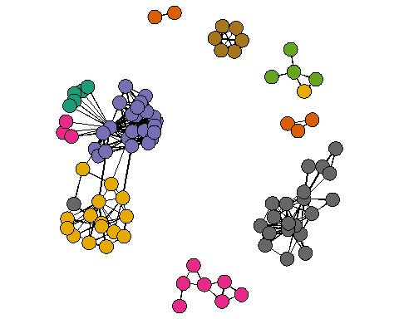

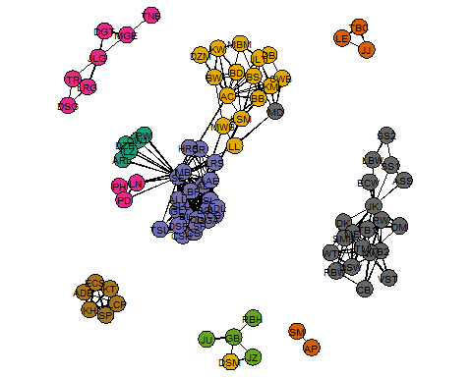

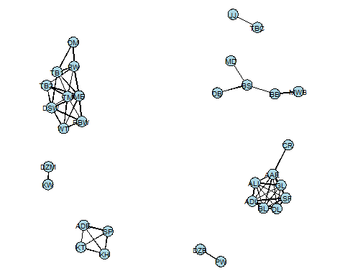

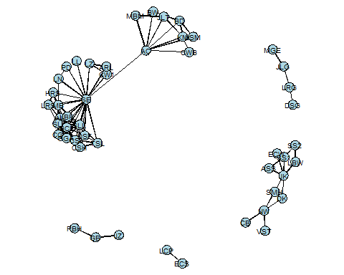

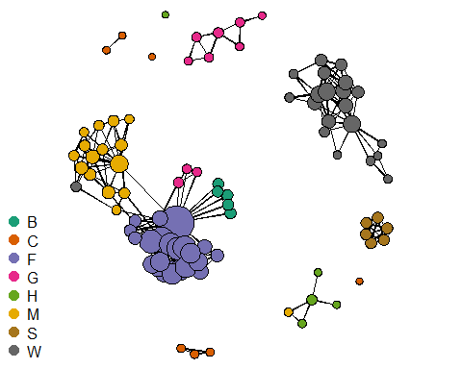

## Warning in x[use] + xhat * vertex.radius[use] + (lh * label.pad + lw) * :  
## longer object length is not a multiple of shorter object length

## Warning in y[use] + yhat * vertex.radius[use] + (lh * label.pad + lh) * :  
## longer object length is not a multiple of shorter object length

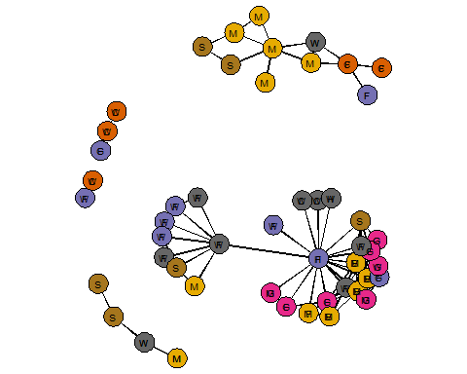

## Warning in x[use] + xhat * vertex.radius[use] + (lh * label.pad + lw) * :  
## longer object length is not a multiple of shorter object length

## Warning in y[use] + yhat * vertex.radius[use] + (lh * label.pad + lh) * :  
## longer object length is not a multiple of shorter object length

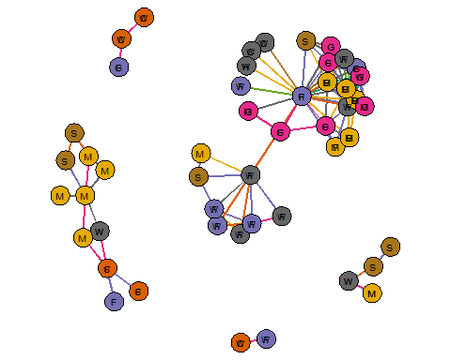

## Warning in x[use] + xhat * vertex.radius[use] + (lh * label.pad + lw) * :  
## longer object length is not a multiple of shorter object length

## Warning in y[use] + yhat * vertex.radius[use] + (lh * label.pad + lh) * :  
## longer object length is not a multiple of shorter object length

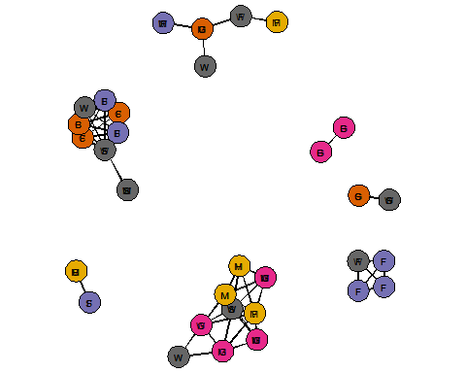

## Warning in x[use] + xhat * vertex.radius[use] + (lh * label.pad + lw) * :  
## longer object length is not a multiple of shorter object length

## Warning in y[use] + yhat * vertex.radius[use] + (lh * label.pad + lh) * :  
## longer object length is not a multiple of shorter object length

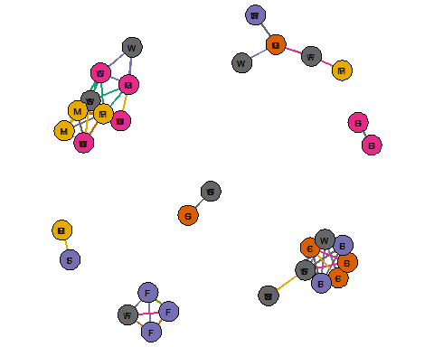

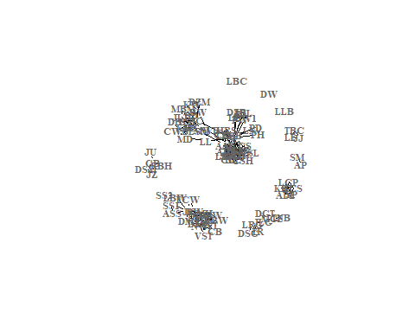

## [1] "layout_as_star"

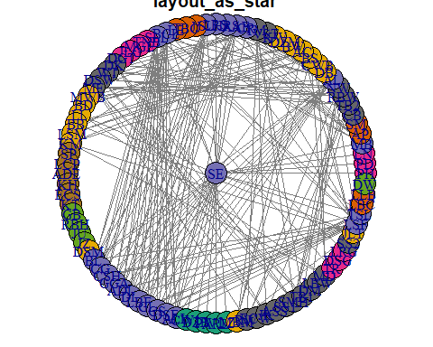

## [1] "layout_components"

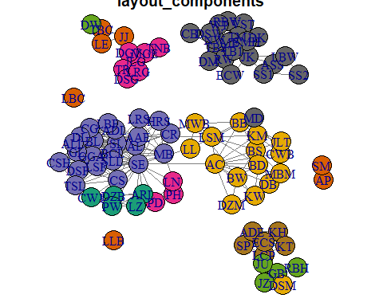

## [1] "layout_in_circle"

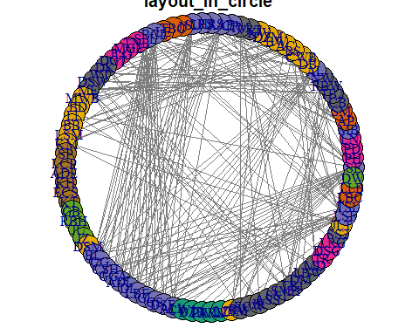

## [1] "layout_nicely"

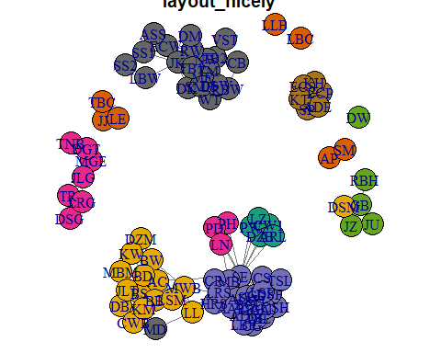

## [1] "layout_on_grid"

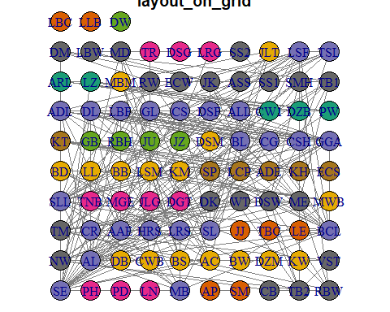

## [1] "layout_on_sphere"

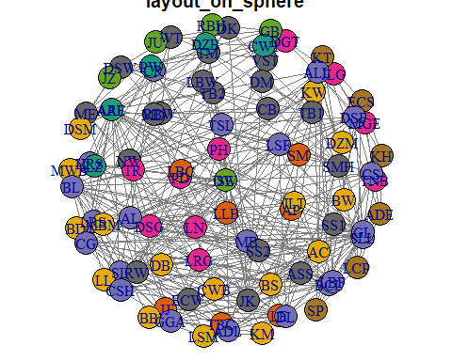

## [1] "layout_randomly"

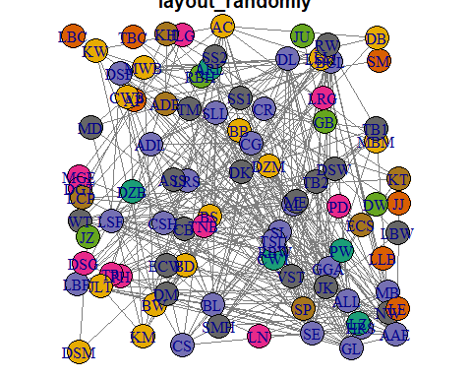

## [1] "layout_with_dh"

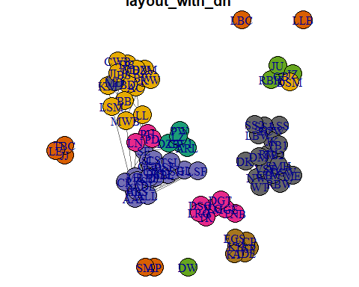

## [1] "layout_with_drl"

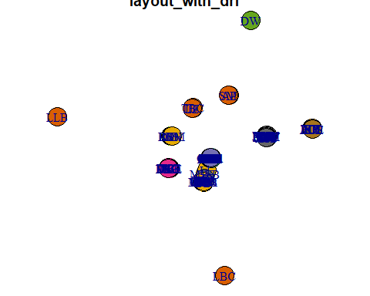

## [1] "layout_with_fr"

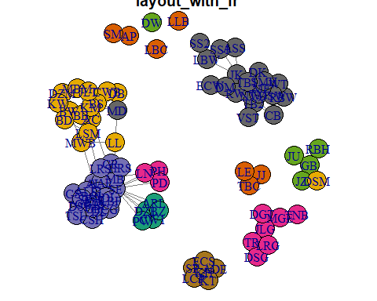

## [1] "layout_with_gem"

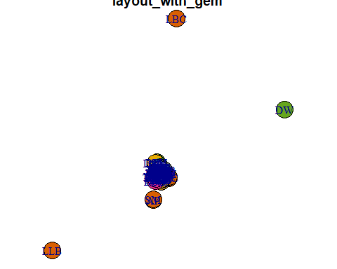

## [1] "layout_with_graphopt"

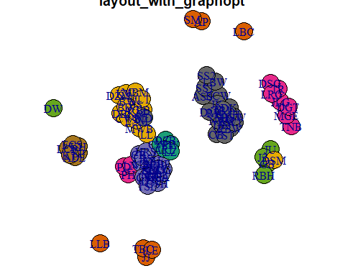

## [1] "layout_with_kk"

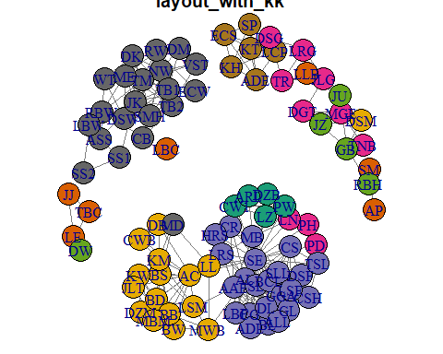

## [1] "layout_with_lgl"

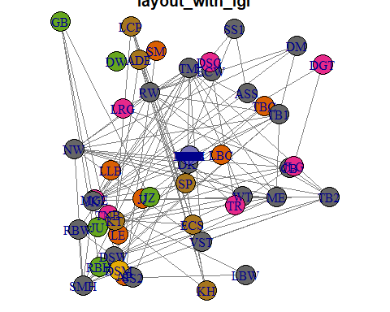

## [1] "layout_with_mds"

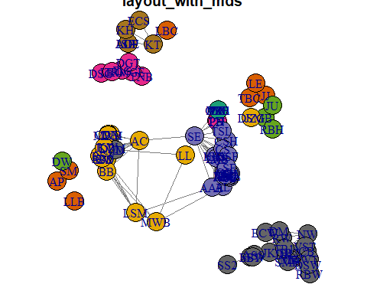

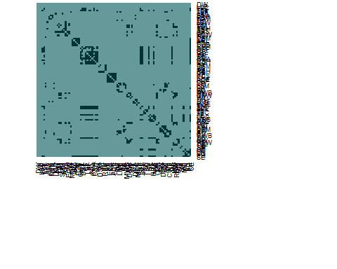

## [1] 8 9 76 78 87

## Warning in plot.window(...): "edge.color" is not a graphical parameter

## Warning in plot.window(...): "edge.arrow.mode" is not a graphical parameter

## Warning in plot.xy(xy, type, ...): "edge.color" is not a graphical  
## parameter

## Warning in plot.xy(xy, type, ...): "edge.arrow.mode" is not a graphical  
## parameter

## Warning in title(...): "edge.color" is not a graphical parameter

## Warning in title(...): "edge.arrow.mode" is not a graphical parameter

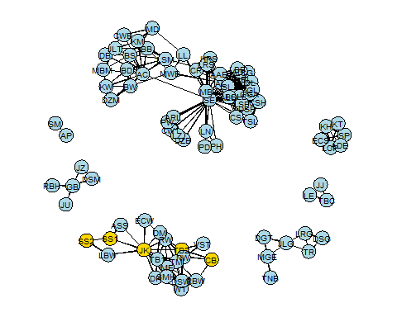

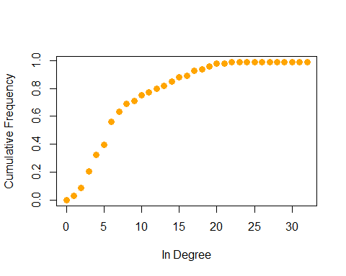

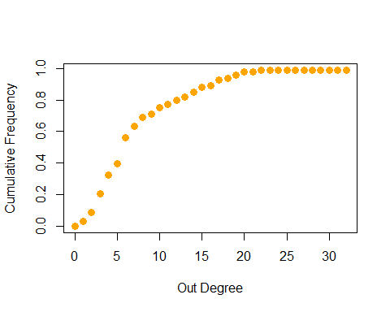

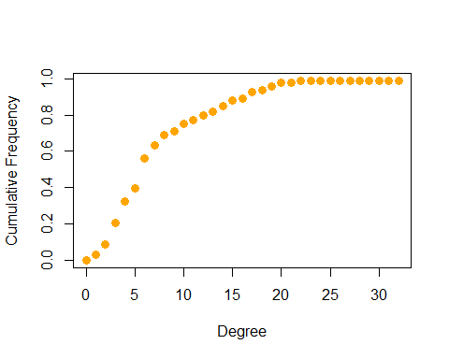

# ================ 8. Subgroups and communities ================

## [1] "igraph"

# ——->> Cliques ——–

## Warning in plot.window(...): "gmode" is not a graphical parameter

## Warning in plot.xy(xy, type, ...): "gmode" is not a graphical parameter

## Warning in title(...): "gmode" is not a graphical parameter

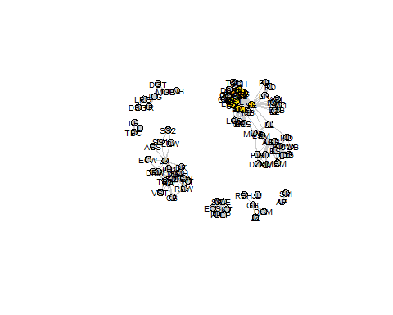 # ——->> Communities ——–

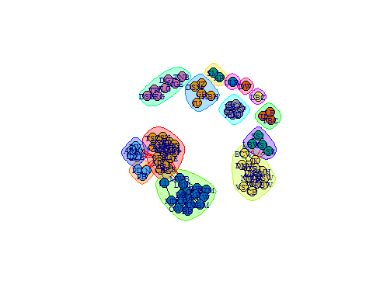

## [1] "communities"

## [1] 14

## SE PH PD LN MB AP SM CB TB2 RBW NW AL DB CWB BS AC BW DZM   
## 1 2 2 2 1 3 3 4 4 4 4 1 5 5 5 5 5 5   
## KW VST TM CR AAE HRS LRS SL JJ TBC LE BCL SLL TNB MGE JLG DGT DK   
## 5 4 4 1 1 1 1 1 6 6 6 1 1 7 7 7 7 4   
## WT DSW ME MWB BD LL BB LSM KM SP LCP ADE KH ECS KT GB RBH JU   
## 4 4 4 5 5 5 5 5 5 8 8 8 8 8 8 9 9 9   
## JZ DSM BL CG CSH GGA ADL DL LBF GL CS DSF ALL CW1 DZB PW ARL LZ   
## 9 9 1 1 1 1 1 1 1 1 1 1 1 10 10 10 10 10   
## MBM RW ECW JK ASS SS1 SMH TB1 DM LBW MD TR DSG LRG SS2 JLT LSF TSL   
## 5 4 4 4 11 11 4 4 4 11 5 7 7 7 11 5 1 1   
## LBC LLB DW   
## 12 13 14

## [1] 0.6313681

## SE PH PD LN MB AP SM CB TB2 RBW NW AL DB CWB BS AC BW DZM   
## 6 6 6 6 6 9 9 3 3 3 3 6 4 4 4 4 4 4   
## KW VST TM CR AAE HRS LRS SL JJ TBC LE BCL SLL TNB MGE JLG DGT DK   
## 4 3 3 6 6 6 6 6 8 8 8 6 6 7 7 7 7 3   
## WT DSW ME MWB BD LL BB LSM KM SP LCP ADE KH ECS KT GB RBH JU   
## 3 3 3 4 4 4 4 4 4 2 2 2 2 2 2 5 5 5   
## JZ DSM BL CG CSH GGA ADL DL LBF GL CS DSF ALL CW1 DZB PW ARL LZ   
## 5 5 6 6 6 6 6 6 6 6 6 6 6 1 1 1 1 1   
## MBM RW ECW JK ASS SS1 SMH TB1 DM LBW MD TR DSG LRG SS2 JLT LSF TSL   
## 4 3 3 3 3 3 3 3 3 3 4 7 7 7 3 4 6 6   
## LBC LLB DW   
## 10 11 12

## [1] 0.6321301

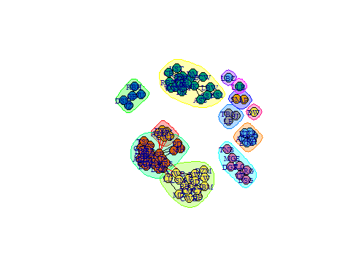

## SE PH PD LN MB AP SM CB TB2 RBW NW AL DB CWB BS AC BW DZM   
## 1 1 1 1 1 2 2 3 3 3 3 1 4 4 4 4 4 4   
## KW VST TM CR AAE HRS LRS SL JJ TBC LE BCL SLL TNB MGE JLG DGT DK   
## 4 3 3 1 1 1 1 1 5 5 5 1 1 6 6 6 6 3   
## WT DSW ME MWB BD LL BB LSM KM SP LCP ADE KH ECS KT GB RBH JU   
## 3 3 3 4 4 4 4 4 4 7 7 7 7 7 7 8 8 8   
## JZ DSM BL CG CSH GGA ADL DL LBF GL CS DSF ALL CW1 DZB PW ARL LZ   
## 8 8 1 1 1 1 1 1 1 1 1 1 1 9 9 9 9 9   
## MBM RW ECW JK ASS SS1 SMH TB1 DM LBW MD TR DSG LRG SS2 JLT LSF TSL   
## 4 3 3 3 3 3 3 3 3 3 4 6 6 6 3 4 1 1   
## LBC LLB DW   
## 10 11 12

## [1] 0.6321301

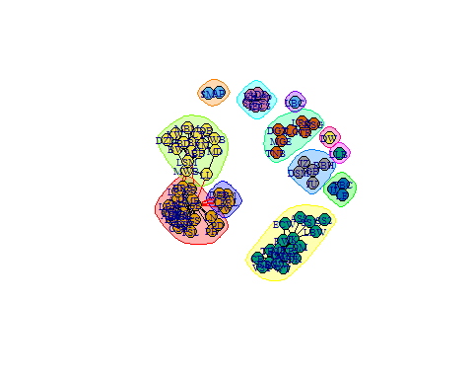

## SE PH PD LN MB AP SM CB TB2 RBW NW AL DB CWB BS AC BW DZM   
## 1 11 11 11 1 2 2 3 3 3 3 1 12 12 12 12 12 12   
## KW VST TM CR AAE HRS LRS SL JJ TBC LE BCL SLL TNB MGE JLG DGT DK   
## 12 3 3 1 1 1 1 1 4 4 4 1 1 5 5 5 5 3   
## WT DSW ME MWB BD LL BB LSM KM SP LCP ADE KH ECS KT GB RBH JU   
## 3 3 3 12 12 12 12 12 12 6 6 6 6 6 6 7 7 7   
## JZ DSM BL CG CSH GGA ADL DL LBF GL CS DSF ALL CW1 DZB PW ARL LZ   
## 7 7 1 1 1 1 1 1 1 1 1 1 1 13 13 13 13 13   
## MBM RW ECW JK ASS SS1 SMH TB1 DM LBW MD TR DSG LRG SS2 JLT LSF TSL   
## 12 3 3 3 3 3 3 3 3 3 12 5 5 5 3 12 1 1   
## LBC LLB DW   
## 8 9 10

## [1] 0.6356095

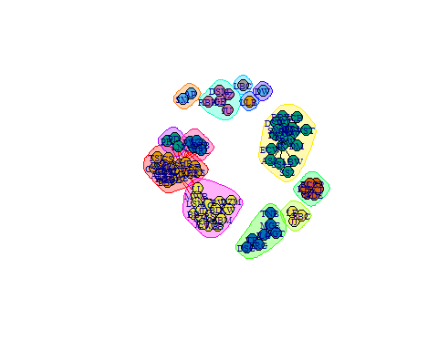

## SE PH PD LN MB AP SM CB TB2 RBW NW AL DB CWB BS AC BW DZM   
## 3 1 1 1 3 2 2 9 9 9 9 3 5 5 5 5 5 5   
## KW VST TM CR AAE HRS LRS SL JJ TBC LE BCL SLL TNB MGE JLG DGT DK   
## 5 9 9 3 3 3 3 3 4 4 4 3 3 10 10 10 10 9   
## WT DSW ME MWB BD LL BB LSM KM SP LCP ADE KH ECS KT GB RBH JU   
## 9 9 9 5 5 5 5 5 5 6 6 6 6 6 6 7 7 7   
## JZ DSM BL CG CSH GGA ADL DL LBF GL CS DSF ALL CW1 DZB PW ARL LZ   
## 7 7 3 3 3 3 3 3 3 3 3 3 3 8 8 8 8 8   
## MBM RW ECW JK ASS SS1 SMH TB1 DM LBW MD TR DSG LRG SS2 JLT LSF TSL   
## 5 9 9 9 9 9 9 9 9 9 5 10 10 10 9 5 3 3   
## LBC LLB DW   
## 11 12 13

## [1] 0.6356095

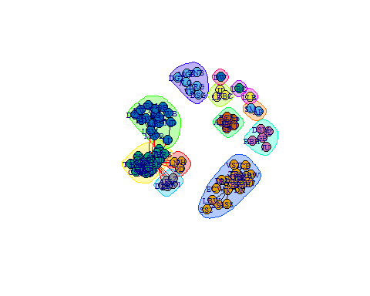

## SE PH PD LN MB AP SM CB TB2 RBW NW AL DB CWB BS AC BW DZM   
## 1 1 1 1 1 2 2 3 3 3 3 4 5 5 5 5 5 5   
## KW VST TM CR AAE HRS LRS SL JJ TBC LE BCL SLL TNB MGE JLG DGT DK   
## 5 3 3 1 4 1 1 4 6 6 6 4 4 7 7 7 7 3   
## WT DSW ME MWB BD LL BB LSM KM SP LCP ADE KH ECS KT GB RBH JU   
## 3 3 3 5 5 5 5 5 5 8 8 8 8 8 8 9 9 9   
## JZ DSM BL CG CSH GGA ADL DL LBF GL CS DSF ALL CW1 DZB PW ARL LZ   
## 9 9 4 4 4 4 4 4 4 4 4 4 4 1 1 1 1 1   
## MBM RW ECW JK ASS SS1 SMH TB1 DM LBW MD TR DSG LRG SS2 JLT LSF TSL   
## 5 3 3 3 3 3 3 3 3 3 5 7 7 7 3 5 4 4   
## LBC LLB DW   
## 10 11 12

## [1] 0.6380968

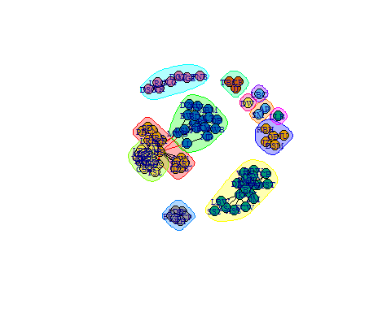

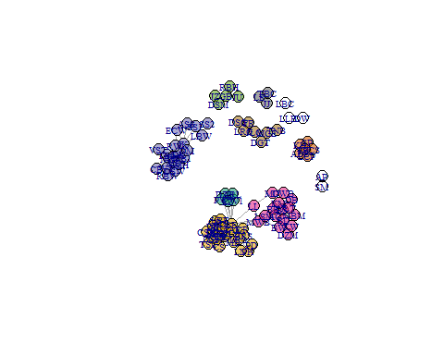

# K-core decomposition



## Starting maximum pseudolikelihood estimation (MPLE):

## Evaluating the predictor and response matrix.

## Maximizing the pseudolikelihood.

## Finished MPLE.

## Stopping at the initial estimate.

## Evaluating log-likelihood at the estimate.

## [1] "ergm"

##   
## ==========================  
## Summary of model fit  
## ==========================  
##   
## Formula: facebook.net ~ edges  
##   
## Iterations: 6 out of 20   
##   
## Monte Carlo MLE Results:  
## Estimate Std. Error MCMC % z value Pr(>|z|)   
## edges -2.50508 0.05787 0 -43.29 <1e-04 ***  
## ---  
## Signif. codes: 0 '***' 0.001 '**' 0.01 '*' 0.05 '.' 0.1 ' ' 1  
##   
## Null Deviance: 5931 on 4278 degrees of freedom  
## Residual Deviance: 2290 on 4277 degrees of freedom  
##   
## AIC: 2292 BIC: 2298 (Smaller is better.)

## edges   
## 0.07550257

## Starting maximum pseudolikelihood estimation (MPLE):

## Evaluating the predictor and response matrix.

## Maximizing the pseudolikelihood.

## Finished MPLE.

## Stopping at the initial estimate.

## Evaluating log-likelihood at the estimate.

## [1] "ergm"

##   
## ==========================  
## Summary of model fit  
## ==========================  
##   
## Formula: facebook.net ~ edges + nodefactor("sex")  
##   
## Iterations: 6 out of 20   
##   
## Monte Carlo MLE Results:  
## Estimate Std. Error MCMC % z value Pr(>|z|)   
## edges -2.49401 0.09047 0 -27.567 <1e-04 ***  
## nodefactor.sex.male -0.01324 0.08345 0 -0.159 0.874   
## ---  
## Signif. codes: 0 '***' 0.001 '**' 0.01 '*' 0.05 '.' 0.1 ' ' 1  
##   
## Null Deviance: 5931 on 4278 degrees of freedom  
## Residual Deviance: 2290 on 4276 degrees of freedom  
##   
## AIC: 2294 BIC: 2307 (Smaller is better.)

## edges nodefactor.sex.male   
## 0.07627902 0.49668922

## Starting maximum pseudolikelihood estimation (MPLE):

## Evaluating the predictor and response matrix.

## Maximizing the pseudolikelihood.

## Finished MPLE.

## Stopping at the initial estimate.

## Evaluating log-likelihood at the estimate.

## [1] "ergm"

##   
## ==========================  
## Summary of model fit  
## ==========================  
##   
## Formula: facebook.net ~ edges + nodefactor("group") + nodefactor("sex")  
##   
## Iterations: 6 out of 20   
##   
## Monte Carlo MLE Results:  
## Estimate Std. Error MCMC % z value Pr(>|z|)   
## edges -3.31465 0.42187 0 -7.857 < 1e-04 ***  
## nodefactor.group.C -1.55095 0.41423 0 -3.744 0.000181 ***  
## nodefactor.group.F 1.25223 0.22037 0 5.682 < 1e-04 ***  
## nodefactor.group.G -0.62207 0.28552 0 -2.179 0.029354 *   
## nodefactor.group.H -1.19128 0.41589 0 -2.864 0.004178 **   
## nodefactor.group.M 0.07725 0.23825 0 0.324 0.745758   
## nodefactor.group.S -0.01697 0.28466 0 -0.060 0.952466   
## nodefactor.group.W 0.23209 0.22931 0 1.012 0.311492   
## nodefactor.sex.male 0.06375 0.08852 0 0.720 0.471385   
## ---  
## Signif. codes: 0 '***' 0.001 '**' 0.01 '*' 0.05 '.' 0.1 ' ' 1  
##   
## Null Deviance: 5931 on 4278 degrees of freedom  
## Residual Deviance: 1989 on 4269 degrees of freedom  
##   
## AIC: 2007 BIC: 2064 (Smaller is better.)

## edges nodefactor.group.C nodefactor.group.F   
## 0.03507216 0.17494864 0.77768632   
## nodefactor.group.G nodefactor.group.H nodefactor.group.M   
## 0.34931024 0.23302971 0.51930254   
## nodefactor.group.S nodefactor.group.W nodefactor.sex.male   
## 0.49575794 0.55776277 0.51593329

## Warning: You appear to be calling simulate.formula() directly.  
## simulate.formula() is a method, and will not be exported in a future  
## version of 'ergm'. Use simulate() instead, or getS3method() if absolutely  
## necessary.

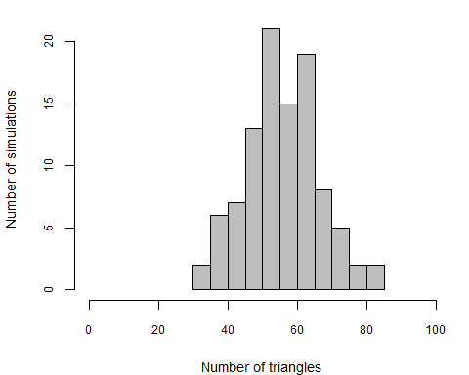

## Starting MCMC iterations to generate 1 network

## Finished simulation 1 of 1.

## Starting MCMC iterations to generate 1 network

## Finished simulation 1 of 1.

## Starting MCMC iterations to generate 1 network

## Finished simulation 1 of 1.

## edges degree0 degree1 degree2 degree3 degree4 degree5 triangle  
## Facebok 323 3 5 11 11 7 15 764  
## Null 330 0 1 0 1 14 10 53  
## Model(I) 297 8 2 11 9 11 11 128  
## Model(II) 317 0 0 3 2 9 13 47

## Starting GOF for the given ERGM formula.

## Calculating observed network statistics.

## Starting simulations.

## Sim 1 of 100: Starting MCMC iterations to generate 1 network   
## Finished simulation 1 of 1.  
## Sim 2 of 100: Starting MCMC iterations to generate 1 network   
## Finished simulation 1 of 1.  
## Sim 3 of 100: Starting MCMC iterations to generate 1 network   
## Finished simulation 1 of 1.  
## Sim 4 of 100: Starting MCMC iterations to generate 1 network   
## Finished simulation 1 of 1.  
## Sim 5 of 100: Starting MCMC iterations to generate 1 network   
## Finished simulation 1 of 1.  
## Sim 6 of 100: Starting MCMC iterations to generate 1 network   
## Finished simulation 1 of 1.  
## Sim 7 of 100: Starting MCMC iterations to generate 1 network   
## Finished simulation 1 of 1.  
## Sim 8 of 100: Starting MCMC iterations to generate 1 network   
## Finished simulation 1 of 1.  
## Sim 9 of 100: Starting MCMC iterations to generate 1 network   
## Finished simulation 1 of 1.  
## Sim 10 of 100: Starting MCMC iterations to generate 1 network   
## Finished simulation 1 of 1.  
## Sim 11 of 100: Starting MCMC iterations to generate 1 network   
## Finished simulation 1 of 1.  
## Sim 12 of 100: Starting MCMC iterations to generate 1 network   
## Finished simulation 1 of 1.  
## Sim 13 of 100: Starting MCMC iterations to generate 1 network   
## Finished simulation 1 of 1.  
## Sim 14 of 100: Starting MCMC iterations to generate 1 network   
## Finished simulation 1 of 1.  
## Sim 15 of 100: Starting MCMC iterations to generate 1 network   
## Finished simulation 1 of 1.  
## Sim 16 of 100: Starting MCMC iterations to generate 1 network   
## Finished simulation 1 of 1.  
## Sim 17 of 100: Starting MCMC iterations to generate 1 network   
## Finished simulation 1 of 1.  
## Sim 18 of 100: Starting MCMC iterations to generate 1 network   
## Finished simulation 1 of 1.  
## Sim 19 of 100: Starting MCMC iterations to generate 1 network   
## Finished simulation 1 of 1.  
## Sim 20 of 100: Starting MCMC iterations to generate 1 network   
## Finished simulation 1 of 1.  
## Sim 21 of 100: Starting MCMC iterations to generate 1 network   
## Finished simulation 1 of 1.  
## Sim 22 of 100: Starting MCMC iterations to generate 1 network   
## Finished simulation 1 of 1.  
## Sim 23 of 100: Starting MCMC iterations to generate 1 network   
## Finished simulation 1 of 1.  
## Sim 24 of 100: Starting MCMC iterations to generate 1 network   
## Finished simulation 1 of 1.  
## Sim 25 of 100: Starting MCMC iterations to generate 1 network   
## Finished simulation 1 of 1.  
## Sim 26 of 100: Starting MCMC iterations to generate 1 network   
## Finished simulation 1 of 1.  
## Sim 27 of 100: Starting MCMC iterations to generate 1 network   
## Finished simulation 1 of 1.  
## Sim 28 of 100: Starting MCMC iterations to generate 1 network   
## Finished simulation 1 of 1.  
## Sim 29 of 100: Starting MCMC iterations to generate 1 network   
## Finished simulation 1 of 1.  
## Sim 30 of 100: Starting MCMC iterations to generate 1 network   
## Finished simulation 1 of 1.  
## Sim 31 of 100: Starting MCMC iterations to generate 1 network   
## Finished simulation 1 of 1.  
## Sim 32 of 100: Starting MCMC iterations to generate 1 network   
## Finished simulation 1 of 1.  
## Sim 33 of 100: Starting MCMC iterations to generate 1 network   
## Finished simulation 1 of 1.  
## Sim 34 of 100: Starting MCMC iterations to generate 1 network   
## Finished simulation 1 of 1.  
## Sim 35 of 100: Starting MCMC iterations to generate 1 network   
## Finished simulation 1 of 1.  
## Sim 36 of 100: Starting MCMC iterations to generate 1 network   
## Finished simulation 1 of 1.  
## Sim 37 of 100: Starting MCMC iterations to generate 1 network   
## Finished simulation 1 of 1.  
## Sim 38 of 100: Starting MCMC iterations to generate 1 network   
## Finished simulation 1 of 1.  
## Sim 39 of 100: Starting MCMC iterations to generate 1 network   
## Finished simulation 1 of 1.  
## Sim 40 of 100: Starting MCMC iterations to generate 1 network   
## Finished simulation 1 of 1.  
## Sim 41 of 100: Starting MCMC iterations to generate 1 network   
## Finished simulation 1 of 1.  
## Sim 42 of 100: Starting MCMC iterations to generate 1 network   
## Finished simulation 1 of 1.  
## Sim 43 of 100: Starting MCMC iterations to generate 1 network   
## Finished simulation 1 of 1.  
## Sim 44 of 100: Starting MCMC iterations to generate 1 network   
## Finished simulation 1 of 1.  
## Sim 45 of 100: Starting MCMC iterations to generate 1 network   
## Finished simulation 1 of 1.  
## Sim 46 of 100: Starting MCMC iterations to generate 1 network   
## Finished simulation 1 of 1.  
## Sim 47 of 100: Starting MCMC iterations to generate 1 network   
## Finished simulation 1 of 1.  
## Sim 48 of 100: Starting MCMC iterations to generate 1 network   
## Finished simulation 1 of 1.  
## Sim 49 of 100: Starting MCMC iterations to generate 1 network   
## Finished simulation 1 of 1.  
## Sim 50 of 100: Starting MCMC iterations to generate 1 network   
## Finished simulation 1 of 1.  
## Sim 51 of 100: Starting MCMC iterations to generate 1 network   
## Finished simulation 1 of 1.  
## Sim 52 of 100: Starting MCMC iterations to generate 1 network   
## Finished simulation 1 of 1.  
## Sim 53 of 100: Starting MCMC iterations to generate 1 network   
## Finished simulation 1 of 1.  
## Sim 54 of 100: Starting MCMC iterations to generate 1 network   
## Finished simulation 1 of 1.  
## Sim 55 of 100: Starting MCMC iterations to generate 1 network   
## Finished simulation 1 of 1.  
## Sim 56 of 100: Starting MCMC iterations to generate 1 network   
## Finished simulation 1 of 1.  
## Sim 57 of 100: Starting MCMC iterations to generate 1 network   
## Finished simulation 1 of 1.  
## Sim 58 of 100: Starting MCMC iterations to generate 1 network   
## Finished simulation 1 of 1.  
## Sim 59 of 100: Starting MCMC iterations to generate 1 network   
## Finished simulation 1 of 1.  
## Sim 60 of 100: Starting MCMC iterations to generate 1 network   
## Finished simulation 1 of 1.  
## Sim 61 of 100: Starting MCMC iterations to generate 1 network   
## Finished simulation 1 of 1.  
## Sim 62 of 100: Starting MCMC iterations to generate 1 network   
## Finished simulation 1 of 1.  
## Sim 63 of 100: Starting MCMC iterations to generate 1 network   
## Finished simulation 1 of 1.  
## Sim 64 of 100: Starting MCMC iterations to generate 1 network   
## Finished simulation 1 of 1.  
## Sim 65 of 100: Starting MCMC iterations to generate 1 network   
## Finished simulation 1 of 1.  
## Sim 66 of 100: Starting MCMC iterations to generate 1 network   
## Finished simulation 1 of 1.  
## Sim 67 of 100: Starting MCMC iterations to generate 1 network   
## Finished simulation 1 of 1.  
## Sim 68 of 100: Starting MCMC iterations to generate 1 network   
## Finished simulation 1 of 1.  
## Sim 69 of 100: Starting MCMC iterations to generate 1 network   
## Finished simulation 1 of 1.  
## Sim 70 of 100: Starting MCMC iterations to generate 1 network   
## Finished simulation 1 of 1.  
## Sim 71 of 100: Starting MCMC iterations to generate 1 network   
## Finished simulation 1 of 1.  
## Sim 72 of 100: Starting MCMC iterations to generate 1 network   
## Finished simulation 1 of 1.  
## Sim 73 of 100: Starting MCMC iterations to generate 1 network   
## Finished simulation 1 of 1.  
## Sim 74 of 100: Starting MCMC iterations to generate 1 network   
## Finished simulation 1 of 1.  
## Sim 75 of 100: Starting MCMC iterations to generate 1 network   
## Finished simulation 1 of 1.  
## Sim 76 of 100: Starting MCMC iterations to generate 1 network   
## Finished simulation 1 of 1.  
## Sim 77 of 100: Starting MCMC iterations to generate 1 network   
## Finished simulation 1 of 1.  
## Sim 78 of 100: Starting MCMC iterations to generate 1 network   
## Finished simulation 1 of 1.  
## Sim 79 of 100: Starting MCMC iterations to generate 1 network   
## Finished simulation 1 of 1.  
## Sim 80 of 100: Starting MCMC iterations to generate 1 network   
## Finished simulation 1 of 1.  
## Sim 81 of 100: Starting MCMC iterations to generate 1 network   
## Finished simulation 1 of 1.  
## Sim 82 of 100: Starting MCMC iterations to generate 1 network   
## Finished simulation 1 of 1.  
## Sim 83 of 100: Starting MCMC iterations to generate 1 network   
## Finished simulation 1 of 1.  
## Sim 84 of 100: Starting MCMC iterations to generate 1 network   
## Finished simulation 1 of 1.  
## Sim 85 of 100: Starting MCMC iterations to generate 1 network   
## Finished simulation 1 of 1.  
## Sim 86 of 100: Starting MCMC iterations to generate 1 network   
## Finished simulation 1 of 1.  
## Sim 87 of 100: Starting MCMC iterations to generate 1 network   
## Finished simulation 1 of 1.  
## Sim 88 of 100: Starting MCMC iterations to generate 1 network   
## Finished simulation 1 of 1.  
## Sim 89 of 100: Starting MCMC iterations to generate 1 network   
## Finished simulation 1 of 1.  
## Sim 90 of 100: Starting MCMC iterations to generate 1 network   
## Finished simulation 1 of 1.  
## Sim 91 of 100: Starting MCMC iterations to generate 1 network   
## Finished simulation 1 of 1.  
## Sim 92 of 100: Starting MCMC iterations to generate 1 network   
## Finished simulation 1 of 1.  
## Sim 93 of 100: Starting MCMC iterations to generate 1 network   
## Finished simulation 1 of 1.  
## Sim 94 of 100: Starting MCMC iterations to generate 1 network   
## Finished simulation 1 of 1.  
## Sim 95 of 100: Starting MCMC iterations to generate 1 network   
## Finished simulation 1 of 1.  
## Sim 96 of 100: Starting MCMC iterations to generate 1 network   
## Finished simulation 1 of 1.  
## Sim 97 of 100: Starting MCMC iterations to generate 1 network   
## Finished simulation 1 of 1.  
## Sim 98 of 100: Starting MCMC iterations to generate 1 network   
## Finished simulation 1 of 1.  
## Sim 99 of 100: Starting MCMC iterations to generate 1 network   
## Finished simulation 1 of 1.  
## Sim 100 of 100: Starting MCMC iterations to generate 1 network   
## Finished simulation 1 of 1.

##   
## Goodness-of-fit for degree   
##   
## obs min mean max MC p-value  
## 0 3 0 3.97 9 0.90  
## 1 5 1 6.91 13 0.48  
## 2 11 2 7.43 13 0.22  
## 3 11 4 8.74 15 0.44  
## 4 7 4 9.18 17 0.62  
## 5 15 3 9.63 16 0.14  
## 6 7 2 8.15 15 0.82  
## 7 5 2 6.64 13 0.76  
## 8 2 0 4.66 12 0.36  
## 9 4 0 3.37 9 0.74  
## 10 2 0 2.66 7 1.00  
## 11 2 0 2.51 8 1.00  
## 12 2 0 2.53 8 1.00  
## 13 3 0 2.56 6 0.86  
## 14 3 0 2.63 6 0.96  
## 15 1 1 2.79 6 0.44  
## 16 3 0 2.53 7 0.98  
## 17 1 0 2.00 7 0.80  
## 18 2 0 1.58 5 0.94  
## 19 2 0 1.01 4 0.50  
## 20 0 0 0.63 3 1.00  
## 21 1 0 0.41 3 0.66  
## 22 0 0 0.23 3 1.00  
## 23 0 0 0.11 2 1.00  
## 24 0 0 0.08 1 1.00  
## 25 0 0 0.05 1 1.00  
## 27 0 0 0.01 1 1.00  
## 32 1 0 0.00 0 0.00  
##   
## Goodness-of-fit for edgewise shared partner   
##   
## obs min mean max MC p-value  
## esp0 16 84 105.85 134 0  
## esp1 29 62 89.57 123 0  
## esp2 26 31 59.08 88 0  
## esp3 17 21 35.34 55 0  
## esp4 48 8 17.92 34 0  
## esp5 27 0 9.53 26 0  
## esp6 22 0 3.93 16 0  
## esp7 8 0 1.53 6 0  
## esp8 9 0 0.49 4 0  
## esp9 6 0 0.07 1 0  
## esp10 6 0 0.03 1 0  
## esp11 12 0 0.02 1 0  
## esp12 30 0 0.00 0 0  
## esp13 24 0 0.00 0 0  
## esp14 15 0 0.00 0 0  
## esp15 14 0 0.00 0 0  
## esp16 6 0 0.00 0 0  
## esp17 6 0 0.00 0 0  
## esp18 1 0 0.00 0 0  
## esp19 1 0 0.00 0 0  
##   
## Goodness-of-fit for dyadwise shared partner   
##   
## obs min mean max MC p-value  
## dsp0 3404 2128 2415.59 2681 0.00  
## dsp1 402 938 1093.30 1246 0.00  
## dsp2 92 358 448.57 546 0.00  
## dsp3 63 123 187.63 256 0.00  
## dsp4 74 42 77.16 118 0.92  
## dsp5 39 14 34.74 67 0.68  
## dsp6 42 1 13.50 41 0.00  
## dsp7 13 0 4.98 23 0.08  
## dsp8 14 0 1.86 11 0.00  
## dsp9 10 0 0.53 5 0.00  
## dsp10 10 0 0.11 2 0.00  
## dsp11 16 0 0.03 1 0.00  
## dsp12 31 0 0.00 0 0.00  
## dsp13 24 0 0.00 0 0.00  
## dsp14 16 0 0.00 0 0.00  
## dsp15 14 0 0.00 0 0.00  
## dsp16 6 0 0.00 0 0.00  
## dsp17 6 0 0.00 0 0.00  
## dsp18 1 0 0.00 0 0.00  
## dsp19 1 0 0.00 0 0.00  
##   
## Goodness-of-fit for model statistics   
##   
## obs min mean max MC p-value  
## edges 323 281 323.36 357 0.98  
## nodefactor.group.C 8 3 7.97 16 1.00  
## nodefactor.group.F 331 289 333.11 384 1.00  
## nodefactor.group.G 28 18 28.57 42 0.94  
## nodefactor.group.H 8 3 8.26 16 1.00  
## nodefactor.group.M 86 58 85.33 106 1.00  
## nodefactor.group.S 30 18 29.92 52 1.00  
## nodefactor.group.W 130 90 129.40 156 0.96  
## nodefactor.sex.male 269 219 268.02 314 1.00

