Git: fatal: The remote end hung up unexpectedly solution

在我们执行git push时可能会碰到下面这个的情况

Counting objects: 61350, done.

Delta compression using up to 2 threads.

Compressing objects: 100% (20587/20587), done.

efatal: The remote end hung up unexpecterror: RPC failed; HTTP 413 curl 22 The requested U

RL returned error: 413 Request Entity Too Large

dly

Writing objects: 100% (61350/61350), 4.32 GiB | 657.00 KiB/s, done.

Total 61350 (delta 39636), reused 59367 (delta 37653)

fatal: The remote end hung up unexpectedly

Everything up-to-date

我们可以用下面两个解决方案来处理

solution 1: use command

git config --global http.postBuffer 524288000

# some comments below report having to double the value:

git config --global http.postBuffer 1048576000

solution 2: modify the profile

.git/config 文件中加入

[http]

postBuffer = 524288000

hung up solution:

执行上面的方案后我们也可能会碰到没有报hung up 错误, 但一直卡主问题, 如下:

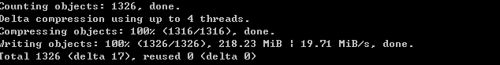

解决方案是:

添加sendpack.sideband属性并置为false

全局的：git config –global sendpack.sideband false

仓库的：git config –local sendpack.sideband false

然后提交, 如果还是没用. 可以先执行git pull虽然当前明明已经是up-to-date, 然后git push

————————————————

版权声明：本文为CSDN博主「wangliyao518」的原创文章，遵循CC 4.0 BY-SA版权协议，转载请附上原文出处链接及本声明。

原文链接：https://blog.csdn.net/wangliyao518/java/article/details/84237016