1.Rms上报扫描结果

{"id":"*","msgType":"com.geekplus.athena.api.msg.callback.WarehouseCallbackMsg","request":{"header":{"clientCode":"GEEK","channelId":"*","warehouseCode":"GEEK","requestId":"fc78baf2a1ed4975bbf5f9fab7994418","version":"3.3.0"},"body":{"callbackCategory":"ROBOT","callbackType":"ROBOT_EVENT_FRAME","robotId":80017,"robotAngle":0.0,"robotDirection":0,"eventFrame":{"currentTaskStage":0,"ledState":0,"parameter20":0,"parameter21":0,"parameter22":0,"parameter23":0,"parameter24":0,"parameter25":0,"parameter26":0,"parameter27":0,"parameter28":0,"parameter29":0,"parameter10":0,"parameter11":0,"parameter12":0,"eventType":1,"parameter13":0,"robotId":80017,"parameter14":0,"parameter15":0,"parameter16":0,"parameter17":0,"parameter18":0,"parameter19":0,"warehouseId":0,"lifterAngle":0,"currentTaskMode":0,"lifterHeight":0,"parameter40":0,"eventVersion":256,"parameter41":0,"parameter42":0,"eventSource":1,"parameter43":0,"parameter44":0,"parameter45":0,"parameter46":0,"eventGroup":1,"batteryLevel":0,"locationY":0,"orientation":0,"parameter30":0,"locationX":0,"parameter9":0,"parameter31":0,"parameter32":0,"parameter33":0,"parameter34":0,"parameter35":0,"parameter36":0,"parameter37":0,"parameter38":0,"parameter39":0,"parameterNum":21,"createTime":1589200701744,"parameter8":0,"parameter7":49,"parameter6":859124281,"parameter5":808990007,"parameter4":943141169,"motionMode":0,"parameter3":808661045,"parameter2":808726833,"parameter1":257}}}}

从66位对应的回调parmeter1开始

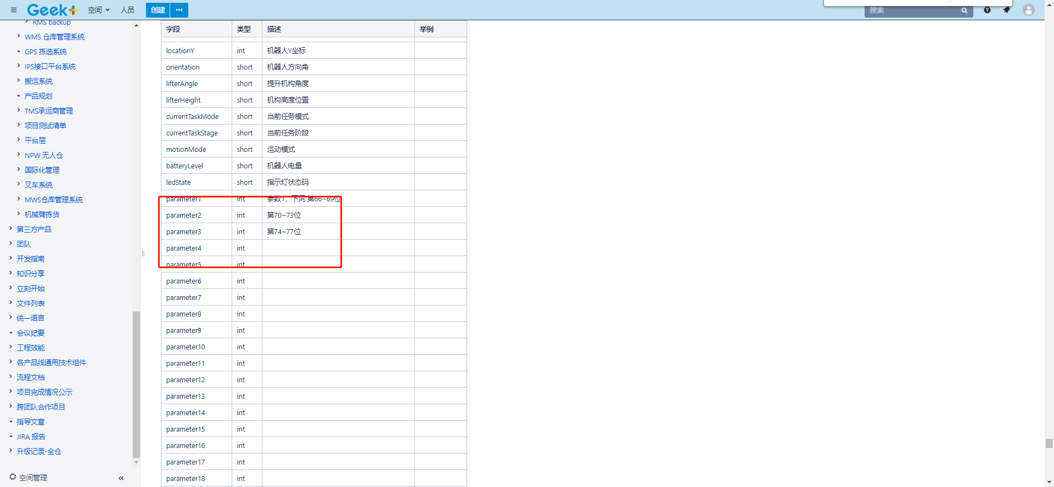

第66位是发送失败或成功0x00成功， 0x01失败

67位代表二维码个数，范围0-8，0x01-0x08

68-69都是0预留的

从parameter2开始指的是二维码的信息

例子假如我通过模拟器发送数字1（其实是ass码）

1的asscci码值对应的16进制为0x31,(就是键盘上的所有符号都通过assci码值表示传输给硬件，)

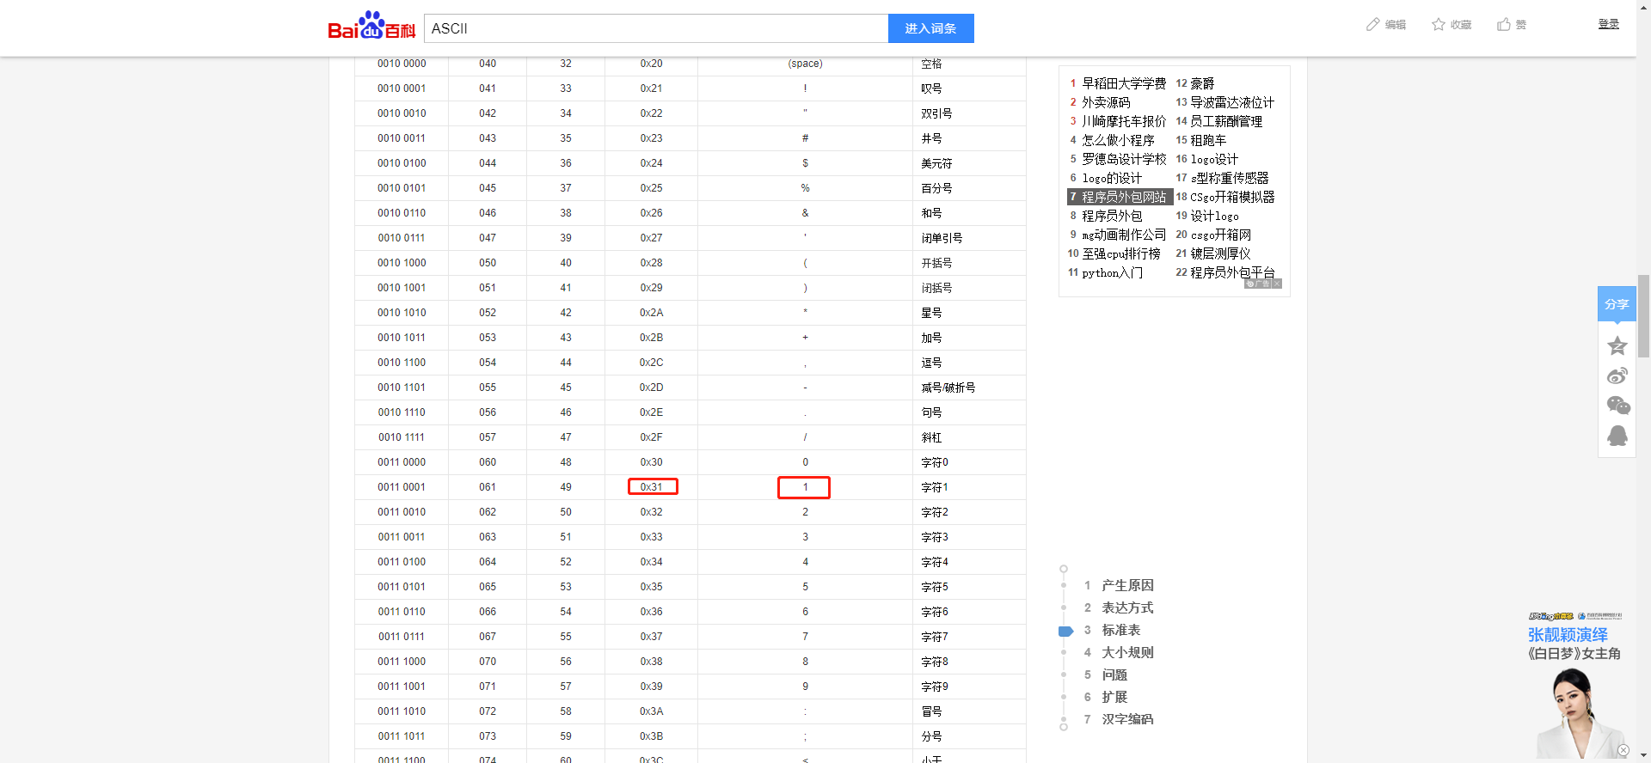

那么回调parameter2=49（10进制）

进制转换工具：31就是0x31

