Q Metric Variation – Minimization & Jacobian
y = x_i
k_i = sqrt(2)*erf_inverse(2*a_i – 1)
a_i = i/n+1
F = (1/2)(1 + erf[(log[y] - u)/(sqrt[2] s)])/exp[u + s k]
D[F,u]
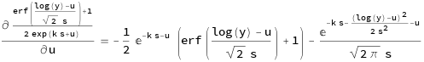

D[F,s]
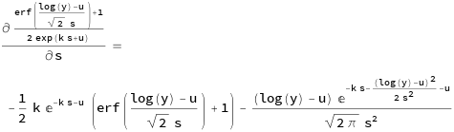

D[D[F,s],u] = D[D[F,u],s]
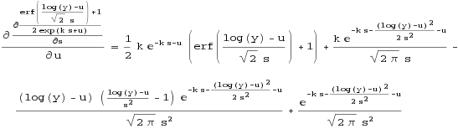

D[D[F,u],u]
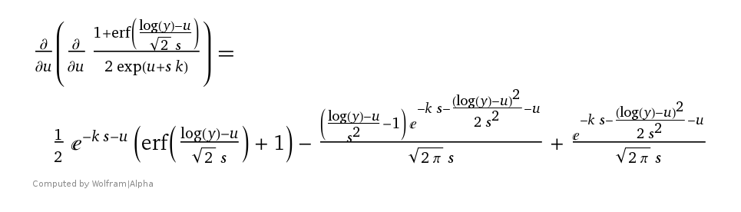

D[D[F,s],s]
