Lognormal Equations for

Anderson-Darling MDE

Conventions
Using z = y[n-1-i]
Using y = y[i]

Primary Optimization
d{log(F(y)) + log(1-F(z))}/du
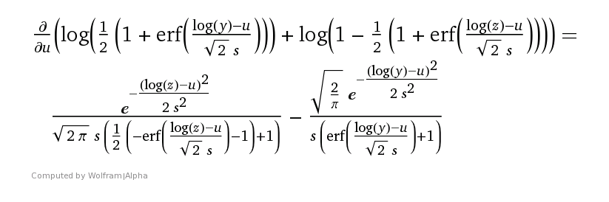

d{log(F(y)) + log(1-F(z))}/ds
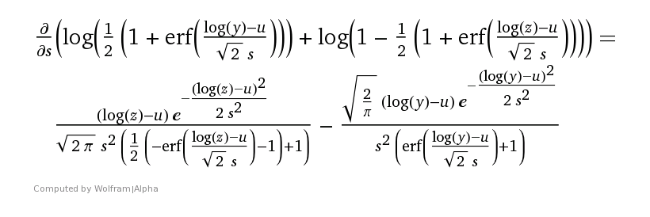

Jacobian Matrix
J[0,0] = d^2{log(F(y)) + log(1-F(z))}/du^2
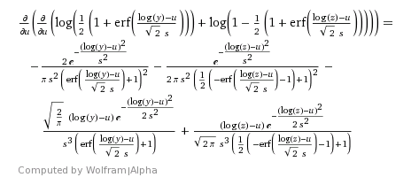

J[0,1] = d^2{log(F(y)) + log(1-F(z))}/ds du
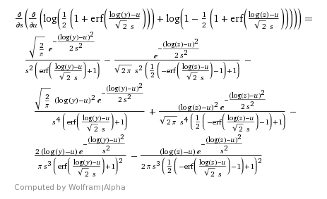

J[1,0] = d^2{log(F(y)) + log(1-F(z))}/du ds
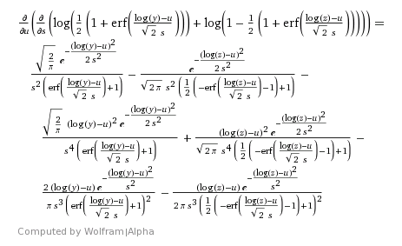

J[1,1] = d^2{log(F(y)) + log(1-F(z))}/ds^2
