ESIA
Employee Skill Intelligence & Recruitment Assistant

High-Level Design & Low-Level Design
  - System architecture, detailed component design, data design, API contracts and end-to-end process flows

Document control | Value
Version | 1.0
Status | Current implementation baseline
Prepared | 26 July 2026
Audience | Engineering, architecture, HR technology and operations
Classification | Internal technical documentation

Document objective
Define how ESIA is structured and how each major request moves from Streamlit through FastAPI, PostgreSQL, ChromaDB, local files and the configured LLM provider.

Document contents
Part I | High-Level Design
1 | Executive summary and scope
2 | Business and system capabilities
3 | Technology stack
4 | System context
5 | Deployment and runtime topology
6 | Logical component architecture
7 | Data architecture
8 | Security, observability and non-functional design
9 | High-level design decisions
Part II | Low-Level Design
10 | Presentation-layer design
11 | API-layer design
12 | Service and repository design
13 | Resume ingestion and indexing design
14 | Employee directory and profile design
15 | ESIRA RAG and search design
16 | Job-fit scoring algorithm
17 | ChromaDB design
18 | Validation, error handling and logging
19 | State, consistency and transaction design
20 | Configuration and operational design
21 | Testing design
22 | Known gaps and recommendations
Appendix | API catalogue, module map and glossary
Design baseline
Physical database DDL and SQLAlchemy model declarations are not present in the repository. Database entities in this document are derived from the active repository SQL and API contracts.

PART I — HIGH-LEVEL DESIGN
System context, topology, components, data and architectural decisions

1. Executive summary and scope
ESIA is a workforce-intelligence application that combines operational employee data with AI-extracted resume intelligence. The system uses PostgreSQL as the authoritative store for employee and resume metadata, ChromaDB as the semantic and structured resume-intelligence store, and a configurable LLM provider for extraction, classification and explanation.

1.1 Primary objectives
- Maintain an authoritative employee directory in PostgreSQL.
- Accept one current PDF resume per employee using a deterministic file name.
- Extract resume text and a structured employee profile with an LLM.
- Keep skills, primary skill, projects, training and certifications in ChromaDB rather than PostgreSQL skill master tables.
- Provide semantic employee search with deterministic, explainable job-fit scoring.
- Expose employee and resume intelligence through Streamlit dashboards and ESIRA Assistant.

1.2 In scope
Area | Included design
Presentation | All active Streamlit pages, API adapter, session state and navigation.
Backend | FastAPI routers, middleware, schemas, services and repositories.
AI | Resume extraction, LangGraph routing, RAG, guardrails, grounding and scoring.
Persistence | PostgreSQL, ChromaDB, resume files, temp files and logs.
Operations | Configuration, runtime processes, logging, failure behavior and testing.

1.3 Out of scope / not implemented
- Production identity provider, authentication and role-based authorization.
- Distributed deployment, container orchestration and cloud infrastructure.
- A distributed transaction across PostgreSQL, ChromaDB and filesystem.
- Live ChromaDB vector-audit and orphaned-chunk reconciliation API.
- Background job queue for resume ingestion or bulk reindex.

2. Business and system capabilities
Capability | User outcome | Primary components
Workforce overview | View employee, status, location, experience and resume metrics. | Streamlit Overview + employee/resume APIs
Employee directory | Search and filter employees and open a profile. | Employee page + EmployeeRepository
Employee 360 | View PostgreSQL record with Chroma resume intelligence. | EmployeeProfileService + ChromaService
Knowledge Studio | Upload, preview, match and save a resume. | ResumeService + Groq + storage
Knowledge status | Monitor resume metadata and index status; reindex an employee. | Resume metadata + embedding endpoint
ESIRA Assistant | Find and compare employees using natural language. | LangGraph + SearchService + job-fit scoring
Resume download | Download the current original employee PDF. | FileResponse + deterministic file storage

Authoritative-source principle
Operational identity and resume metadata come from PostgreSQL. Resume-derived skills and profile intelligence come from ChromaDB. The UI labels each source separately.

3. Technology stack
Layer | Technology | Design role
Presentation | Streamlit, requests, pandas | Multipage web UI, charts, HTTP calls and session state.
API | FastAPI, Uvicorn, Pydantic | HTTP routing, validation and response contracts.
Application | Python services | Business workflow orchestration.
Relational data | PostgreSQL + SQLAlchemy 2 | Employee and resume metadata persistence.
Vector data | ChromaDB persistent client | Resume chunk and structured-profile index.
PDF parsing | PyMuPDF (fitz) | Text extraction from uploaded PDF resumes.
Embeddings | sentence-transformers/all-MiniLM-L6-v2 | Local query, chunk and profile embeddings.
AI orchestration | LangChain + LangGraph | RAG pipeline and intent-driven graph execution.
LLM providers | Groq, Gemini or Ollama via ProviderFactory | Extraction, classification, summary and explanation.
Observability | Loguru + optional LangSmith | Request logs, file rotation and AI tracing.

4. System context
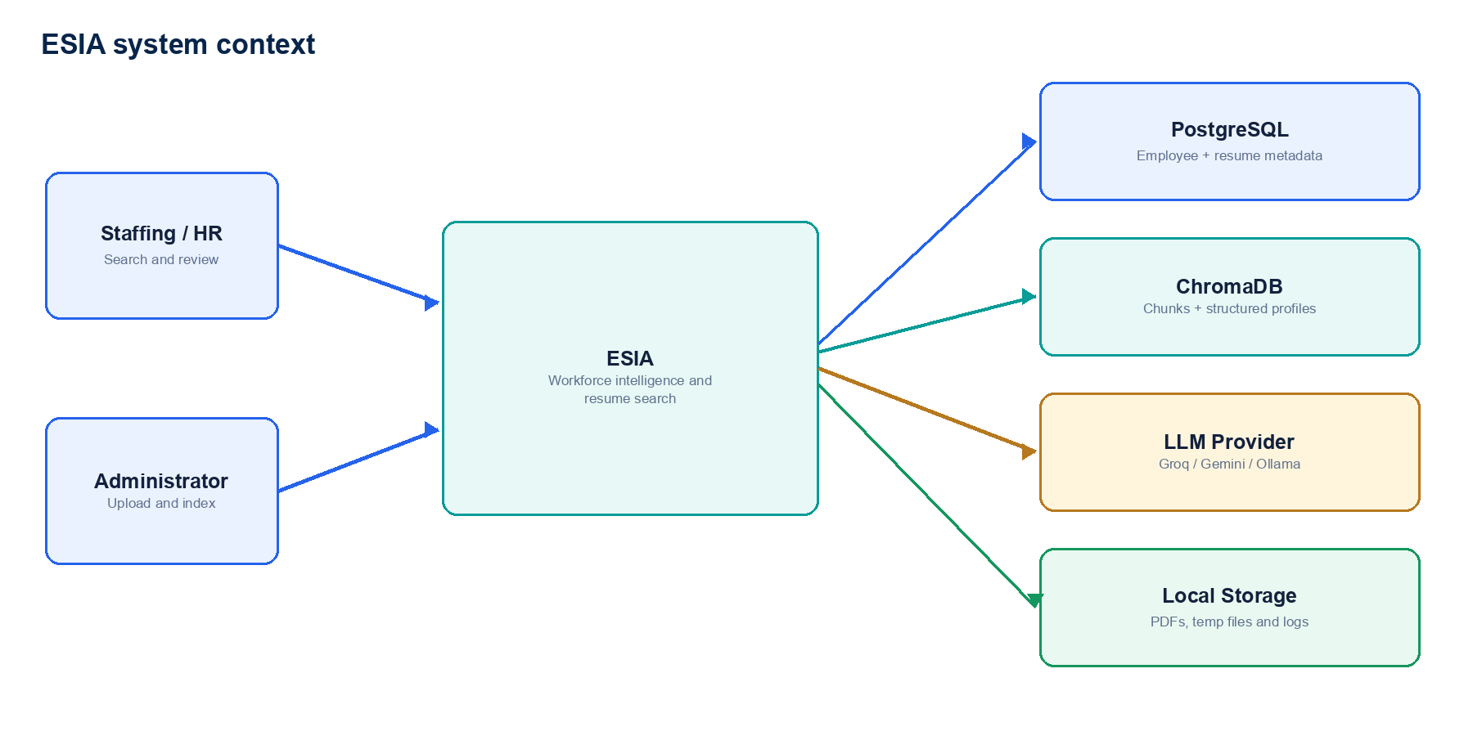
Figure 1 — ESIA system boundary, users and external dependencies.
Actor / system | Responsibility
Staffing / HR manager | Search, rank and review candidates; inspect evidence and profile details.
Administrator | Upload resumes, review extracted data, save employees and reindex knowledge.
PostgreSQL | Authoritative operational employee and resume-metadata storage.
ChromaDB | Semantic resume search and structured resume-profile storage.
LLM provider | Structured extraction, intent classification, summary, comparison and explanation.
Local storage | Original PDFs, temporary processing files and application logs.

5. Deployment and runtime topology
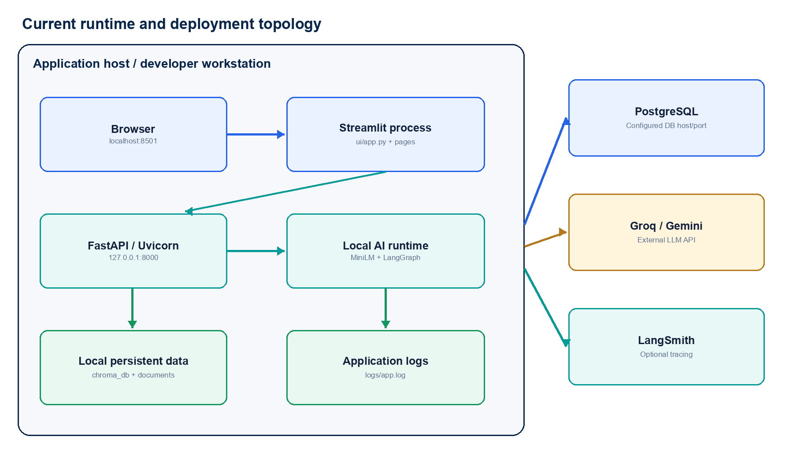
Figure 2 — Current local/runtime topology and configured external services.
- Streamlit normally listens on localhost:8501.
- FastAPI/Uvicorn normally listens on 127.0.0.1:8000.
- The UI API base URL is statically configured as http://127.0.0.1:8000.
- ChromaDB, resume PDFs, temporary files and logs use paths relative to the application working directory.
- PostgreSQL and external LLM endpoints are configured through environment variables.
- The current topology assumes one shared application filesystem and effectively a single application instance.
Scaling implication
ProcessManager is in memory and the vector/file stores are local. A multi-worker or multi-host deployment requires shared process state, shared object storage and a remotely accessible vector database.

6. Logical component architecture
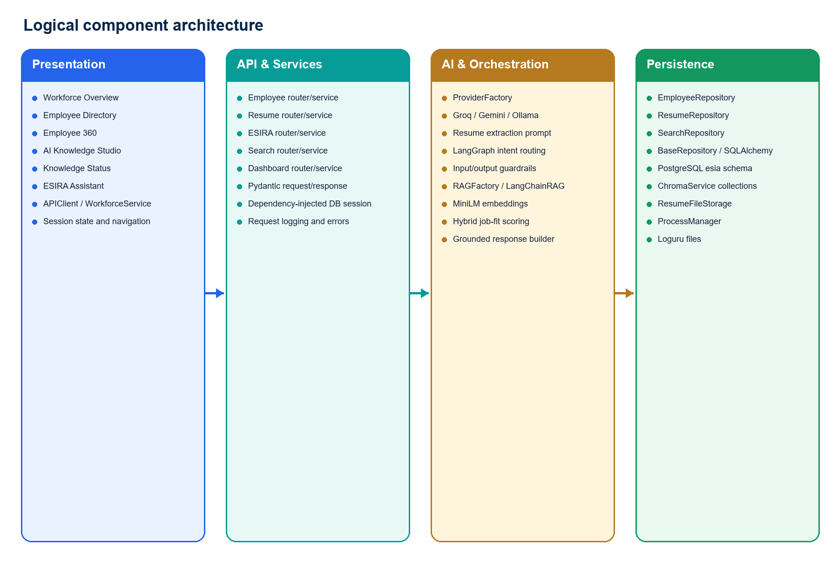
Figure 3 — Presentation, API/service, AI/orchestration and persistence components.
Layer | Responsibilities | Key modules
Presentation | Render pages, collect input, retain session state, call HTTP APIs. | ui/app.py, ui/pages, APIClient, WorkforceService
API | Route requests, inject DB session, validate schemas and shape responses. | app/api, app/schemas, middleware
Services | Coordinate employee, resume, search, dashboard and ESIRA workflows. | app/services
AI orchestration | Provider selection, extraction, RAG, guardrails, scoring and grounding. | app/ai, app/graph, app/guardrails, app/llm
Persistence | Execute SQL, query Chroma, store files and track temporary processes. | app/repository, ChromaService, ResumeFileStorage, ProcessManager

7. Data architecture
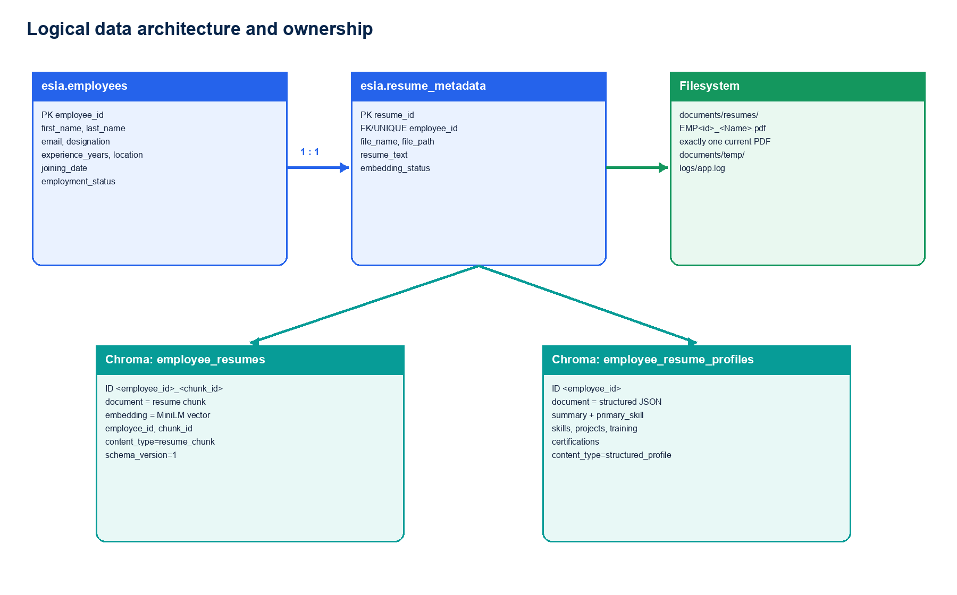
Figure 4 — Active PostgreSQL, filesystem and ChromaDB data ownership.

7.1 Active PostgreSQL entities
Entity | Key fields | Usage
esia.employees | employee_id; first_name; last_name; email; designation; experience_years; location; joining_date; employment_status | Directory, identity verification, Employee 360 and resume matching.
esia.resume_metadata | resume_id; employee_id; file_name; file_path; resume_text; embedding_status | One resume per employee, download, parse, reindex and index status.

7.2 Legacy/reference PostgreSQL entities
Entity group | Tables inferred from repository SQL | Current role
Skills | skills, employee_skills | Read by legacy SkillRepository/DashboardRepository; not written by resume save.
Projects | projects, employee_projects | Read by legacy ProjectRepository; not used by active EmployeeProfileService.
Certifications | certifications, employee_certifications | Read by legacy repositories/dashboard; resume certifications stay in Chroma.
AI profile | employee_ai_profile, employee_ai_entities | Repository methods exist but active resume save indexes profiles in ChromaDB.

7.3 ChromaDB collections
Collection | Record identity | Document and metadata
employee_resumes | <employee_id>_<chunk_index> | Clean resume chunk; MiniLM vector; employee_id, chunk_id, content_type=resume_chunk, schema_version=1.
employee_resume_profiles | <employee_id> | Structured profile JSON; MiniLM vector; employee_id, content_type=structured_profile, schema_version=1.

Storage policy
Primary skill, skills, projects, training, certifications and AI summary are held in employee_resume_profiles. Resume save does not create skill master or employee-skill rows in PostgreSQL.

8. Security, observability and non-functional design

8.1 Security controls currently present
Control | Current implementation
Input guardrails | Prompt-injection patterns, PII email/phone detection, toxicity terms and workforce-scope validation.
Output guardrails | No-result, JSON, hallucination, groundedness and PII masking checks.
Grounding | Canonical employee identity, rank and score are taken from deterministic retrieval/scoring, not the LLM response.
File validation | PDF extension, PDF signature, non-empty content and 10 MB size limit.
SQL safety | Runtime values are generally bound parameters; allowed sort columns are whitelisted.

8.2 Security gaps
- JWT/security modules are empty and no authentication or authorization middleware is active.
- No role-based restriction exists for resume upload, download, employee profile or ESIRA queries.
- Application-level encryption for stored resumes and Chroma documents is not implemented.
- Audit logging identifies route, status and duration but not an authenticated user.
- Resume content may be sent to an externally configured LLM provider and requires organizational privacy approval.

8.3 Non-functional characteristics
Quality | Current design | Constraint
Availability | Simple local processes with persistent PG/Chroma/files. | No HA or failover design.
Performance | Local MiniLM model reuse; paginated employee queries. | Synchronous embeddings/LLM and sequential Streamlit calls.
Scalability | Employee-level vector grouping and top-k reranking. | Local state and filesystem limit horizontal scaling.
Reliability | embedding_status remains false until Chroma upsert succeeds. | No cross-system atomic transaction.
Observability | Request time/status logging and optional LangSmith tracing. | No metrics, alerts or correlation ID.
Maintainability | Layered routers/services/repositories and provider factory. | Legacy/unwired modules and duplicate paths remain.

9. High-level design decisions
Decision | Rationale | Consequence
PostgreSQL for operational data | Strong relational identity, filtering and metadata consistency. | Employee/resume metadata remains authoritative outside the vector store.
ChromaDB for resume intelligence | Supports semantic retrieval without relational skill-master writes. | Profile reads require PostgreSQL + Chroma composition.
One PDF per employee | Avoid stale versions and ambiguous downloads. | New upload atomically replaces the deterministic employee file.
Two-stage process/save | Allows human review before durable persistence. | process_id must survive between calls.
Local MiniLM embeddings | Stable, low-cost embedding generation. | Model load and CPU inference occur in the API process.
Deterministic job-fit score | Human-facing scores must be explainable and repeatable. | LLM only explains; it does not determine rank or percentage.
embedding_status in PostgreSQL | Expose indexing state without scanning Chroma per page load. | Status is a proxy and can drift without an audit API.

PART II — LOW-LEVEL DESIGN
Modules, APIs, workflows, algorithms, state and operational behavior

10. Presentation-layer design

10.1 Streamlit execution model
- The active page script executes from top to bottom on initial load and widget interactions.
- st.session_state stores selected employee, pagination, Knowledge Studio preview/process ID, selected Knowledge Status row and chat messages.
- st.switch_page changes pages; the destination executes and makes its own API calls.
- API calls are synchronous and wrapped in APIError for user-safe connection messages.
- No st.cache_data layer is currently applied to workforce or resume API calls.

10.2 Page design
Page | State | API calls | Primary output
Workforce Overview | None | GET /employees/ twice; GET /resume/ | Metrics, charts and recent resume activity.
Employees | employee_page | GET /employees/; GET /resume/ | Filtered directory with profile navigation.
Employee 360 | selected_employee_id | GET employee; GET profile; GET resume; download link | Joined PostgreSQL + Chroma profile.
AI Knowledge Studio | studio_profile/process_id/match/saved | POST process; POST save | Reviewable extraction preview and persistence pipeline.
Knowledge Status | search/status/selected ID | GET resumes; POST embedding; download link | Resume metadata and index status.
ESIRA Assistant | messages/conversations | POST esiraChat | Grounded candidate cards, score evidence and navigation.

10.3 UI API adapter
Component | Responsibility
APIClient.get/post | Build base URL, set timeouts, parse JSON and convert HTTP/connection failures into APIError.
APIClient.process_resume | Send multipart PDF upload with a 300-second timeout.
APIClient.download_url | Produce a browser-direct resume download URL.
WorkforceService | Expose typed page-oriented methods for employees, profiles, resumes, reindex, save and ESIRA.

11. API-layer design

11.1 Routing and dependency injection
- FastAPI application construction occurs in app/main.py.
- Routers are registered for dashboard, ESIRA, employees, resume, search, AI and health/version.
- get_db creates one SQLAlchemy Session per request and closes it in a finally block.
- API routers construct services with the injected database session.
- Pydantic schemas validate request/response data.

11.2 Standard response envelope
Field | Type | Meaning
success | boolean | Request/business-operation outcome.
message | string | User-safe operation description.
data | any / null | Returned record, list or workflow result.
pagination | Pagination / null | Page, size, total records and page count when applicable.

Contract exceptions
ESIRA returns {intent, content_type, answer}. Resume download returns application/pdf. /resume/process-all returns a manually constructed success/message/data dictionary.

11.3 Endpoint catalogue
Method | Path | Service | Result | UI/status
GET | / | Health | Root health payload | Not directly used by active UI
GET | /health | Health | Detailed health payload | Not directly used by active UI
GET | /version | Application | Application version | Not directly used by active UI
GET | /dashboard | DashboardService | Summary/top skills/experience/certifications | Active router; active Overview does not call it
GET | /employees/ | EmployeeService | Paginated filtered employees | Overview and Directory
GET | /employees/{id} | EmployeeService | One employee | Employee 360
GET | /employees/{id}/profile | EmployeeProfileService | PG employee + Chroma profile | Employee 360
GET | /resume/ | ResumeService | Resume metadata list | Overview, Directory, Knowledge Status
GET | /resume/{id} | ResumeService | One employee resume metadata | Employee 360
GET | /resume/{id}/download | ResumeService | Original PDF | Employee 360, Knowledge Status
POST | /resume/process | ResumeService | AI preview and process_id | Knowledge Studio
POST | /resume/save | ResumeService | Persist and index processed resume | Knowledge Studio
POST | /resume/{id}/parse | ResumeService | Extract/store resume text | Available; no current page action
POST | /resume/{id}/embedding | ResumeService | Replace one Chroma index | Knowledge Status
POST | /resume/process-all | ResumeService | Parse/reindex all resumes | Available; no current page action
POST | /resume/{id}/upload | ResumeService | Direct existing-employee upload | Available; Knowledge Studio uses process/save
POST | /search/resumes | SearchService | Direct semantic result list | Available; ESIRA calls SearchService internally
POST | /esira/esiraChat | ESIRAService | Guarded intent-routed answer | ESIRA Assistant
GET | /ai/resume-summary/{id} | AIService | Resume summary | Available via API
GET | /ai/compare | AIService | Two-resume comparison | Available via API
POST | /ai/search | AIService | Direct AI search | Legacy path; constructor call requires correction

12. Service and repository design

12.1 Service responsibilities
Service | Dependencies | Responsibilities
EmployeeService | EmployeeRepository plus legacy repositories/AIService | Paginated employees and one employee lookup.
EmployeeProfileService | EmployeeRepository, ResumeRepository, ChromaService | Compose operational employee with structured resume intelligence.
ResumeService | ResumeRepository, EmployeeRepository, parser, embeddings, Chroma, AIService | Validate, process, match, save, parse, index, bulk process, upload and clean up.
SearchService | SearchRepository, EmployeeRepository, JobFitScoreService | Retrieve broad semantic pool, group employees, verify data and rerank.
AIService | ResumeRepository, RAGFactory, ProviderFactory | Search, summarize, compare and produce/parse structured LLM output.
ESIRAService | GraphService | Execute the asynchronous guarded LangGraph conversation workflow.
DashboardService | DashboardRepository | Aggregate relational dashboard statistics.

12.2 Repository responsibilities
Repository | Data source | Key operations
BaseRepository | SQLAlchemy Session | Bound SQL execution, fetch one/all/scalar, pagination and immediate commit on execute.
EmployeeRepository | esia.employees | Filter/paginate, lookup by ID/email/name, create and update employee.
ResumeRepository | esia.resume_metadata and legacy AI tables | Metadata upsert, resume text, index status and AI profile/entity methods.
SearchRepository | Chroma employee_resumes | Query vectors and load all employee documents.
Dashboard/legacy repositories | Master/reference tables | Top skills, projects and certifications; not active resume-profile storage.

Transaction behavior
BaseRepository.execute commits immediately. A ResumeService save invokes multiple repository writes and external/file operations, so the workflow is not one atomic database transaction.

13. Resume ingestion and indexing design

13.1 Process / preview sequence
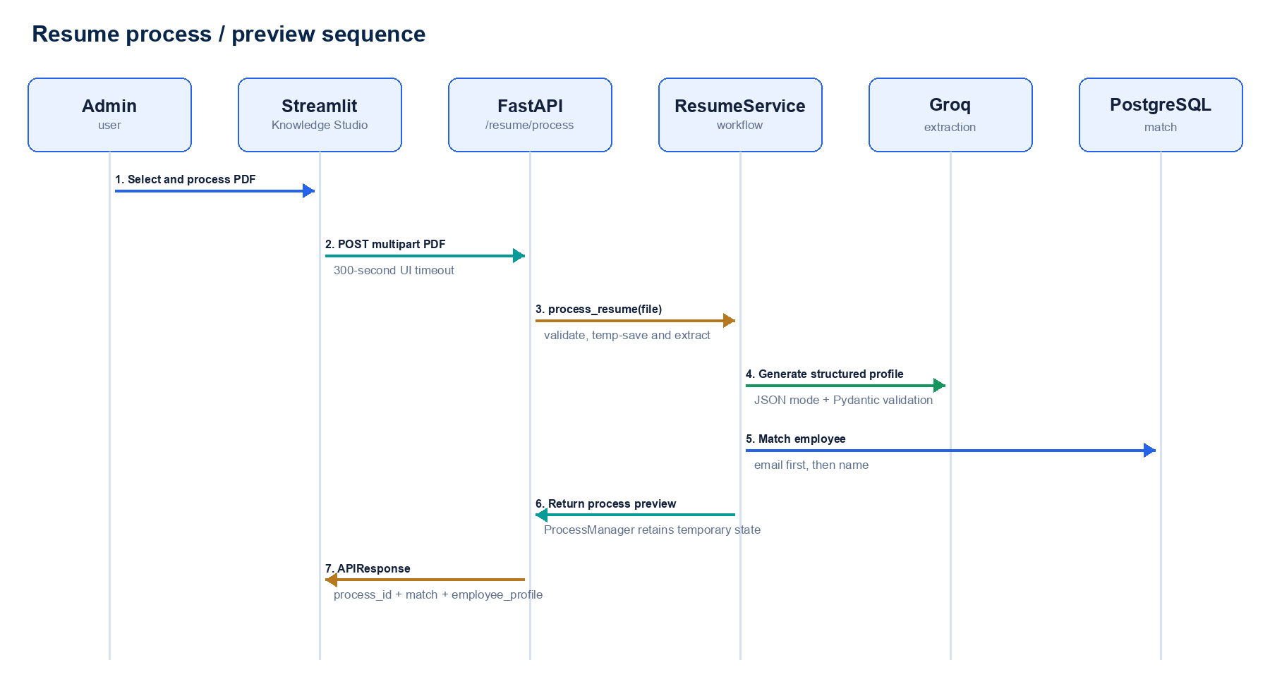
Figure 5 — POST /resume/process sequence and temporary preview state.
1 | Validate file name, PDF extension, maximum size, PDF signature and non-empty content.
2 | Generate UUID process_id and create documents/temp.
3 | Write the temporary PDF and extract clean text with PyMuPDF.
4 | Write the temporary text file for the process lifecycle.
5 | Build the extraction prompt and call the configured provider in JSON mode.
6 | Normalize alternate AI field names and validate EmployeeProfileResponse.
7 | Match existing employee by email (100% confidence), then name (95% confidence); otherwise choose CREATE.
8 | Store profile, matching result, text and temporary paths in ProcessManager.
9 | Return process_id and profile preview; no permanent employee/profile persistence yet.

13.2 Save / persistence sequence
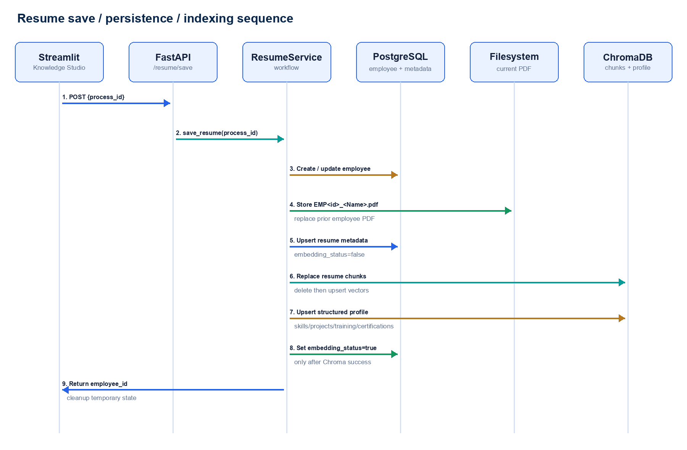
Figure 6 — POST /resume/save persistence, file replacement and Chroma indexing.
1 | Load the in-memory process by process_id.
2 | Update the matched employee or create a new employee.
3 | Copy the PDF through a temporary target and atomically replace the deterministic EMP<id>_<Name>.pdf destination.
4 | Remove stale employee PDF names and upsert resume_metadata with embedding_status=false.
5 | Chunk the resume with size 1,000 and overlap 200; discard empty/boilerplate-only chunks.
6 | Generate all-MiniLM-L6-v2 embeddings for chunks and structured profile JSON.
7 | Set embedding_status=false, delete old employee chunks and upsert employee_resumes.
8 | Upsert employee_resume_profiles when structured profile data is available.
9 | Set embedding_status=true only after required Chroma writes succeed.
10 | Delete temporary files and remove ProcessManager state.

13.3 File naming and replacement
Rule | Implementation
Destination | documents/resumes/EMP<employee_id>_<safe employee name>.pdf
Sanitization | Non-word characters collapse to underscore; empty names become Employee.
Atomic copy | Copy to a UUID-suffixed temporary file, then os.replace into final destination.
Previous versions | Known legacy and EMP<id>_*.pdf variants are removed after successful replacement.
Database cardinality | resume_metadata is upserted ON CONFLICT(employee_id), enforcing one logical resume per employee.

14. Employee directory and profile design

14.1 Directory query
Filter | Repository SQL behavior
search | Wildcard ILIKE across first name, last name, email, designation and location.
location | ILIKE location.
designation/domain | ILIKE designation; domain currently aliases designation filtering.
employment_status | ILIKE employment_status.
min/max experience | Numeric lower/upper bounds against experience_years.
sort | Whitelisted column map and normalized ASC/DESC.
pagination | COUNT followed by LIMIT/OFFSET query.

14.2 Employee 360 composition
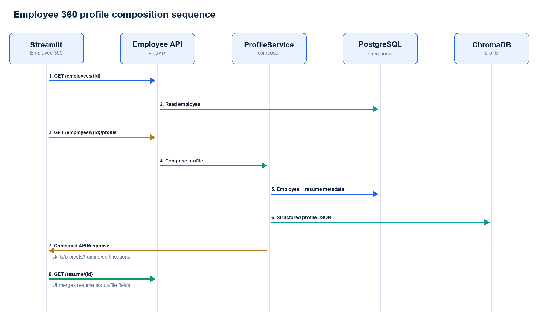
Figure 7 — Employee 360 read path across PostgreSQL, ChromaDB and resume metadata.
Current field behavior
EmployeeRepository returns NULL placeholders for domain, primary_skill, utilization and availability. primary_skill is available through the Chroma structured profile, but the operational employee query does not merge it.

15. ESIRA RAG and search design
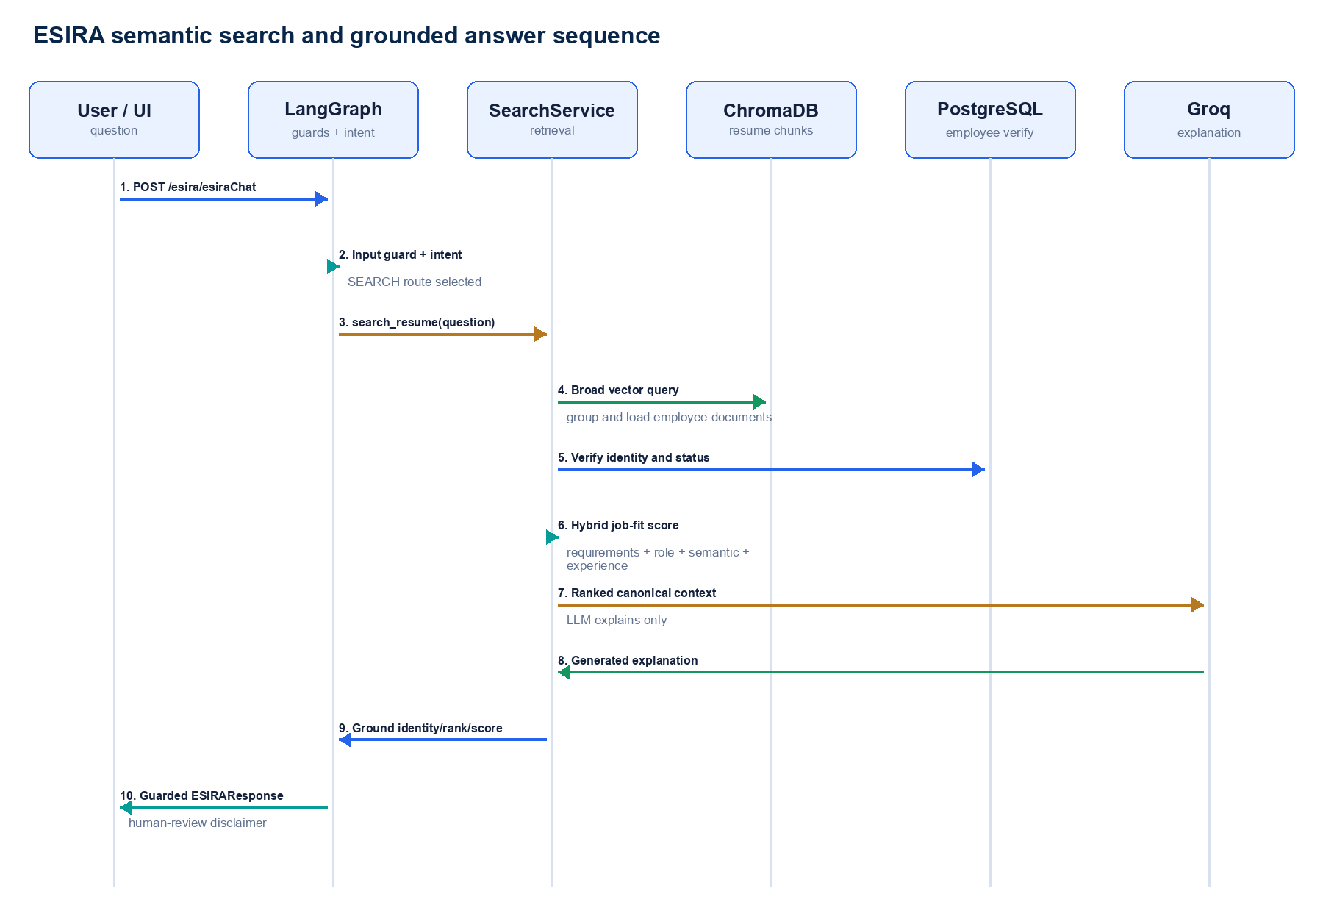
Figure 8 — Guarded ESIRA search, deterministic reranking and grounded response sequence.

15.1 LangGraph state and routing
Graph stage | Behavior
guard | Run prompt-injection, PII, toxicity and workforce-scope guards.
intent | Use the configured LLM provider to classify SEARCH, SUMMARY, COMPARE, GREETING or UNKNOWN.
search | AIService.search_resume → RAGFactory → SearchService + LLM explanation.
summary | Parse an employee ID, load PostgreSQL resume_text and summarize.
compare | Parse two employee IDs, load both resume_text values and compare.
output_guard | Validate result, sanitize PII and replace failed outputs with a grounded no-result structure.

15.2 SEARCH retrieval and reranking
1 | Embed the natural-language query with all-MiniLM-L6-v2.
2 | Query Chroma employee_resumes with a broad pool: max(top_k × 40, 120) chunks, capped by collection count.
3 | Group retrieved chunks by employee and retain each employee’s best semantic distance.
4 | Keep a candidate pool of max(top_k × 5, 15) employees.
5 | Load all indexed resume chunks for each candidate.
6 | Verify employee identity, role, experience and operational status in PostgreSQL.
7 | Convert L2 distance to semantic percentage: 100 / (1 + distance).
8 | Calculate the hybrid job-fit score and sort by score descending, then distance ascending.
9 | Give the LLM canonical ranked context for explanation only.
10 | Ground the final response against canonical employee ID, identity, rank and score.

15.3 Guardrail chain
Direction | Guard | Purpose
Input | PromptInjectionGuard | Reject known instruction-bypass phrases.
Input | PIIGuard | Reject email addresses and ten-digit phone numbers in the question.
Input | ToxicityGuard | Reject configured abusive/harmful terms.
Input | ScopeGuard | Restrict questions to workforce, resume, skill and supported greetings.
Output | NoResult/JSON/Hallucination/Groundedness | Reject malformed, empty or unsupported responses.
Output | PIIMaskGuard | Sanitize output before return.
Search | search_grounding | Use only deterministic identity/rank/score and accept LLM explanation text.

16. Job-fit scoring algorithm

16.1 Formula
Hybrid score
fit_score = Σ(component_score × configured_weight) / Σ(active_weights). Components are activated only when the query supplies the corresponding requirement.

Component | Default weight | Calculation
Requirements | 60% | Average evidence score for extracted query requirements.
Role | 15% | Alignment between requested role, employee designation and resume role evidence.
Semantic | 25% | Monotonic conversion of best Chroma L2 distance.
Experience | 15% when explicit | min(100, candidate_years / required_years × 100); active weights normalize.

16.2 Requirement evidence strength
Evidence location | Score | Interpretation
Project / professional experience | 100 | Strong work-delivery evidence.
Skills / professional summary | 85 | Declared capability or summarized expertise.
General resume mention | 70 | Mention outside recognized sections.
Training / certification | 60 | Learning or qualification evidence, not necessarily delivery.
Not found | 0 | Explicit gap.

16.3 Score bands
Band | Range | UI meaning
Strong | 80–100 | High resume evidence against the query.
Good | 65–79.9 | Material fit with some review areas.
Partial | 50–64.9 | Mixed evidence or meaningful gaps.
Low | 0–49.9 | Insufficient evidence for the stated requirements.

Decision-support boundary
The score is job-related resume evidence, not a hiring decision. The response includes a human-review disclaimer and explicit missing requirements.

17. ChromaDB design
Design item | Current implementation
Persistence path | ./chroma_db relative to the API working directory.
Embedding model | sentence-transformers/all-MiniLM-L6-v2; model instance cached at class level.
Chunk strategy | RecursiveCharacterTextSplitter, 1,000 characters, 200-character overlap.
Separators | Double newline, newline, sentence space, space, then character.
Boilerplate filter | Drops empty chunks and exact markers such as employee profile / resume text.
Replacement strategy | Delete all employee_resumes records by employee_id, then upsert deterministic IDs.
Profile fallback | get_profile first reads employee_resume_profiles, then attempts legacy embedded-profile recovery.
Status synchronization | PostgreSQL embedding_status set true after resume/profile upsert success.

17.1 Reindex process
1 | Load resume metadata from PostgreSQL.
2 | Parse the PDF if resume_text is empty (bulk process path).
3 | Create cleaned chunks and embeddings.
4 | Read any existing structured profile before deleting resume chunks.
5 | Set PostgreSQL embedding_status=false.
6 | Delete and replace employee resume chunks.
7 | Upsert profile collection when profile JSON is available.
8 | Set embedding_status=true.

18. Validation, error handling and logging
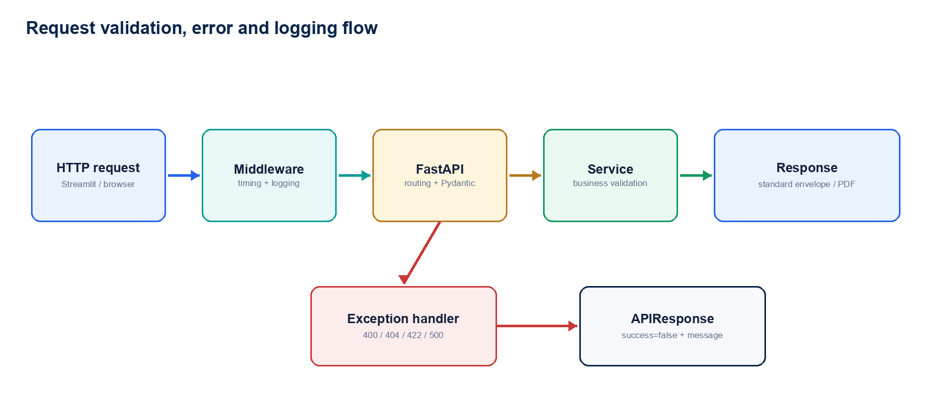
Figure 9 — Validation, exception conversion, response and request-log path.
Failure type | HTTP behavior
FastAPI request validation | 422 APIResponse with Validation Error and encoded field errors.
Pydantic model validation | 422 APIResponse with Validation Error.
ResourceNotFoundException | 404 APIResponse with '<resource> not found'.
Bad request / service ValueError | Usually 400 on explicitly handled resume endpoints.
Connection failure in UI | APIError instructs the user to confirm FastAPI is running on port 8000.
Resume processing timeout | UI-specific message after the 300-second multipart timeout.

18.1 Logging
- RequestLoggingMiddleware records method, path, status and elapsed milliseconds.
- Loguru writes console output and logs/app.log.
- File rotation is 10 MB, retention is 30 days and old logs are zipped.
- LangSmith tracing is configurable for LLM/intent calls.
Current defect
global_exception_handler raises the exception before executing its logging and standardized 500-response code. Unhandled exceptions therefore escape to the ASGI server instead of returning the intended envelope.

19. State, consistency and transaction design
State | Location | Lifetime / behavior
UI selection/filter/chat state | Streamlit session_state | Browser session; drives reruns and navigation.
Resume processing state | ProcessManager class dictionary | API process memory until Save/cleanup or process restart.
DB session | SQLAlchemy SessionLocal | One request dependency; closed after request.
MiniLM model | EmbeddingGenerator class cache | API process lifetime after lazy first load.
Chroma client/collections | ChromaService instance | Persistent local database; instance per service construction.
LLM provider/RAG | AIService instance | Request/service lifetime with lazy RAG initialization.

19.1 Consistency behavior
- Employee and resume metadata commits occur before Chroma indexing finishes.
- The permanent PDF may be replaced before the vector index completes.
- embedding_status=false identifies a resume requiring reindex after partial failure.
- Old Chroma chunks are deleted before replacement chunks are inserted.
- No compensating transaction automatically restores the old PDF, metadata or Chroma index.
Recommended consistency pattern
Introduce an ingestion job record with explicit RECEIVED, EXTRACTED, METADATA_SAVED, INDEXING, INDEXED and FAILED states; process through an idempotent background worker and retain the previous active index until the replacement is complete.

20. Configuration and operational design

20.1 Environment configuration
Group | Settings
Application | APP_NAME, APP_VERSION, DEBUG, LOG_LEVEL
PostgreSQL | DB_HOST, DB_PORT, DB_NAME, DB_USER, DB_PASSWORD, DB_SCHEMA
LLM selection | LLM_PROVIDER, GROQ_MODEL, GEMINI_MODEL, OLLAMA_MODEL
Secrets/endpoints | GROQ_API_KEY, GOOGLE_API_KEY, OLLAMA_BASE_URL
RAG/tracing | RAG_PROVIDER, AI_ENGINE, LANGCHAIN_TRACING_V2, LANGCHAIN_ENDPOINT, LANGCHAIN_API_KEY, LANGCHAIN_PROJECT

20.2 Startup sequence
1 | Settings load the project .env file using Pydantic Settings.
2 | SQLAlchemy engine and SessionLocal are constructed.
3 | FastAPI application, exception handlers, middleware and routers are registered.
4 | Startup event writes application-started log messages.
5 | Streamlit starts separately and calls the configured API base URL.
6 | MiniLM, Chroma collections and LLM clients initialize lazily on first use.

20.3 Operational commands
Process | Typical command / endpoint
Backend | python -m uvicorn app.main:app --reload --port 8000
UI | streamlit run ui/app.py --server.port 8501
Health | GET /health
Bulk reindex | POST /resume/process-all
Single reindex | POST /resume/{employee_id}/embedding

21. Testing design
Test area | Existing coverage | Recommended additional coverage
Resume storage | Deterministic naming/replacement tests. | Concurrent upload and partial file failure.
Resume reindex | Index replacement/status tests. | Chroma failure, rollback and orphan audit.
Search ranking | Semantic grouping/ranking tests. | Large collection, duplicate chunks and tie behavior.
Job-fit scoring | Component score and evidence tests. | Broader role/skill taxonomy and adversarial queries.
Employee APIs | Basic endpoint tests exist. | Filter combinations, pagination and missing employee.
Guardrails | Manual/limited tests. | PII variants, false positives, injection bypass and output masking.
UI | No automated Streamlit test suite identified. | Page smoke tests, session state, upload/save and navigation.
End-to-end | Manual local workflow. | Disposable PostgreSQL/Chroma/filesystem fixture and mocked LLM.

21.1 Critical acceptance scenarios
- New employee resume: preview → create employee → save one PDF → metadata → Chroma profile/chunks → status true.
- Existing employee upload: match → update employee → replace prior PDF and index without duplicates.
- Chroma failure: API fails, embedding_status remains false and reindex can recover.
- Employee 360: identity remains PostgreSQL-authoritative and resume intelligence comes from Chroma.
- ESIRA search: only indexed employees are returned; ranks and percentages remain deterministic.
- Resume download: returned file matches the current metadata path and correct employee.

22. Known gaps and recommendations
Priority | Gap | Recommendation
P0 | Global exception handler re-raises before standardized handling. | Remove the early raise; log exception and return the 500 APIResponse.
P0 | No authentication or authorization. | Integrate enterprise identity, RBAC and audited access to resume/employee data.
P1 | ProcessManager is in-memory. | Persist ingestion state in PostgreSQL/Redis and use an idempotent job token.
P1 | Cross-store save is non-atomic. | Use staged ingestion, background worker, retry policy and explicit failure states.
P1 | Knowledge Status is not a live Chroma audit. | Add collection audit/reconciliation endpoint and orphan detection.
P1 | Local Chroma/files prevent horizontal scale. | Use shared vector infrastructure and object storage for PDFs.
P2 | Employee 360 performs redundant sequential reads. | Create one optimized profile endpoint/contract and remove redundant UI calls.
P2 | Overview bypasses /dashboard and loads only 100 employees. | Create authoritative aggregate APIs backed by PostgreSQL/Chroma analytics.
P2 | Legacy relational skill/project/certification paths conflict with Chroma-only policy. | Deprecate or clearly isolate legacy repositories/dashboard contracts.
P2 | Request middleware is registered twice in app/main.py. | Register RequestLoggingMiddleware once.
P2 | No background execution for embedding and bulk reindex. | Use a queue/worker and surface progress/status through APIs.
P3 | Hard-coded UI API base URL. | Move the base URL to environment/configuration per deployment.

Appendix A. Module map
Package | Purpose
ui/pages | Active multipage Streamlit user journeys.
ui/components | Reusable cards, styles, layout and legacy components.
ui/services + ui/api_client.py | Backend API adapter and request handling.
app/api | FastAPI route definitions.
app/schemas | Pydantic request, response and profile contracts.
app/services | Application and workflow orchestration.
app/repository | PostgreSQL and Chroma query boundaries.
app/ai | Parsing, chunking, embeddings, RAG, prompts and grounding.
app/graph | LangGraph state, nodes and routing.
app/guardrails | Input and output safety validation.
app/llm | Provider abstraction and Groq/Gemini/Ollama implementations.
app/middleware + app/core | Settings, logging, dependencies and exception handling.
app/utils | File storage, JSON parsing and question parsing.
app/tests | Ranking, scoring, resume storage and reindex tests.

Appendix B. Key request/response contracts
Contract | Fields
EmployeeProfileResponse | first_name, last_name, email, phone, designation, department, location, experience_years, primary_skill, skills[], projects[], certifications[], training[], summary
ResumeProcessResponse | process_id, matched, confidence, action, employee_profile
SaveResumeRequest | process_id
ESIRARequest | question
ESIRAResponse | intent, content_type, answer
SearchRequest | query, top_k=5
APIResponse | success, message, data, pagination

Appendix C. Glossary
Term | Meaning
HLD | High-Level Design: system boundaries, components, deployment and major decisions.
LLD | Low-Level Design: modules, data contracts, algorithms, sequences and error behavior.
RAG | Retrieval-Augmented Generation.
Embedding | Numeric vector representation used for semantic similarity.
ChromaDB | Persistent vector database used by ESIA.
Grounding | Constraining generated output to retrieved canonical facts.
Job-fit score | Deterministic weighted score over resume evidence and query requirements.
embedding_status | PostgreSQL flag indicating that the expected Chroma indexing completed.
ProcessManager | Current in-memory storage between resume Process and Save calls.

— End of ESIA HLD/LLD —

