ESIA
Employee Skill Intelligence & Recruitment Assistant

UI-to-API Process Flow
  - Current implementation architecture, page workflows, data ownership and operational behavior

Document type | Technical architecture and process-flow reference
System | ESIA Streamlit UI + FastAPI backend
Prepared | 26 July 2026
Status | Current implementation

Purpose
Provide one authoritative view of every API currently called by the Streamlit UI, the services and repositories involved, and the final PostgreSQL, ChromaDB, filesystem or Groq effect.

Contents
1 | Architecture at a glance
2 | UI API-call summary
3 | Workforce Overview
4 | Employee Directory
5 | Employee 360
6 | AI Knowledge Studio
7 | Resume Knowledge Status
8 | ESIRA Assistant
9 | Data ownership
10 | Streamlit execution behavior
11 | Available APIs not wired to the current UI
12 | Operational observations
Appendix | Implementation reference

Scope note
This document describes the current code paths. Navigation-only buttons are identified separately because they change Streamlit pages without making an API request.

1. Architecture at a glance
The Streamlit UI never accesses PostgreSQL or ChromaDB directly. All external data operations pass through the HTTP adapter and FastAPI application services.
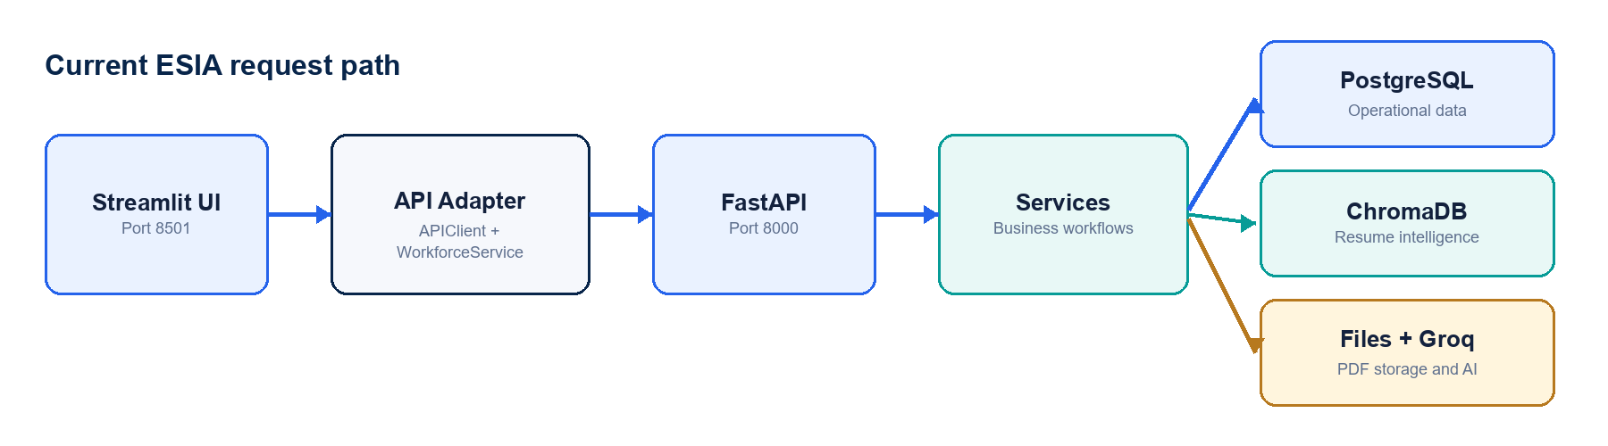
Figure 1 — Current request path from Streamlit to persistence and AI services.
Response contracts
Most endpoints return {success, message, data, pagination}. ESIRA returns {intent, content_type, answer}. Resume download returns a binary application/pdf response.

2. UI API-call summary
Method | Endpoint | UI consumer | Data/services | Purpose
GET | /employees/ | Overview, Directory, Employee 360 fallback | PostgreSQL | Read employee records with server-side filters and pagination.
GET | /resume/ | Overview, Directory, Knowledge Status | PostgreSQL | Read resume metadata joined with employee identity.
GET | /employees/{id} | Employee 360 | PostgreSQL | Read one employee record.
GET | /employees/{id}/profile | Employee 360 | PostgreSQL + ChromaDB | Build the combined employee and structured resume profile.
GET | /resume/{id} | Employee 360 | PostgreSQL | Read one employee’s resume metadata.
GET | /resume/{id}/download | Employee 360, Knowledge Status | PostgreSQL + filesystem | Resolve metadata and stream the original PDF.
POST | /resume/process | AI Knowledge Studio | Temp files + Groq + PostgreSQL lookup | Extract and preview; no durable employee/profile save.
POST | /resume/save | AI Knowledge Studio | PostgreSQL + filesystem + ChromaDB | Persist employee/resume and create the searchable index.
POST | /resume/{id}/embedding | Knowledge Status | PostgreSQL + ChromaDB | Replace the employee’s vector index.
POST | /esira/esiraChat | ESIRA Assistant | Groq + ChromaDB + PostgreSQL | Guard, retrieve, rank, explain and return a grounded answer.

3. Workforce Overview
The Overview page composes its dashboard from employee and resume endpoints rather than using the existing /dashboard endpoint.
1 | GET /employees/?page=1&size=100 loads employee data used for totals, location and experience charts.
2 | GET /employees/?page=1&size=1&employment_status=active loads the active-employee total.
3 | GET /resume/ loads recent resume activity and indexed status.
4 | Streamlit calculates cards and charts locally from the returned payloads.

UI item | Source | Calculation
Total Employees | PostgreSQL | Pagination total_records.
Active Employees | PostgreSQL | Filtered employee total_records.
Inactive Employees | PostgreSQL | Calculated from the first 100 returned rows.
Resumes Indexed | PostgreSQL | Count of resume_metadata.embedding_status=true.
AI Skills / Certifications | Not currently loaded | Displayed as an informational placeholder; query through ESIRA.

Navigation-only actions
Open ESIRA Assistant and View Knowledge Status call st.switch_page(). They make no API request until the destination page executes.

4. Employee Directory

4.1 Directory loading and filtering
1 | Any search, location, designation, status, page-size or pagination change reruns the Streamlit page.
2 | GET /employees/ is sent with page, size and non-empty filter query parameters.
3 | EmployeeService delegates the request to EmployeeRepository.
4 | EmployeeRepository builds the PostgreSQL WHERE, ORDER BY and pagination queries.
5 | GET /resume/ loads resume-uploaded and resume-indexed summary counts.

UI filter | API parameter | Backend behavior
Search | search | ILIKE across first name, last name, email, designation and location.
Location | location | ILIKE against employee location.
Designation | designation | ILIKE against employee designation.
Status | employment_status | ILIKE against employment status.
Page / rows | page / size | Server-side pagination, maximum size 100.

View Profile
The button stores selected_employee_id in Streamlit session state and switches to Employee 360. The destination page then performs its own API calls.

5. Employee 360
Employee 360 combines authoritative employee data from PostgreSQL with structured resume intelligence from ChromaDB.
Sequence | API | Service path | Result
1 | GET /employees/{id} | EmployeeService → EmployeeRepository | Identity, designation, location, experience, joining date and status.
2 | GET /employees/{id}/profile | EmployeeProfileService → PostgreSQL + ChromaService | Employee, resume, summary, primary skill, skills, projects, training and certifications.
3 | GET /resume/{id} | ResumeService → ResumeRepository | Resume file data and embedding status; merged into the page profile.

5.1 Resume download
1 | The browser opens GET /resume/{employee_id}/download directly.
2 | ResumeService reads file_name and file_path from esia.resume_metadata.
3 | FastAPI resolves the file under the project root.
4 | FileResponse streams the PDF with application/pdf media type.

Why Domain and Availability may be blank
The current EmployeeRepository SELECT explicitly returns NULL aliases for domain, primary_skill, utilization and availability. These are not currently loaded from a PostgreSQL column or Chroma profile.

6. AI Knowledge Studio
Knowledge Studio uses a deliberate two-stage workflow. Process creates a reviewable preview. Save performs the durable writes and indexing.
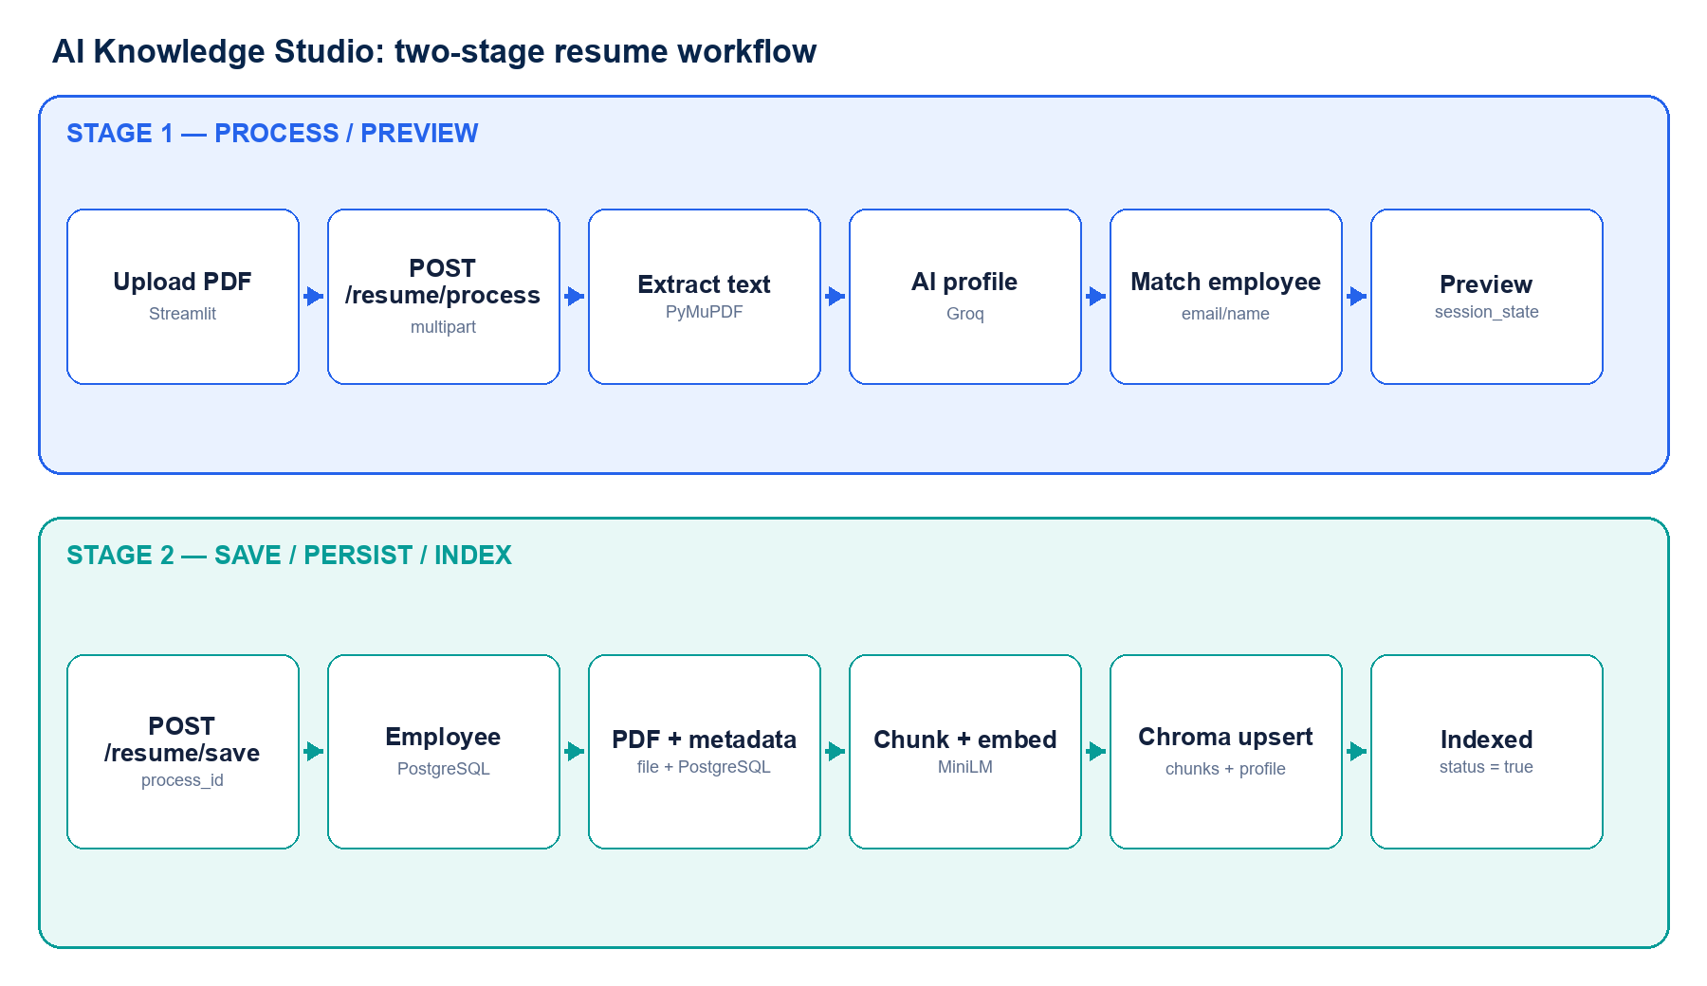
Figure 2 — Resume preview and persistence are separate API transactions.

6.1 Process Resume — POST /resume/process
1 | Streamlit sends the selected PDF as multipart/form-data.
2 | The backend validates the filename, PDF signature, non-empty content and 10 MB limit.
3 | The PDF is written to documents/temp/{process_id}.pdf.
4 | PyMuPDF extracts and cleans text; the text is also written to a temporary file.
5 | Groq receives the resume-extraction prompt and returns a structured profile.
6 | The result is normalized and validated as EmployeeProfileResponse.
7 | ResumeMatcher searches PostgreSQL by email first, then by employee name.
8 | ProcessManager holds the profile, matching result, resume text and temporary paths.
9 | The API returns process_id, match action and profile preview to Streamlit session state.

Persistence boundary
Process Resume does not permanently create or update an employee and does not write a ChromaDB index. It does create temporary files and an in-memory process record.

6.2 Save Employee — POST /resume/save
1 | The UI sends {process_id} from Streamlit session state.
2 | If the resume matched an employee, core employee fields are updated; otherwise a new employee is created.
3 | ResumeFileStorage atomically copies the PDF to documents/resumes/EMP<id>_<Name>.pdf and removes stale employee PDF names.
4 | esia.resume_metadata is inserted or updated with the file path and extracted resume text; embedding_status is set false.
5 | Resume text is cleaned and divided into searchable chunks.
6 | all-MiniLM-L6-v2 creates embeddings for every chunk and the structured profile.
7 | Old Chroma records for the employee are deleted.
8 | employee_resumes receives raw resume chunks; employee_resume_profiles receives the structured profile.
9 | PostgreSQL embedding_status becomes true only after the required Chroma operations succeed.
10 | Temporary PDF/text files and the ProcessManager entry are removed.

7. Resume Knowledge Status

7.1 Page load
1 | GET /resume/ reads all stored resume metadata joined with employee identity.
2 | Streamlit calculates Total, Indexed, Pending and Failed cards.
3 | Search and status filtering run locally against the already-loaded list.
4 | Refresh reruns the page and repeats GET /resume/.

Status meaning
The screen does not query ChromaDB to verify every vector. “Indexed” means esia.resume_metadata.embedding_status=true. Orphaned chunks cannot be calculated until a vector-audit API is implemented.

7.2 Reindex Chroma
1 | POST /resume/{employee_id}/embedding loads resume metadata and resume_text from PostgreSQL.
2 | The request fails if metadata or parsed text is missing.
3 | Resume text is chunked and embedded.
4 | embedding_status is set false before index replacement.
5 | Existing Chroma chunks are deleted and replacement chunks are upserted.
6 | The structured profile is preserved or rewritten when available.
7 | embedding_status is set true only after Chroma indexing succeeds.

8. ESIRA Assistant
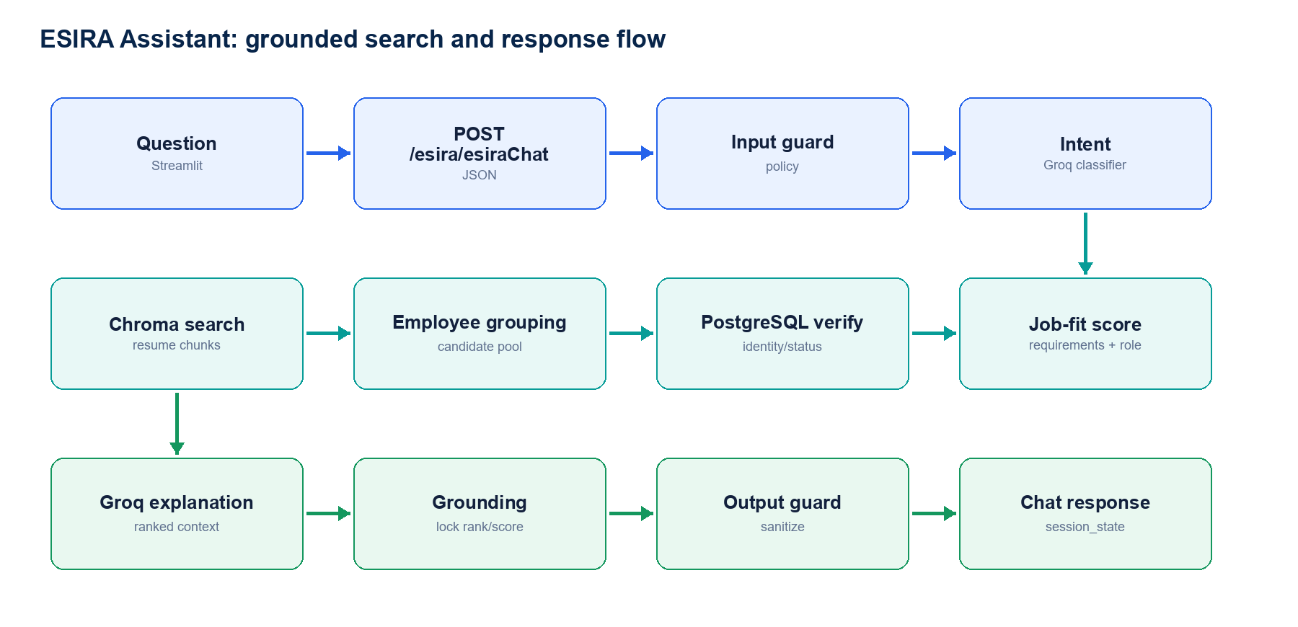
Figure 3 — ESIRA combines semantic retrieval, deterministic ranking and guarded AI explanation.

8.1 Chat request — POST /esira/esiraChat
1 | The UI appends the question to esira_messages and posts {question} to FastAPI.
2 | The LangGraph input guard validates the question.
3 | Groq classifies the request as SEARCH, SUMMARY, COMPARE, GREETING or UNKNOWN.
4 | The graph routes the request to the matching node.
5 | The output is passed through the output guard and sanitized.
6 | FastAPI returns intent, content_type and answer.
7 | The UI appends the response to session state and reruns the chat page.

8.2 SEARCH intent
Step | Component | Action
1 | SearchRepository | Embed the query and retrieve a broad resume-chunk pool from employee_resumes.
2 | SearchService | Group chunks by employee and retain the best semantic distance.
3 | ChromaDB | Load all indexed resume documents for each candidate.
4 | EmployeeRepository | Verify name, designation, experience, employment status and availability.
5 | JobFitScoreService | Calculate deterministic requirements, role, experience and semantic components.
6 | Groq | Generate a human-readable explanation from the ranked context.
7 | Search grounding | Prevent the LLM from changing retrieved identity, rank or score.

Current hybrid score
Default weighting is requirements 60%, role 15% and semantic 25%. When the query explicitly requests experience, experience receives 15% and the active weights are normalized.

8.3 Other intents
Intent | Source and processing
SUMMARY | Loads resume_text from PostgreSQL and asks the configured RAG/LLM provider to summarize it.
COMPARE | Loads two PostgreSQL resume_text values and asks the LLM to compare them.
GREETING | Returns a static capability message.
UNKNOWN | Returns an unsupported-request message.

9. Data ownership
Store | Authoritative content | Written by
PostgreSQL: esia.employees | Employee ID, name, email, designation, experience, location, joining date and employment status. | Resume save / existing employee update.
PostgreSQL: esia.resume_metadata | Resume ID, employee ID, file name, file path, extracted text and embedding status. | Resume save, parse and reindex.
Filesystem: documents/resumes | One deterministic PDF per employee: EMP<id>_<Name>.pdf. | ResumeFileStorage.
ChromaDB: employee_resumes | Cleaned resume chunks, vectors and employee/chunk metadata. | Resume save and reindex.
ChromaDB: employee_resume_profiles | Structured summary, primary skill, skills, projects, training and certifications. | Resume save and profile reindex.
Groq | No ESIA persistence. Used for extraction, intent classification, summary, comparison and explanations. | ProviderFactory-selected LLM provider.

Skill storage policy
Skills and primary skill are not written to esia.skills or another PostgreSQL skill master. They remain inside the ChromaDB structured profile.

10. Streamlit execution behavior
- A widget change reruns the active page from top to bottom.
- Page-load API calls are therefore repeated after filter, pagination and many button interactions.
- st.session_state preserves selected employee, resume preview, process ID and chat history across reruns.
- st.switch_page performs navigation; the destination page makes its own API calls.
- Current page calls are synchronous and generally sequential.
- No caching layer currently protects employee, resume or profile API calls.
Example
Employee Directory performs GET /employees/ and GET /resume/ on each rerun. Employee 360 normally performs three sequential reads on every rerun.

11. Available APIs not wired to the current UI
API | Current status
GET /dashboard | A UI DashboardService exists, but the active Overview page does not use it.
POST /search/resumes | Not called directly; ESIRA invokes SearchService inside the backend.
POST /resume/process-all | Backend bulk reindex endpoint; no current Streamlit action.
POST /resume/{id}/parse | A WorkforceService method exists, but no active page button uses it.
POST /resume/{id}/upload | Direct existing-employee upload endpoint; Knowledge Studio uses process + save instead.
/ai/* | Legacy/direct AI endpoints; the active Assistant uses /esira/esiraChat.

12. Operational observations
Priority | Observation | Operational impact
High | ProcessManager stores process_id state in application memory. | A backend restart or request routed to another worker can invalidate a preview before Save.
High | Resume save is a multi-system workflow, not one distributed transaction. | If Chroma indexing fails after PostgreSQL/file updates, embedding_status remains false and reindex is required.
Medium | Knowledge Status trusts PostgreSQL embedding_status. | It cannot detect missing vectors, orphaned chunks or profile/chunk mismatch.
Medium | Employee 360 performs overlapping employee/profile/resume reads. | The page has additional latency and repeated database queries.
Medium | Overview loads employee data to calculate dashboard aggregates locally. | Counts and analytics can be incomplete when employee volume exceeds the 100-row request.
Low | Employee domain and availability are returned as NULL aliases. | The fields remain blank until their authoritative source is defined and queried.

Appendix A. Implementation reference
Area | Primary implementation
HTTP client | ui/api_client.py
UI API adapter | ui/services/workforce_service.py
Overview | ui/app.py
Employee Directory | ui/pages/1_Employees.py
Employee 360 | ui/pages/2_Employee_360.py
AI Knowledge Studio | ui/pages/3_AI_Knowledge_Studio.py
Knowledge Status | ui/pages/4_Knowledge_Status.py
ESIRA Assistant | ui/pages/5_ESIRA_Assistant.py
FastAPI routes | app/api/employee.py, app/api/resume.py, app/api/esira.py
Resume workflow | app/services/resume_service.py
Employee profile join | app/services/employee_profile_service.py
Chroma access | app/ai/chroma_service.py
Semantic retrieval | app/services/search_service.py
Job-fit score | app/services/job_fit_score_service.py
Graph orchestration | app/graph/esira_graph.py and app/graph/esira_nodes.py

— End of document —

