Person Recognition using Hand shapes

A Project Report

BY
Amit Kumar Gautam
IIT2013200

Under Guaidance of
Dr Satish Kumar Singh

Inspired from:-
Identity verification using shape and geometry of human hands

by-
Shefali Sharma, Shiv Ram Dubey, Satish Kumar Singh, Rajiv Saxena, Rajat Kumar Singh

Acknowledgements

I want to thank Dr Satish Kumar Singh for his immense support and motivation without which I couldnt have coded a single line. He has been best mentor and I think I was lucky for choosing to do project with him. I must also thank Mr Soumyendu Chakraborty and Mr Shivram Dubey for their help in coding. I cannot forget to thank Mr Kush Kumar who helped me and motivated me in hard times. I would also like to pay my gratitude towards team which came up with the idea of hand shaped based person verification which includes Dr Shefali Sharma, Mr Shiv Ram Dubey, Dr Satish Kumar Singh, Mr Rajiv Saxena and Rajat Kumar Singh. I would also like to thank project panel who modified the objective and thus motivated me learn something new from this project. Last but not the least I would also like to thank my classmates who were ready always for any help in making of the project.

Abstract
A multimodal biometric system for personal identity verification is proposed using hand shape and hand geometry in this paper. Shape and geometry features are derived with the help of only contour of the hand image for which only one image acquisition device is sufficient. All the processing is done with respect to a stable reference point at wrist line which is more stable as compared to the centroid against the finger rotation and peaks and valleys determination. Two shape based features are extracted by using the distance and orientation of each point of hand contour with respect to the reference point followed by wavelet decomposition to reduce the dimension. Seven distances are used to encode the geometrical information of the hand. Shape and geometry based features are fused at score levels and their perfor- mances are evaluated using standard ROC curves between false acceptance rate, true acceptance rate, equal error rate and decidability index. Different similarity measures are used to examine the accuracy of the introduced method. Performance of system is analyzed for shape based (distance and orientation) and geometrical features individually as well as for all possible combinations of feature and score level fusion.

Introduction
Biometrics has gained lot of interest among researchers because of its exponentially growing applications in several areas and its being highly reliable and dependable as far as security is concerned. Different physiological and behavioral traits are used for biometric authentication. Hand based biometrics is considered in this research due to its advantages of low cost, low computational complexity, low template size and more user friendly. Uni-modal systems face major problems of noisy data and intra-class variations (Mansoor, Masood, & Mumtaz, 2011). Such problems can easily be reduced by developing multimodal biometric systems.

Researchers have reported various new multi-model biometric systems based on the hand geometry, hand shape and their combinations with other biometrics in literature. Hand shape and hand geometry are widely adopted because these can be easily captured with any image capturing device. Moreover, the JUET database used in this paper are created using a simple document scanner. Basically hand shape characterizes the boundary of the hand (i.e. relation of one point with other points at the silhouettes), whereas, the hand geometry characterizes the relation of one part of the hand with other part such as relation between the length of fingers, palm, hand etc. The hand shape and hand geometry only requires the contour of the hand as input. It provides more flexibility to the users and also the number of points to be processed (i.e. only contour points) becomes small which decrease the time complexity of the algorithm. The main problem with the hand shape and hand geometry is that the hand contour can differ too much with the movement of the fingers which is solved in this paper by adopting the finger registration concept.

Proposed Work
OpenCV is being used along with python. Python frameworks are also used extensivley specially numpy and tkinter. Hand features are extracted using both numpy and OpenCV.

Extraction of binary Image
First module was designed using opencv, PIL and tkinter which determines the best threshold for extraction of binary image containing palm area only using 6 sliders which are used to determine lower and upper RGB values dynamically. It is found that HSV color space works best for binary image extraction because it is illumination invariant. Below image describes working module.
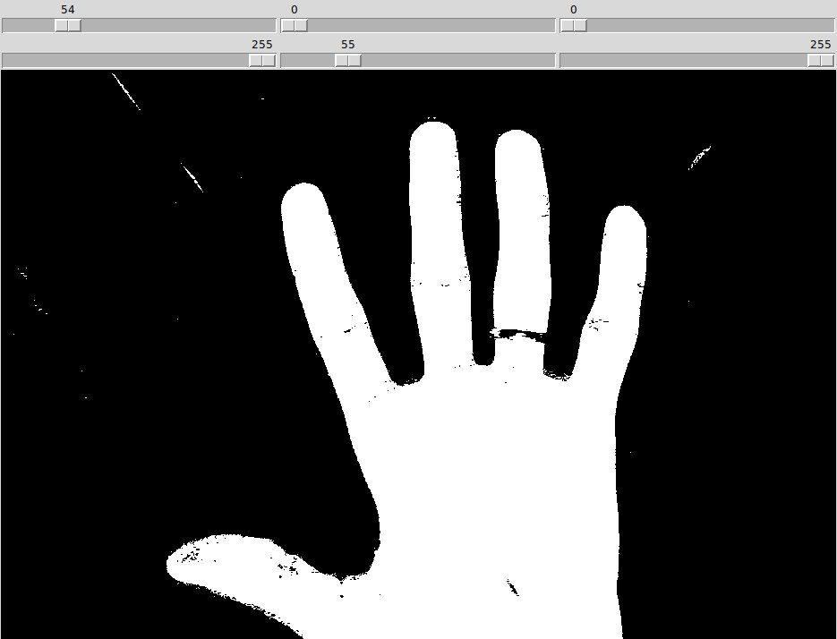

Rectifying Errors
As we can see that there are many glitches and errors which must be removed in order to proceed forward. These errors will be removed using contour feature available in OpenCV library. When we try to take contour of all white pixels then many such contours are available. Contour with biggest area is longing one while others are noise. We will sort these contours according to increasing area and make all countours black except the biggest one. In this way we can get rid of white noise present in binary image. Similar approach will be required to remove the black noise inside the palm area. Resultant binary image will be the below one.
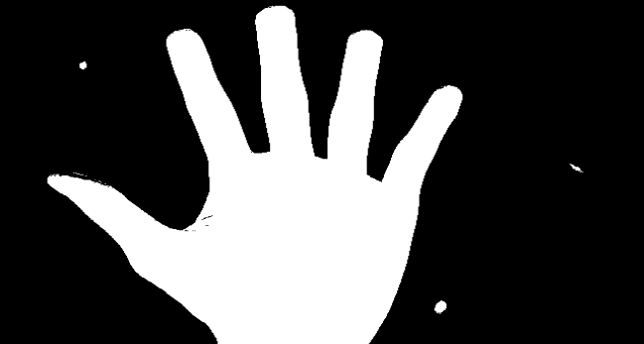

Identifying Contour
cv2.findContours() function will return the contour which is our only requirement for next steps of algorithm. Better extraction of contour will yeild better results. Below is the example contour from same database.

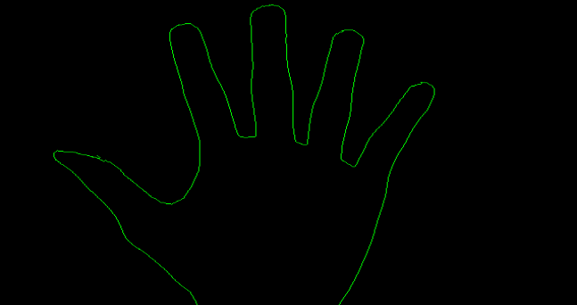

Determining convex hull and convexity defects
This contour will be required to obtain the convex hull of contour. Using convex hull and contour we will obtain convexity defects. Convexity defects are the points lying on contour who are either nearest to contour or farthest to contour in their locality. Below image shows convex hull and convexity defects plotted in single image.
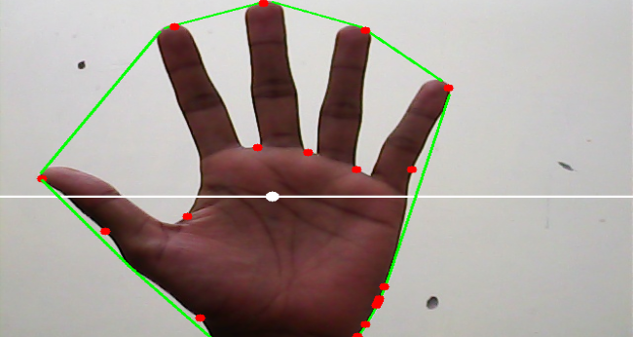

Extraction of Points
As we are trying the extract the fingertips and points between two finger joints. Convexity defects lying in upper portion of moment of contour are the longing and rest can be ignored. Moment is shown as white dot and line horizonal to it describes that points above it are the suitable ones. We can also see that point with minima between forefinger and thumb is ignored in this procedure. We will extract this point separetely assuming that this is the point with minimum distance from moment of contour below the moment. All ten extracted points are shown in the below image.

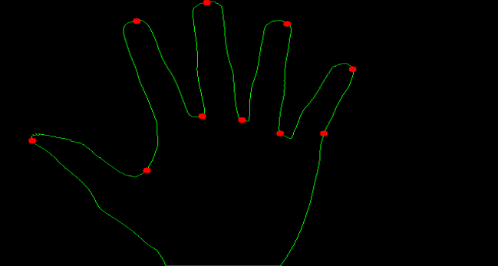

Encoding of points

