A Project Report on

APEX REALTY AI

California Housing Price Prediction Using Machine Learning
Submitted in partial fulfillment of the requirements for
Bachelor of Computer Applications (Data Analytics)
MACHINE LEARNING LAB
Paper Code: BCADA 5P 126
Submitted by
Student 1: Suzanne P Register No.: 241BCADA04
Student 2: Anushka Kalahasthi Register No.:241BCADA07
Student 3: Gautami V Desai Register No.: 241BCADA08
Student 4: Sania Jeswin Register No.: 241BCADA09
Student 5: Annie Maria T Register No.: 241BCADA11
Student 6: Sindhu L Register No.: 241BCADA68

ST. JOSEPH'S UNIVERSITY, BENGALURU - 27
DEPARTMENT OF ADVANCED COMPUTING
ACADEMIC YEAR: 2026-2027

CERTIFICATE
This is to certify that the project titled
“APEX REALTY AI: CALIFORNIA HOUSING PRICE PREDICTION USING MACHINE LEARNING ”
has been successfully completed as part of the Machine Learning Lab (Paper Code: BCADA 5P 126) prescribed by ST. JOSEPH'S UNIVERSITY, under the Department of Advanced Computing, Bachelor of Computer Applications (Data Analytics) programme during the academic year 2026-2027.

Signature of the Teacher in-charge | Head of the Department
____________________________ | ____________________________

DECLARATION
We hereby declare that the project report titled “APEX REALTY AI: CALIFORNIA HOUSING PRICE PREDICTION USING MACHINE LEARNING” submitted for the Machine Learning Lab (BCADA 5P 126), Bachelor of Computer Applications (Data Analytics), is a record of the work carried out by our group. The work presented in this report has not been submitted elsewhere for any other academic award.
We further declare that all datasets, libraries, external references, code resources and AI-assisted tools used during the project have been appropriately acknowledged wherever applicable.

Place: Bengaluru
Date: 01/10/2026
Signatures of Students:
1. ______________________________
2. ______________________________
3. ______________________________
4. ______________________________
5. ______________________________
6. ______________________________

ACKNOWLEDGEMENT
We would like to express our sincere gratitude to St. Joseph's University, Bengaluru, and the Department of Advanced Computing for providing us with the opportunity to undertake this project as part of the Machine Learning Lab.
We are deeply thankful to our faculty members for their guidance, support, and valuable feedback throughout the course of this project. Their guidance helped us develop a better understanding of machine learning concepts and their practical applications.
We would also like to thank our team members for their cooperation, contribution, and coordination throughout the various stages of the project. The collaborative effort of the team played an important role in completing the project successfully.
This project has been a valuable learning experience and has helped us strengthen our understanding of machine learning, data analysis, visualization, problem-solving, and teamwork.

ABSTRACT
Apex Realty AI is a machine learning project developed to predict median housing values using the California Housing dataset. The project focuses on analyzing housing and demographic information to explore the relationship between various features and median house values. The dataset contains 20,640 observations, eight numerical input features and one target variable, MedHouseVal, representing the median house value of each census block group.
The project follows a structured machine learning workflow consisting of dataset collection, data understanding, data quality assessment, preprocessing, exploratory data analysis, model development and evaluation. The preprocessing stage includes checking for missing values, duplicate records, invalid observations and potential outliers using the Interquartile Range (IQR) method. The dataset was divided into training and testing sets using an 80:20 split, and the input features were standardized using Scikit-learn's StandardScaler. Potential outliers were recorded for inspection rather than automatically removed.
The prepared dataset was then used for training and evaluating the regression models selected by the project team. Model performance was assessed using the evaluation metrics implemented in the final workflow, with the aim of understanding prediction errors and comparing model performance. A visualization dashboard was also developed to present selected housing data insights and project findings.
The project demonstrates the application of machine learning techniques to a real-world regression problem and provides practical experience in data preparation, model development, performance evaluation and collaborative project implementation. As the dataset is based on historical 1990 census information, the resulting predictions are intended for academic analysis and should not be treated as current real estate valuations.
Keywords: California Housing, Machine Learning, Regression, Data Preprocessing, Housing Price Prediction

CONTENTS
1. INTRODUCTION
1.1 Overview of the Project
1.2 Problem Statement
1.3 Objectives of the Project
1.4 Scope of the Project
1.5 End User / Stakeholder and Project Value
2. DATASET AND DATA UNDERSTANDING
2.1 Dataset Description
2.2 Dataset Source
2.3 Features / Variables and Target
2.4 Class Distribution / Data Distribution
2.5 Dataset Limitations
3. DATA PREPARATION AND EXPLORATORY DATA ANALYSIS
3.1 Data Cleaning
3.2 Preprocessing
3.3 Feature Extraction / Feature Engineering
3.4 Exploratory Data Analysis
3.5 Key Insights from EDA
4. MACHINE LEARNING METHODOLOGY
4.1 ML Problem Type
4.2 Train-Test / Validation Strategy
4.3 Algorithms / Models Used
4.4 Model Training
4.5 Hyperparameter Tuning
4.6 Mathematical / Statistical Concepts Used
5. MODEL EVALUATION AND RESULTS
5.1 Evaluation Metrics
5.2 Model Comparison
5.3 Final Model Selection
5.4 Error Analysis / Confusion Matrix / Residual Analysis
5.5 Interpretation of Results
6. DASHBOARD / VISUALISATION AND IMPLEMENTATION
6.1 Dashboard / Visualisation
6.2 Important KPIs / Insights
6.3 Prediction / Application Workflow
6.4 Sample Input and Output
7. CHALLENGES, LIMITATIONS AND IMPROVEMENTS
7.1 Challenges Faced
7.2 Approaches That Did Not Work
7.3 Current Limitations
7.4 Future Improvements
8. TEAM CONTRIBUTION AND LEARNING
8.1 Team Roles and Contributions
8.2 Skills / Learning Outcomes
9. CONCLUSION
10. REFERENCES / BIBLIOGRAPHY
11. APPENDICES

1. INTRODUCTION

1.1 Overview of the Project
Housing price prediction is an important application of data analysis and machine learning in the real estate domain. Housing values are influenced by several factors, including household income, housing characteristics, population and geographical location. Understanding how these factors relate to housing values can help analysts examine patterns in the real estate market.
The project, Apex Realty AI, applies machine learning techniques to the California Housing dataset to predict median house values based on selected numerical features. The dataset includes information about census block groups in California and was originally collected from the 1990 U.S. census.
The project involves examining the dataset, assessing its quality, preparing the data for machine learning, training regression models and evaluating their predictions. A dashboard is also used to visualize relevant housing data and present findings in a more accessible format.
This project provides practical experience in the complete machine learning workflow, including data preparation, exploratory data analysis, model development, evaluation and visualization.

1.2 Problem Statement
Housing values are influenced by several variables, and analyzing their relationships can be challenging when working with large datasets. This project addresses the problem of predicting median housing values using available demographic, housing and geographical information.
The input to the system consists of eight numerical features: median income, house age, average rooms, average bedrooms, population, average occupancy, latitude and longitude. The expected output is a predicted median house value for an observation with the given input features.
The project uses supervised regression techniques to learn relationships from the historical California Housing dataset. The aim is to develop and evaluate models that can estimate median house values and analyze their prediction performance.

1.3 Objectives of the Project
- To understand and explore the California Housing dataset and its numerical features.
- To perform data quality assessment and prepare the dataset for machine learning.
- To analyze feature distributions and relationships through exploratory data analysis.
- To train and compare machine learning regression models for predicting median house values.
- To evaluate model performance using appropriate regression metrics.
- To visualize relevant dataset information and findings using a dashboard.

1.4 Scope of the Project
The scope of the project includes the collection and preparation of the California Housing dataset, data quality checks, exploratory data analysis, feature scaling, model training and model evaluation.
The project focuses on estimating median house values for California census block groups based on the eight input features included in the dataset. The workflow also includes visualization of relevant insights and the documentation of the team's development process.
The project does not provide verified current market prices, individual property valuations or predictions for locations outside the dataset's geographical coverage. The dataset is historical, and the project does not claim that its predictions can directly represent present-day real estate conditions.

1.5 End User / Stakeholder and Project Value
Potential stakeholders include students, academic researchers and data analysts interested in applying machine learning to housing data. The project can also serve as an educational demonstration of how numerical and geographical variables can be used to develop regression models.
The project's academic value lies in providing practical experience with data cleaning, outlier detection, feature scaling, regression model development, evaluation and visualization. Its dashboard component can help users explore housing data and understand selected patterns in the dataset.
The project is a prototype for learning and analysis, not a validated property valuation service. Its predictions should be interpreted within the limitations of the historical dataset.

2. DATASET AND DATA UNDERSTANDING

2.1 Dataset Description
The California Housing dataset is a numerical tabular dataset containing housing and demographic information for California census block groups. It is used in this project as the source of input features and target values for supervised regression.
The dataset contains 20,640 observations, eight input features and one target variable. Each observation represents a census block group and contains summary statistics related to housing, population and geographical location.
Dataset property | Details
Dataset name | California Housing
Domain | Housing and real estate
Number of records | 20,640
Number of input features | 8
Target variable | MedHouseVal
Problem type | Supervised regression
Data format | Numerical tabular data
Original collection period | 1990 census

2.2 Dataset Source
Dataset Name: California Housing Dataset
Source / URL: fetch_california_housing — scikit-learn 1.9.1 documentation
Access Date: 13 September 2026

2.3 Features / Variables and Target
The dataset includes eight independent input features and one dependent target variable. The input features describe housing characteristics, income, population and geographical location.
Feature | Description
MedInc | Median income of households in the block group, expressed in tens of thousands of dollars
HouseAge | Median house age in the block group
AveRooms | Average number of rooms per household
AveBedrms | Average number of bedrooms per household
Population | Population of the block group
AveOccup | Average household occupancy
Latitude | Geographic latitude
Longitude | Geographic longitude
MedHouseVal | Target: median house value

2.4 Class Distribution / Data Distribution
As this is a regression problem, the target variable is continuous rather than divided into predefined classes. The distribution of MedHouseVal and the input features was therefore examined using numerical summaries and visualizations.
Descriptive statistics were used to examine the mean, standard deviation, minimum, maximum and quartiles of the variables. These statistics provide an overview of the spread and scale of the dataset.
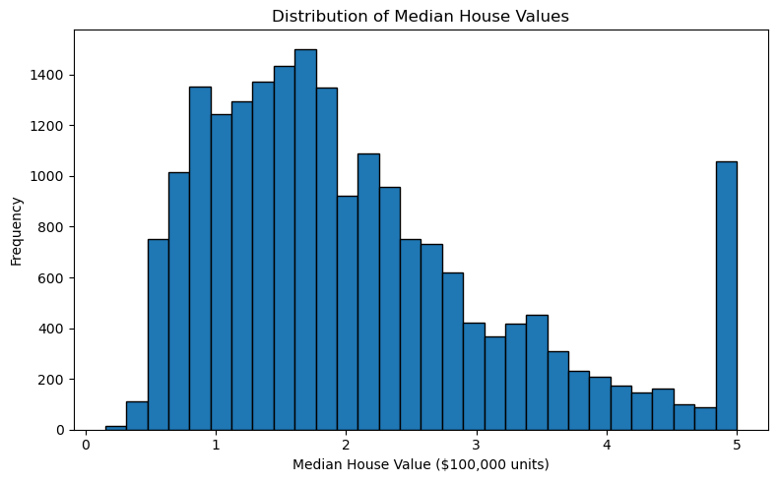
Interpretation: The histogram illustrates how the median house values are distributed among the census block groups in the dataset. It can be used to observe where the target values are concentrated and whether the distribution contains a long tail or unusually high values. Describe the actual pattern shown in your graph.
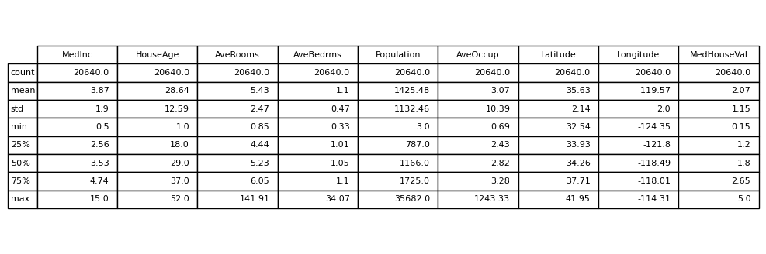
The descriptive statistics provide information about the central tendency and spread of each numerical feature. They also show the different numerical ranges of the variables, supporting the need to examine feature scaling before model development.

2.5 Dataset Limitations
The California Housing dataset has several limitations that are important when interpreting the model's results.
- Historical information: The dataset is based on 1990 census data and does not represent current housing market conditions.
- Geographical limitation: The dataset covers California and may not generalize to other locations.
- Aggregated observations: The observations represent census block groups rather than individual houses, so property-specific details are not available.
- Limited input features: The dataset does not include all possible factors affecting house values, such as individual property condition, current demand or recent interest rates.
- Potential outliers: Some numerical values are flagged by the IQR method and require careful interpretation.
- Target limitations: The target represents historical median house values at block-group level, not a verified selling price for a particular property.
These limitations should be considered when assessing model performance and deciding whether the model can be applied to other datasets or present-day housing data.

3. DATA PREPARATION AND EXPLORATORY DATA ANALYSIS

3.1 Data Cleaning
Data cleaning was performed to assess the quality of the dataset before model training. The main checks included missing values, duplicate records, invalid observations and potential outliers.
The dataset was loaded into a Pandas DataFrame for analysis. Data-quality checks were carried out to identify incomplete or repeated records and examine unusual numerical values.

Missing-value check
The dataset was checked for null values in each column. The check returned zero missing values. Therefore, no missing-value imputation was required in the implemented preprocessing workflow.

Duplicate-record check
The dataset was checked for duplicate rows to determine whether any observations were repeated. The check returned zero duplicate records. No duplicate removal was required.

Invalid-value check
The implemented data-quality checks were used to identify invalid observations according to the project's selected validation rules. No invalid values were reported by these checks.

Outlier detection
The Interquartile Range method was used to identify potential outliers in the numerical features and target variable.
The IQR is calculated as:
IQR=Q3−Q1
The lower and upper bounds are:
LB=Q1−1.5(IQR)
UB=Q3+1.5(IQR)
Observations below the lower bound or above the upper bound were flagged as potential outliers.
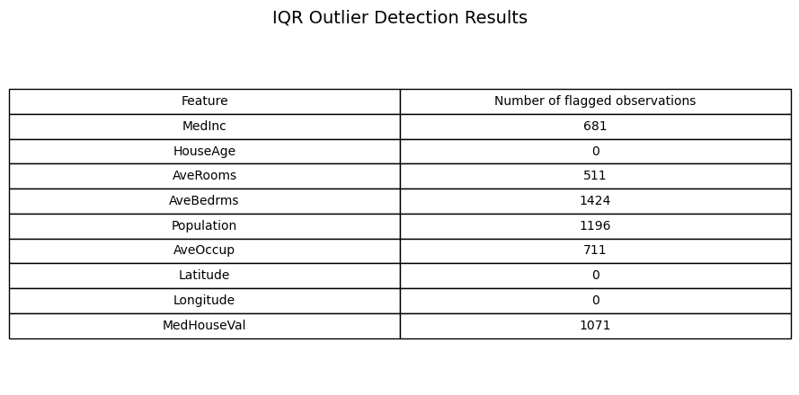
The IQR method identified 5,594 feature-level flags. This total represents the number of flags across the individual variables and does not necessarily represent the number of unique rows, as an observation can be flagged in multiple columns.
The highest number of flagged observations was found in AveBedrms, followed by Population. These flags were recorded for further consideration rather than automatically removed. An observation outside the IQR bounds may represent an unusual but valid characteristic of a census block group rather than a data-entry error.
Data cleaning summary
Check | Result
Missing values | 0
Duplicate records | 0
Invalid values | 0
Potential outlier flags | 5,594
Automatic outlier removal | Not performed

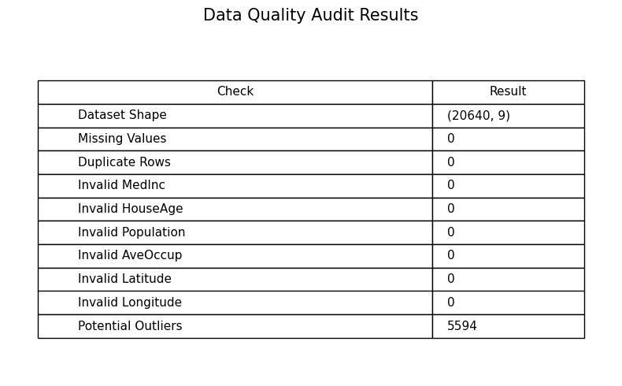
The data quality audit log records the results of the checks performed during preprocessing. It provides a reference for understanding the initial condition of the dataset and helps document the steps taken before model training.

3.2 Preprocessing
[Explain scaling, normalization, encoding, text/image/audio preprocessing, etc., as applicable.]
Preprocessing was performed to transform the dataset into a suitable format for machine learning. The process included separating input and target variables, dividing the data into training and testing sets, standardizing the features and saving the processed data.

Separation of input and target variables
The eight independent variables were assigned to the input matrix, while MedHouseVal was assigned to the target vector.
The input features were:
MedInc, HouseAge, AveRooms, AveBedrms, Population, AveOccup, Latitude and Longitude.
The target variable was MedHouseVal.

Train-test split
The dataset was divided into 80% training data and 20% testing data using Scikit-learn's train_test_split() function. The random state was set to 42 to make the split reproducible.

Dataset portion | Number of observations
Total | 20,640
Training set (80%) | 16,512
Testing set (20%) | 4,128

The training set was used for model fitting, while the testing set was kept separate for evaluating model performance on observations not used during training.

Feature scaling
StandardScaler was used to standardize the numerical input features. This transforms each feature based on its mean and standard deviation.
Standardization Formula:
z = $\frac{x-μ}{σ}$
Where:
• x is the original feature value.
• μ is the mean calculated from the training data.
• σ is the standard deviation calculated from the training data.
• z is the standardized feature value.
The scaler was fitted only on the training features and then used to transform both the training and testing data. This prevented the test data from contributing to the calculation of the scaling parameters.

Saving processed data
After preprocessing, the training and testing datasets were saved for use by the other team members.
The generated files included:
- data/processed/train_processed.csv
- data/processed/test_processed.csv
- data_quality_audit.csv
The processed files helped maintain consistency between the preprocessing and model development stages.

3.3 Feature Extraction / Feature Engineering
The project used the eight numerical features available in the original California Housing dataset. Since the dataset was already structured, additional feature extraction was not required.
The preprocessing stage involved separating the input features from the target variable and applying standardization to the input variables. The original features were retained without creating additional derived variables.
The geographical variables Latitude and Longitude were also preserved because they provide location information that may be useful for identifying spatial patterns in housing values.

3.4 Exploratory Data Analysis
Exploratory Data Analysis (EDA) was performed to understand the statistical characteristics, distributions, relationships and potential anomalies in the California Housing dataset before machine learning model development. Statistical summaries including mean, median, standard deviation, minimum and maximum values were analysed for the numerical variables. Skewness and coefficient of variation were also examined to understand the distribution and relative variability of the features.

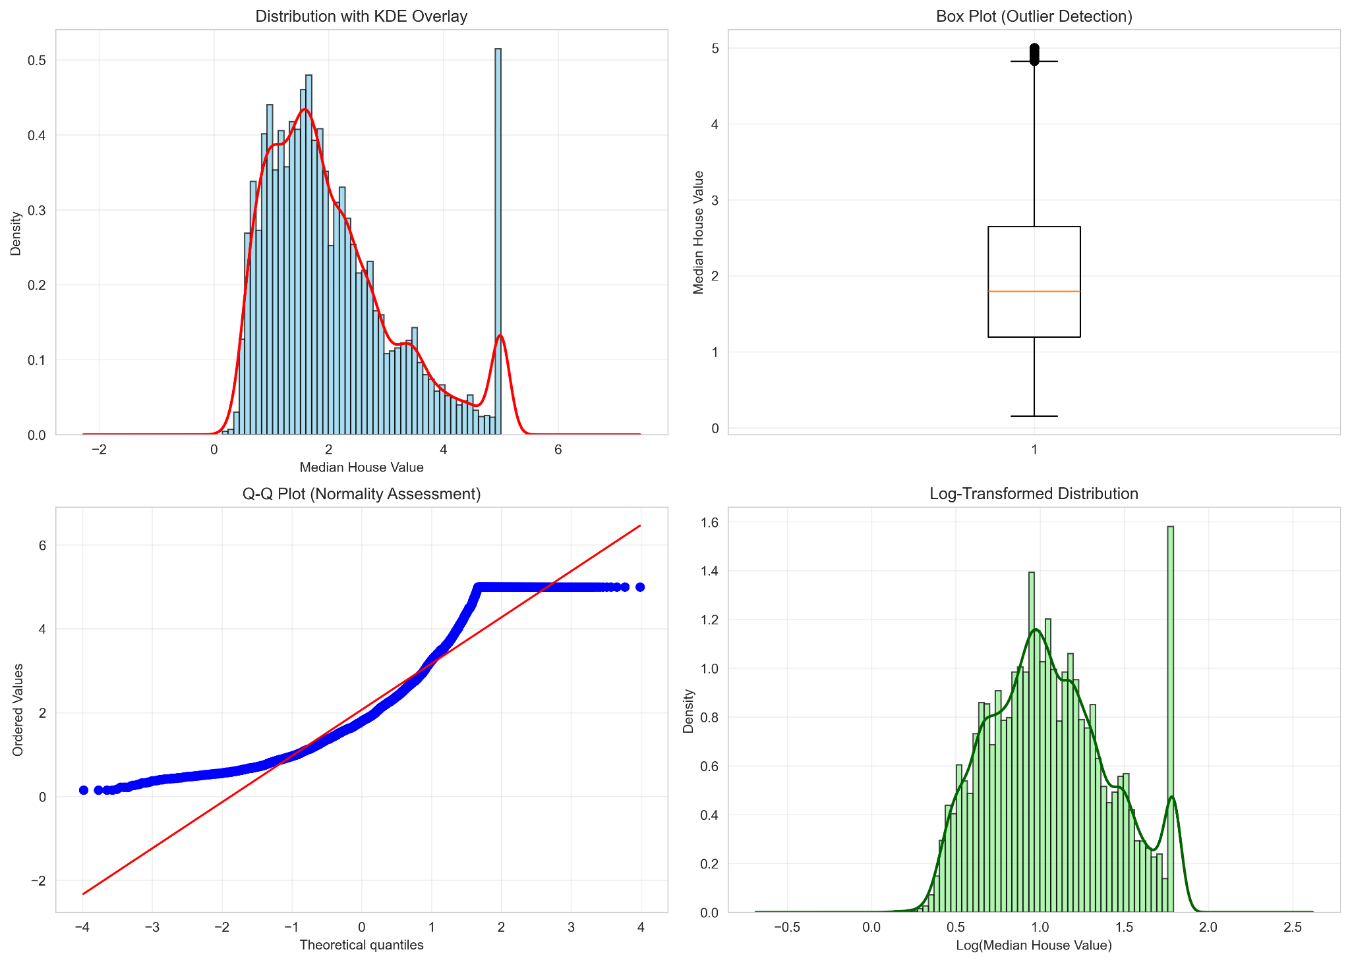
Figure 1: Distribution, Outlier and Normality Analysis of Median House Value
The distribution of MedHouseVal shows positive skewness, indicating that a larger number of observations are concentrated at lower and middle house-value ranges, with a smaller number of higher-valued observations. The box plot identifies several potential high-value outliers. The Q-Q plot also indicates that the target variable does not follow a normal distribution. A log transformation was examined to reduce the skewness of the target variable and produce a more balanced distribution.
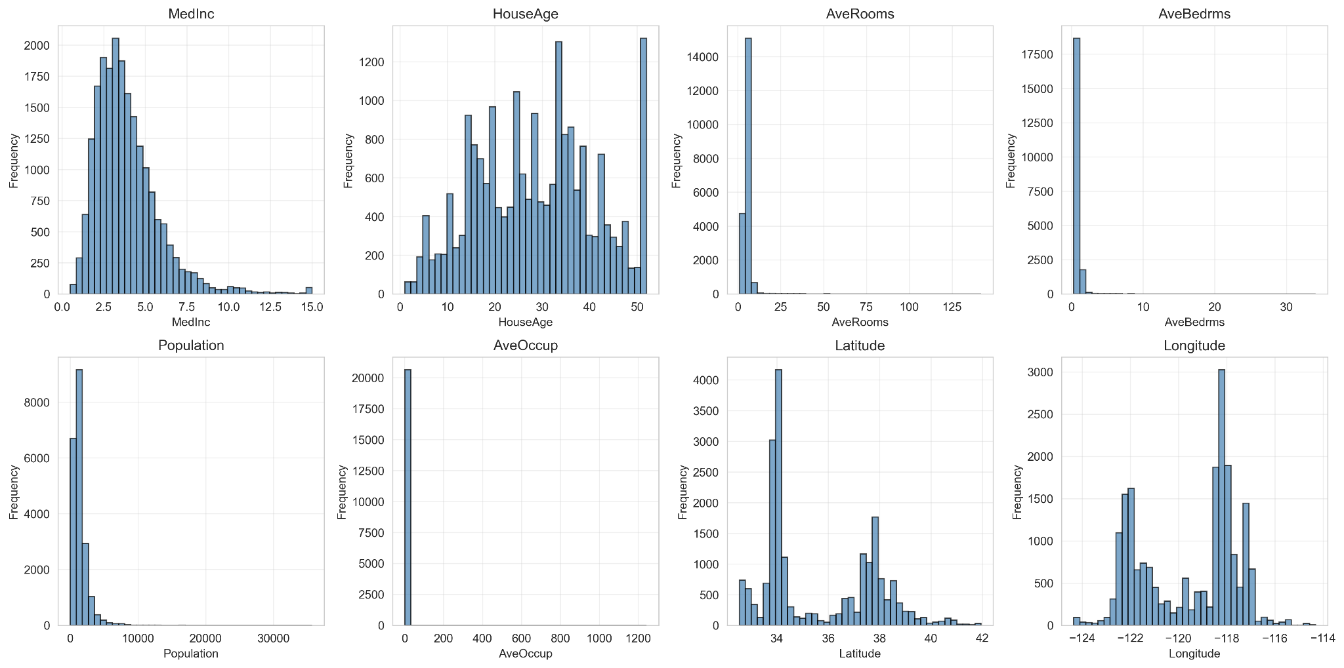
Figure 2: Distribution of Input Features

The input features show different distribution patterns and levels of variability. MedInc is positively skewed, while Population, AveOccup, AveRooms and AveBedrms show substantial right-skewness. Latitude and Longitude show geographic distributions specific to the California Housing dataset. These distributions were examined to understand the characteristics of the variables before model development.
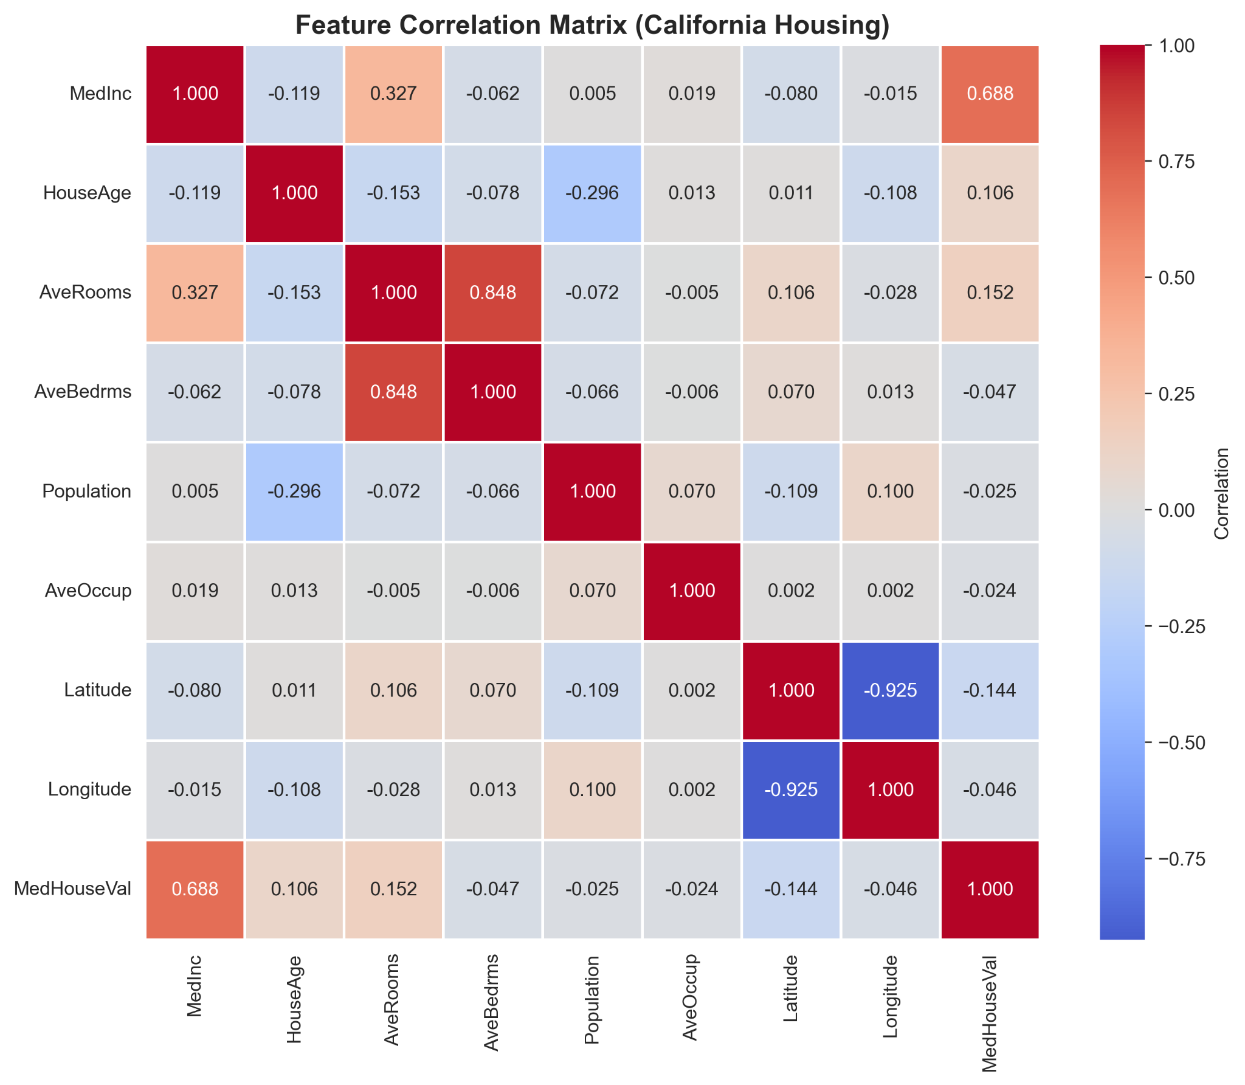
Figure 3: Correlation Matrix of Features and Median House Value

The correlation matrix shows that MedInc has the strongest positive correlation with MedHouseVal, with a correlation coefficient of approximately 0.688. Latitude has a weaker negative correlation of approximately -0.144, while Longitude has a correlation of approximately -0.046. The heatmap also shows a strong correlation of approximately 0.848 between AveRooms and AveBedrms, indicating a strong relationship between these two features.

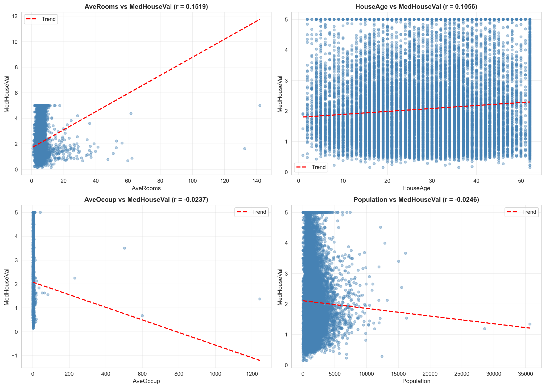
Figure 4: Relationships Between Selected Features and Median House Value
The scatter plots show the relationships between selected numerical features and MedHouseVal. HouseAge and AveRooms show weak positive relationships with the target, while AveOccup and Population show very weak negative relationships. The plots also show considerable variation in house values for individual feature values, indicating that these variables alone do not fully explain house-value variation.

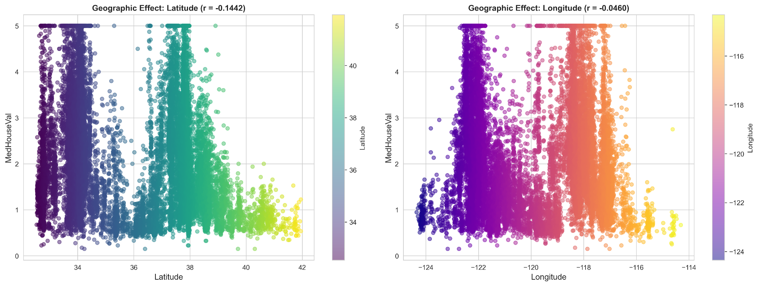
Figure 5: Geographic Relationship Between Location and Median House Value
The geographic analysis shows variation in median house values across different latitude and longitude locations. Latitude has a correlation of approximately -0.1442 with MedHouseVal, while Longitude has a much weaker correlation of approximately -0.0460. This indicates that geographical location provides additional information about house values, although its individual linear relationship with the target is weaker than that of MedInc.

3.5 Key Insights from EDA

Insight 1 – Income and Geography
Income is strongly associated with house value, while geographic variables also provide additional information. MedInc showed the strongest correlation with MedHouseVal at approximately 0.6881. Latitude showed a weaker negative correlation of approximately -0.1442, while Longitude showed a correlation of approximately -0.0460. This indicates that both socioeconomic and geographic variables are relevant when analysing house values.

Insight 2 – Skewed Variables
Several variables show strong right-skewness. The target variable had a skewness of approximately 0.9777. After applying a log1p() transformation, the skewness decreased to approximately 0.2759. AveOccup and Population also showed high skewness, indicating that transformations may be useful during model development.

Insight 3 – Outliers Can Represent Real Observations
Potential outliers should not automatically be treated as errors. The IQR method identified 1,071 potential outliers in MedHouseVal. These observations were retained because statistical outlier detection alone does not establish that an observation is invalid. Extreme housing values may represent genuine high-value properties and therefore can contain useful information for the model.

4. MACHINE LEARNING METHODOLOGY

4.1 ML Problem Type
This is a regression problem. The target variable, MedHouseVal (median house value per California census block group), is a continuous numeric quantity rather than a discrete class label, so the task is to predict a real-valued output — not to assign a category. This rules out classification-specific tools (accuracy, confusion matrices, class balancing) and instead calls for continuous-error metrics such as RMSE, MAE, and R².

4.2 Train-Test / Validation Strategy
The dataset was split 80% training / 20% test using train_test_split with random_state=42, ensuring the partition is exactly reproducible across every team member's run. Stratification was not applied: stratified splitting preserves class-label proportions across a split, which is only meaningful for classification targets; since MedHouseVal is continuous with no discrete classes, a plain random split is the standard and appropriate choice.
For model comparison and hyperparameter tuning, 5-fold cross-validation (KFold, shuffle=True, random_state=42) was used on the training set only. Each model was trained on 4 folds and evaluated on the 5th, repeated 5 times, so every fold served as validation data exactly once.
Data leakage was prevented at three points:
- The StandardScaler was fit exclusively on the training split (fit_transform on train, transform only on test) — test-set statistics never influenced feature scaling.
- Cross-validation and hyperparameter tuning used only the training set; the test set was not touched until the single, final evaluation in Section 5.
- Before finalizing, an automated check confirmed the train and test index sets share zero overlapping rows, and that a self-contained inference pipeline (scaler + model bundled together) reproduces identical predictions to the training-time pipeline — preventing any train/serve inconsistency during handoff to deployment.

4.3 Algorithms / Models Used
Seven models were evaluated, deliberately spanning the bias-variance spectrum rather than selected arbitrarily:
Model | Role in the comparison
Baseline (Mean) | Predicts the average target value regardless of input; establishes the minimum performance any real model must exceed to justify its complexity
Linear Regression | Simplest model that uses the actual features; tests whether the relationship between features and price is approximately linear
Ridge Regression | Linear Regression with L2 regularization; tests whether penalizing large coefficients (useful when features are correlated) improves generalization
Decision Tree | An unconstrained, single tree; included specifically to demonstrate the overfitting failure mode (near-zero training error, poor generalization)
Random Forest | An ensemble of many trees trained on bootstrapped samples, averaged together; reduces the single tree's overfitting via variance reduction (bagging)
LightGBM | Gradient boosting with leaf-wise tree growth; builds trees sequentially, each correcting the previous ensemble's residual errors
XGBoost | Gradient boosting with level-wise tree growth; included alongside LightGBM since the two use different growth strategies and either can outperform the other depending on the dataset's structure

4.4 Model Training
Workflow: cleaned data was loaded, split, and scaled (Section 4.2). All seven models were then evaluated identically via cross_validate() with return_train_score=True, recording RMSE, MAE, and R² on both validation folds and training folds. Results were compiled into a single comparison table (Section 5.2), and the model with the lowest mean cross-validation RMSE was selected for tuning.
Libraries used: pandas and numpy for data handling; scikit-learn for splitting, scaling, cross-validation, baseline/linear/tree models, and search utilities (KFold, cross_validate, GridSearchCV, RandomizedSearchCV, StandardScaler, Pipeline); lightgbm and xgboost for the two gradient boosting implementations; joblib for model serialization; matplotlib for residual and diagnostic visualization.

4.5 Hyperparameter Tuning
LightGBM was selected as the top candidate by cross-validation RMSE and tuned using RandomizedSearchCV (n_iter=20, same 5-fold CV, scoring = negative RMSE) over six hyperparameters: n_estimators, learning_rate, num_leaves, max_depth, subsample, and colsample_bytree.
Randomized search was chosen over grid search for this model specifically because of the size of its hyperparameter space. With 6 hyperparameters at roughly 4-5 candidate values each, an exhaustive grid would require several thousand model fits — computationally impractical. Randomized sampling of a fixed number of combinations (20) covers a comparable breadth of the search space at a small fraction of the cost. By contrast, models with only one or two hyperparameters (Ridge's alpha; Decision Tree's max_depth and min_samples_leaf) used exhaustive GridSearchCV, since their small search spaces made a complete search computationally cheap and guaranteed to find the best combination within the specified grid. The search method was therefore matched to each model's hyperparameter space size, not applied uniformly.

4.6 Mathematical / Statistical Concepts Used
- RMSE (Root Mean Squared Error): √(mean of (actual − predicted)²). Penalizes large errors disproportionately due to squaring, making it sensitive to big misses.
- MAE (Mean Absolute Error): mean of |actual − predicted|. Treats all errors linearly regardless of size, giving a more intuitive "typical error" figure than RMSE.
- R² (Coefficient of Determination): 1 − (sum of squared residuals / total variance in the target). Represents the proportion of variance in the target explained by the model; ranges from 0 (no better than predicting the mean) to 1 (perfect fit).
- Bias-Variance Tradeoff: bias is error from a model's assumptions being too rigid to capture the true pattern (underfitting — both training and validation error remain high); variance is error from a model being too sensitive to the specific training sample (overfitting — training error is very low but validation error is high). The Bias-Variance Gap (CV RMSE − Train RMSE) was used as a direct, quantitative diagnostic of where each model sits on this spectrum.
- Gradient Boosting mechanism: each new tree is trained to predict the residual errors of the current ensemble rather than the raw target — for squared-error loss, this residual is mathematically the negative gradient of the loss function with respect to the current predictions, which is where the "gradient" in gradient boosting comes from. Each tree is thus a small, targeted correction rather than an independent guess.

5. MODEL EVALUATION AND RESULTS

5.1 Evaluation Metrics
RMSE, MAE, and R² were used — standard metrics for regression problems. Accuracy was not used, since it is a classification-only concept (percentage of exactly-correct predictions) that has no meaningful definition for a continuous target. RMSE was treated as the primary metric for model selection since it penalizes large mispredictions more heavily — appropriate here, as a large single error (e.g., a severely mispriced property) carries disproportionate real-world cost for a valuation business. MAE was reported alongside it for an easily interpretable "typical error in dollars" figure, and R² was reported to express performance on a normalized, scale-free basis.

5.2 Model Comparison
5-fold cross-validation results on the training set (sorted by CV RMSE):
Algorithm | CV RMSE (Mean) | CV RMSE (Std) | Train RMSE (Mean) | Bias-Variance Gap | CV MAE (Mean) | CV R² (Mean)
LightGBM | 0.4713 | 0.0122 | 0.3869 | 0.0844 | 0.3156 | 0.8338
XGBoost | 0.4739 | 0.0083 | 0.2522 | 0.2218 | 0.3158 | 0.8319
Random Forest | 0.5109 | 0.0119 | 0.1913 | 0.3196 | 0.3349 | 0.8047
Ridge Regression | 0.7205 | 0.0139 | 0.7196 | 0.0009 | 0.5291 | 0.6115
Linear Regression | 0.7205 | 0.0139 | 0.7196 | 0.0009 | 0.5291 | 0.6115
Decision Tree | 0.7337 | 0.0282 | ~0.0000 | 0.7337 | 0.4727 | 0.5966
Baseline (Mean) | 1.1562 | 0.0122 | 1.1562 | ~0.0000 | 0.9139 | ~0.0000

5.3 Final Model Selection
LightGBM was selected, on the basis of multiple converging pieces of evidence rather than a single top score:
- It achieved the lowest CV RMSE (0.4713) among all seven candidates.
- Its Bias-Variance Gap (0.0844) is small relative to Random Forest (0.3196) and Decision Tree (0.7337), indicating it is not merely fitting training noise — it generalizes well rather than memorizing.
- After hyperparameter tuning, its CV RMSE improved further to 0.4412, confirming the tuning process added genuine value rather than overfitting to the search.
- Critically, its final test-set RMSE (0.4315) was not worse than — in fact slightly better than — its tuned CV RMSE, confirming the model generalizes to genuinely unseen data at least as well as cross-validation predicted, with no evidence of having been overfit to the tuning process itself.
XGBoost was a close second (CV RMSE 0.4739) with an even smaller Bias-Variance Gap in isolation (0.2218) but a higher absolute error; LightGBM's combination of lower error and an acceptable gap made it the stronger overall choice.

5.4 Error Analysis / Confusion Matrix / Residual Analysis
Residual diagnostics were produced across three views: predicted-vs-actual, residuals-vs-predicted, and a residual distribution histogram, supplemented by a geographic plot of residuals against Latitude/Longitude (directly addressing the client's requirement to check for systemic geographic mispricing).
Findings:
- For low-to-mid-range home values, residuals cluster tightly around zero, indicating strong, well-calibrated performance in this range.
- For higher-value homes, residual spread widens noticeably (heteroscedasticity) and the model tends to under-predict, i.e., residuals skew toward the model guessing too low for expensive homes.
- A visible diagonal artifact in the residuals-vs-predicted plot was traced to the dataset's known top-coding of MedHouseVal at $500,001 — any house genuinely worth more is recorded at exactly this cap, which mechanically produces a residual pattern unrelated to model quality.
- The geographic residual map showed no broad, sweeping regional bias; a visible cluster of larger residuals near the Bay Area was attributed to the concentration of high-value (and thus more frequently top-coded) properties in that specific region, rather than an independent geographic weakness.

5.5 Interpretation of Results
The final model explains approximately 86% of the variance in house values (R² = 0.8579) with a typical prediction error of about $43,000 (RMSE) and a typical absolute error of about $28,000 (MAE), using only 8 census-block-level features.
Strengths: strong, well-calibrated performance for the majority of the price range; performance validated as genuinely generalizable (test performance matched cross-validation estimates); no evidence of broad systemic geographic bias beyond a known, explainable dataset artifact.
Weaknesses: reduced reliability for high-value homes, partly due to genuine model limitations (fewer high-value training examples, more complex pricing dynamics at the top of the market) and partly due to the dataset's top-coding artifact, which inherently limits how accurately any model can be evaluated in that price segment. The model is also constrained by its available features — it has no access to square footage, individual bedroom/bathroom counts, home condition, or school quality, all of which are known real-world price drivers absent from this dataset.

6. DASHBOARD / VISUALISATION AND IMPLEMENTATION

6.1 Dashboard / Visualisation
The Power BI dashboard was developed to provide an interactive view of model performance, prediction errors, geographic patterns and house-price prediction. The dashboard consists of four main pages: Executive Summary, Model Performance, Geographic Analysis, and House Price Simulator.

Executive Summary
The Executive Summary provides an overall view of the model's performance using five KPI cards:
- RMSE (Root Mean Squared Error)
- MAE (Mean Absolute Error)
- Residual R²
- Average Actual Price
- Average Prediction Error
Four slicers are provided for interactive filtering:
- Median Income
- House Age
- Geographic Area
- Error Category
These controls allow the user to examine model performance for different income levels, property ages, geographic regions and prediction-error categories.
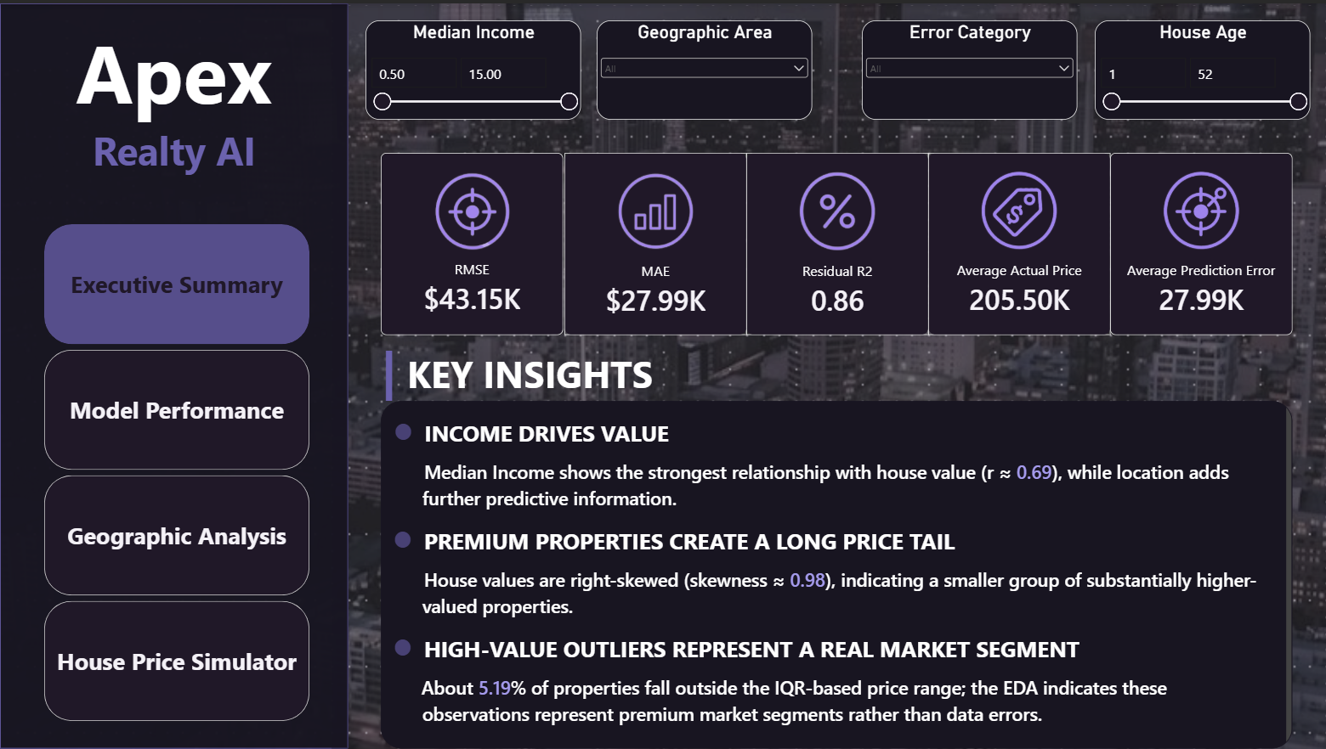

Model Performance
The Model Performance page focuses on the relationship between actual and predicted house prices and the distribution of prediction errors.

Actual Price and Predicted Price
A scatter plot is used with:
- X-axis: Actual Price
- Y-axis: Predicted Price
- Legend: Residual Sign
- RecordID: Used to distinguish individual observations
A trend line and symmetry shading are included to help visually assess the relationship between actual and predicted values.
The scatter plot allows the user to identify how closely the model's predictions correspond to the actual house prices and observe observations associated with over- and under-prediction.

Residual Distribution
A clustered column chart displays the distribution of residual values using residual bins. Binning groups individual residual values into ranges, making it easier to observe where prediction errors are concentrated.

Prediction Error by Median Income
A bar chart displays Average Absolute Error by Median Income Range. The Income Range field groups properties according to median income, while the Average Absolute Error measure represents the magnitude of prediction error within each group.
The page also contains the same four interactive slicers used on the Executive Summary.
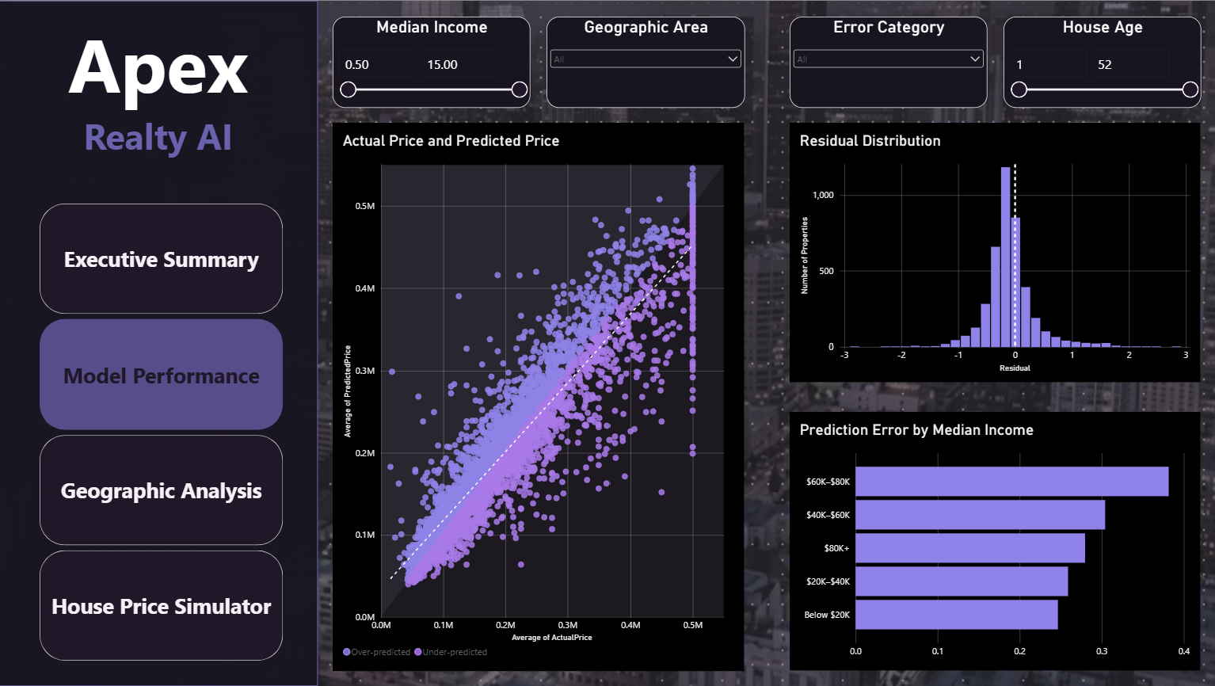

Geographic Analysis
The Geographic Analysis page examines the spatial distribution of the model's predictions and errors across California.
An interactive California map uses:
- Latitude
- Longitude
- Actual/target price
- Predicted price
- Average residual
- Property count
- Median income
- House age
This allows prediction performance to be examined geographically and supports the identification of areas where prediction errors may be concentrated.
A second visual, Average Absolute Error by Region, compares prediction-error magnitude across geographic regions.
The page also contains slicers for:
- Median Income
- Geographic Area
- Error Category
- House Age
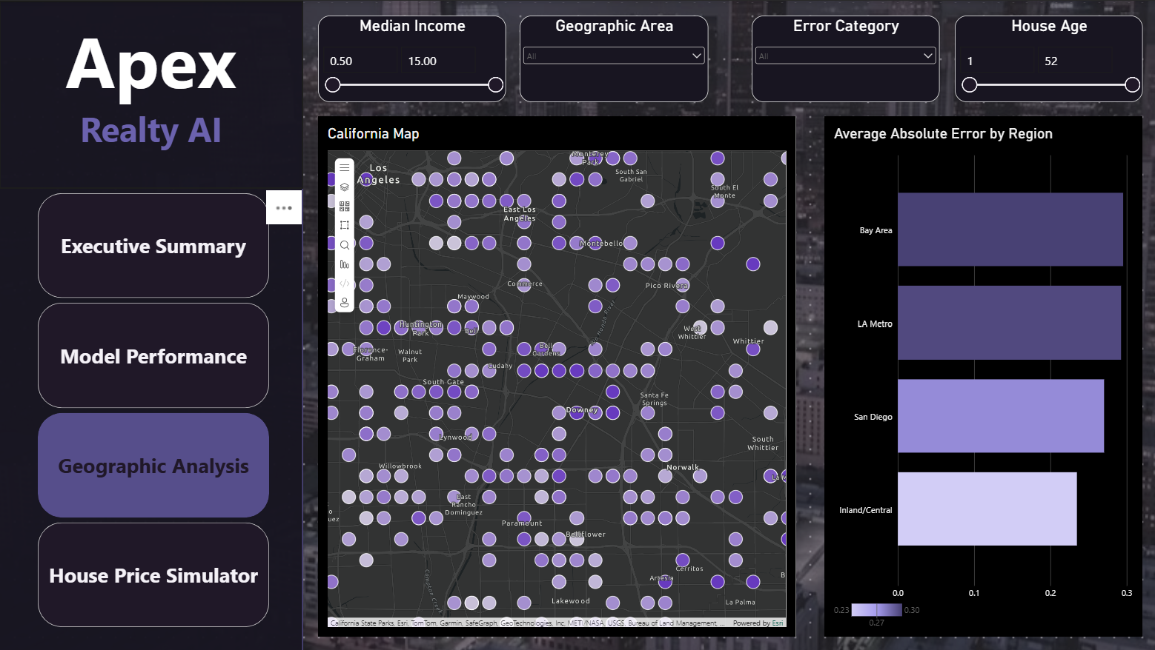

House Price Simulator
The House Price Simulator provides an interactive what-if prediction interface. The user can specify eight input characteristics:
- Median Income
- House Age
- Average Rooms
- Average Bedrooms
- Population
- Average Occupancy
- Latitude
- Longitude
The selected values are passed to the trained machine-learning model through the Power BI Python visual. The resulting prediction is displayed as an Estimated House Value.
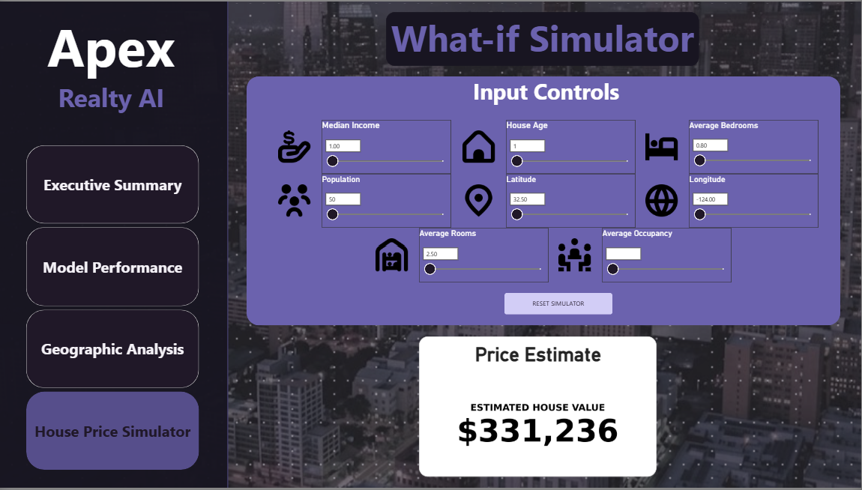

6.2 Important KPIs / Insights
The Executive Summary presents five key performance indicators to evaluate the performance and prediction behaviour of the California Housing regression model.

Key Performance Indicators
- RMSE: $43.15K
The model has a Root Mean Squared Error of $43.15K, representing the magnitude of prediction error while giving greater weight to larger errors.
- MAE: $27.99K
The Mean Absolute Error is $27.99K, indicating that the average absolute difference between the actual and predicted house values is approximately $27.99K.
- Residual R²: 0.86
The model records a Residual R² of 0.86, providing an additional measure of the model's ability to explain variation in the target values through its predictions.
- Average Actual Price: $205.50K
The average actual house value in the evaluated dataset is approximately $205.50K, providing a reference point for the typical observed property value.
- Average Prediction Error: $27.99K
The average absolute prediction error is approximately $27.99K, indicating the typical magnitude by which the model's predicted house values differ from the actual values.

Key Insights
The dashboard identifies three major patterns from the exploratory analysis:
- Income drives value:
Median Income shows the strongest relationship with house value, with a correlation of approximately r ≈ 0.69. Geographic location provides additional predictive information.
- Premium properties create a long price tail:
House values are right-skewed, with skewness ≈ 0.98, indicating that a smaller group of substantially higher-valued properties contributes to the long upper tail of the distribution.
- High-value outliers represent a real market segment:
Approximately 5.19% of properties fall outside the IQR-based price range. The EDA indicates that these observations represent premium market segments rather than simply being treated as data errors.

Overall dashboard interpretation
Together, these KPIs and insights show that the model provides a relatively strong predictive relationship while still exhibiting measurable prediction error. The dashboard also highlights that income, geographic location, and the presence of premium high-value properties are important factors when interpreting the model's predictions and errors

6.3 Prediction / Application Workflow
The House Price Simulator demonstrates how a new hypothetical property input is passed through the trained machine-learning model to generate a predicted house value.
The workflow is:
User selects property characteristics
↓
Power BI input slicers
↓
Selected-value measures
↓
Python visual
↓
Trained ML model
↓
Model prediction
↓
Convert target from $100,000 units
↓
Estimated House Value
The simulator uses eight input variables corresponding to the features used by the California Housing model:
MedInc, HouseAge, AveRooms, AveBedrms, Population, AveOccup, Latitude and Longitude.
The selected values are collected by the Power BI Python visual and arranged into a single input record. This record is passed to the trained model using its predict() function. Since the California Housing target is represented in units of $100,000, the model output is multiplied by 100,000 to display the estimated monetary house value.
This is also consistent with the project guide's requirement for a what-if simulation/single-record tester as part of the BI Developer role.

6.4 Sample Input and Output
For demonstrating the application workflow, one hypothetical property can be entered into the House Price Simulator.

Sample input
Feature | Sample value
Median Income | 5.0
House Age | 30
Average Rooms | 5.0
Average Bedrooms | 1.0
Population | 1,500
Average Occupancy | 3.0
Latitude | 34.0
Longitude | -118.0
These values are entered using the eight simulator controls.
The selected values are then passed to the trained regression model, which produces a predicted California Housing target value. The result is converted from the dataset's $100,000 target units into a monetary estimate and displayed in the Estimated House Value section.
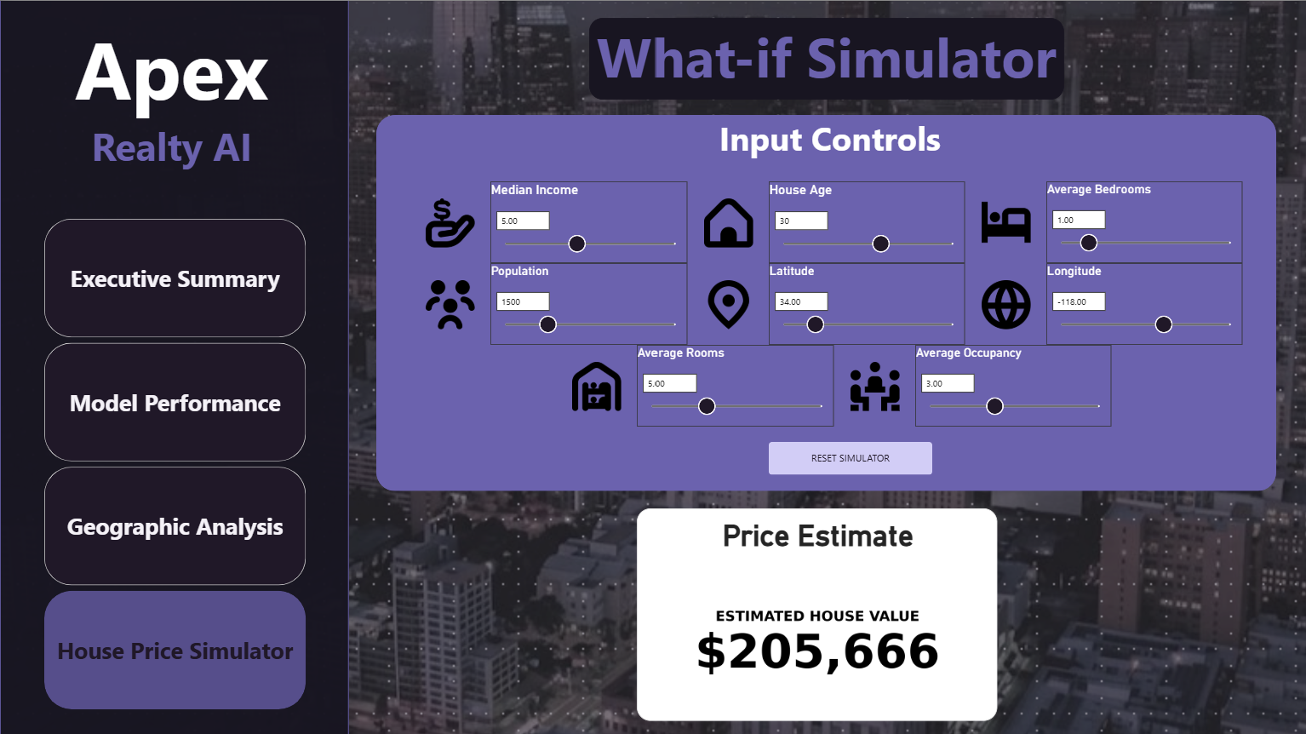
For the above sample input, the trained model produced an estimated house value of $205,666.

7. CHALLENGES, LIMITATIONS AND IMPROVEMENTS

7.1 Challenges Faced
One of the main challenges was understanding the dataset and checking its quality before model training. Although the dataset contained no missing values or duplicate rows, the IQR method flagged potential outliers in several features. These values needed to be considered carefully because an unusual value is not necessarily an error, and removing valid observations could result in loss of useful information.
Another challenge was preparing the data for machine learning while avoiding data leakage. The team split the data into training and testing sets and used a preprocessing pipeline so that the scaler was fitted on the training data and then applied to the test data. Coordinating different project tasks and combining the work into a consistent workflow was also an important part of the project.

7.2 Approaches That Did Not Work
The team compared multiple regression models during the model development process rather than relying on a single algorithm. The model comparison and validation process showed that different models produced different levels of prediction performance, which required further evaluation and tuning before selecting the final model.
An issue was also identified in the initial scaler handoff between preprocessing and model inference. This could result in inconsistency between the way training data and new prediction inputs were processed. The issue was corrected by implementing a self-contained pipeline so that preprocessing and prediction were handled consistently.
This highlighted the importance of maintaining the same preprocessing steps throughout the complete machine learning workflow and checking the prediction pipeline separately from model training.

7.3 Current Limitations
The project uses the California Housing dataset, which is based on historical 1990 census data. Therefore, its predictions may not reflect current housing prices, market conditions, inflation, or recent changes in local areas.
The dataset also contains a limited set of features. Factors such as property condition, building age at the individual property level, nearby facilities, interest rates, and current market demand are not fully represented. In addition, the target variable is capped at the upper end, which limits how well the model can distinguish among very high-value properties.
The model should therefore be treated as an educational prediction system based on the available dataset, rather than as a source of current property valuations.

7.4 Future Improvements
The project could be improved by using more recent housing data and adding relevant features such as property condition, local amenities, transport access, and current market indicators, where reliable data is available.
Further improvements could include testing additional regression algorithms, carrying out systematic hyperparameter tuning, and evaluating model performance on newer or geographically separate data. A deployed version could also include a user-friendly interface for entering property details, along with clear information about prediction uncertainty and the dataset’s limitations.
If the system is updated with new data over time, its performance should be monitored and the model retrained when necessary.

8. TEAM CONTRIBUTION AND LEARNING

8.1 Team Roles and Contributions
Student Name / Register No. | Assigned Role | Major Contribution | Tools / Skills Used
241BCADA08 | Data Engineer (DE) | Loaded and inspected the California Housing dataset; checked dataset shape, missing values, duplicates and invalid values; performed IQR-based outlier checks and created the data quality audit log; split the data into training and testing sets (80:20); applied feature scaling using a preprocessing pipeline and saved the processed datasets | Python, Pandas, NumPy, Scikit-learn, Jupyter Notebook, data cleaning, data validation, IQR outlier detection, train-test splitting, StandardScaler, GitHub
241BCADA09 | Data Analyst (DA) | Exploratory Data Analysis, statistical analysis, feature distributions, correlation analysis, outlier analysis, visualizations and identification of key EDA insights | Python, Pandas, NumPy, Matplotlib, Seaborn, SciPy, statistical analysis, data visualization
241BCADA07 | Data Scientist (DS) | Compared 7 models via 5-fold CV; selected & tuned LightGBM (Test RMSE 0.4315, R² 0.858); fixed scaler-handoff bug via self-contained pipeline; added error diagnostics and sanity checks. | Python, Pandas, NumPy, Scikit-learn, LightGBM, XGBoost, Joblib, Matplotlib; cross-validation, hyperparameter tuning (GridSearchCV/RandomizedSearchCV), bias-variance analysis, model serialization
241BCADA68 | ML Engineer (MLE) | Developed the prediction pipeline using the trained model; implemented model loading, reusable house-price prediction, input validation, prediction testing, reproducibility checks, inference-latency benchmarking, and prediction logging. Performed end-to-end inference testing and verified the prediction pipeline. | Python, Pandas, Joblib, Scikit-learn, Pathlib, time/performance measurement, input validation, model inference, testing, model serialization, CSV logging.
241BCADA04 | Analytics Engineer (AE) | Contribution as an Analytics Engineer: Model performance evaluation, regression metrics calculation (MAE, RMSE, and residual R²), prediction error analysis, overprediction and underprediction analysis, identification of top prediction errors, geographical error analysis, and visualization of model performance and prediction errors. | Tools/Skills Used: Python, Pandas, NumPy, Matplotlib, statistical analysis, regression model evaluation, residual analysis, data visualization and error analysis.
241BCADA11 | BI / Power BI Developer (BI) | Power BI dashboard development, interactive KPI cards, slicers and filters, model performance visualization, geographic analysis, residual/error analysis, ML prediction visualization, interactive House Price Simulator, dashboard navigation, visual layout and executive-ready presentation | Power BI, DAX, data visualization, dashboard design, interactive filters/slicers, KPI development, ML prediction interpretation, geographic analysis, residual analysis

8.2 Skills / Learning Outcomes
Through this project, our team developed practical skills in data analysis, data preprocessing, exploratory data analysis, machine learning, model evaluation, data visualization, and collaborative problem-solving. We gained experience in understanding and preparing a real-world dataset, analysing feature distributions, identifying correlations and potential outliers, and interpreting statistical and visual findings.
The project also helped us understand the complete machine learning workflow, from data preparation and exploratory analysis to model development, evaluation, prediction, and visualization. We gained practical experience with Python and libraries such as Pandas, NumPy, Matplotlib, Seaborn, Scikit-learn, and machine learning libraries used in the project.
Working in different assigned roles helped us understand how different stages of an end-to-end machine learning project are connected. We also improved our teamwork, communication, documentation, problem-solving, and presentation skills through collaboration and integration of our individual contributions.
Overall, the project strengthened our ability to apply theoretical machine learning concepts to a practical problem and interpret the results in a structured and meaningful manner.

9. CONCLUSION
This project focused on developing a machine learning solution for house price prediction using the California Housing dataset. The dataset contains 20,640 observations with eight input features and MedHouseVal as the continuous target variable. The project followed an end-to-end workflow involving data cleaning, preprocessing, exploratory data analysis, feature engineering, model development, evaluation, and dashboard implementation.
The EDA identified important patterns in the dataset. MedInc showed the strongest correlation with MedHouseVal, while geographic variables such as Latitude and Longitude also provided useful information. The analysis also identified skewed variables and potential outliers, which were considered during the data preparation and modelling process.
Several machine learning models were evaluated, and LightGBM was selected as the final model based on the evaluation results. The final model achieved a test RMSE of approximately 0.4315, with MAE of approximately 0.2899 and R² of approximately 0.8600. These results indicate that the model was able to explain a substantial portion of the variation in median house values within the test data.
The project also provided practical experience in data analysis, machine learning, model evaluation, visualization, and teamwork. Overall, the project demonstrated how exploratory analysis and machine learning techniques can be combined to analyse housing data and generate predictions while also highlighting the limitations of using historical and geographically limited data for this type of problem.

10. REFERENCES / BIBLIOGRAPHY
[1] Dataset source -
Scikit-learn, “The California Housing Dataset,” Scikit-learn Course Documentation. Available: https://inria.github.io/scikit-learn-mooc/python_scripts/datasets_california_housing.html
[2] Library / official documentation -
G. Ke, Q. Meng, T. Finley, T. Wang, W. Chen, W. Ma, Q. Ye, and T.-Y. Liu, “LightGBM: A Highly Efficient Gradient Boosting Decision Tree,” Advances in Neural Information Processing Systems 30 (NeurIPS 2017), 2017. NeurIPS Papers
[3] Research paper / article -
J. V. N. Lakshmi, “Machine learning techniques using Python for data analysis in performance evaluation,” International Journal of Intelligent Systems Technologies and Applications, vol. 17, nos. 1/2, pp. 3–18, 2018. DOI: 10.1504/IJISTA.2018.10012853. ResearchGate
P. E. Simlai, “Predicting owner-occupied housing values using machine learning: An empirical investigation of California census tracts data,” Journal of Property Research, vol. 38, no. 4, pp. 305–336, 2021. https://doi.org/10.1080/09599916.2021.1890187 . This paper examines machine-learning regression methods for California housing values, including Ridge, LASSO, and Elastic Net.
Preethi, D. H. R. Murthy, V. Hiremani, R. M. Devadas, et al., “Optimizing Polynomial and Regularization Techniques for Enhanced Housing Price Prediction Accuracy,” SN Computer Science, vol. 6, article 96, 2025. https://doi.org/10.1007/s42979-024-03578-7 . This study compares regression approaches using the California Housing dataset, including regularization and polynomial regression.
[4] Additional reference -
GeeksforGeeks, “Regression Models for California Housing Price Prediction,” 2025.

11. APPENDICES

Appendix A - GitHub Repository
Repository Name: ML-Final-Lab-Group-10
Repository Link: https://github.com/gautamivdesai/ML-Final-Lab-Group-10
The GitHub repository contains the project notebooks, source code, preprocessing workflow, model development files, prediction pipeline, dashboard-related files and other supporting project resources. The repository is the team's central location for maintaining and organizing the project implementation.

Appendix B - Additional Screenshots / Outputs
