APEX REALTY AI
Residential House Price Prediction on the California Housing Dataset
Formal Technical Report | Machine Learning Lab (BCADA 5P 126) | Group 10
St. Joseph's University, Bengaluru | Department of Advanced Computing | BCA (Data Analytics), 2026–2027
Repository: github.com/gautamivdesai/ML-Final-Lab-Group-10
Suzanne P  Reg. No.: 241BCADA04 | Anushka Kalahasthi  Reg. No.: 241BCADA07 | Gautami V Desai  Reg. No.: 241BCADA08
Sania Jeswin  Reg. No.: 241BCADA09 | Annie Maria T  Reg. No.: 241BCADA11 | Sindhu L  Reg. No.: 241BCADA68

Abstract. This report describes an end-to-end regression pipeline that predicts median house value (MedHouseVal) for California census block groups from eight demographic, housing and geographic features. Seven models were compared with 5-fold cross-validation on the training split; a tuned LightGBM model was selected and evaluated once on a held-out test set, giving RMSE 0.4315, MAE 0.2799 and R² 0.8579 (target in units of $100,000). Exploratory analysis found that median income is the dominant predictor (r = 0.688), that the target and several features are strongly right-skewed, and that statistical outliers represent real premium properties rather than errors. Residual analysis shows weaker performance on high-value homes, partly caused by top-coding of the target at $500,001. Results are delivered through a four-page Power BI dashboard.

1. Problem Statement and Business Context
Apex Realty AI is a hypothetical real estate technology client that wants to estimate residential market prices and detect deviations between predicted and actual values. The task is supervised regression: given eight numerical features of a census block group, predict the continuous target MedHouseVal. Success is judged by RMSE (primary), MAE and R², together with residual diagnostics that check for systematic over- or under-prediction, including geographic bias, as required by the project guide for Group 10.

2. Dataset Description
The dataset is the California Housing dataset (StatLib; 1990 U.S. Census), loaded through scikit-learn’s fetch_california_housing() and stored as data/raw/california_housing.csv (accessed 13 September 2026). It has 20,640 records, eight input features and one target, with each row describing a census block group rather than an individual house.
Variable | Description
MedInc | Median household income of the block group, in tens of thousands of dollars
HouseAge / AveRooms / AveBedrms | Median house age; average rooms and bedrooms per household
Population / AveOccup | Block-group population; average household occupancy
Latitude / Longitude | Geographic coordinates of the block group
MedHouseVal (target) | Median house value, in units of $100,000

3. Cleaning and Preprocessing
Quality checks found 0 missing values, 0 duplicate rows and 0 invalid values (shape 20,640 × 9). The IQR rule (Q1 − 1.5·IQR, Q3 + 1.5·IQR) produced 5,594 feature-level flags, concentrated in AveBedrms and Population; because one row can be flagged in several columns, this is not a count of unique rows. Flagged records were retained rather than removed, since an extreme value is not necessarily an invalid one (see Section 5).
Features and target were separated and split 80/20 with random_state = 42, giving 16,512 training and 4,128 test rows. A StandardScaler (z = (x − μ)/σ) was fitted on the training features only and then applied to both splits, so that no test-set statistic influenced scaling. Cross-validation and tuning used the training set only, and the test set was used once for final evaluation. Processed files are saved in data/processed/, with the audit log in data_quality_audit.csv.

4. Exploratory Data Analysis
EDA covered summary statistics, skewness, normality (histogram, box plot, Q-Q plot), correlation analysis, feature–target scatter plots, geographic patterns and outlier profiling.
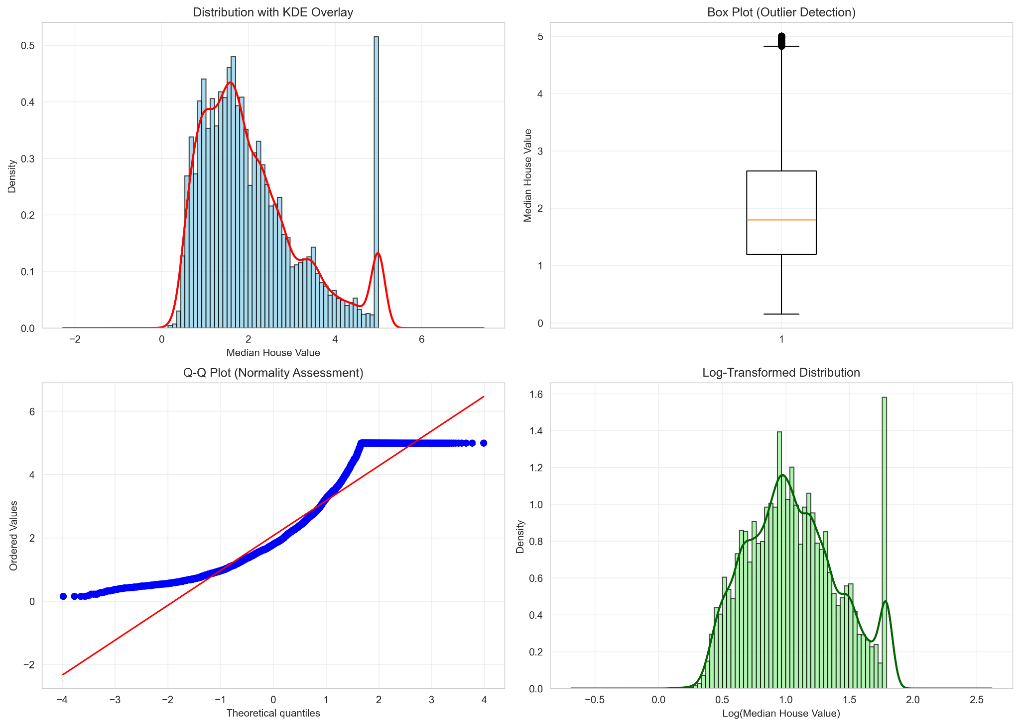
Figure 1. Distribution, outlier and normality analysis of MedHouseVal (skewness 0.9777).

4.1 Distributions and skewness
MedHouseVal is right-skewed (skewness 0.9777) and fails the Q-Q normality check; a log1p transform reduces skewness to 0.2759, a 72% reduction. AveOccup (skewness 97.63) and Population (4.94) are the most extreme features, and MedInc, AveRooms and AveBedrms are also right-skewed.

4.2 Correlation analysis
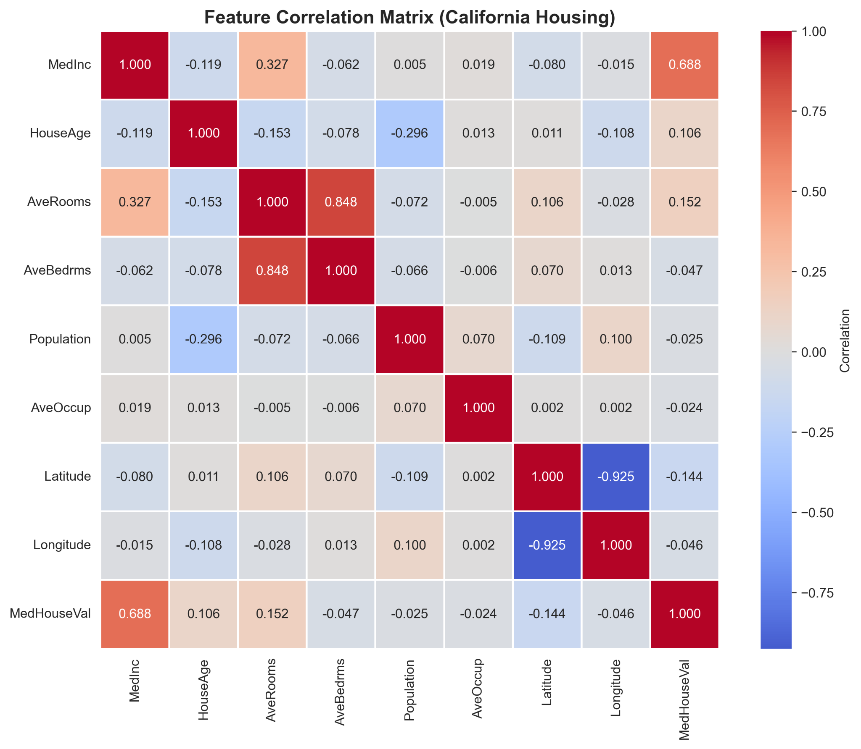
Figure 2. Correlation matrix of the eight features and MedHouseVal.
Correlations with the target, from strongest to weakest by magnitude, are: MedInc 0.688, AveRooms 0.152, Latitude −0.144, HouseAge 0.106, AveBedrms −0.047, Longitude −0.046, Population −0.025 and AveOccup −0.024. MedInc is the only strong linear predictor. AveRooms and AveBedrms are highly correlated with each other (r ≈ 0.848), which is a multicollinearity concern for linear models.

4.3 Outliers and anomalies
In MedHouseVal, 1,071 properties (5.19%) fall outside the IQR bounds. They have a higher average income ($76,183) and average value ($499,267) and are concentrated in coastal regions, which indicates a genuine premium segment.

5. Key EDA Insights
- Income dominates, but geography adds information. MedInc (r = 0.688) is the strongest single signal; Latitude (−0.144) is weak linearly but consistent with a north–south price pattern that a tree-based model can exploit.
- Skew in the target and key features calls for care. The long upper tail of MedHouseVal and the extreme skew of AveOccup and Population affect linear models most; log transforms or tree-based models are appropriate.
- Outliers are market segments, not errors. The 5.19% flagged properties are high-income coastal premium homes, so deleting them would remove exactly the cases a valuation client cares about. They were retained.

6. Feature Engineering
No derived features were created; the eight original features were retained and standardized, and Latitude and Longitude were kept to preserve spatial information. The EDA suggested a MedInc × Latitude interaction as a possible future feature, which was not implemented in the submitted pipeline.

7. ML Methodology
Seven models were compared under identical 5-fold cross-validation (KFold, shuffle = True, random_state = 42) on the training set, recording RMSE, MAE and R² on both validation and training folds: a mean-predicting Dummy baseline, Linear Regression, Ridge, Decision Tree, Random Forest, LightGBM and XGBoost. The bias–variance gap (CV RMSE − train RMSE) was used to diagnose overfitting. The best model by CV RMSE, LightGBM, was tuned with RandomizedSearchCV (20 iterations, 5-fold, negative-RMSE scoring) over n_estimators, learning_rate, num_leaves, max_depth, subsample and colsample_bytree. Models with one or two hyperparameters (Ridge, Decision Tree) were tuned with exhaustive GridSearchCV. Final inference uses a self-contained pipeline (scaler plus model) serialized with joblib; this replaced an earlier scaler hand-off that risked train/serve inconsistency.

8. Model Evaluation and Comparison
RMSE is the primary metric because squaring penalizes large mispricings; MAE gives an interpretable typical error and R² gives a scale-free fit. Accuracy is not defined for a continuous target. Table 1 gives the 5-fold CV results on the training set.
Model | CV RMSE | CV std | Train RMSE | Gap | CV MAE | CV R²
LightGBM | 0.4713 | 0.0122 | 0.3869 | 0.0844 | 0.3156 | 0.8338
XGBoost | 0.4739 | 0.0083 | 0.2522 | 0.2218 | 0.3158 | 0.8319
Random Forest | 0.5109 | 0.0119 | 0.1913 | 0.3196 | 0.3349 | 0.8047
Ridge | 0.7205 | 0.0139 | 0.7196 | 0.0009 | 0.5291 | 0.6115
Linear Regression | 0.7205 | 0.0139 | 0.7196 | 0.0009 | 0.5291 | 0.6115
Decision Tree | 0.7337 | 0.0282 | ≈ 0.0000 | 0.7337 | 0.4727 | 0.5966
Baseline (mean) | 1.1562 | 0.0122 | 1.1562 | ≈ 0.0000 | 0.9139 | ≈ 0.0000
Table 1. Cross-validation comparison (target units: $100,000). Ridge and Linear Regression coincide at the reported precision.
Final selection. LightGBM had the lowest CV RMSE (0.4713) and a small gap (0.0844), compared with 0.3196 for Random Forest and 0.7337 for the Decision Tree, which memorizes the training data. XGBoost was close in error (0.4739) but had a larger gap (0.2218). After tuning, the LightGBM CV RMSE fell to 0.4412. On the 4,128 held-out test rows the final model reached RMSE 0.4315, MAE 0.2799 and R² 0.8579 — about $43,150 and $27,990 in dollar terms — and the test RMSE was no worse than the tuned CV estimate, so there is no sign of overfitting to the tuning search.
Residual analysis. The mean residual is −0.0021, with 56.44% over-predictions and 43.56% under-predictions. Residuals are tight for low and mid-range values but widen for expensive homes (heteroscedasticity), where the model tends to under-predict. A diagonal band in residuals-versus-predicted is explained by the dataset’s top-coding of MedHouseVal at $500,001, which limits both training and evaluation in that segment. The geographic residual plot shows no broad regional bias; larger residuals around the Bay Area coincide with the concentration of high-value, top-coded blocks.

9. Dashboard
The Power BI dashboard (dashboard/Project_Dashboard.pbix) has four pages: Executive Summary, Model Performance, Geographic Analysis and a House Price Simulator. The Executive Summary shows five KPI cards (RMSE, MAE, residual R², average actual price, average prediction error) with slicers for median income, house age, geographic area and error category. The Model Performance page shows actual versus predicted values, residual distribution and error by income range; the Geographic Analysis page maps predictions and residuals; and the simulator passes eight user-set inputs to the trained model through a Power BI Python visual and returns an estimated value. For the sample input in the report (MedInc 5.0, HouseAge 30, Latitude 34.0, Longitude −118.0, and so on) it returned $205,666.

Figure 3. Dashboard – Executive Summary page.

10. Key Findings and Recommendations
- Use the model as a decision-support estimate for typical properties. It explains about 86% of variance with a typical absolute error of about $28K, against a baseline RMSE of 1.1562.
- Treat predictions for high-value homes with lower confidence. Error is larger and biased low there; flag these cases for manual review.
- Keep premium outliers in the data. They are a real market segment and removing them would worsen the model where it matters commercially.
- Prefer tree-based boosting over linear models for this data. Boosting cut CV RMSE by about 35% relative to Linear Regression (0.4713 versus 0.7205).

11. Limitations and Future Work
The data are from the 1990 census, cover California only and describe block groups, not individual houses, so the model cannot give current or property-level valuations. Features such as floor area, condition and school quality are absent. The target is capped at $500,001, which distorts evaluation at the top end. Future work includes adding the MedInc × Latitude interaction and other engineered features, modelling the log-transformed target, using more recent data, and monitoring for drift with scheduled retraining if the model were deployed.

12. Individual Contributions
Member | Role | Contribution
Gautami V Desai (241BCADA08) | Data Engineer | Data loading and quality audit, IQR outlier flags, 80/20 split, leakage-free StandardScaler, processed datasets
Sania Jeswin (241BCADA09) | Data Analyst | Statistical EDA, distribution and skewness analysis, correlation analysis, outlier analysis, key insights
Anushka K (241BCADA07) | Data Scientist | Seven-model 5-fold CV comparison, LightGBM tuning, bias–variance analysis, scaler-pipeline fix
Sindhu L (241BCADA68) | ML Engineer | Inference pipeline, model loading, input validation, latency benchmarking, prediction logging
Suzanne P (241BCADA04) | Analytics Engineer | MAE/RMSE/R² computation, over/under-prediction and top-error analysis, geographic error analysis
Annie Maria T (241BCADA11) | BI Developer | Power BI dashboard, KPIs, slicers, geographic views, House Price Simulator

References
[1] scikit-learn, “fetch_california_housing,” scikit-learn documentation. https://scikit-learn.org/stable/modules/generated/sklearn.datasets.fetch_california_housing.html
[2] G. Ke et al., “LightGBM: A Highly Efficient Gradient Boosting Decision Tree,” NeurIPS 30, 2017.
[3] P. E. Simlai, “Predicting owner-occupied housing values using machine learning: An empirical investigation of California census tracts data,” Journal of Property Research, vol. 38, no. 4, pp. 305–336, 2021. doi:10.1080/09599916.2021.1890187
[4] Preethi et al., “Optimizing Polynomial and Regularization Techniques for Enhanced Housing Price Prediction Accuracy,” SN Computer Science, vol. 6, art. 96, 2025. doi:10.1007/s42979-024-03578-7

