IB Incentive Platform
User and work manual · 21 September 2026
Document editor and business owner: gautam.jaiswal@vyapar.com
This guide follows the platform workflow from access and agent mapping through targets, planning, incentive calculation, and review. The figures show the application interface; operational records remain in the connected Google Sheets backend.
1. Access and sign in
1 Open the IB Operations Platform URL supplied by the owner.
2 Existing users enter their work email and password and select Sign in.
3 New users select Request platform access, enter name, work email, requested role, and business reason. An owner or admin reviews the request under Access requests.
4 After approval, select Have an activation code?, enter the eight-digit code and a password of at least 12 characters, then sign in. The code expires after 48 hours.

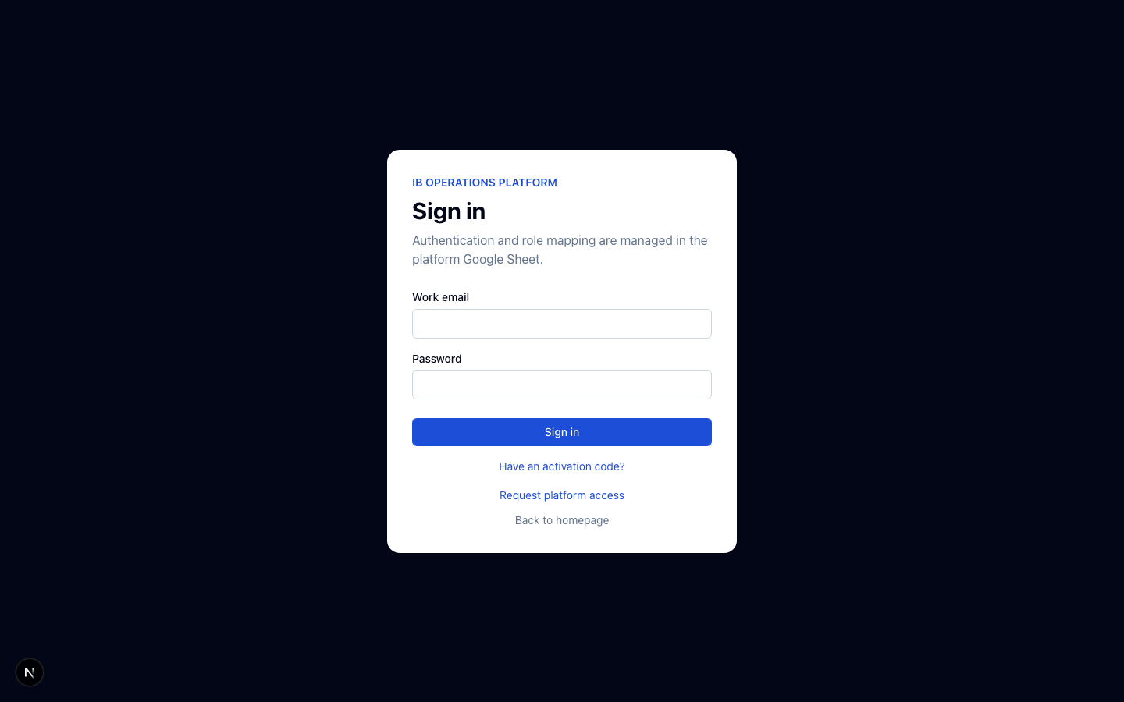
Figure 1. Platform sign-in screen.
Roles at a glance
Role
What the user can do
Viewer
View overview, mappings, targets, planning results, incentives, and analytics.
Editor
Viewer actions plus monthly agent mappings, connected Sheet agent fetch and import, target creation, planning snapshots, and incentive calculation.
Admin
Editor actions plus access approval, source and Sheet connection settings, and rule publishing.
Owner
All platform actions. Gautam Jaiswal and Aryan Sachdeva are seeded as owners.
2. Map agents for a month
1 Open Agent mappings and choose the month at the top.
2 Select Batch add. Choose Existing agents, Paste new, or Connected sheet.
3 For the connected Sheet, select Fetch active agents. Search and tick the required agents. Fetch reads the latest scheduled app snapshot; it does not write agent mappings.
4 Set Source, Tenurity (M0, M1, or M1+), Status if needed, and the weeks that should participate. Connected identity supplies employee ID, name, email, joining date, and manager. The selected mapping month is separate from the source data month.
5 Select Review selected agents. Check each agent’s Source, Tenurity, Status, and weeks. Tick the final confirmation and select Confirm and save.
Connected Sheet freshness: Google Sheets refreshes the Connected Sheet on its own schedule. The Apps Script job copies it into the app-readable agentDataDump snapshot daily at about 02:00 in the script time zone. If the connection is temporarily unavailable, the platform retains the last successful snapshot. Ask an admin to check the connection if expected agents are missing.
Existing agents and pasted agents follow the same final review. Unselected weeks are left blank and do not contribute to incentives. New agents require a valid Source and Tenurity; preserve existing operational values unless you intentionally change them.
3. Prepare targets and planning
Target versions
1 Open Target fetch. Select Fetch previous month to review the prior source matrix for the current month, or Create new target for a specific Source and Tenurity.
2 For a new version, choose active Source, Tenurity, Status, effective dates, and integer targets. Review the confirmation preview before saving.
3 An active version closes the previous active version for that Source and Tenurity. Inactive versions need an end date and cannot overlap existing history.
Planning snapshots
Open Planning. Generate current week captures the Monday roster, manager, target version, and weekly targets. Generate current month freezes the approved monthly roster for historical reporting. Review mappings and targets first because snapshots preserve those values.
4. Calculate and review incentives
1 Open Incentives → Calculations and select the month.
2 Confirm mapped agents, weekly targets, revenue data, and effective slab rules are ready. An admin manages the revenue connection under Sources & integrations.
3 Select Calculate [month]. Review agent and team lead rows, search by agent or team, and check the calculation version.
4 Use Download CSV for a local extract or Export Google Sheet for a shareable result.
Agent awards use the highest completed achievement slab. Monthly agent incentive sums weekly awards; applicable bonus is then added to Total Payout. The Slab rules tab shows effective Agent and Team Lead rules. Preview new rules is a local review, while publishing a new rule version requires admin or owner access.
5. Monitor and troubleshoot
Overview summarizes operating status. Analytics charts historical targets, revenue, and incentives from saved snapshots. Use the month selector consistently across mappings, targets, and incentives when checking a result.
Problem
Action
Connected agent missing
Confirm the source Sheet refreshed, wait for the app snapshot, then fetch again. Ask an admin to inspect the connection and source headers.
Cannot confirm an agent
Complete Source and Tenurity in the final review, check the selected weeks, then tick confirmation.
Unexpected payout
Check the agent’s mapped Source, week selection, target version, revenue rows, effective slab, and calculation version.
Access denied
Check your role. Only admins and owners can approve access or change integration settings.
For platform ownership and manual edits: gautam.jaiswal@vyapar.com.

