Intro: Idea behind the development of this app was web check while user rushes towards airport.

Requirement to run the apps:

* npm install
* npm start

Application will start with the below screen .

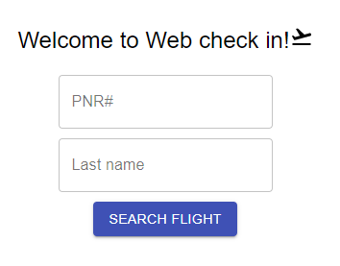

It was intended to see the details of passenger after putting PNR and last name. However, with dummy PNR “WA1FFCFSXFR638354” ,”1G4HP54K64U832718” will be enough to go to the next page .

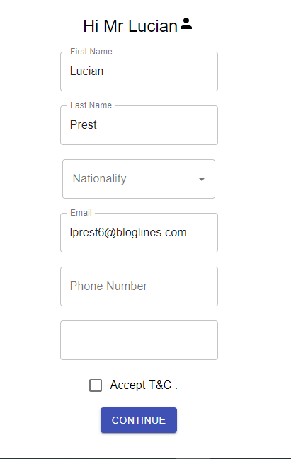

This is just for demonstration purpose .