
RBH Assets
Power BI Reporting Plan
For management review · CK Birla Hospitals · Rukmani Birla Hospital

The proposal in one paragraph
RBH will get a live Power BI executive dashboard fed by the same operational asset system the ward staff use. Managers and executives view Power BI only — they never log in to any website. Ward staff use the data-collection app on their phones to keep the data fresh. Both connect to the same underlying Postgres database — one truth, two audiences.

What management gets
Below is the exact mockup of the executive dashboard. This is what will open in Power BI Desktop or on the mobile Power BI app when it is built:
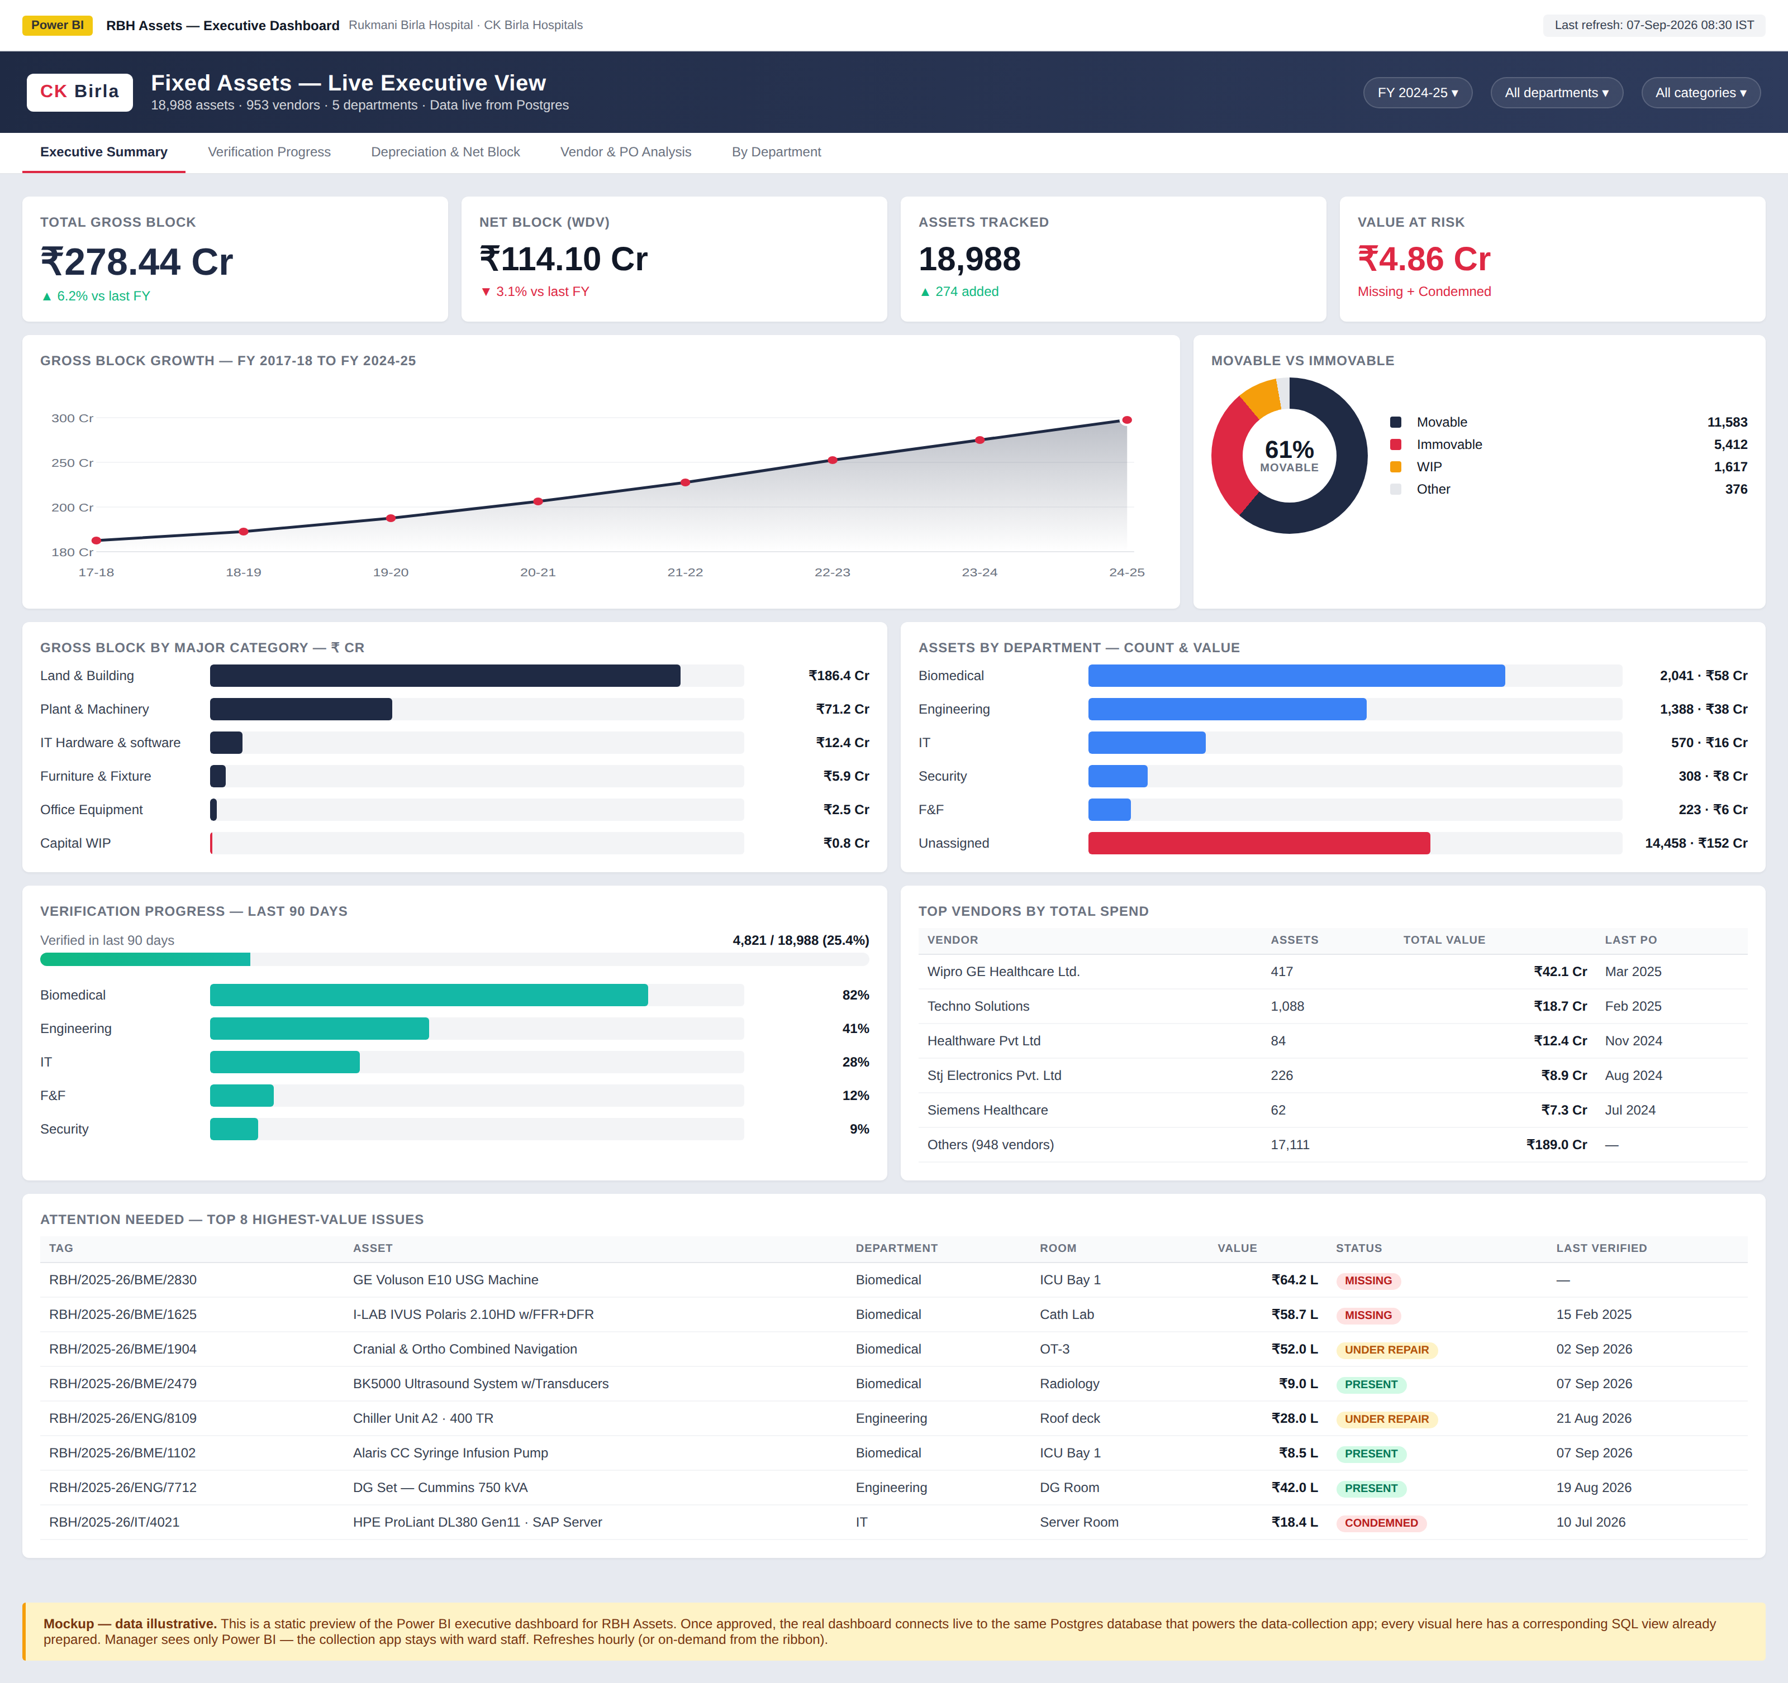
Mockup data is illustrative; the real dashboard will show live numbers from the system.

Five report pages
- Executive Summary — the mockup you just saw. Total gross block, net block, assets tracked, value at risk, and the 8 highest-value issues that need attention.
- Verification Progress — monthly walk-through progress by department, days since last verified per room, staff performance leaderboard.
- Depreciation & Net Block — per-fiscal-year depreciation curves, category-wise decline, comparison against balance-sheet position.
- Vendor & PO Analysis — top vendors by spend, GST distribution, PO match confidence, purchase trends.
- By Department — drill-down per department (Biomedical, Engineering, IT, F&F, Security), with per-room breakdown.

How it stays secure
Manager and executive access | Power BI mobile app or Power BI web (already part of Microsoft 365). No new login, no new website.
Ward staff access | Password-protected app on their phones. Read/write access only to their own department's data.
Power BI connection | Read-only Postgres user (SELECT-only, no INSERT/UPDATE/DELETE possible). Password stored in Power BI's credential vault.
Row-level security | Available if needed — each Power BI viewer sees only their own department. Requires Power BI Pro licence (usually included with Microsoft 365 E3/E5).
Data residency | Postgres can be hosted in India (Vercel Mumbai region, or Azure India). Never leaves the country.
Audit trail | Every write to the data (by any staff member) is written to an immutable audit_log with actor, timestamp, and before/after values.
Physical device | Managers use their existing corporate laptop. No new device or app to install.

Cost estimate
Data-collection app (Vercel) | ≈ ₹1,700/month (Vercel Pro + Postgres + Blob storage)
Power BI Pro licenses | ≈ ₹850/user/month — often already included in Microsoft 365 E5
One-time build of Power BI dashboards | ≈ 3–5 working days (existing SQL views already prepared)
Ongoing maintenance | ≈ 1–2 hours/month for schema updates when the finance workbook changes

Timeline
- Week 1: Deploy the data-collection app. Import the current fixed-asset workbook.
- Week 2: Set up the read-only Postgres user for Power BI. Load SQL views. Test connection.
- Week 3: Build the Executive Summary page in Power BI. Review with management.
- Week 4: Build remaining four pages. Publish to Power BI Service. Grant access to executives.
- Ongoing: Ward staff use the collection app; dashboards refresh hourly.

What we need from you (management)
- Approval to proceed.
- Confirmation of who gets Power BI access (typically: CEO, CFO, COO, CMO, head of biomedical, head of engineering, head of finance).
- Access to your Microsoft 365 admin so we can enable Power BI Pro licences if not already assigned.
- The list of KPIs or reports management currently reviews manually — we can add them to the dashboard.

