ABSTRACT

Managing and resolving customer issues is one of the main components of the Maintenance Phase of SDLC. This process is simplified with the help of Customer Interaction Systems. Organisations making use of such tools must adapt the systems based on the number of clients, as Current systems are far from flexible or scalable. The system proposed solves the problem of scalability and flexibility by integrating a document oriented NoSQL database which allows for data to be semi-structured and improves the overall throughput of the application. A Dynamic form generation component is used to customize gathering information from users.
CHAPTER-1
INTRODUCTION

1.1 GENERAL
Whenever a business deals with a group of people, whether it is customers or employees, there are problems that can crop up, especially if a website is used. Most businesses, luckily, have a ticket system in place that allows people to report various issues. If you have trouble with the site or program, you click a button to access the site's help desk and send a trouble ticket. What most people don't realize, however, is how those tickets are handled on the back end. Many companies use a ticket system that puts all parts of the puzzle in one convenient place.
A ticket system is better than many other methods of dealing with customer questions or reported issues. If a ticket system is built around email, for example, there is really no way to make sure that tickets are read by the right person or to check or track whether the problem has been fixed; all the messages go into the same pot, so to speak, and it can be difficult to manage this pool. In addition, even if the problem is fixed, nobody knows if the person who reported the issue has received any information about the fix, which can be frustrating to customers and employees. A ticket system, on the other hand, is specifically designed to organize issues as they are reported and keeps track of all fixes made, acting as an issue tracking system as well.

1.2 OVERVIEW
A ticket is an element contained within an issue tracking system which contains information about support interventions made by technical support staff or third parties on behalf of an end-user who has reported an incident that is preventing them from working with their computer as they would expect to be able to. Tickets are commonly created in a help desk or call center environment. Typically the ticket will have a unique reference number, also known as a case, issue or call log number which is used to allow the user or support staff to quickly locate, add to or communicate the status of the user's issue or request.

These tickets are so called because of their origin as small cards within a typical wall mounted work planning system when this kind of support started. Operators or staff receiving a call or query from a user would fill out a small card with the user's details and a brief summary of the request and place it into a position (usually the last) in a column of pending slots for an appropriate engineer, so determining the staff member who would deal with the query and the priority of the request.

Issues can have several aspects to them. Each issue in the system may have an urgency value assigned to it, based on the overall importance of that issue. Critical issues are the most severe that should be resolved in the most expedient way possible, taking precedence over all other issues. Low or zero urgency issues are minor, and should be resolved as time permits. Other details of issues include the customer experiencing the issue (whether external or internal), date of submission, detailed descriptions of the problem being experienced, attempted solutions or workarounds, and other relevant information. Each issue maintains a history of each change.

CHAPTER-2
LITERATURE SURVEY
2.1 EXISTING SYSTEM
An issue tracking system (ITS) is a software application that allows an enterprise to record and follow the progress of every problem or "issue" that a computer system user identifies until the problem is resolved. With an ITS, an "issue", which can be anything from a simple customer question to a detailed technical report of an error or bug, can be tracked.

2.2 PROPOSED SYSTEM
In the Customer Interaction System(CIS) we are going to describe about the ticket management system their functionalities, their characteristics, features, advantages, benefits. The customer’s issue can be maintained as ticket in this system. Each ticket can be classified according to their customer issue and that ticket can be forwarded to the particular department. The departmental experts can solve the issue and close the ticket.
The ticket can be prioritized according to the importance of the issue, the highest priority ticket taken into account and it will solve immediately.

2.3 ADVANTAGE
- This system is more efficient and convenient than traditional contact form or email.
- Uses a scalable, high-performance, open-source, schema-free, document-oriented database.
- Custom Schema for storing Responses from Dynamic Forms.
- Critical issues are resolved in the most expedient way possible.
- Departmental separation and Prioritization is used to transfer the issue in that particular department

CHAPTER-3
SYSTEM REQUIREMENTS
3.1 HARDWARE REQUIREMENTS
- Hard Disk : 40GB and above
- RAM : 512MB and above
- Processor : Dual Core and above

3.2 SOFTWARE REQUIREMENTS
- Operating System : Linux
- Server : Apache2.2
- Interpreter : PHP 5.3.10
- Databases : MongoDB 2.0.4,MySQL 5.5
- Framework : CakePHP 2.1(Stable)
- Caching Engine : Memcached 1.4
- Drivers : MongoDB driver 1.2.9, Memcache driver 3
- Version Control : GIT 1.6.3.3

3.3 TECHNOLOGY DESCRIPTION
3.3.1 Introduction to PHP
PHP (PHP: Hypertext Preprocessor) is a widely-used open source general-purpose scripting language that is especially suited for web development and can be embedded into HTML. The PHP code is enclosed in special start and end processing instructions <?php and ?> that allows you to jump into and out of "PHP mode."

PHP is that the code is executed on the server, generating HTML which is then sent to the client. The client would receive the results of running that script, but would not know what the underlying code was. You can even configure your web server to process all your HTML files with PHP.The best things in using PHP are that it is extremely simple for a newcomer, but offers many advanced features for a professional programmer.

There are three main areas where PHP scripts are used.
- Server-side scripting: This is the most traditional and main target field for PHP. You need three things to make this work. The PHP parser (CGI or server module), a web server and a web browser. You need to run the web server, with a connected PHP installation. You can access the PHP program output with a web browser, viewing the PHP page through the server.
- Command line scripting: You can make a PHP script to run it without any server or browser. You only need the PHP parser to use it this way. This type of usage is ideal for scripts regularly executed using cron (on Linux) or Task Scheduler (on Windows). These scripts can also be used for simple text processing tasks.
- Writing desktop applications: PHP is probably not the very best language to create a desktop application with a graphical user interface, but if you know PHP very well, and would like to use some advanced PHP features in your client-side applications you can also use PHP-GTK to write such programs.

PHP's abilities includes outputting images, PDF files and even Flash movies generated on the fly. You can also output easily any text, such as XHTML and any other XML file. PHP can auto generate these files, and save them in the file system, instead of printing it out, forming a server-side cache for your dynamic content.

One of the strongest and most significant features in PHP is its support for a wide range of databases. Writing a database-enabled web page is incredibly simple using one of the database specific extensions (e.g., for mysql), or using an abstraction layer like PDO, or connect to any database supporting the Open Database Connection standard via the ODBC extension.

PHP also has support for talking to other services using protocols such as LDAP, IMAP, SNMP, NNTP, POP3, HTTP, COM. You can also open raw network sockets and interact using any other protocol. PHP has support for the WDDX complex data exchange between virtually all Web programming languages.

PHP has useful text processing features, which includes the Perl compatible regular expressions (PCRE), and many extensions and tools to parse and access XML documents.

3.3.2 Introduction to Apache
The Apache HTTP Server, commonly referred to as Apache is web server software notable for playing a key role in the initial growth of the World Wide Web.

Apache supports a variety of features, many implemented as compiled modules which extend the core functionality. These can range from server-side programming language support to authentication schemes. Some common language interfaces support Perl, Python, Tcl, and PHP. Popular authentication modules include mod_access, mod_auth, mod_digest, and mod_auth_digest, the successor to mod_digest.

Apache include the external extension module, mod_gzip, implemented to help with reduction of the size (weight) of web pages served over HTTP. ModSecurity is an open source intrusion detection and prevention engine for web applications. Apache logs can be analyzed through a web browser using free scripts.Virtual hosting allows one Apache installation to serve many different actual websites.

Apache provides a variety of MultiProcessing Modules (MPMs) which allow Apache to run in a process-based, hybrid (process and thread) or event-hybrid mode, to better match the demands of each particular infrastructure.Apache is to reduce latency and increase throughput, relative to simplify handling more requests, thus ensuring consistent and reliable processing of requests within reasonable time-frames.

The Apache version considered by the Apache Foundation as providing high-performance is the multithreaded version which mixes the use of several processes and several threads per process.

3.3.3 Introduction to CakePHP
The CakePHP framework provides a robust base for your application. It can handle every aspect, from the user’s initial request all the way to the final rendering of a web page. And since the framework follows the principles of MVC, it allows you to easily customize and extend most aspects of your application.
The framework also provides a basic organizational structure, from filenames to database table names, keeping your entire application consistent and logical. This concept is simple but powerful.

3.3.4 Introduction to MongoDB
3.3.4.1 Document-oriented
- Documents (objects) map nicely to programming language data types.
- Embedded documents and arrays reduce need for joins.
- Dynamically-typed (schema less) for easy schema evolution.
- No joins and no multi-document transactions for high performance and easy scalability.

3.3.4.2 High performance
- No joins and embedding makes reads and writes fast.
- Indexes including indexing of keys from embedded documents and arrays.
- Optional streaming writes (no acknowledgements).

3.3.4.3 High availability
- Replicated servers with automatic master failover.

3.3.4.5 Easy scalability
- Automatic sharding (auto-partitioning of data across servers).
  - Reads and writes are distributed over shards.
  - No joins or multi-document transactions make distributed queries easy and fast.
- Eventually-consistent reads can be distributed over replicated servers.

3.3.4.6 Rich query language
To retrieve certain documents from a db collection, you supply a query document containing the fields the desired documents should match. Queries will also match inside embedded arrays. For example, {keywords: 'storage'} will match all documents with 'storage' in its keywords array. Likewise, {keywords: {$in: ['storage', 'DBMS']}} will match all documents with 'storage' or 'DBMS' in its keywords array.
3.3.5 Introduction to MySQL
MySQL is currently the most popular open source database server in existence. On top of that, it is very commonly used in conjunction with PHP scripts to create powerful and dynamic server-side applications.

A database is a structure that comes in two flavors: a flat database and a relational database. A relational database is much more oriented to the human mind and is often preferred over the flat database that are just stored on hard drives like a text file. MySQL is a relational database.

In a relational structured database there are tables that store data. The columns define which kinds of information will be stored in the table. An individual column must be created for each type of data you wish to store.

3.3.6 MongoDB Driver
To access MongoDB from PHP you will need:-
- The MongoDB server running - the server is the "mongod" file, not the "mongo" client (note the "d" at the end)
- The MongoDB PHP driver installed
sudo pecl install mongo

Open your php.ini file and add to it:-
extension=mongo.so

It is recommended to add this to the section with the other "extensions", but it will work from anywhere within the php.ini file.

pecl requires that pear be installed. For those using apt-get, you may need to run the following:
sudo apt-get install php5-dev php5-cli php-pear

CHAPTER-4
UML DIAGRAM
4.1USE CASE DIAGRAM

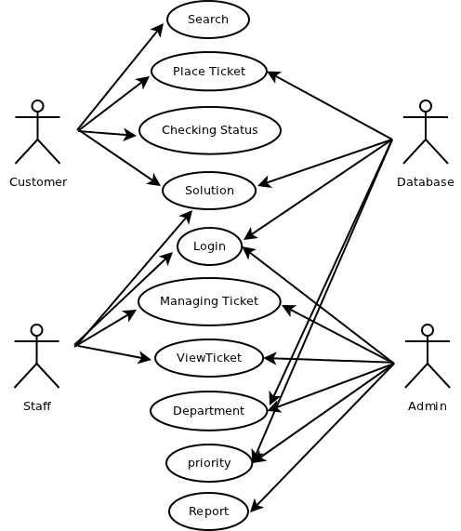

4.2 SEQUENCE DIAGRAM

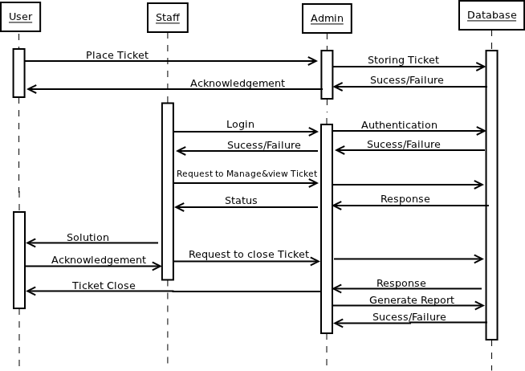

4.3 ACTIVITY DIAGRAM

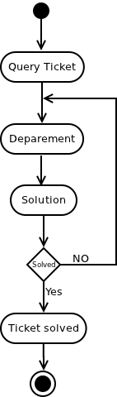

4.4 STATECHART DIAGRAM

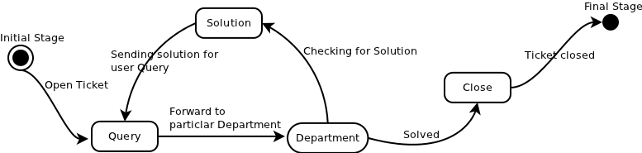

CHAPTER-5
MODULES

5.1 AUTHENTICATION
Authentication is any process by which you verify that someone is who they claim they are. Authorization is any process by which someone is allowed to be where they want to go, or to have information that they want to have.Authentication is accepting proof of identity given by a credible person which has evidence on the said identity or on the originator and the object under assessment as his artifact respectively.The Authenticate person can only view the ticket so that the ticket can be managed safely.

