**Faculty Induction Program**

**Day 5-Assignment 5**

This report is prepared by Mr Fesal Shaikh (35562), from Parul institute of technology, for day 5 and is submitted to CHRD as a part of assignment.

**Day 5: Theme:"Empowering Educators: Research, Resources & Reflective Tools"**

**Session 1 Topic Name: Research Support Services & Resources at Parul University**

**Session 1 Expert Name:** **Dr.Vijay Upadhye**

**Key Takeaways of Session 1:**

Parul University offers robust research support through its Research & Development Cell, advanced Central Instrumentation Facility, and well-equipped libraries. It promotes global collaboration via projects like the EU-funded CABCIN. Ethical research is ensured through clear policies and dedicated assistance. Specialized centers like the Ayurveda Institute further enhance interdisciplinary innovation.

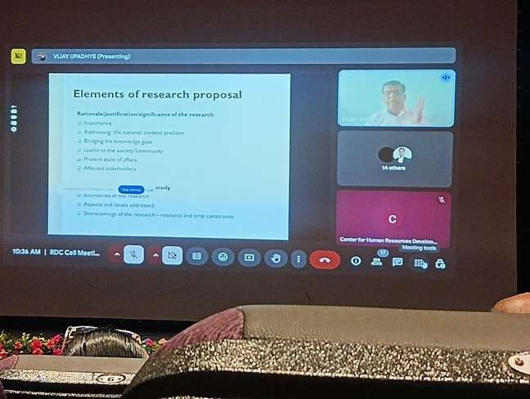**Session 1 Images (G-Tag):(Upload atleast 2 images per session)**

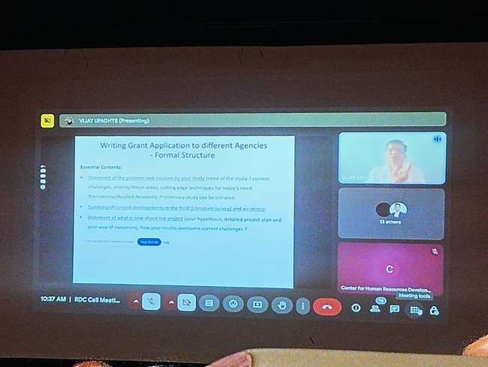

**Session 2 Topic Name:** DSR polices of Parul University

**Session 2 Expert Name:** **Dr. Purvi Shah**

**Key Takeaways of Session 2:**

Parul University's Doctoral Studies & Research (DSR) policies are designed to foster a robust and ethical research environment. The university emphasizes integrity, transparency, and adherence to national and international research standards. Through its Centre of Research for Development (CR4D), Parul University coordinates research activities, ensuring compliance with ethical guidelines and promoting interdisciplinary collaboration. The institution also provides support for securing research funding and encourages innovation through its Intellectual Property Rights (IPR) policy.

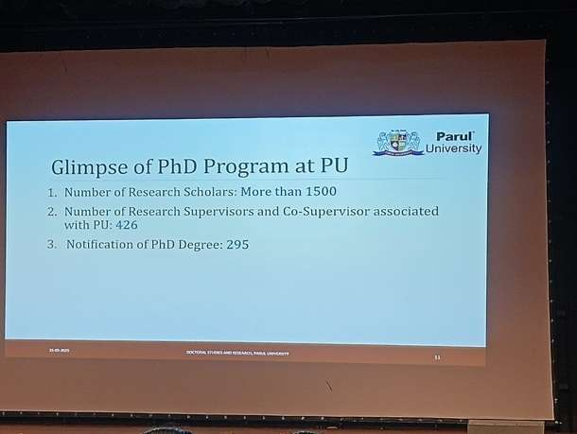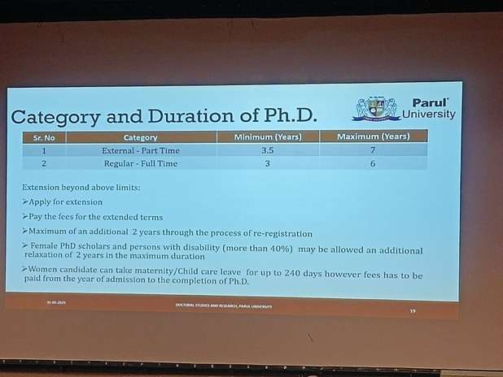**Session 2 Images (G-Tag):(Upload atleast 2 images per session)**

**Session 3 Topic Name: Assessment & Grading System (Examination Cell) Policies**

**Session 3 Expert Name:** **Mr. Nirav Bhavsar**

**Key Takeaways of Session 3:**

Parul University's Examination Cell implements a comprehensive assessment and grading system to ensure academic integrity and transparency. The university employs a continuous evaluation approach, incorporating weekly tests, internal assessments, and project-based evaluations, all managed through a digital Management Information System (MIS) for efficiency. Adhering to the UGC 10-point grading scale, the system ensures standardized evaluation across disciplines. Additionally, the university has established clear policies for rechecking answer scripts and conducting supplementary exams, as detailed in its official examination notifications.

**Session 3 Images (G-Tag):(Upload atleast 2 images per session)**

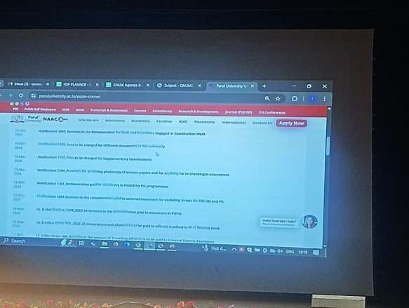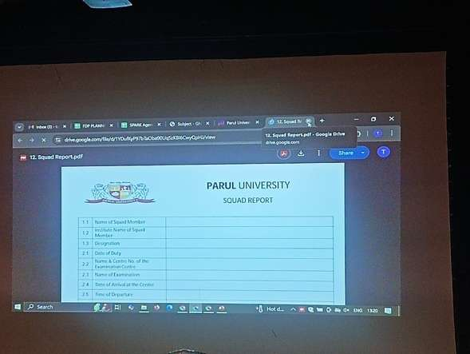

**Session 4 Topic Name: Library Services at Parul University**

**Session 4 Expert Name:** **Dr. Dhaval Bhatt/Mr. Prashant Raj**

**Key Takeaways of Session 4**

Parul University offers extensive library services across its campuses, providing access to a vast collection of books, journals, e-resources, and research databases. Libraries support academic and research activities with services like book lending, reference assistance, and remote access to digital materials. Specialized services include plagiarism checking, citation help, and research guidance through a “Research Assistant” program. The libraries are automated and integrated with modern systems to enhance user experience and resource accessibility.

**Session 4 Images (G-Tag):(Upload atleast 2 images per session)**

