**Differences**

1. HashMap vs TreeMap

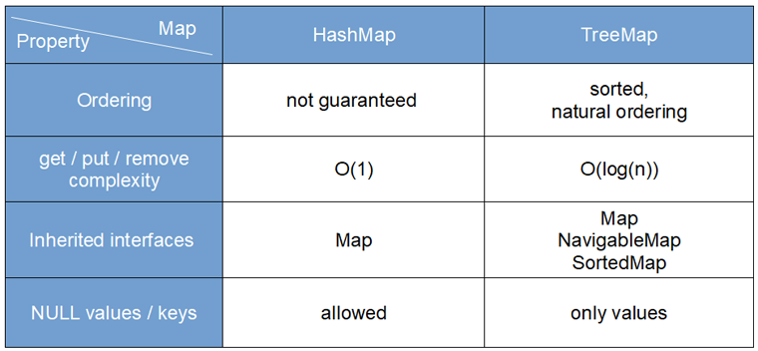

1. Array vs Collection

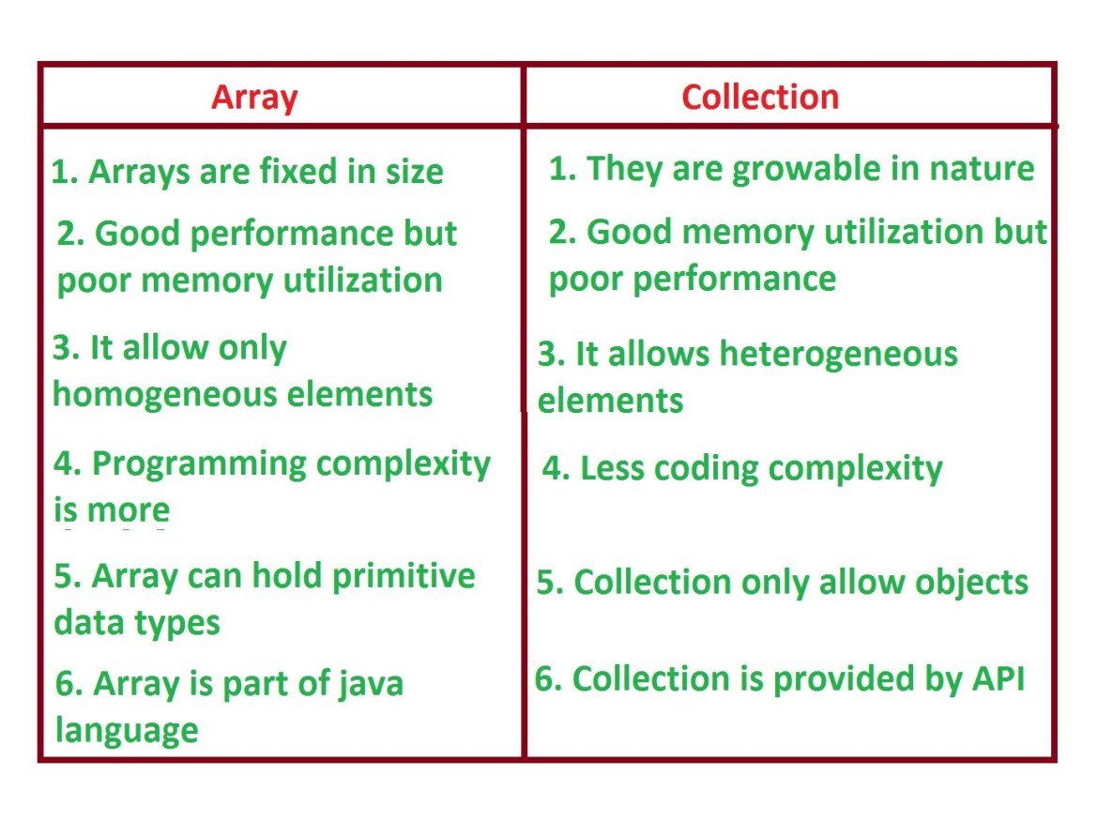

1. LinkedList vs ArrayList

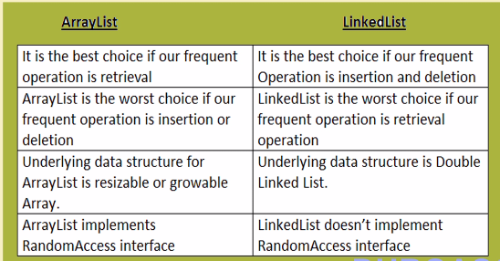

1. HashMap vs HashTable

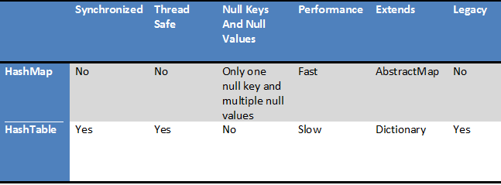

1. == vs .equals()

== => reference comparison

.equals() => content comparison

1. Checked vs Unchecked Exception

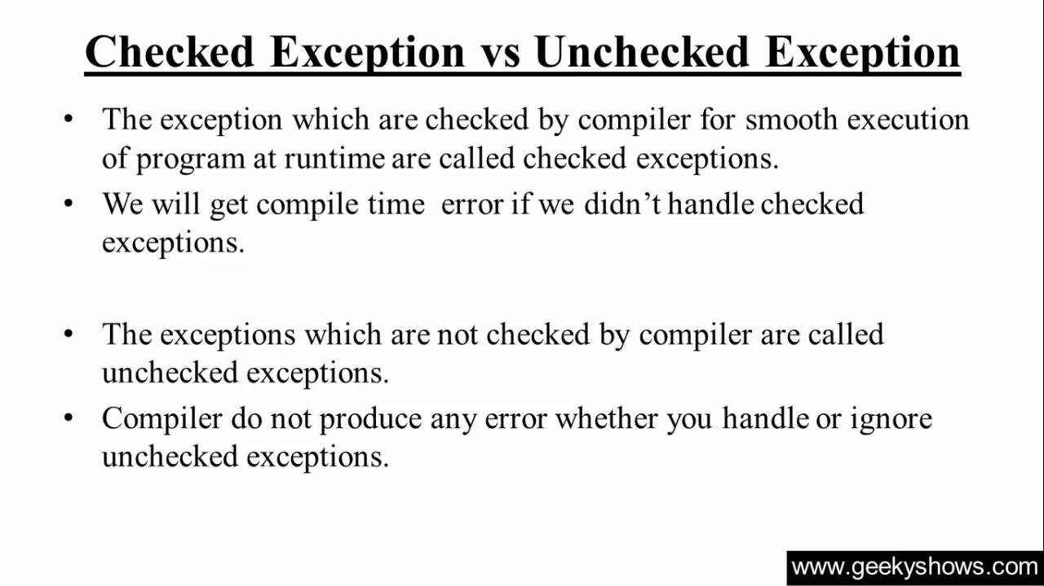

1. Thread vs Process

|  |  |
| --- | --- |
| Process | Thread |
| 1. Process means any program is in execution | 1. Part of a process |
| 1. Process takes more time | 1. Takes less time |
| 1. Process is less efficient in term of communication. | 1. More efficient |
| 1. Consumes more resources | 1. Consumes less resources |
| 1. Heavy weight | 1. Light weight |
| 1. Process is isolated | 1. Threads share memory |

1. String vs StringBuffer vs StringBuilder

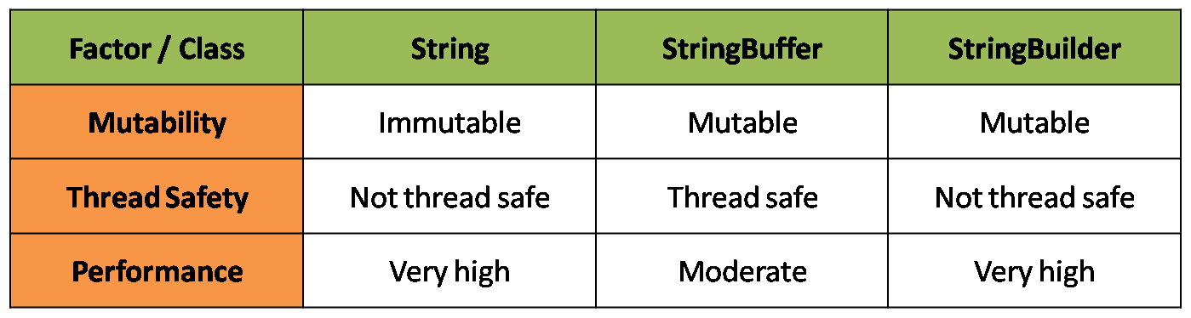

1. Abstraction vs Encapsulation

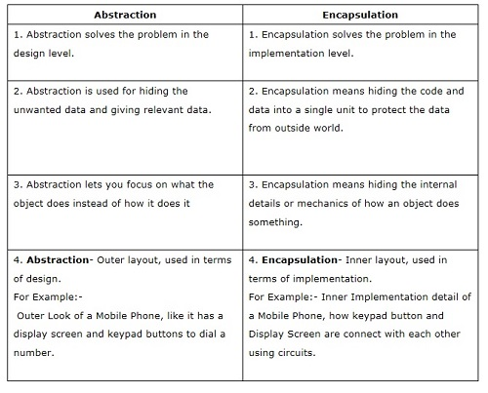

1. Overloading Vs Overriding

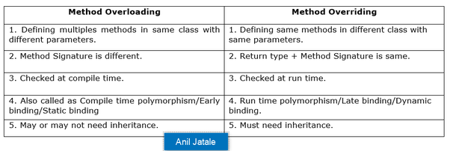

1. Vector vs ArrayList

17. Comparable vs Comparator

|  |  |
| --- | --- |
| Comparable | Comparator |
| 1. Java.lang package | 1. Java.util package |
| 1. Default natural sorting order | 1. Customized sorting order |
| 1. compareTo() | 1. compare() & equals() |

1. Final vs finally vs finalize

|  |  |  |
| --- | --- | --- |
| Final | Finally | Finalize |
| Keyword | Block | Method |
| Final is used to apply restrictions on class, method and variable. Final class can't be inherited, final method can't be overridden and final variable value can't be changed | Finally is used to place important code, it will be executed whether exception is handled or not. | Finalize is used to perform clean up processing just before object is garbage collected. |

18. Runnable vs Callable

|  |  |
| --- | --- |
| Runnable | Callable |
| 1. java.lang package | 1. Java.util.concurrent package |
| 1. A runnable object doesn’t return any value | 1. May return value |
| 1. Can’t throw checked exception | 1. Can throw exception |
| 1. Introduce in 1.0 | 1. In 1.5 |
| 1. run() method | 1. call() method |

19. sleep() vs wait()

|  |  |
| --- | --- |
| Sleep() | Wait() |
| 1. Thread class | 1. Object class |
| 1. Called from anywhere | 1. Called from only synchronized block |
| 1. Doesn’t release lock | 1. Releases lock |
| 1. Awaken by interrupt() or time expires | 1. Awaken by notify() or notifyAll() |

20. new() vs newInstance()

new() => object creation by using constructor

**NoClassDefFoundError** is an error that occurs when a particular class is present at compile time, but was missing at run time

newInstance() => If we want to decide type of object to be created at runtime. In this case, we have to use newInstance() method

**ClassNotFoundException** is an exception that occurs when you try to load a class at run time using **Class.forName()**

21. Abstract class vs Interface

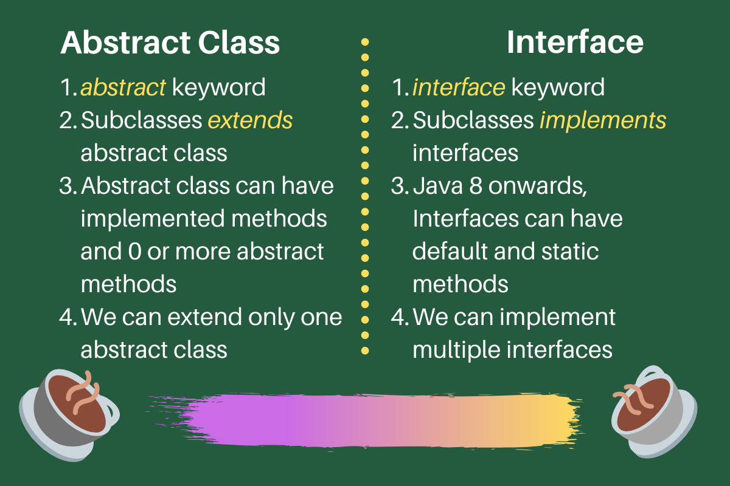

22. Overriding vs Method Hiding

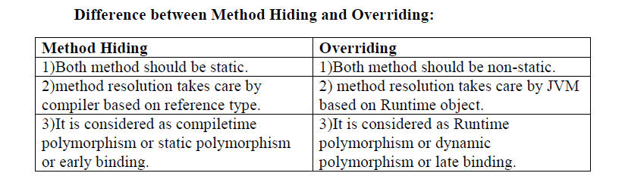

23.

| **Procedural Oriented Programming** | **Object Oriented Programming** |
| --- | --- |
| In procedural programming, program is divided into small parts called functions. | In object oriented programming, program is divided into small parts called objects. |
| Procedural programming follows top down approach. | Object oriented programming follows bottom up approach. |
| There is no access specifier in procedural programming. | Object oriented programming have access specifiers like private, public, protected etc. |
| Adding new data and function is not easy. | Adding new data and function is easy. |
| Procedural programming does not have any proper way for hiding data so it is less secure. | Object oriented programming provides data hiding so it is more secure. |
| In procedural programming, overloading is not possible. | Overloading is possible in object oriented programming. |
| In procedural programming, function is more important than data. | In object oriented programming, data is more important than function. |
| Procedural programming is based on unreal world. | Object oriented programming is based on real world. |
| Examples: C, FORTRAN, Pascal, Basic etc. | Examples: C++, Java, Python, C# etc. |