Dimension reduction
● More efficient storage and computation
● Remove less-informative "noise" features
● ... which cause problems for prediction tasks, e.g. classification, regression

Principal Component Analysis
● PCA = "Principal Component Analysis"
● Fundamental dimension reduction technique
● First step "decorrelation" (considered here)
● Second step reduces dimension (considered later)
from sklearn import datasets
from sklearn.decomposition import PCA
import pandas as pd
import numpy as np
import matplotlib.pyplot as plt
import seaborn as sns

%matplotlib inline

iris data set
iris = datasets.load_iris()
print iris.feature_names
['sepal length (cm)', 'sepal width (cm)', 'petal length (cm)', 'petal width (cm)']

PCA follows the fit/transform pattern
● PCA a scikit-learn component like KMeans or StandardScaler
● fit() learns the transformation from given data
● transform() applies the learned transformation
● transform() can also be applied to new data
data = iris.data
print data.shape
print data[:4]

plt.scatter(data[:,0], data[:,2], c=iris.target)
plt.axhline(color='r', y=0, linewidth=5)
plt.axvline(color='r')
(150L, 4L)
[[ 5.1 3.5 1.4 0.2]
[ 4.9 3. 1.4 0.2]
[ 4.7 3.2 1.3 0.2]
[ 4.6 3.1 1.5 0.2]]
<matplotlib.lines.Line2D at 0xcf06a90>
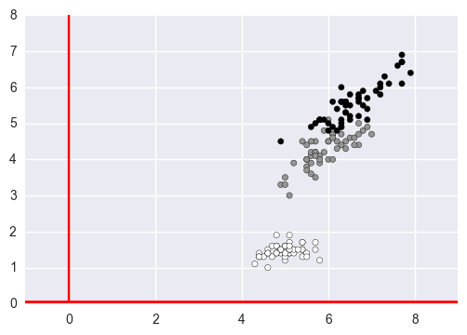

PCA aligns data with axes
● Rotates data samples to be aligned with axes
● Shifs data samples so they have mean 0
● No information is lost

after pca, data algins with 0, 0
- add a line http://matplotlib.org/api/pyplot_summary.html
pca = PCA(2)
pca_data = pca.fit_transform(data[:,[0,2]])

plt.scatter(pca_data[:,0], pca_data[:,1], c=iris.target)
plt.axhline(color='b')
plt.axvline(color='b')
<matplotlib.lines.Line2D at 0xd29eac8>
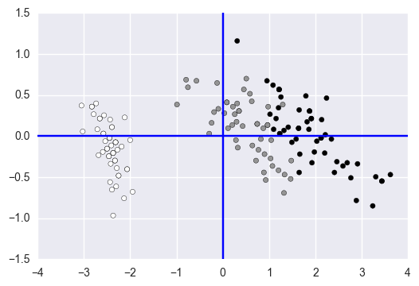

PCA features
● Rows of transformed correspond to samples
● Columns of transformed are the "PCA features"
● Row gives PCA feature values of corresponding sample

Pearson correlation
● Measures linear correlation of features
● Value between -1 and 1
● Value of 0 means no linear correlation

PCA features are not correlated
● Features of dataset are o"en correlated, e.g. total_phenols and od280
● PCA aligns the data with axes
● Resulting PCA features are not linearly correlated ("decorrelation") PCA
- cmap http://matplotlib.org/examples/color/colormaps_reference.html

statistics by scipy

from scipy.stats import pearsonr
from scipy.stats import pearsonr

# Calculate the Pearson correlation
correlation, pvalue = pearsonr(data[:,0], data[:,2])
print pvalue
print correlation
1.03845406279e-47
0.871754157305

before PCA correlation is not 0
np.corrcoef(data[:,0], data[:,2])
array([[ 1. , 0.87175416],
[ 0.87175416, 1. ]])
pd.DataFrame(data[:,[0,2]]).corr()
 | 0 | 1
0 | 1.000000 | 0.871754
1 | 0.871754 | 1.000000

plot linear correlation with Seaborn
- color http://seaborn.pydata.org/tutorial/color_palettes.html
df = pd.DataFrame(data[:,[0,2]], columns= ['x','y'])
df.head(3)
 | x | y
0 | 5.1 | 1.4
1 | 4.9 | 1.4
2 | 4.7 | 1.3
sns.lmplot('x','y',data=df, size=4, aspect=1.5)
<seaborn.axisgrid.FacetGrid at 0xce10d30>
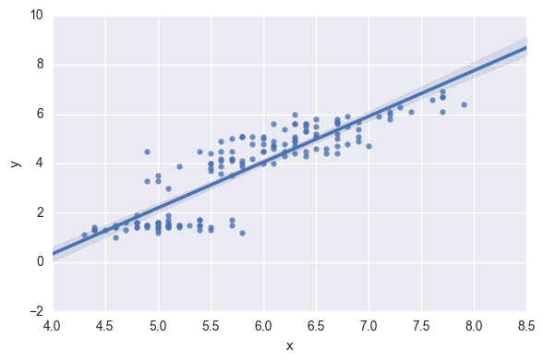
plt.scatter(data[:,0], data[:,2], alpha=.6, c ='gold')
plt.axis('equal')
(4.0, 8.5, 0.0, 8.0)
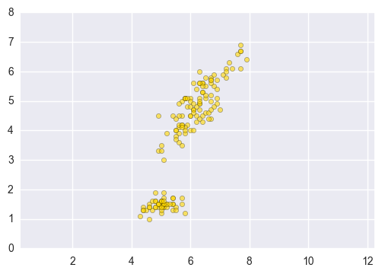

after PCA correlation is 0
np.corrcoef(pca_data[:,0], pca_data[:,1])
array([[ 1.00000000e+00, 2.49817039e-17],
[ 2.49817039e-17, 1.00000000e+00]])
pd.DataFrame(pca_data).corr()
 | 0 | 1
0 | 1.000000e+00 | 1.769537e-17
1 | 1.769537e-17 | 1.000000e+00

for numpy ndarray, similar to R cbind and rbind

cbind : np.vstack([ arr1, arr2,...])

rbind : np.hstack([ arr1, arr2,...])
print data[:,[0,2]].shape, pca_data.shape
pair = np.hstack([data[:,[0,2]], pca_data])
print pair.shape
(150L, 2L) (150L, 2L)
(150L, 4L)

here I just found out binding colomns do not work for seaborn

so binding rows in pd as DataFrame and add a new category for two distinct groups
df2 = pd.DataFrame(pca_data, columns= ['x','y'])
df2.head(3)
 | x | y
0 | -2.460806 | -0.245533
1 | -2.539563 | -0.061692
2 | -2.710240 | 0.082770
df['cat']='before_pca'
df2['cat']='after_pca'
df3 = pd.concat([df,df2])
print df3.shape
df3.tail(3)
(300, 3)
 | x | y | cat
147 | 1.583463 | -0.036035 | after_pca
148 | 1.649168 | 0.318483 | after_pca
149 | 1.255272 | 0.476108 | after_pca

plotting dataset of linear relationship
- after PCA, there is NO correlation
sns.lmplot('x','y',data=df3, size=4, aspect=1.5, hue = 'cat')
<seaborn.axisgrid.FacetGrid at 0xcf575c0>
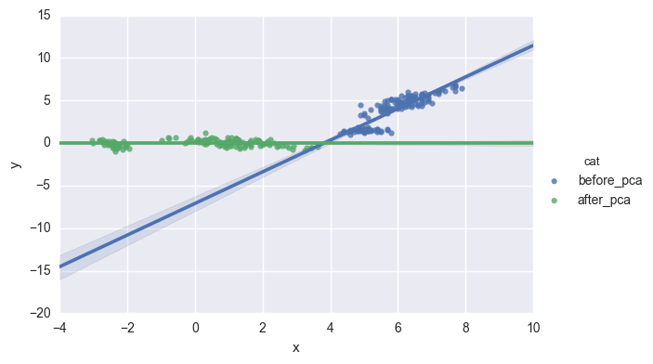
sns.lmplot('x','y',data=df3, size=3.5, col = 'cat')
<seaborn.axisgrid.FacetGrid at 0xe7d7e10>
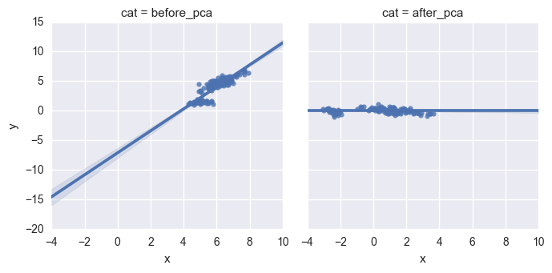

Principal components
● "Principal components" = directions of variance
● PCA aligns principal components with the axes
● Available as components_attribute of PCA object
● Each row defines displacement from mean
print pca.components_
[[ 0.39378459 0.91920275]
[-0.91920275 0.39378459]]

Intrinsic dimension
Intrinsic dimension of a flight path
● 2 features: longitude and latitude at points along a flight path
● Dataset appears to be 2-dimensional
● But can approximate using one feature: displacement along flight path
● Is intrinsically 1-dimensional
plt.imshow(plt.imread('ch3_slides.jpg'))
plt.grid('off')
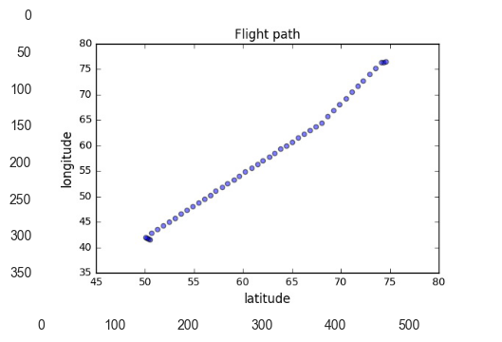

The first principal component

The first principal component of the data is the direction in which the data varies the most.
- In this exercise, your job is to use PCA to find the first principal component of the length and width measurements of the iris petal , and represent it as an arrow on the scatter plot.
print iris.feature_names
['sepal length (cm)', 'sepal width (cm)', 'petal length (cm)', 'petal width (cm)']
# Make a scatter plot of the untransformed points
plt.scatter(iris.data[:,2], iris.data[:,3], alpha=.7, c='g')

# Create a PCA instance: model
model = PCA()

# Fit model to points
model.fit(iris.data[:,2:4])

# Get the mean of the grain samples: mean
mean = model.mean_
print mean

# Get the first principal component: first_pc
first_pc = model.components_[0,:]
print first_pc

# Plot first_pc as an arrow, starting at mean
plt.arrow(mean[0], mean[1], first_pc[0], first_pc[1], color='red', width=0.01)

sec_pc = model.components_[1,:]
print sec_pc

# Plot second_pc as an arrow, starting at mean
plt.arrow(mean[0], mean[1], sec_pc[0], sec_pc[1], color='b', width=0.01)

# Keep axes on same scale
plt.axis('equal')
plt.show()
[ 3.75866667 1.19866667]
[ 0.92154695 0.38826694]
[-0.38826694 0.92154695]
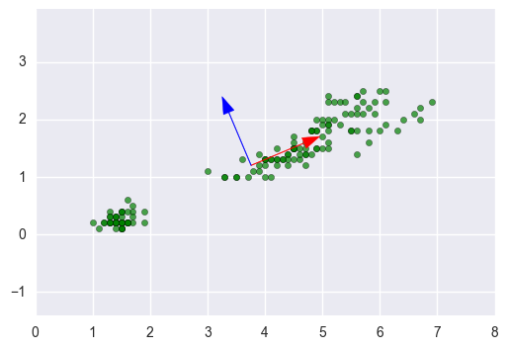

Intrinsic dimension
● Intrinsic dimension = number of features needed to approximate the dataset
● Essential idea behind dimension reduction
● What is the most compact representation of the samples?
● Can be detected with PCA

Versicolor dataset
● "versicolor", one of the iris species
● Only 3 features: sepal length, sepal width, and petal width
● Samples are points in 3D space

create verisocolor dataset
print iris.target_names
print iris.feature_names
['setosa' 'versicolor' 'virginica']
['sepal length (cm)', 'sepal width (cm)', 'petal length (cm)', 'petal width (cm)']
iri = pd.DataFrame(iris.data, columns = ['sepal_l','sepal_w','petal_l','petal_w'])
iri['target']=iris.target
versicolor = iri[iri['target']==1]
versicolor = versicolor.iloc[:,[0,1,3]]
versicolor.head()
 | sepal_l | sepal_w | petal_w
50 | 7.0 | 3.2 | 1.4
51 | 6.4 | 3.2 | 1.5
52 | 6.9 | 3.1 | 1.5
53 | 5.5 | 2.3 | 1.3
54 | 6.5 | 2.8 | 1.5

Versicolor dataset has intrinsic dimension 2
● Samples lie close to a flat 2-dimensional sheet
● So can be approximated using 2 features

the easiest 3D plotting
from mpl_toolkits.mplot3d import Axes3D

fig = plt.figure(figsize=(6,4))

ax = Axes3D(fig)

ax.scatter(versicolor.iloc[:, 1], versicolor.iloc[:, 1], versicolor.iloc[:, 2])
<mpl_toolkits.mplot3d.art3d.Path3DCollection at 0x10630b00>
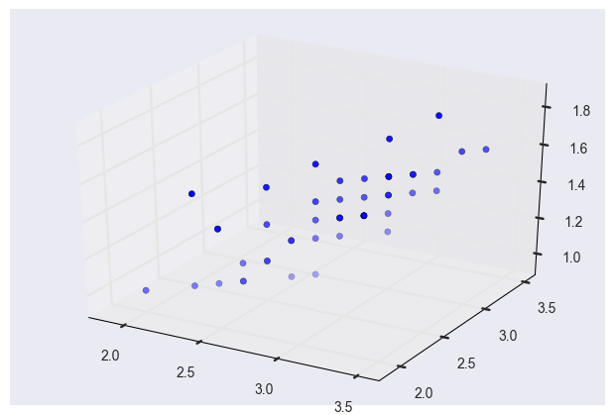

PCA identifies intrinsic dimension
● Scatter plots work only if samples have 2 or 3 features
● PCA identifies intrinsic dimension when samples have any number of features
● Intrinsic dimension = number of PCA features with significant variance
pca2 = PCA()
pca2.fit(versicolor)
versicolor_pca = pca2.transform(versicolor)
versicolor_pca[:3]
array([[-1.13236543, 0.09514055, -0.17654689],
[-0.62150644, -0.20612416, -0.04140747],
[-1.02792193, 0.10180149, -0.03853535]])
fig = plt.figure(figsize=(10,4))

ax= fig.add_subplot(1,2,1, projection='3d')

l1 = ax.scatter(versicolor.iloc[:, 1], versicolor.iloc[:, 1], versicolor.iloc[:, 2])
ax.set_title('before PCA')

ax = fig.add_subplot(1,2,2, projection='3d')

l2 = ax.scatter(versicolor_pca[:, 1], versicolor_pca[:, 1], versicolor_pca[:, 2])
ax.set_title('after PCA')

plt.show()
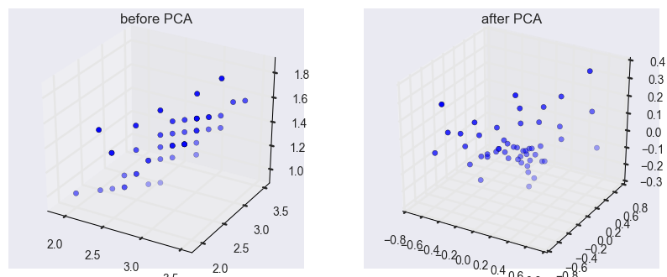

Variance and intrinsic dimension
● Intrinsic dimension is number of PCA features with significant variance
● In our example: the first two PCA features
● So intrinsic dimension is 2
plt.figure(figsize=(4,4))
features = range(pca2.n_components_)

plt.bar(features, pca2.explained_variance_, alpha = .6, color='r')
plt.xticks(features)
plt.ylabel('variance')
plt.xlabel('PCA feature')
<matplotlib.text.Text at 0x10cba4a8>
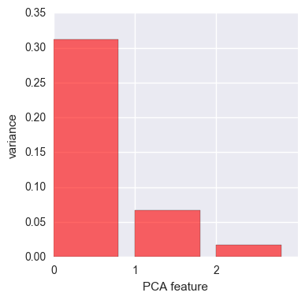

Intrinsic dimension can be ambiguous
● Intrinsic dimension is an idealization
● … there is not always one correct answer!
● Boston data from sklearn: could argue for 2, or for 3, or more

NOT standardize feature so the dimension is ambiguous
bos = datasets.load_boston()
bos_data = bos.data
bos_data.shape
(506L, 13L)
pca3 = PCA()
pca3.fit(bos_data)
PCA(copy=True, iterated_power='auto', n_components=None, random_state=None,
svd_solver='auto', tol=0.0, whiten=False)
plt.figure(figsize=(7,4))
features = range(pca3.n_components_)

plt.bar(features, pca3.explained_variance_, alpha = .6, color='g')
plt.xticks(features)
plt.ylabel('variance')
plt.xlabel('PCA feature')

plt.axvline(x=2, ls = '--', c='r')
plt.axvline(x=3, ls = '--', c='r')
<matplotlib.lines.Line2D at 0xd2deda0>
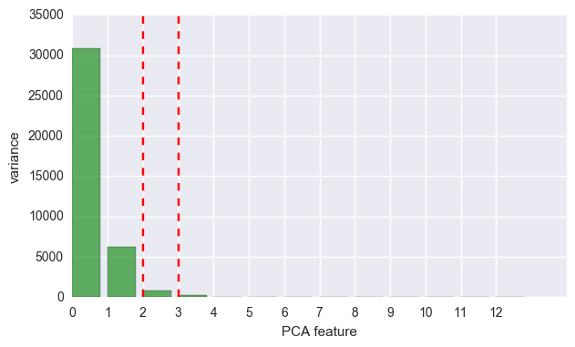

standardize features first

Variance of the PCA features
The Boston dataset is 13-dimensional. But what is its intrinsic dimension?
Make a plot of the variances of the PCA features to find out.
As before, samples is a 2D array, where each row represents a fish. You'll need to standardize the features first.
# Perform the necessary imports
from sklearn.decomposition import PCA
from sklearn.preprocessing import StandardScaler
from sklearn.pipeline import make_pipeline
import matplotlib.pyplot as plt

# Create scaler: scaler
scaler = StandardScaler()

# Create a PCA instance: pca
pca4 = PCA()

# Create pipeline: pipeline
pipeline = make_pipeline(scaler, pca4)

# Fit the pipeline to 'samples'
pipeline.fit(bos_data)

# Plot the explained variances
features = range(pca4.n_components_)

plt.figure(figsize=(9,4))

plt.bar(features, pca4.explained_variance_, color='r', alpha=.6)
plt.xlabel('PCA feature')
plt.ylabel('variance')
plt.xticks(features)
plt.show()
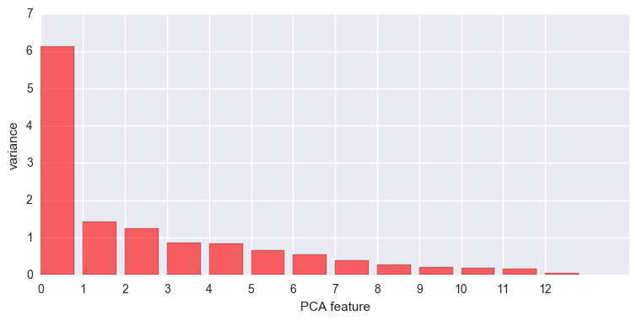

Dimension reduction with PCA
Dimension reduction
● Represents same data, using less features
● Important part of machine-learning pipelines
● Can be performed using PCA

Dimension reduction with PCA
● PCA features are in decreasing order of variance
● Assumes the low variance features are "noise"
● … and high variance features are informative informative noisy

Specify how many features to keep
● E.g. PCA(n_components=2)
● Keeps the first 2 PCA features
● Intrinsic dimension is a good choice

Dimension reduction of iris dataset
● samples = array of iris measurements (4 features)
● species = list of iris species numbers
pca5 = PCA(2)
pca5.fit(iris.data)

transform = pca5.transform(iris.data)
print (transform.shape)
(150L, 2L)

Iris dataset in 2 dimensions
● PCA has reduced the dimension to 2
● Retained the 2 PCA features with highest variance
● Important information preserved: species remain distinct
plt.scatter(transform[:,0], transform[:,1], c=iris.target)
<matplotlib.collections.PathCollection at 0x10f34f60>
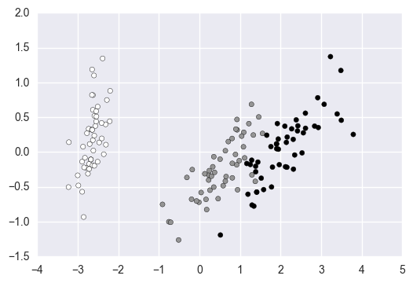

Dimension reduction with PCA
● Discards low variance PCA features
● Assumes the high variance features are informative
● Assumption typically holds in practice (e.g. for iris)

Word frequency arrays
● Rows represent documents, columns represent words
● Entries measure presence of each word in each document
● ... measure using "tf-idf" (more later)
plt.imshow(plt.imread('tfidf.jpg'))
plt.grid('off')
plt.axis('off')
(-0.5, 542.5, 292.5, -0.5)
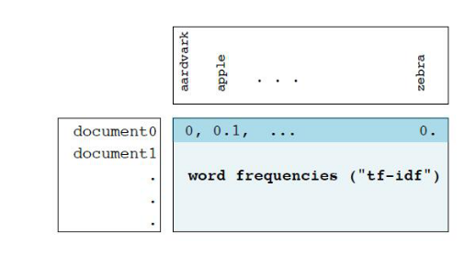

A tf-idf word-frequency array
- create a tf-idf word frequency array for a toy collection of documents.
  - For this, use the TfidfVectorizer from sklearn. It transforms a list of documents into a word frequency array, which it outputs as a csr_matrix.
    - It has fit() and transform() methods like other sklearn objects.
      - You are given a list documents of toy documents about pets. It's contents have been printed in the IPython Shell.
documents = ['cats say meow', 'dogs say woof', 'dogs chase cats']
# Import TfidfVectorizer
from sklearn.feature_extraction.text import TfidfVectorizer

# Create a TfidfVectorizer: tfidf
tfidf = TfidfVectorizer()

# Apply fit_transform to document: csr_mat
csr_mat = tfidf.fit_transform(documents)

# Print result of toarray() method
print(csr_mat.toarray())

# Get the words: words
words = tfidf.get_feature_names()

# Print words
print
print(words)
[[ 0.51785612 0. 0. 0.68091856 0.51785612 0. ]
[ 0. 0. 0.51785612 0. 0.51785612 0.68091856]
[ 0.51785612 0.68091856 0.51785612 0. 0. 0. ]]

[u'cats', u'chase', u'dogs', u'meow', u'say', u'woof']
csr_mat
<3x6 sparse matrix of type '<type 'numpy.float64'>'
with 9 stored elements in Compressed Sparse Row format>
print csr_mat
(0, 0) 0.517856116168
(0, 4) 0.517856116168
(0, 3) 0.680918560399
(1, 4) 0.517856116168
(1, 2) 0.517856116168
(1, 5) 0.680918560399
(2, 0) 0.517856116168
(2, 2) 0.517856116168
(2, 1) 0.680918560399

Sparse arrays and csr_matrix
● Array is "sparse": most entries are zero
● Can use scipy.sparse.csr_matrix instead of NumPy array
● csr_matrix remembers only the non-zero entries (saves space!)

TruncatedSVD and csr_matrix
● scikit-learn PCA doesn't support csr_matrix
● Use scikit-learn TruncatedSVD instead
● Performs same transformation
plt.imshow(plt.imread('svd.jpg'))
plt.grid('off')
plt.axis('off')
(-0.5, 717.5, 247.5, -0.5)
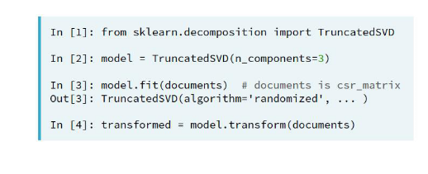

Clustering twitter data

TruncatedSVD is able to perform PCA on sparse arrays in csr_matrix format
- such as word-frequency arrays.
  - Combine your knowledge of TruncatedSVD and k-means to cluster some popular pages from Wikipedia.
    - build the pipeline.
- Create a Pipeline object consisting of a TruncatedSVD followed by KMeans.
# Perform the necessary imports
from sklearn.decomposition import TruncatedSVD
from sklearn.cluster import KMeans
from sklearn.pipeline import make_pipeline

# Create a TruncatedSVD instance: svd
svd = TruncatedSVD(n_components=50)

# Create a KMeans instance: kmeans
kmeans = KMeans(n_clusters=6)

# Create a pipeline: pipeline
pipeline = make_pipeline(svd, kmeans)

prepare twitter data
twi = pd.read_csv('tweets.csv')
twi.shape
(615, 33)
text = twi['text']
text.shape
(615L,)
text.head()
0 RT @MeckeringBoy: Does Pauline secretly wear h...
1 RT @lordaedonis: if you a grown man afraid of ...
2 RT @alaskantexanQCT: I'm not "White" but still...
3 We dont discriminate like Libs, divede by sex,...
4 @TMattis7 @babsmarshall1 @Randazzoj @realDonal...
Name: text, dtype: object
# Import TfidfVectorizer
from sklearn.feature_extraction.text import TfidfVectorizer

# Create a TfidfVectorizer: tfidf
tfidf = TfidfVectorizer()

# Apply fit_transform to document: csr_mat
tweet_mat = tfidf.fit_transform(text)

# Get the words: words
word = tfidf.get_feature_names()

# Print words
len(word)
1286
tweet_mat
<615x1286 sparse matrix of type '<type 'numpy.float64'>'
with 10947 stored elements in Compressed Sparse Row format>

clustering

article is the name of the post

label is the group of the post
# Import pandas
import pandas as pd

# Fit the pipeline to articles
pipeline.fit(tweet_mat)

# Calculate the cluster labels: labels
labels = pipeline.predict(tweet_mat)

# Create a DataFrame aligning labels and titles: df
df = pd.DataFrame({'label': labels, 'article': range(1,616)})

# Display df sorted by cluster label
print(df.sort_values('label').head())
df['label'].unique()
article label
247 248 0
276 277 0
287 288 0
238 239 0
19 20 0
array([2, 0, 1, 3, 5, 4], dtype=int64)

the results show there are 6 categories in total, the biggest group has 322 twitter posts
df['label'].value_counts(ascending = False)
2 320
1 149
3 90
5 23
0 23
4 10
Name: label, dtype: int64
df.head()
 | article | label
0 | 1 | 2
1 | 2 | 0
2 | 3 | 1
3 | 4 | 2
4 | 5 | 2

check out the group with the least posts
index = list(df[df['label']==4]['article'])
index
[52, 82, 84, 132, 249, 327, 357, 359, 407, 607]
text.iloc[index]
52 RT @DebraJenson: Marine veteran pushing @jason...
82 RT @PhDdropout: Reminder that Chaffetz wouldn'...
84 RT @PhDdropout: Reminder that Chaffetz wouldn'...
132 RT @PhDdropout: Reminder that Chaffetz wouldn'...
249 RT @alaskantexanQCT: I'm not "White" but still...
327 RT @DebraJenson: Marine veteran pushing @jason...
357 RT @PhDdropout: Reminder that Chaffetz wouldn'...
359 RT @PhDdropout: Reminder that Chaffetz wouldn'...
407 RT @PhDdropout: Reminder that Chaffetz wouldn'...
607 RT @alaskantexanQCT: I'm not "White" but still...
Name: text, dtype: object
for i in text.iloc[index]: print i+'\n'
RT @DebraJenson: Marine veteran pushing @jasoninthehouse to defend his flip-flop on Trump and pussy-grabbing, VAWA, and Session. #chaffetzt…

RT @PhDdropout: Reminder that Chaffetz wouldn't endorse Trump after pussy tape, only to reverse. Not the spine you'd want in ethics chair #…

RT @PhDdropout: Reminder that Chaffetz wouldn't endorse Trump after pussy tape, only to reverse. Not the spine you'd want in ethics chair #…

RT @PhDdropout: Reminder that Chaffetz wouldn't endorse Trump after pussy tape, only to reverse. Not the spine you'd want in ethics chair #…

RT @alaskantexanQCT: I'm not "White" but still I think that "pussy hats", burning a college campus, attacking Trump supporters and obstr…

RT @DebraJenson: Marine veteran pushing @jasoninthehouse to defend his flip-flop on Trump and pussy-grabbing, VAWA, and Session. #chaffetzt…

RT @PhDdropout: Reminder that Chaffetz wouldn't endorse Trump after pussy tape, only to reverse. Not the spine you'd want in ethics chair #…

RT @PhDdropout: Reminder that Chaffetz wouldn't endorse Trump after pussy tape, only to reverse. Not the spine you'd want in ethics chair #…

RT @PhDdropout: Reminder that Chaffetz wouldn't endorse Trump after pussy tape, only to reverse. Not the spine you'd want in ethics chair #…

RT @alaskantexanQCT: I'm not "White" but still I think that "pussy hats", burning a college campus, attacking Trump supporters and obstr…

check out the group with the second least posts
text.iloc[df[df['label']==0]['article'].values]
2 RT @alaskantexanQCT: I'm not "White" but still...
7 @juliahosack @Marina_Sirtis your the problem ...
13 RT @alaskantexanQCT: I'm not "White" but still...
20 RT @alaskantexanQCT: I'm not "White" but still...
90 RT @LEngelhorn: You can do "things" in Russia ...
135 RT @PhDdropout: Reminder that Chaffetz wouldn'...
239 Trump is China's bitch. They're definitely gra...
242 RT @lordaedonis: if you a grown man afraid of ...
243 Immigration kills black AMERICANS more than an...
245 RT @lordaedonis: if you a grown man afraid of ...
246 RT @alaskantexanQCT: I'm not "White" but still...
248 RT @daylinleach: @XGrabMyY @realDonaldTrump Ci...
255 RT @lordaedonis: if you a grown man afraid of ...
256 RT @alaskantexanQCT: I'm not "White" but still...
264 RT @bavegan2951: 👍👍👍👍😂😂😂😂😂😂😂🇺🇸🇮�...
268 RT @Caycioldman: If you were upset by Trump's ...
271 Donald is now seen as such a pussy that Access...
277 RT @alaskantexanQCT: I'm not "White" but still...
282 @juliahosack @Marina_Sirtis your the problem ...
288 RT @alaskantexanQCT: I'm not "White" but still...
295 RT @alaskantexanQCT: I'm not "White" but still...
365 RT @LEngelhorn: You can do "things" in Russia ...
410 RT @PhDdropout: Reminder that Chaffetz wouldn'...
Name: text, dtype: object
for i in text.iloc[df[df['label']==0]['article'].values]: print i+'\n'
RT @alaskantexanQCT: I'm not "White" but still I think that "pussy hats", burning a college campus, attacking Trump supporters and obstr…

@juliahosack @Marina_Sirtis your the problem with the insecure pussy hat. Your afraid of anything someone puts in your head. I.e. Trump

RT @alaskantexanQCT: I'm not "White" but still I think that "pussy hats", burning a college campus, attacking Trump supporters and obstr…

RT @alaskantexanQCT: I'm not "White" but still I think that "pussy hats", burning a college campus, attacking Trump supporters and obstr…

RT @LEngelhorn: You can do "things" in Russia you can't get away with here. Think Thailand. Children. Pussy grabbers are welcomed.…

RT @PhDdropout: Reminder that Chaffetz wouldn't endorse Trump after pussy tape, only to reverse. Not the spine you'd want in ethics chair #…

Trump is China's bitch. They're definitely grabbing him by the pussy. Pathetic.

RT @lordaedonis: if you a grown man afraid of a Trump presidency please do not speak to me. the only pussy I like around me is on women.

Immigration kills black AMERICANS more than any other group. This guy gets it! https://t.co/yiDmuauje5

RT @lordaedonis: if you a grown man afraid of a Trump presidency please do not speak to me. the only pussy I like around me is on women.

RT @alaskantexanQCT: I'm not "White" but still I think that "pussy hats", burning a college campus, attacking Trump supporters and obstr…

RT @daylinleach: @XGrabMyY @realDonaldTrump Civil to Trump? You know he calls your gender "disgusting pigs" and "filthy animals" whose puss…

RT @lordaedonis: if you a grown man afraid of a Trump presidency please do not speak to me. the only pussy I like around me is on women.

RT @alaskantexanQCT: I'm not "White" but still I think that "pussy hats", burning a college campus, attacking Trump supporters and obstr…

RT @bavegan2951: 👍👍👍👍😂😂😂😂😂😂😂🇺🇸🇮🇱 https://t.co/yPpGIdVETg

RT @Caycioldman: If you were upset by Trump's "grab her by the pussy" comment but are defending our ASUN speaker saying "people change" I w…

Donald is now seen as such a pussy that Access Hollywood has released a tape of President Xi saying that he "grabbe… https://t.co/kdrkvYxVw6

RT @alaskantexanQCT: I'm not "White" but still I think that "pussy hats", burning a college campus, attacking Trump supporters and obstr…

@juliahosack @Marina_Sirtis your the problem with the insecure pussy hat. Your afraid of anything someone puts in your head. I.e. Trump

RT @alaskantexanQCT: I'm not "White" but still I think that "pussy hats", burning a college campus, attacking Trump supporters and obstr…

RT @alaskantexanQCT: I'm not "White" but still I think that "pussy hats", burning a college campus, attacking Trump supporters and obstr…

RT @LEngelhorn: You can do "things" in Russia you can't get away with here. Think Thailand. Children. Pussy grabbers are welcomed.…

RT @PhDdropout: Reminder that Chaffetz wouldn't endorse Trump after pussy tape, only to reverse. Not the spine you'd want in ethics chair #…

>>>>>>>>>>>>>>>>>>>>>>>>>>>>>>>>>>>>>>>>>>>>>>>>>>>>>>>>>>>>>>>>>>>...

Correlated data in nature
You are given an array grains giving the width and length of samples of grain. You suspect that width and length will be correlated. To confirm this, make a scatter plot of width vs length and measure their Pearson correlation.

Instructions
70xp
- Import:
  - matplotlib.pyplot as plt.
  - pearsonr from scipy.stats.
- Assign column 0 of grains to width and column 1 of grains to length.
- Make a scatter plot with width on the x-axis and length on the y-axis.
- Use the pearsonr() function to calculate the Pearson correlation of width and length.
SOLUTION>
# Perform the necessary imports
import matplotlib.pyplot as plt
from scipy.stats import pearsonr

# Assign the 0th column of grains: width
width = grains[:,0]

# Assign the 1st column of grains: length
length = grains[:,1]

# Scatter plot width vs length
plt.scatter(width, length)
plt.axis('equal')
plt.show()

# Calculate the Pearson correlation
correlation, pvalue = pearsonr(width, length)

# Display the correlation
print(correlation)

>>>>>>>>>>>>>>>>>>>>>>>>>>>>>>>>>>>>>>>>>>>>>>>>>>>>>>>>>>>>>>>>>>>>>>>

Decorrelating the grain measurements with PCA
You observed in the previous exercise that the width and length measurements of the grain are correlated. Now, you'll use PCA to decorrelate these measurements, then plot the decorrelated points and measure their Pearson correlation.

Instructions
100xp
- Import PCA from sklearn.decomposition.
- Create an instance of PCA called model.
- Use the .fit_transform() method of model to apply the PCA transformation to grains. Assign the result to pca_features.
- The subsequent code to extract, plot, and compute the Pearson correlation of the first two columns pca_features has been written for you, so hit 'Submit Answer' to see the result!
SOLUTIONS>
# Import PCA
from sklearn.decomposition import PCA

# Create PCA instance: model
model = PCA()

# Apply the fit_transform method of model to grains: pca_features
pca_features = model.fit_transform(grains)

# Assign 0th column of pca_features: xs
xs = pca_features[:,0]

# Assign 1st column of pca_features: ys
ys = pca_features[:,1]

# Scatter plot xs vs ys
plt.scatter(xs, ys)
plt.axis('equal')
plt.show()

# Calculate the Pearson correlation of xs and ys
correlation, pvalue = pearsonr(xs, ys)

# Display the correlation
print(correlation)

>>>>>>>>>>>>>>>>>>>>>>>>>>>>>>>>>>>>>>>>>>>>>>>>>>>>>>>>>>>>>>>>>>>>>>>

Principal components
On the right are three scatter plots of the same point cloud. Each scatter plot shows a different set of axes (in red). In which of the plots could the axes represent the principal components of the point cloud?
Recall that the principal components are the directions along which the the data varies.
SOLUTIONS

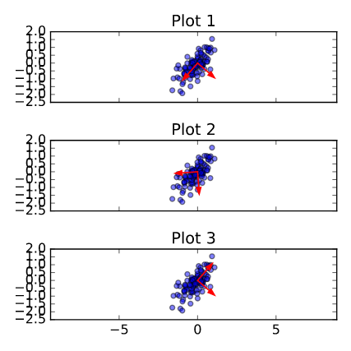

Possible Answers
- None of them.
press
- Both plot 1 and plot 3.
press
- Plot 2
- Well done! You've correctly inferred that the principal components have to align with the axes of the point cloud. This happens in both plot 1 and plot 3.

>>>>>>>>>>>>>>>>>>>>>>>>>>>>>>>>>>>>>>>>>>>>>>>>>>>>>>>>>>>>>>>>>

The first principal component
The first principal component of the data is the direction in which the data varies the most. In this exercise, your job is to use PCA to find the first principal component of the length and width measurements of the grain samples, and represent it as an arrow on the scatter plot.
The array grains gives the length and width of the grain samples. PyPlot (plt) and PCA have already been imported for you.

Instructions
100xp

Instructions
100xp
- Make a scatter plot of the grain measurements. This has been done for you.
- Create a PCA instance called model.
- Fit the model to the grains data.
- Extract the coordinates of the mean of the data using the .mean_ attribute of model.
- Get the first principal component of model using the .components_[0,:] attribute.
- Plot the first principal component as an arrow on the scatter plot, using the plt.arrow() function. You have to specify the first two arguments - mean[0] and mean[1].
Solutions>
# Make a scatter plot of the untransformed points
plt.scatter(grains[:,0], grains[:,1])

# Create a PCA instance: model
model = PCA()

# Fit model to points
model.fit(grains)

# Get the mean of the grain samples: mean
mean = model.mean_

# Get the first principal component: first_pc
first_pc = model.components_[0,:]

# Plot first_pc as an arrow, starting at mean
plt.arrow(mean[0], mean[1], first_pc[0], first_pc[1], color='red', width=0.01)

# Keep axes on same scale
plt.axis('equal')
plt.show()

>>>>>>>>>>>>>>>>>>>>>>>>>>>>>>>>>>>>>>>>>>>>>>>>>>>>>>>>>>>>>>>>>>

Variance of the PCA features
The fish dataset is 6-dimensional. But what is its intrinsic dimension? Make a plot of the variances of the PCA features to find out. As before, samples is a 2D array, where each row represents a fish. You'll need to standardize the features first.

Instructions
100xp

Instructions
100xp
- Create an instance of StandardScaler called scaler.
- Create a PCA instance called pca.
- Use the make_pipeline() function to create a pipeline chaining scaler and pca.
- Use the .fit() method of pipeline to fit it to the fish samples samples.
- Extract the number of components used using the .n_components_ attribute of pca. Place this inside a range() function and store the result as features.
- Use the plt.bar() function to plot the explained variances, with features on the x-axis and pca.explained_variance_ on the y-axis.

SOLUTION>
# Perform the necessary imports
from sklearn.decomposition import PCA
from sklearn.preprocessing import StandardScaler
from sklearn.pipeline import make_pipeline
import matplotlib.pyplot as plt

# Create scaler: scaler
scaler = StandardScaler()

# Create a PCA instance: pca
pca = PCA()

# Create pipeline: pipeline
pipeline = make_pipeline(scaler, pca)

# Fit the pipeline to 'samples'
pipeline.fit(samples)

# Plot the explained variances
features = range(pca.n_components_)
plt.bar(features, pca.explained_variance_)
plt.xlabel('PCA feature')
plt.ylabel('variance')
plt.xticks(features)
plt.show()

>>>>>>>>>>>>>>>>>>>>>>>>>>>>>>>>>>>>>>>>>>>>>>>>>>>>>>>>>>>>>>>>>

Dimension reduction of the fish measurements
In a previous exercise, you saw that 2 was a reasonable choice for the "intrinsic dimension" of the fish measurements. Now use PCA for dimensionality reduction of the fish measurements, retaining only the 2 most important components.
The fish measurements have already been scaled for you, and are available as scaled_samples.

Instructions
100xp
- Import PCA from sklearn.decomposition.
- Create a PCA instance called pca with n_components=2.
- Use the .fit() method of pca to fit it to the scaled fish measurements scaled_samples.
- Use the .transform() method of pca to transform the scaled_samples. Assign the result to pca_features.
SOLUTIONS:
# Import PCA
from sklearn.decomposition import PCA

# Create a PCA model with 2 components: pca
pca = PCA(n_components=2)

# Fit the PCA instance to the scaled samples
pca.fit(scaled_samples)

# Transform the scaled samples: pca_features
pca_features = pca.transform(scaled_samples)

# Print the shape of pca_features
print(pca_features.shape)

>>>>>>>>>>>>>>>>>>>>>>>>>>>>>>>>>>>>>>>>>>>>>>>>>>>>>>>>>>>>>>>

A tf-idf word-frequency array
In this exercise, you'll create a tf-idf word frequency array for a toy collection of documents. For this, use the TfidfVectorizer from sklearn. It transforms a list of documents into a word frequency array, which it outputs as a csr_matrix. It has fit() and transform() methods like other sklearn objects.
You are given a list documents of toy documents about pets. Its contents have been printed in the IPython Shell.

Instructions
100xp

Instructions
100xp
- Import TfidfVectorizer from sklearn.feature_extraction.text.
- Create a TfidfVectorizer instance called tfidf.
- Apply .fit_transform() method of tfidf to documents and assign the result to csr_mat. This is a word-frequency array in csr_matrix format.
- Inspect csr_mat by calling its .toarray() method and printing the result. This has been done for you.
- The columns of the array correspond to words. Get the list of words by calling the .get_feature_names() method of tfidf, and assign the result to words.
SOLUTIONS:
# Import TfidfVectorizer
from sklearn.feature_extraction.text import TfidfVectorizer

# Create a TfidfVectorizer: tfidf
tfidf = TfidfVectorizer()

# Apply fit_transform to document: csr_mat
csr_mat = tfidf.fit_transform(documents)

# Print result of toarray() method
print(csr_mat.toarray())

# Get the words: words
words = tfidf.get_feature_names()

# Print words
print(words)

>>>>>>>>>>>>>>>>>>>>>>>>>>>>>>>>>>>>>>>>>>>>>>>>>>>>>>>>>>>>>>>>>

Clustering Wikipedia part I
You saw in the video that TruncatedSVD is able to perform PCA on sparse arrays in csr_matrix format, such as word-frequency arrays. Combine your knowledge of TruncatedSVD and k-means to cluster some popular pages from Wikipedia. In this exercise, build the pipeline. In the next exercise, you'll apply it to the word-frequency array of some Wikipedia articles.
Create a Pipeline object consisting of a TruncatedSVD followed by KMeans. (This time, we've precomputed the word-frequency matrix for you, so there's no need for a TfidfVectorizer).
The Wikipedia dataset you will be working with was obtained from here.

Instructions
100xp
- Import:
  - TruncatedSVD from sklearn.decomposition.
  - KMeans from sklearn.cluster.
  - make_pipeline from sklearn.pipeline.
- Create a TruncatedSVD instance called svd with n_components=50.
- Create a KMeans instance called kmeans with n_clusters=6.
- Create a pipeline called pipeline consisting of svd and kmeans.
SOLUTIONS>
# Perform the necessary imports
from sklearn.decomposition import TruncatedSVD
from sklearn.cluster import KMeans
from sklearn.pipeline import make_pipeline

# Create a TruncatedSVD instance: svd
svd = TruncatedSVD(n_components=50)

# Create a KMeans instance: kmeans
kmeans = KMeans(n_clusters=6)

# Create a pipeline: pipeline
pipeline = make_pipeline(svd, kmeans)

>>>>>>>>>>>>>>>>>>>>>>>>>>>>>>>>>>>>>>>>>>>>>>>>>>>>>>>>>>>>>>>>>>>>

Clustering Wikipedia part II
It is now time to put your pipeline from the previous exercise to work! You are given an array articles of tf-idf word-frequencies of some popular Wikipedia articles, and a list titles of their titles. Use your pipeline to cluster the Wikipedia articles.
A solution to the previous exercise has been pre-loaded for you, so a Pipeline pipeline chaining TruncatedSVD with KMeans is available.

Instructions
100xp

Instructions
100xp
- Import pandas as pd.
- Fit the pipeline to the word-frequency array articles.
- Predict the cluster labels.
- Align the cluster labels with the list titles of article titles by creating a DataFrame df with labels and titles as columns. This has been done for you.
- Use the .sort_values() method of df to sort the DataFrame by the 'label' column, and print the result.
- Hit 'Submit Answer' and take a moment to investigate your amazing clustering of Wikipedia pages!
SOLUTIONS>
# Import pandas
import pandas as pd

# Fit the pipeline to articles
pipeline.fit(articles)

# Calculate the cluster labels: labels
labels = pipeline.predict(articles)

# Create a DataFrame aligning labels and titles: df
df = pd.DataFrame({'label': labels, 'article': titles})

# Display df sorted by cluster label
print(df.sort_values('label'))

