AWS Storage Gateway

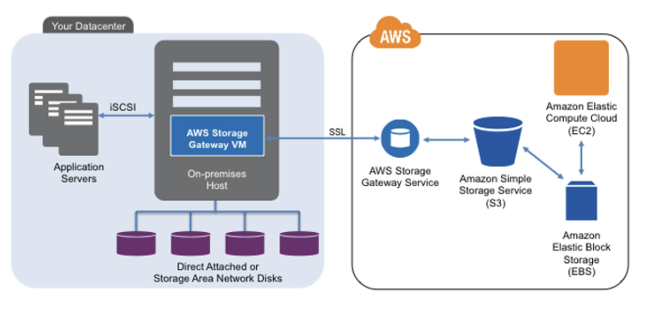

AWS Storage Gateway is a hybrid cloud storage service provided by Amazon Web Services (AWS) that enables seamless integration between on-premises environments and AWS cloud storage. It acts as a bridge between an organization's on-premises infrastructure and the AWS cloud, facilitating data transfer and storage for hybrid cloud architectures.

The primary objective of AWS Storage Gateway is to extend on-premises storage to the cloud while preserving data locality and ensuring low-latency access to frequently accessed data. It offers three different gateway types, each designed to cater to specific use cases and workload requirements.

# Table of Contents

1. Introduction to AWS Storage Gateway

2. Key Concepts

2.1. Storage Gateway Types

2.2. Cached Volume

2.3. Stored Volume

2.4. Virtual Tape Library (VTL)

3. Supported Integrations

4. Getting Started with AWS Storage Gateway

4.1. Prerequisites

4.2. Deployment Options

4.3. Setting Up the Storage Gateway

5. Storage Gateway Features and Benefits

5.1. Hybrid Cloud Storage

5.2. Data Transfer and Synchronization

5.3. Data Protection and Backup

6. Monitoring and Management

6.1. Monitoring Metrics and Logs

6.2. Managing Gateways and Volumes

6.3. Troubleshooting Common Issues

7. Security and Compliance

7.1. Data Encryption

7.2. Identity and Access Management (IAM)

7.3. Compliance Considerations

8. Best Practices for AWS Storage Gateway

8.1. Choosing the Right Gateway Type

8.2. Optimizing Data Transfer

8.3. Implementing Data Protection Strategies

9. Limitations and Considerations

9.1. Supported Regions and Storage Gateway Types

9.2. Performance and Throughput Considerations

9.3. Network Connectivity Requirements

10. Conclusion

# 1. Introduction to AWS Storage Gateway

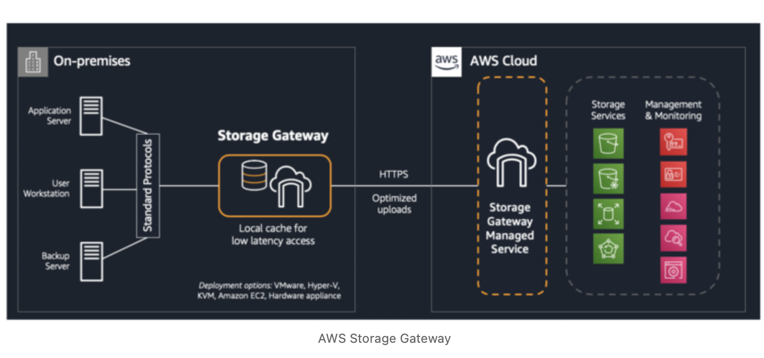

AWS Storage Gateway is a hybrid cloud storage service that provides seamless integration between on-premises environments and AWS cloud storage. It enables organizations to extend their on-premises storage infrastructure to the cloud, making it easy to leverage the scalability and durability of AWS cloud storage services.

# 2. Key Concepts

**2.1. Storage Gateway Types:**

AWS Storage Gateway offers three gateway types: Cached Volume, Stored Volume, and Virtual Tape Library (VTL). Each type caters to different use cases and workloads.

**2.2. Cached Volume:**

Cached Volume stores frequently accessed data on-premises while asynchronously backing up the data to Amazon S3, providing low-latency access to frequently accessed data.

**2.3. Stored Volume:**

Stored Volume keeps all data on-premises and creates point-in-time snapshots, allowing backups to be transferred to Amazon S3 for cost-effective data protection.

**2.4. Virtual Tape Library (VTL):**

Virtual Tape Library emulates tape-based storage, enabling organizations to replace their physical tape infrastructure with scalable and cost-effective virtual tapes in Amazon S3 and Glacier.

# 3. Supported Integrations

AWS Storage Gateway integrates with various AWS services, including Amazon S3, Amazon S3 Glacier, Amazon EBS (Elastic Block Store), and AWS DataSync, enabling flexible data transfer and backup strategies.

# 4. Getting Started with AWS Storage Gateway

**4.1. Prerequisites:**

Before deploying AWS Storage Gateway, ensure that your network and IAM configurations meet the requirements for the selected gateway type.

**4.2. Deployment Options:**

Choose the most suitable deployment option based on your storage and data transfer requirements, whether on-premises or in a virtualized environment.

**4.3. Setting Up the Storage Gateway:**

Step-by-step instructions to create and configure a Storage Gateway instance using the AWS Management Console.

# 5. Storage Gateway Features and Benefits

**5.1. Hybrid Cloud Storage:**

Discover how Storage Gateway enables seamless integration between on-premises and cloud storage for hybrid cloud architectures.

**5.2. Data Transfer and Synchronization:**

Learn how data is transferred between on-premises storage and AWS cloud storage while ensuring data consistency and synchronization.

**5.3. Data Protection and Backup:**

Explore the data protection features of Storage Gateway, including snapshot management and integration with Amazon S3 and Amazon Glacier.

# 6. Monitoring and Management

**6.1. Monitoring Metrics and Logs:**

Understand the monitoring capabilities of AWS Storage Gateway, including CloudWatch metrics and logs for tracking performance and health.

**6.2. Managing Gateways and Volumes:**

Learn how to manage your Storage Gateway instances and associated volumes, including resizing, snapshot management, and lifecycle policies.

**6.3. Troubleshooting Common Issues:**

Identify and resolve common issues and errors that may arise during the setup and usage of Storage Gateway.

# 7. Security and Compliance

**7.1. Data Encryption:**

Explore data encryption options to ensure data security during transfer and storage in AWS cloud storage services.

**7.2. Identity and Access Management (IAM):**

Implement IAM best practices for access control and security in Storage Gateway.

**7.3. Compliance Considerations:**

Considerations for maintaining compliance with industry regulations while using AWS Storage Gateway.

# 8. Best Practices for AWS Storage Gateway

**8.1. Choosing the Right Gateway Type:**

Select the appropriate gateway type based on your workload requirements and data access patterns.

**8.2. Optimizing Data Transfer:**

Implement strategies to optimize data transfer and synchronization between on-premises and cloud storage.

**8.3. Implementing Data Protection Strategies:**

Deploy effective data protection and backup strategies using Storage Gateway features.

# 9. Limitations and Considerations

**9.1. Supported Regions and Storage Gateway Types:**

Review the supported AWS regions and the availability of different Storage Gateway types in each region.

**9.2. Performance and Throughput Considerations:**

Consider performance factors, including bandwidth, latency, and I/O throughput for optimal storage gateway performance.

**9.3. Network Connectivity Requirements:**

Ensure that your network connectivity meets the requirements for using AWS Storage Gateway effectively.

# 10. Conclusion

Summarize the benefits of AWS Storage Gateway for extending on-premises storage to the cloud and enabling hybrid cloud storage solutions.

Thank you