**DEPT. OF ELECTRICAL & ELECTRONICS ENGINEERING**

**SRM INSTITUTE OF SCIENCE AND TECHNOLOGY, Kattankulathur – 603203.**

|  |  |
| --- | --- |
| Title of Experiment | : **HEX TO BCD CONVERSION** |
| Name of the candidate | : GAUTAM NAG |
| Register Number | : RA1811005010278 |
| Date of Experiment | : 05/02/2021 |
| Date of submission | **: 05/02/2021** |

|  |  |  |  |
| --- | --- | --- | --- |
| **S.NO**  **:** | **MARKS SPLIT UP** | **MAXIMUM MARKS (50)** | **MARKS OBTAINED** |
| 1 | PRE LAB | 5 |  |
| 2 | PROGRAM | 25 |  |
| 3 | EXECUTION | 15 |  |
| 4 | POST LAB | 5 |  |
| TOTAL | | 50 |  |

**Staff Signature**

**3. HEX TO BCD CONVERSION**

# What is T -state?

**PRE-LAB**

TCON(Timer control) Register of 8051 Microcontroller

TCON(Timer Control) is an 8-bit register. It's bits are used for generating interrupts on gpio pins internal or external. The most important bits of the timers TRx and TFx are also in it.

# Define opcode and operand.

Each assembly language statement is split into an opcode and an operand. The opcode is the instruction that is executed by the CPU and the operand is the data or memory location used to execute that instruction.

# What is meant by memory mapping?

Memory-mapping is a mechanism that maps a portion of a file, or an entire file, on disk to a range of addresses within an application's address space. The application can then access files on disk in the same way it accesses dynamic memory.

# What is Vectored and Non- Vectored interrupt?

A vectored interrupt is where the CPU actually knows the address of the Interrupt Service Routine in advance A non-vectored interrupt is

where the interrupting device never sends an interrupt vector. An interrupt is received by the CPU, and it jumps the program counter to a fixed address in hardware.

# What is Polling ? What are the different types of Polling?

In the polling method microcontroller keeps checking the status of devices, for example we have a simple microcontroller circuit with one switch and one LED and the circuit working is when we press the switch, LED will turn ON and when release the switch LED will turn OFF. External 0 Interrupt.

Timer 0 Interrupt.

External 1 Interrupt.

Timer 1 Interrupt. Serial Interrupt.

**3. HEX TO BCD CONVERSION**

**Aim:** Write an assembly language program to convert a HEX to its BCD code and display the result in the address field.

**Hardware Requirement:**

8051 microcontroller kit, Power Supply

**Software Requirement :**

8051 EdSim

**Hexadecimal To BCD Conversion**

The Hexadecimal number system (also called base-16) is a number system that uses 16 unique symbols to represent a particular value. Those symbols are 0-9 and A-F. In this program, the hex number is converted to its equivalent BCD number. The hex number to be converted is brought to the accumulator and is divided by 100 D i.e 64 . DIV instruction of 8051 is used in this program. The remainder is now divided by 10 D. Swap the quotient and add the result with remainder obtained from above division. Finally, the result is stored in memory.

**Binary** coded decimal (BCD) is a system of writing numerals that assigns a four-digit binary code to each digit 0 through 9 in a decimal (base-10) numeral. The hexadecimal number system (also called base-16) is a number system that uses 16 unique symbols to represent a particular value. Those symbols are 0-9 and A-F.

BCD number to be converted is brought to the accumulator. Mask the lower order nibble using ANL instruction and swap their nibbles using SWAP instruction. Store the resultant value in any registors. Then multiply the result with 10 Decimal. Mask the higher order nibble and the result is added with the result obtained from above multiplication. Finally, the result is stored in memory .

**Program : Hexadecimal to BCD**

|  |  |  |  |  |
| --- | --- | --- | --- | --- |
| **ADDRESS** | **LABEL** | **MNEMONICS** | **OPCODE** | **COMMENTS** |
| 0000 | **START** | MOV A, 30H |  | **START THE SM** |
| 0002 | **START** | MOV B, #64H |  | **STAR TAND TAKE VALUES** |
| 0005 | **DVIDE** | DIV AB |  | **DIVIDE THE NUMBERS** |
| 0006 | **VALUE** | MOV 31H, A |  | **VALUE IS MOVED** |
| 0008 | **VALUE** | MOV A, B |  | **VALUE IS MOVED** |
| 000A | **VALUE** | MOV B, #0AH |  | **VALUES ADDRESSED** |
| 000D | **DIVIDE** | DIV AB |  | **DIVIDE AB** |

|  |  |  |  |  |
| --- | --- | --- | --- | --- |
| 000E | **CHANGE ORDER** | SWAP A |  | **CHANGE ORDER AND SWAP** |
| 000F | **ADD** | ADD A, B |  | **ADD** |
| 00011 |  | MOV 32H, A |  |  |
| 00013 |  | JMP $ |  |  |

**SAMPLE INPUT AND OUTPUT: INPUT:**

|  |  |
| --- | --- |
| **Memory address** | **Data** |
| 0000. | Hex =30H |

**OUTPUT:**

|  |  |
| --- | --- |
| **Memory address** | **Data** |
| ACC | BCD = 2 |

**SIMULATION :**

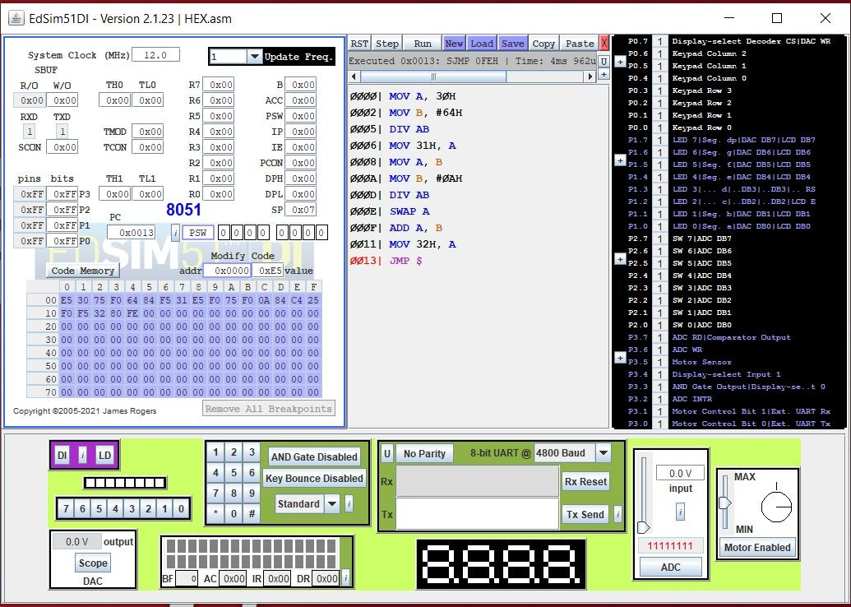

**Result:**

Thus, the assembly language program was written to convert HEX to BCD and executed using 8051 microcontroller.

**POST LAB**

# Define Microcontroller?

A microcontroller is a small computer on a single

metal-oxide-semiconductor integrated circuit chip. A microcontroller contains one or more CPUs along with memory and programmable input/output peripherals

# Show the lowest and highest values (in hex) that the 8051 program counter can take.

00 - 00h

# What is PUSH and POP instruction? Give example.

The easiest and most common way to use the stack is with the dedicated "push" and "pop" instructions. "push" stores a constant or 64-bit register out onto the stack ("push eax" gives an error "instruction not supported

in 64-bit mode"; use "push rax" instead.) "pop" retrieves the last value pushed from the stack.

# What is the difference between SJMP, LJMP and AJMP?

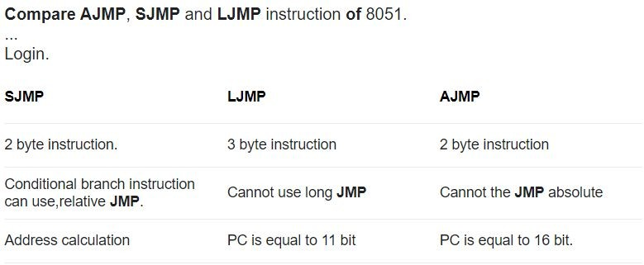

1. **What are the addressing modes of 8051?**

In 8051 There are six types of addressing modes.

Immediate AddressingMode. Register AddressingMode.

Direct AddressingMode.

Register IndirectAddressing Mode. Indexed AddressingMode.

Implied AddressingMode.