Wallet Hub Code

1] Repository : https://github.com/gautamnitj/Z_WalletHub1.git

2] Specifications

1. Tested on chrome Version 77.0.3865.120

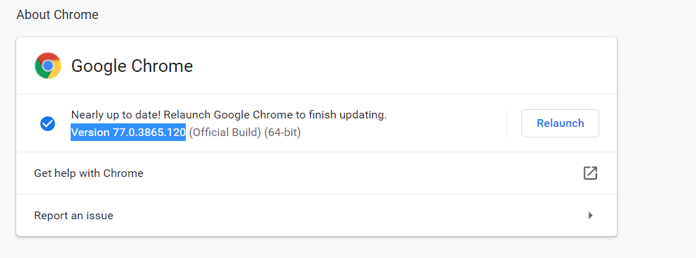

3] Ways to run code

1. Directly from testing.xml file

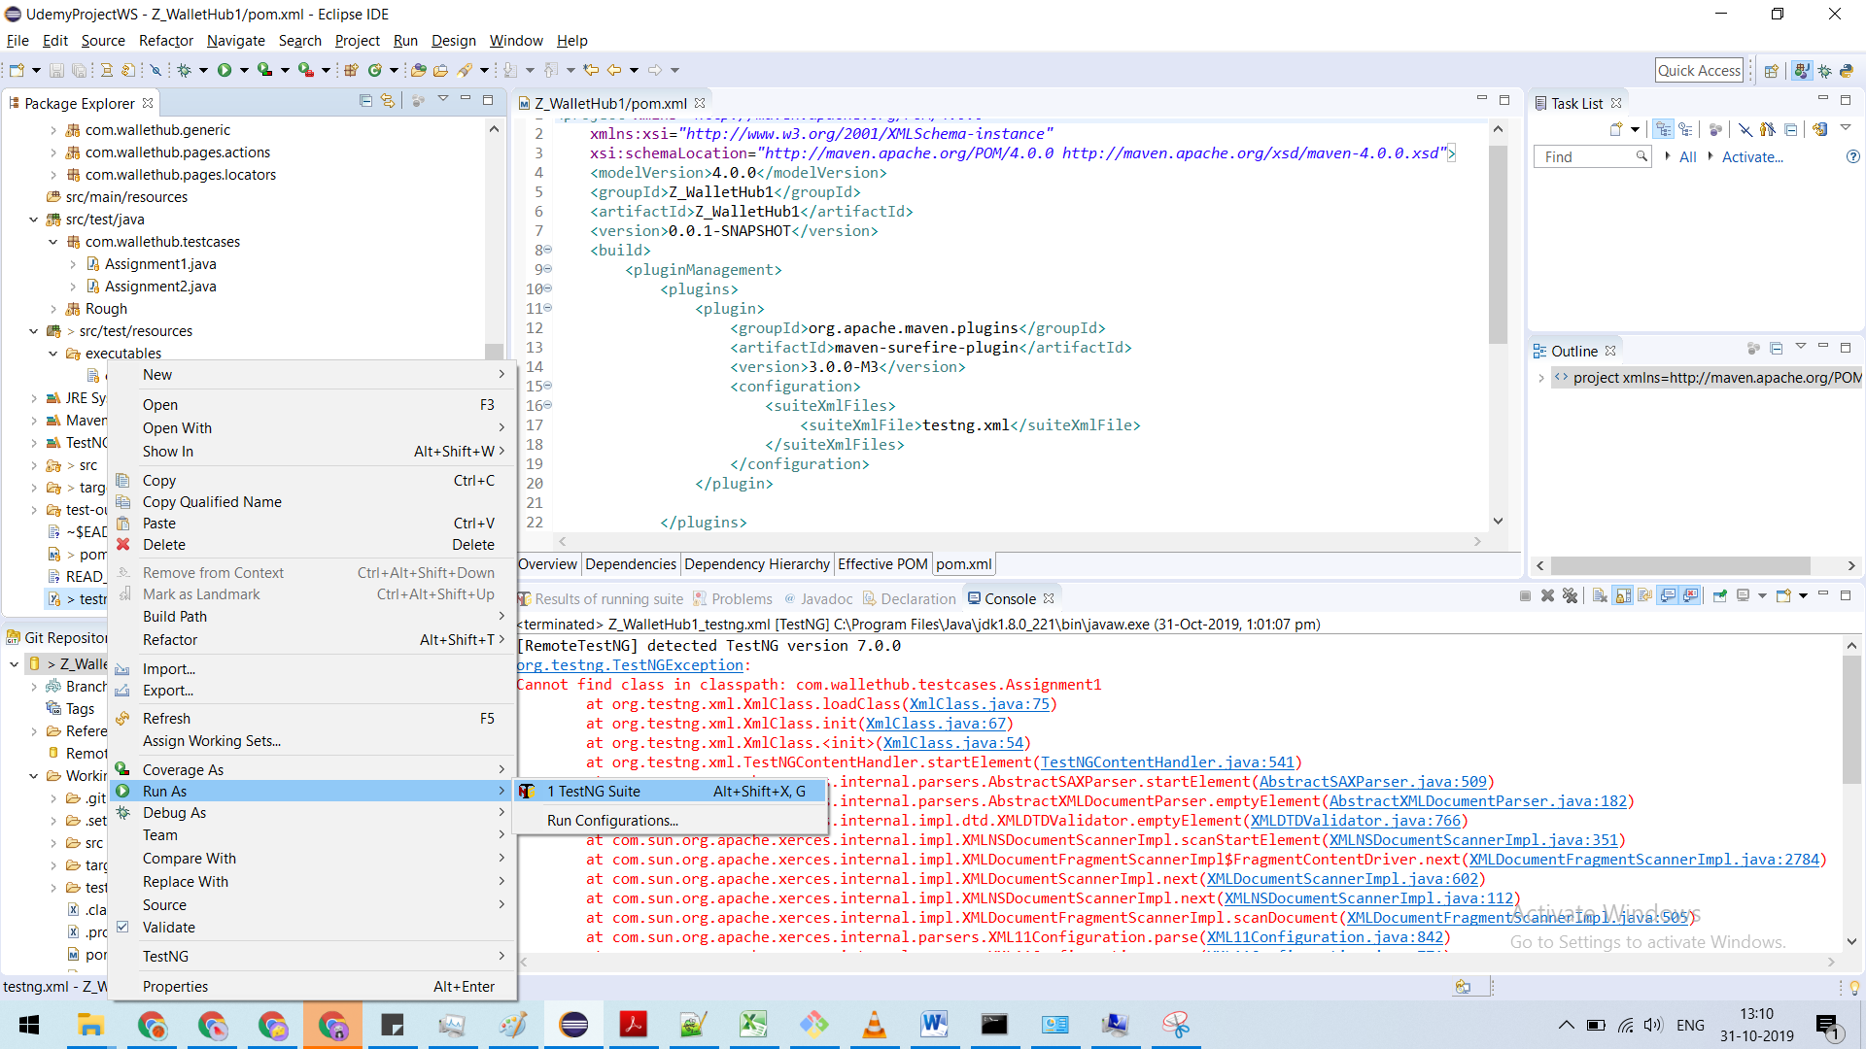

1. From POM file eclipse or command prompt (Imagesbelow)

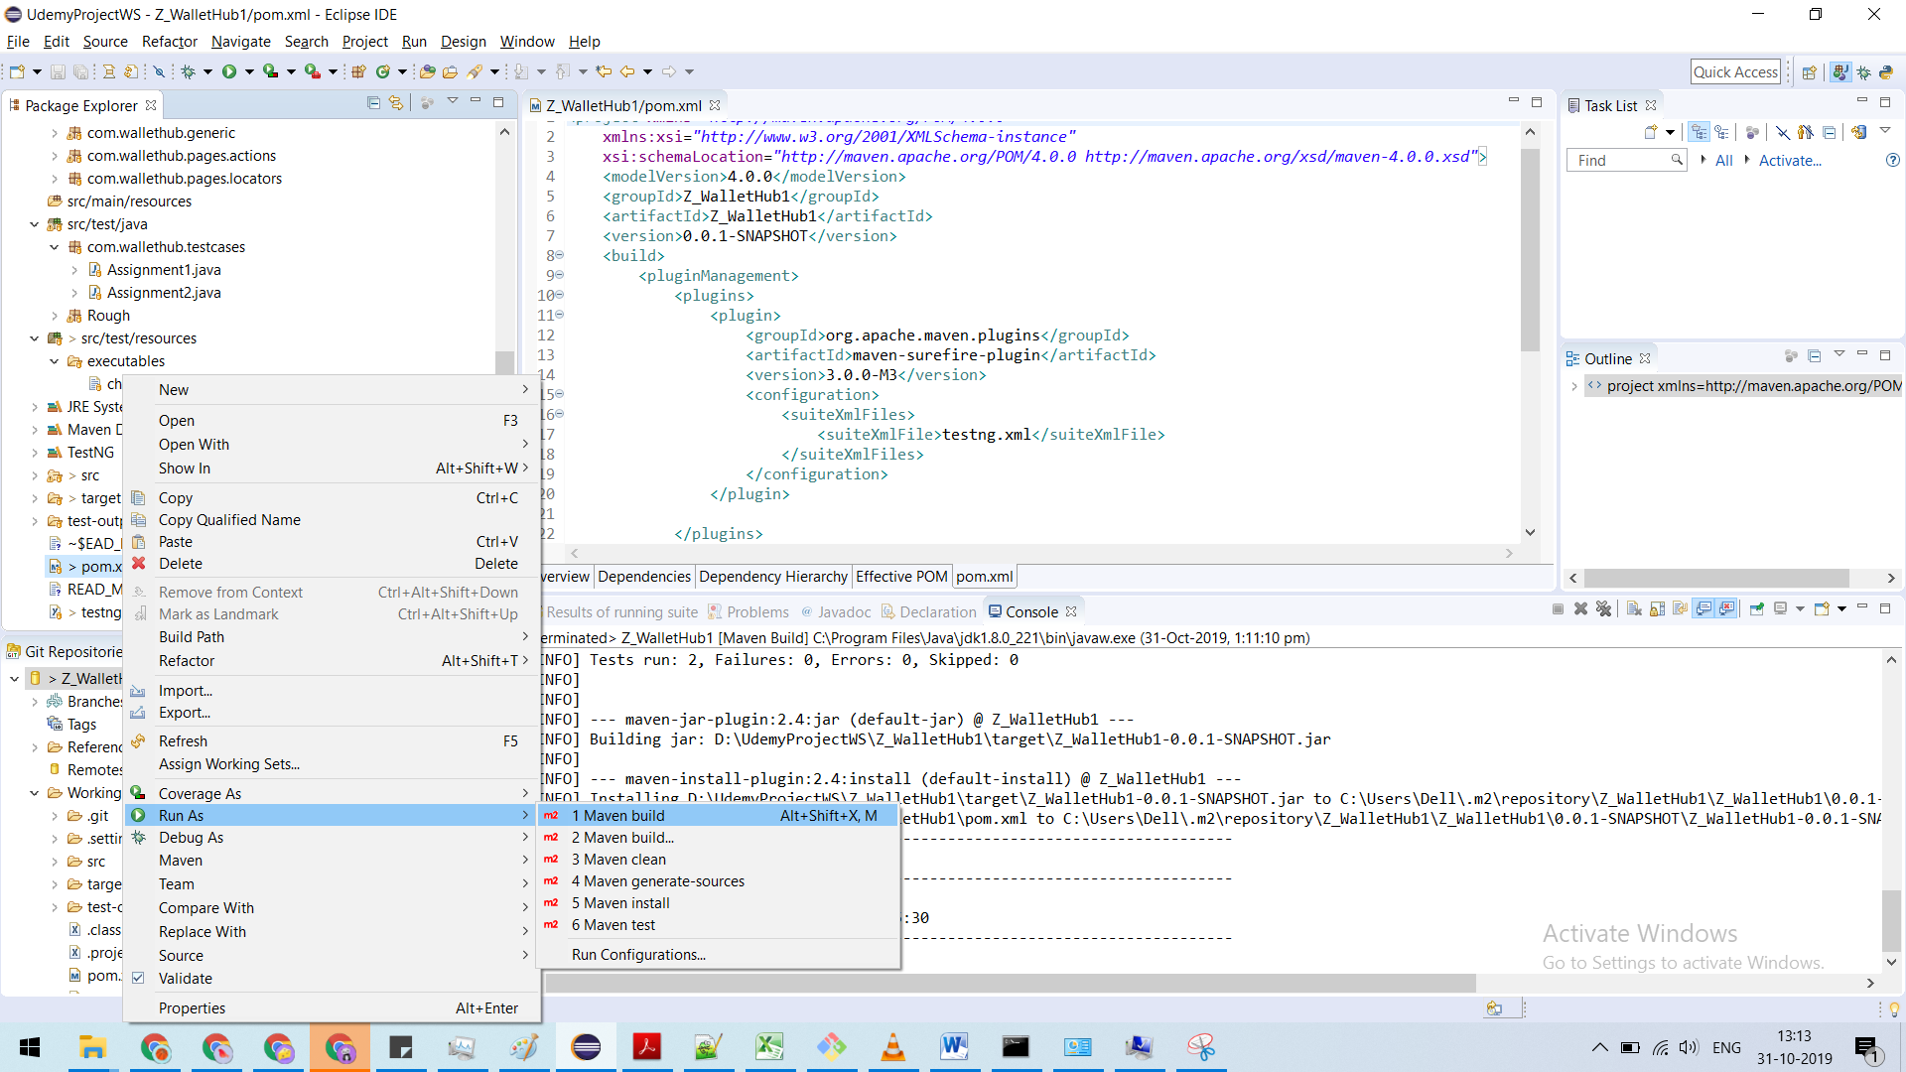

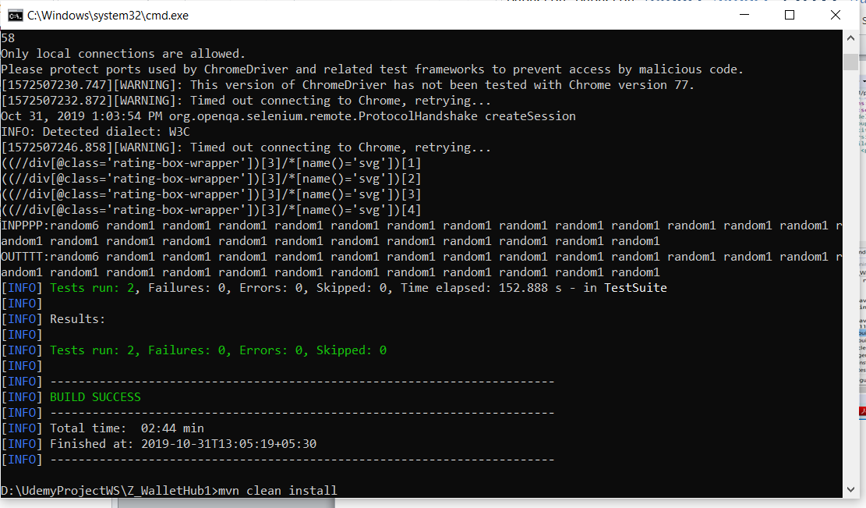

4] Risk and Mitigation

The chrome version in target machine may be incompatible with the “chromedriver.exe” supplied with the code. Hence in that case “chromedriver.exe” may be updated with compatible version in below folder (“Z_WalletHub1\src\test\resources\executables\chromedriver.exe”)

