/* Name – Kanwar Raj Singh (1903122) & Gautam Kumar Mahar (2103114) */

1. Graph between n and log(F(n)) and n and log(T(n))

In this I take till n = 45.

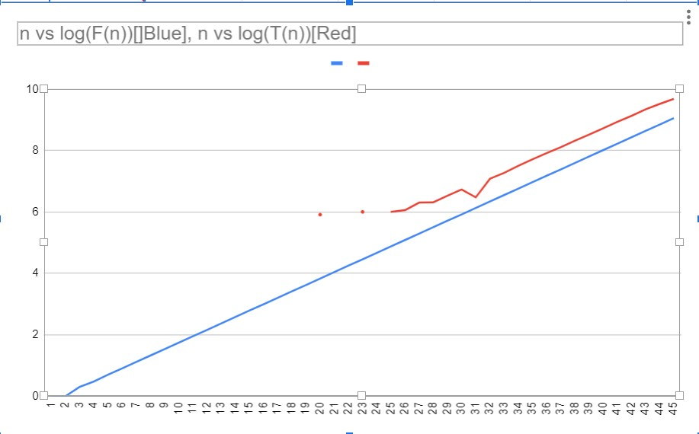

* 1. graph between n & F(n) and n & T(n)

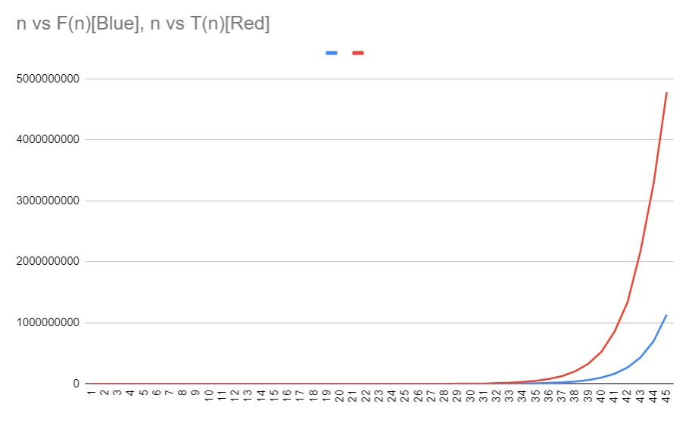

By graph, Fibonacci **series** and the **time taken** grows exponentially with respect to term.

* 1. Slope of n vs log(F(n)) is 0.20898764.

Slope of n vs log(T(n)) is 0.247385377.

* 1. The Fibonacci number F(n) can be represented as a function of n as F(n) = F(n-1) + F(n-2) where F(n-1) and F(n-2) are the previous two Fibonacci numbers.

In my case there will be overflow occur at n=47, so after this value, this algorithm will not give correct answer.

* 1. The time taken to compute the nth Fibonacci number, T(n), can be represented as a function of n as T(n) = T(n-1) + T(n-2) + c, where c is a constant representing the time taken for the operations other than recursive function calls.

After reaching overflow condition, it will give wrong time.

2. If M(n) is the time complexity of multiplying two integer then time complexity of Repeated square algorithm is **O(M(n).Log(n))**.