Fractal-based Texture Analysis

Soundararajan Ezekiel John A Cross
Ohio Northern University Indiana University of Pennsylvania

Abstract

The analysis of texture in images is an important area of research. In this study, we present a fractal-based texture classification approach to images, and show that it is significantly more effective than statistical texture description methods. The limitations and inadequacies of the traditional methods of texture analysis prevent them from fully describing natural textures. This technique demonstrates a correlation between the texture coarseness and the fractal dimension of an image. The appeal of fractal dimension is not dependent on measurement of scale. It describes the “roughness” of images as natural, the way we perceive roughness. We use the Hurst exponent to calculate fractal dimension and to present experimental results demonstrating their effectiveness.

I. Introduction

The aims of texture analysis are texture recognition and texture-based shape analysis. Rosenfeld and Lipkin [1] stated that texture could be studied on at least two levels, statistical and structural. On the statistical level, the texture of an image is defined by a set of statistics extracted from the entire textural regions. On the structural level, a texture is considered to be defined by subpatterns, called ‘primitives’. A variety of statistical methods such has autocorrelation [2], co-occurrence approach [3], edge frequency method [2], primitive length features [5], Law’s method [4], etc, have been proposed for texture analysis which are based on capturing the variability in gray scale images. The different methods capture the inherent coarseness or fineness of texture. The textural character of an image depends on the spatial size of texture primitives. Large primitives give rise to coarse texture (rock surface) and small primitive gives fine texture (silk surface). Although these methods are useful, some refinement is necessary. Fractal based texture classification is another approach that correlates between texture coarseness and fractal dimension. A fractal is defined [7] as a set for which Hausdorff-Besicovich dimension is strictly greater than the topological dimension; therefore fractal dimension is defining property in the study of textual analysis. In this paper, we use fractal dimension as texture description. The remainder of this paper is organized as follows. The methodology is explained in section II. Section III explains the experimental results. Finally, the conclusions of this research in section IV.

II. Computational Method

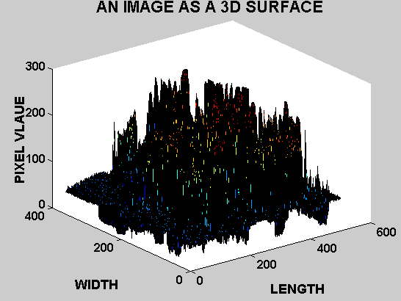
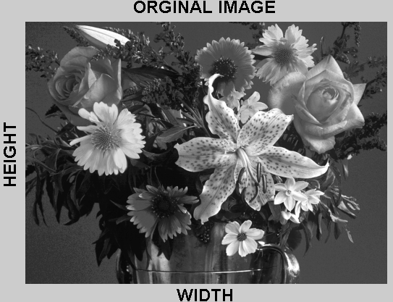
The method proposed here is based on fractal dimension. We hypothesize the fractal dimension correlates with image roughness. Fractal-based texture analysis was introduced by Pentland in 1984[6]. Let T, FD and H be the topological dimension, fractal dimension and the Hurst exponent [7][9]. For images, T=3 because there are two spatial dimensions and the third dimension is image density. Figure 1 shows the original image and its 3-dimensional representation.
The parameters H and FD can be estimated from 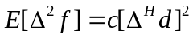 where E,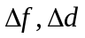, and c are the expectation operator, intensity operation, spatial distance, and scaling constant. Substitute H=3-FD, and 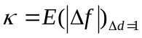in the above equation, we have 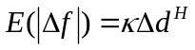. By applying log to both sides we have 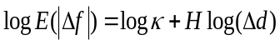. The Hurst exponent H can be obtained by using the least-squares linear regression to estimate the slope of the gray- level difference GD (k) versus k in log-log scales and k varies from 1 to the maximum value s where
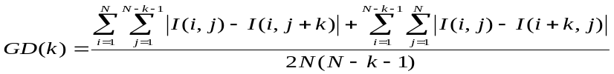 The fractal dimension FD can be derived from the relation FD=3-H. The approximation error of the regression line fit should be determined to prove that the analyzed texture is fractal, and thus be efficiently described using fractal measures. A small value of the fractal dimension FD, implies to a the large value of the Hurst exponent H represents fine texture, while a large FD, implies to a smaller H value, corresponds to the coarse texture.

III Experimental Results

In this section, we present the experimental details of fractal based texture classification. We have used Brodatz[8] images of size 512 by 512 for classification. Figure 2 presents some of the Brodatz images used in this study. They are Grass, Bark, Straw, Herringbone weave, Woolen cloth, Pressed calf leather, Beach sand, Wood grain, Raffia, Pigskin, and Brick wall. Table 1 shows the fractal dimension and the Hurst coefficient for the above images.
Figure 2.
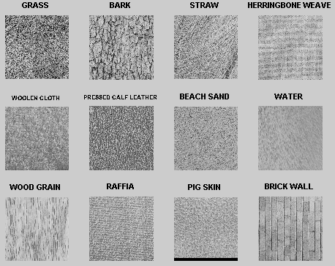
Table 1
Image | Grass | Bark | Straw | Weave | Cloth | Leather
FD | 2. 6571 | 2. 5494 | 2. 6881 | 2. 6323 | 2. 7170 | 2.6884
Image | BeachSand | Water | Woodgrain | Raffia | Pigskin | Brickwall
F D | 2. 6432 | 2. 6827 | 2. 7256 | 2. 5665 | 2. 6142 | 2. 7039

IV Discussion
In this paper we have demonstrated fractal based texture classification. At times, single fractal dimension is not sufficient for description of natural images. Lacunarity, the multiresolution analysis, and the wavelet approaches to fractal feature analysis describe characteristics of textures of different visual appearance that have the same fractal dimension. The research will continue to investigate textures using the methods described above.
V References

[1] A. Rosenfeld and B.S. Lipkin “ Picture Processing and Psychopictorics” Academic Press, NY, 1970,
[2] R.M.Haralick “Statistical and structural approaches to texture”. Proceeding. IEEE, 67(5): 786-804, 79.
[3] R.M.Haralick et.al. “Texture feature image classification”. IEEE Trans. on System, Man, Cyber. 3, 73.
[4] K.I Laws. “Texture energy measures”. In DARPA Image understanding workshop. Los Angeles, CA.
[5] Galloway M.M. “ Texture classification using gray level run length”, Computer graphics and Image Processing, 4: 172-179, 1975
[6] A.P Pentland, “Fractal-based description of natural scenes’, IEEE Trans. on Pattern Analysis and Machine Intelligence, 6:661-674, 1984.
[7] B.B. Mandelbrot, “ Fractal Geometry of Nature “, Freeman, New York, 1982,
[8] P. Brodatz ,” Textures: A photographic Album for Artists and Designer”, Dover, Toronto, 1966.
[9] H E. Hurst.”Long-term storage capacity of reservoirs”. Trans. of ASCE, 116:770-808, 1951

