1. Screenshot of 2 S3 instances created.

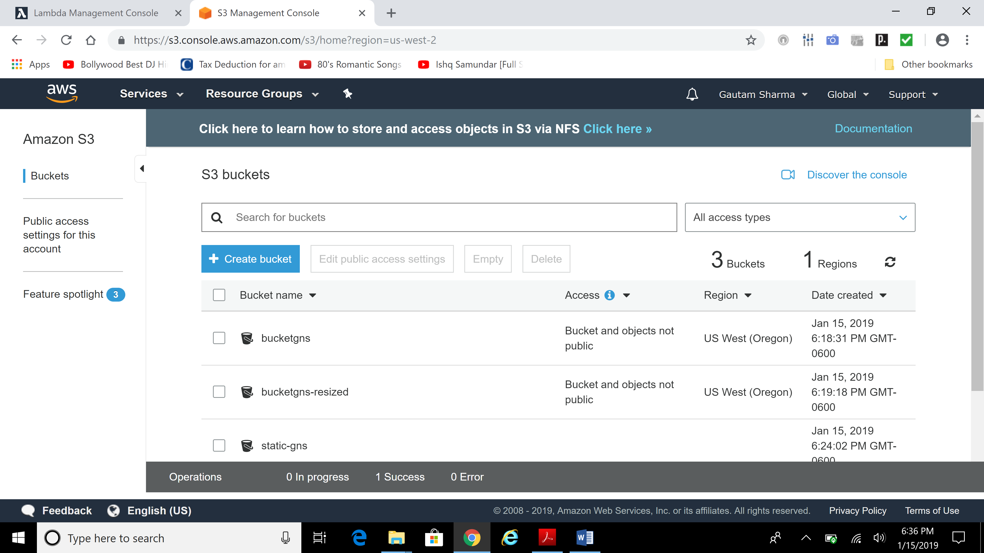

1. Screenshot of thumbnail in resized bucket

