ASSIGNMENT-3

1)

mysql> create table user (UserID INT PRIMARY KEY,

-> Name VARCHAR(255),

-> Email VARCHAR(255) UNIQUE,

-> Password VARCHAR(255),

-> ContactNumber VARCHAR(20),

-> Address TEXT

-> );

INSERT INTO user (UserID, Name, Email, Password, ContactNumber, Address)

-> VALUES

-> (1, 'John', 'john@example.com', 'password123', '123-456-7890', 'City1'),

-> (2, 'Jane', 'jane@example.com', 'pass456', '987-654-3210', 'City2'),

-> (3, 'Bob', 'bob@example.com', 'securePass', '111-222-3333', 'City3'),

-> (4, 'Alice', 'aliceexample.com', 'mySecret', '555-444-7777', 'City4');

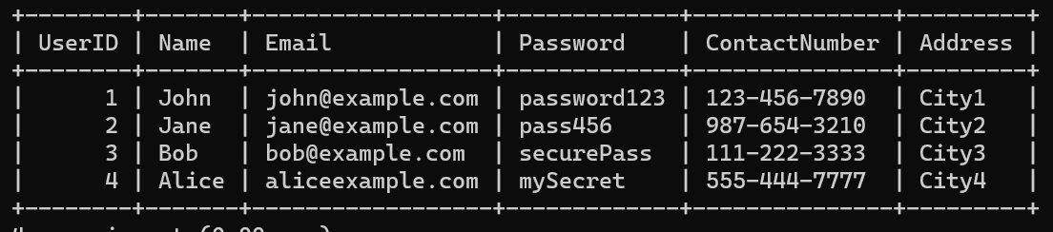

2)

> create table Courier(

-> CourierID INT PRIMARY KEY, SenderName VARCHAR(255),

-> SenderAddress TEXT, ReceiverName VARCHAR(255),

-> ReceiverAddress TEXT, Weight DECIMAL(5, 2),

-> Status VARCHAR(50), TrackingNumber VARCHAR(20) UNIQUE,

-> DeliveryDate DATE);

INSERT INTO Courier (CourierID, SenderName, SenderAddress, ReceiverName,

-> ReceiverAddress, Weight, Status, TrackingNumber, DeliveryDate)

-> VALUES

-> (1, 'John ', ' City1', ' Smith', 'City2', 2.5, 'In Transit', 'ABC123', '2023-01-10'),

-> (2, 'Alice ', 'City4', ' Johnson', 'City3', 1.8, 'Delivered', 'DEF456', '2023-01-15'),

-> (3, 'Charlie ', 'City5', ' Davis', 'City6', 3.0, 'Pending', 'GHI789', NULL),

-> (4, 'Frank ', 'City7', ' Miller', 'City8', 4.2, 'In Transit', 'JKL012', '2023-01-20');

3)

create table CourierServices

(ServiceID INT PRIMARY KEY,

ServiceName VARCHAR(100),

Cost DECIMAL(8, 2));

INSERT INTO CourierServices (ServiceID, ServiceName, Cost)

-> VALUES

-> (1, 'Standard Delivery', 10.99),

-> (2, 'Express Delivery', 24.99),

-> (3, 'Same Day Delivery', 39.99),

-> (4, 'International Shipping', 49.99),

-> (5, 'Overnight Delivery', 29.99);

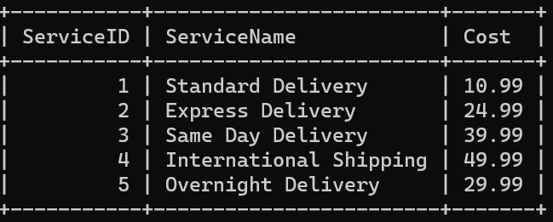

4)

create table Employee

-> (EmployeeID INT PRIMARY KEY,

-> Name VARCHAR(255),

-> Email VARCHAR(255) UNIQUE,

-> ContactNumber VARCHAR(20),

-> Role VARCHAR(50),

-> Salary DECIMAL(10, 2));

INSERT INTO Employee (EmployeeID, Name, Email, ContactNumber, Role, Salary)

-> VALUES

-> (1, 'Manager A', 'managerA@gmail.com', '5551112222', 'Manager', 60000.00),

-> (2, 'Courier Driver B', 'driverB@gmail.com', '555334444', 'Driver', 45000.00),

-> (3, 'Office Staff C', 'staffC@gmail.com', '5555556666', 'Office Staff', 35000.00),

-> (4, 'Courier Driver D', 'driverD@gmail.com', '5557778888', 'Driver', 47000.00),

-> (5, 'Manager E', 'managerE@gmail.com', '5559990000', 'Manager', 62000.00);

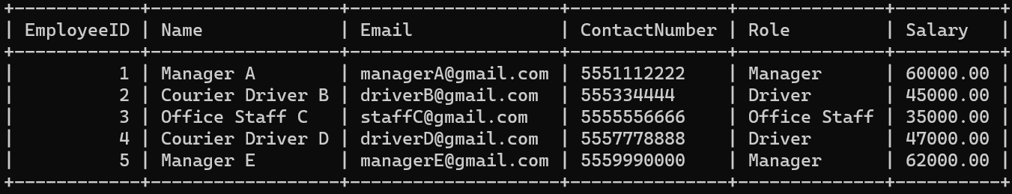

5)

create table Location

-> (LocationID INT PRIMARY KEY,

-> LocationName VARCHAR(100),

-> Address TEXT);

INSERT INTO Location (LocationID, LocationName, Address)

-> VALUES

-> (1, 'City1 ', '123 , City1'),

-> (2, 'City2 ', '456 , City2'),

-> (3, 'City3 ', '789 , City3'),

-> (4, 'City4 ', '101 , City4'),

-> (5, 'City5 ', '202 , City5');

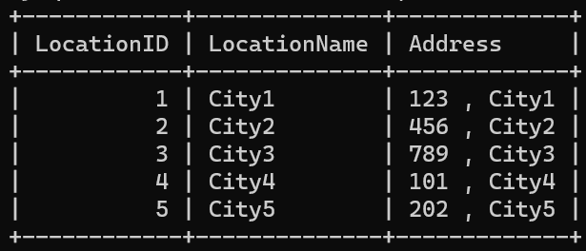

6)

mysql> create table Payment

-> (PaymentID INT PRIMARY KEY,

-> CourierID INT,

-> LocationId INT,

-> Amount DECIMAL(10, 2),

-> PaymentDate DATE,

-> FOREIGN KEY (CourierID) REFERENCES Couriers(CourierID),

-> FOREIGN KEY (LocationID) REFERENCES Location(LocationID));

mysql> INSERT INTO Payment (PaymentID, CourierID, LocationID, Amount, PaymentDate)

-> VALUES

-> (1, 1, 2, 15.99, '2023-01-12'),

-> (2, 2, 4, 20.50, '2023-01-18'),

-> (3, 3, 1, 29.99, '2023-01-22'),

-> (4, 4, 3, 25.00, '2023-01-28'),

-> (5, 5, 5, 12.75, '2023-02-01');

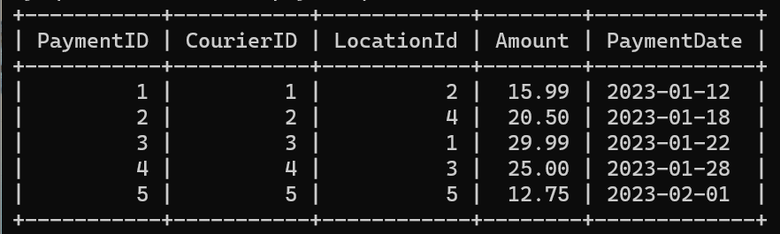

Task-2

1. SELECT * FROM Users;

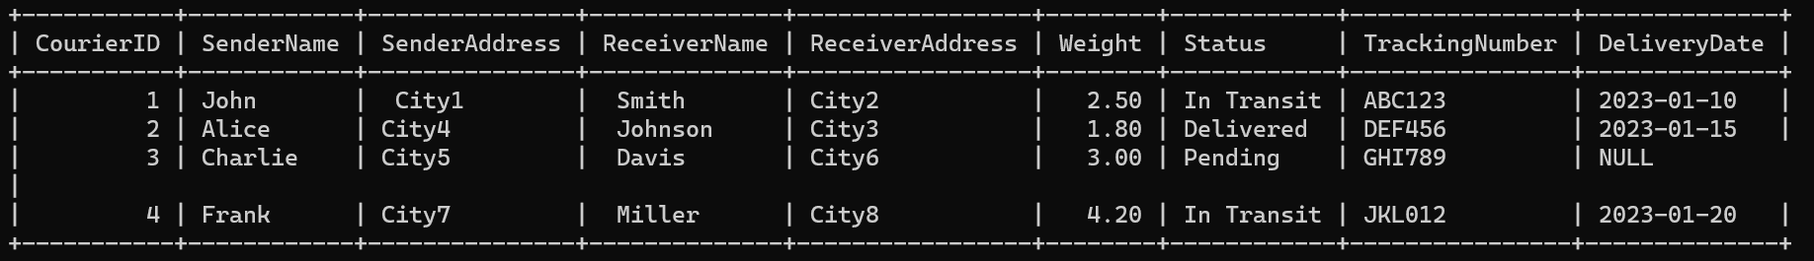

2) SELECT * FROM courier where SenderName = ‘john’;

3) SELECT * FROM courier;

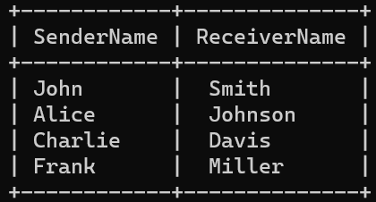

4)

SELECT * FROM courier where TrackingNumber = ‘DEF456’;



5)

SELECT * FROM courier where CourierId = 4;



6)

SELECT * FROM courier where status != ‘Delivered’;

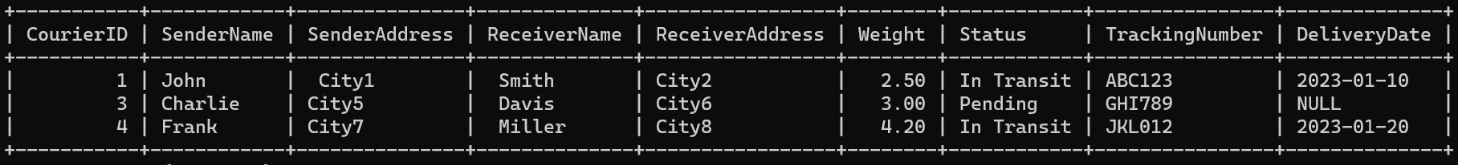

7)

SELECT * FROM courier where DeliveryDate = current_date();



8)

SELECT * FROM courier where status = “Shipped”;



9)

SELECT CourierId, TrackingNumber (SELECT count(*) from c2 where c2.CourierId = Couriers.CourierId) AS TotalPackages from couriers;

10)

11) SELECT * FROM Courier where weight >= 5;

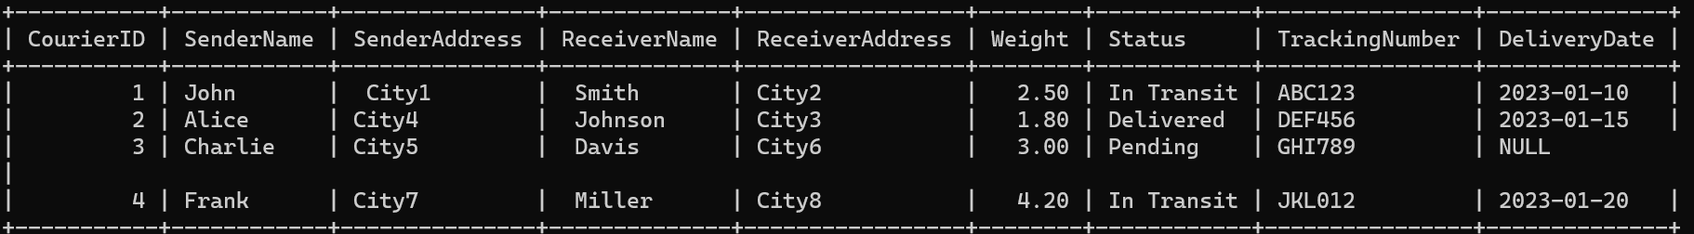

12)

SELECT * from employee where Name = ‘John’;

14)

SELECT EmployeeID, COUNT(CourierID) AS TotalCouriersHandled FROM Courier GROUP BY EmployeeID;

15)

select l.locationid, l.locationname, sum(p.amount) as totalrevenue

-> from location l left join payment p on l.locationid = p.locationid

-> group by l.locationid, l.locationname;

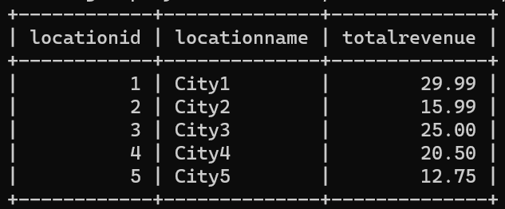

16)

select receiveraddress as location, count(*) as couriercount

-> from courier group by receiveraddress;

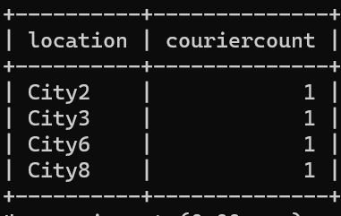

18)

select locationid, sum(amount) as totalpayments

-> from payment group by locationid having totalpayments < 120;

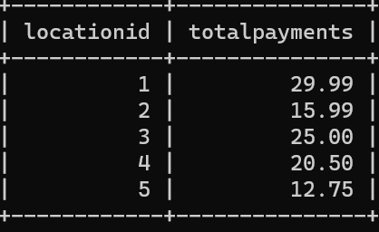

19)

select locationid, sum(amount) as totalpayments

-> from payment group by locationid;

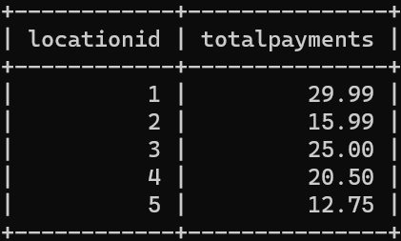

20)

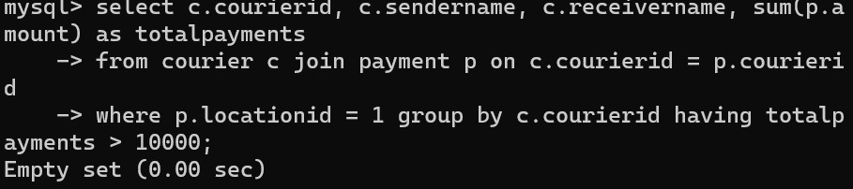

21)

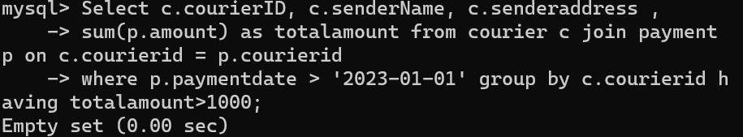

22)

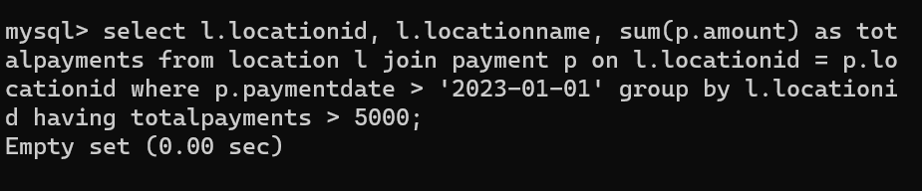

23)

select p.paymentid, p.courierid, c.sendername as sender, c.senderaddress as

-> senderaddress, c.receivername as receiver, c.receiveraddress as

-> receiveraddress, c.weight, c.status, c.trackingnumber, c.deliverydate, p.locationid,

-> p.amount, p.paymentdate

-> from payment p join courier c on p.courierid = c.courierid

-> ;

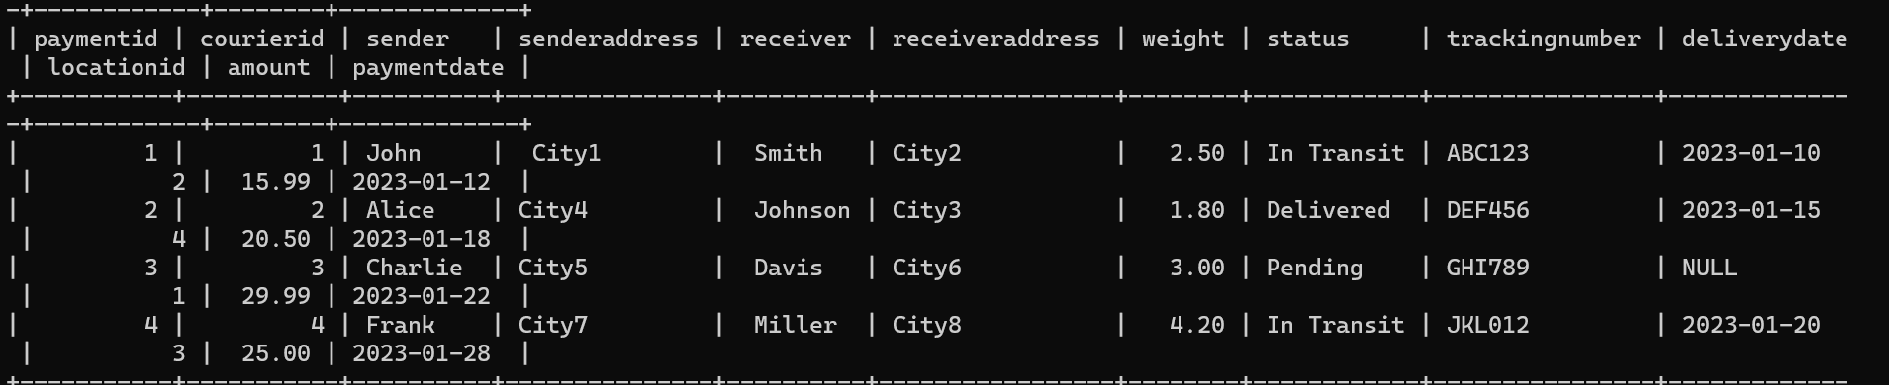

24)

select p.paymentid, p.courierid, l.locationid, l.address, l.locationname, p.amount,

-> p.paymentdate from payment p join location l on p.locationid = l.locationid;

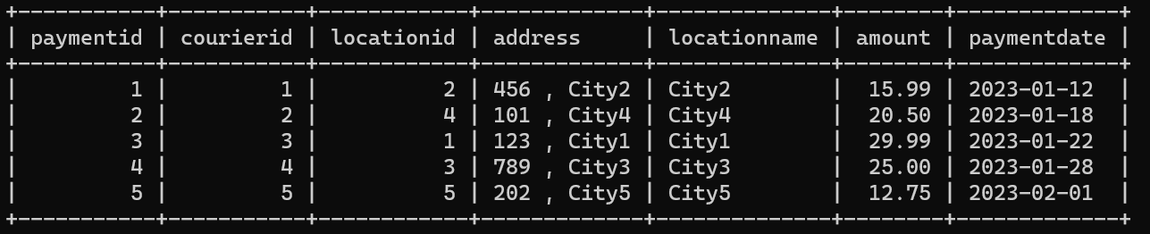

25)

select p.paymentid, p.courierid, l.locationid, c.sendername as sender,

-> c.receivername , c.trackingnumber, c.deliverydate, l.locationname, l.address from

-> payment p join courier c on p.courierid = c.courierid join location l on p.locationid =

-> l.locationid;

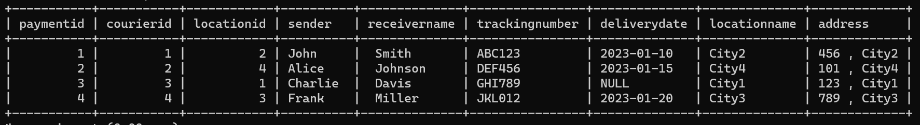

26)

SELECT c.CourierID, c.TrackingNumber, c.SenderName, c.ReceiverName, c.Weight,

-> c.Status, c.DeliveryDate, SUM(p.Amount) AS TotalPayments

-> FROM Courier c

-> JOIN Payment p ON c.CourierID = p.CourierID

-> GROUP BY c.CourierID, c.TrackingNumber, c.SenderName, c.ReceiverName, c.Weight,

-> c.Status, c.DeliveryDate;

mysql> select p.paymentid, p.courierid, c.sendername, c.senderaddress, c.receivername,

-> c.receiveraddress , c.weight, c.status, c.trackingnumber,

-> c.deliverydate , p.locationid, p.amount, p.paymentdate

-> from payment p inner join courier c on p.courierid = c.courierid;

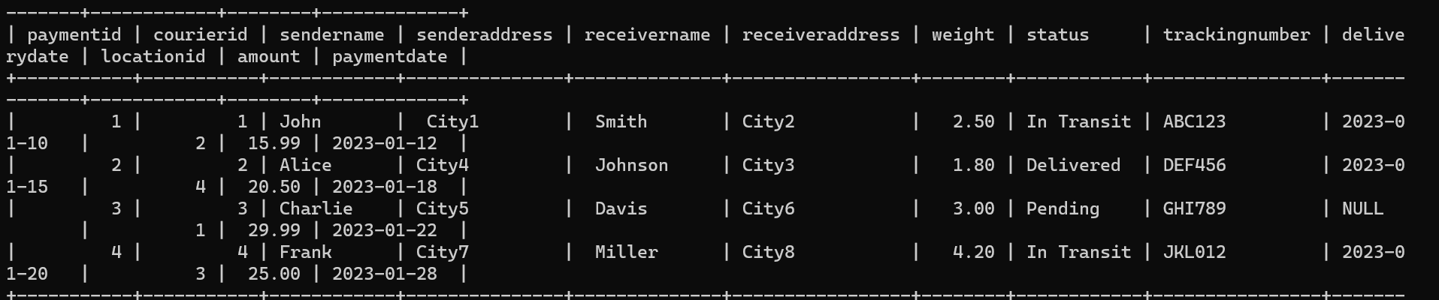

27)

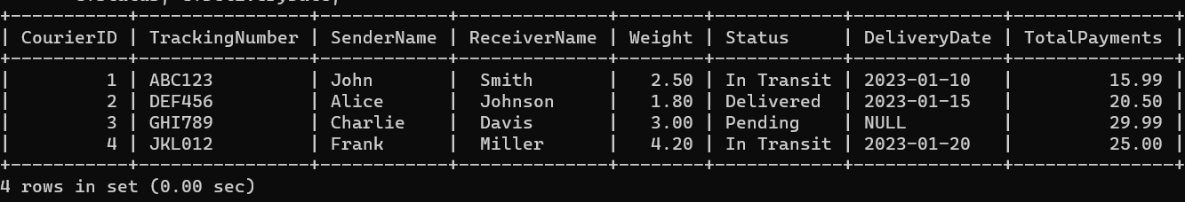

28)

select p.paymentid, p.courierid, p.locationid, p.amount, p.paymentdate,

-> c.sendername, c.receivername from courier c right join payment p on

-> c.courierid = p.courierid

-> where p.paymentdate = '2023-01-12';

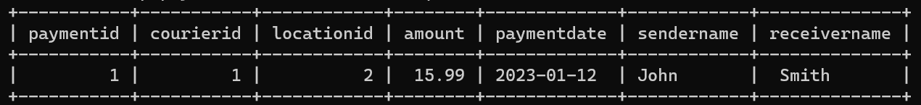

29)

select * from payment p join courier c on p.courierid = c.courierid;

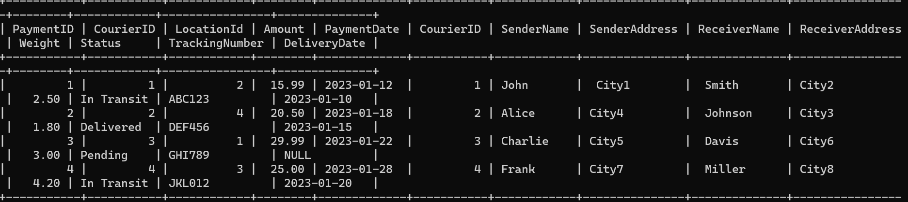

30)

mysql> SELECT CourierID, MAX(AVG(DeliveryTime)) AS HighestAverageDeliveryTime

-> FROM (SELECT CourierID, AVG(DATEDIFF(DeliveryDate, OrderDate)) AS DeliveryTime FROM Orders

-> GROUP BY CourierID) AS AvgDeliveryTimes;

ERROR 1054 (42S22): Unknown column 'CourierID' in 'field list'

mysql> SELECT p.PaymentID, p.Amount, p.PaymentDate, l.LocationID,l.LocationName

-> FROM Payment p JOIN Location l ON p.LocationID = l.LocationID;

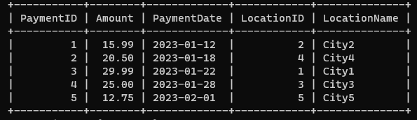

31)

SELECT c.CourierID, c.TrackingNumber,SUM(p.Amount) AS TotalPayments FROM Courier c LEFT JOIN Payment p ON c.CourierID = p.CourierID GROUP BY c.CourierID, c.TrackingNumber;

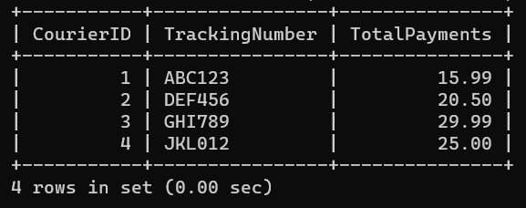

32)

select p.paymentid, p.courierid, p.locationid, p.amount, p.paymentdate,

-> c.sendername, c.receivername

-> from payment p left join courier c on p.courierid = c.courierid

-> where p.paymentdate between '2023-01-01' and '2023-12-12';

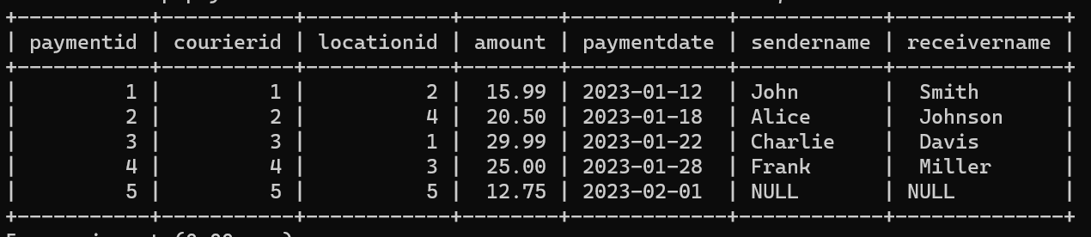

33)

select u.userid, u.username, c.courierid, c.sendername, c.receivername, c.weight, c.status, c.trackingnumber, c.deliverydate from users u outer join on courier c u.userid = c.userid

36)

select u.userid, u.name, c.serviceid, c.serviceid,c.servicename

-> from user u

-> cross join courierservices c;

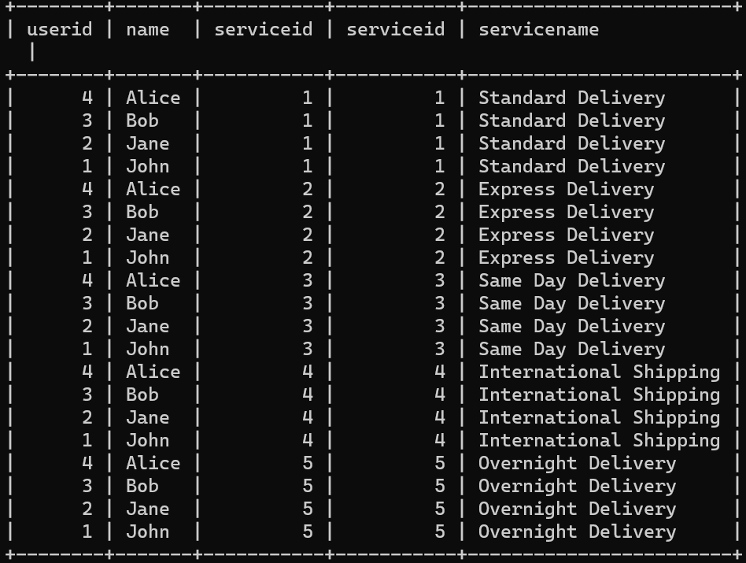

37)

select * from employee cross join location ;

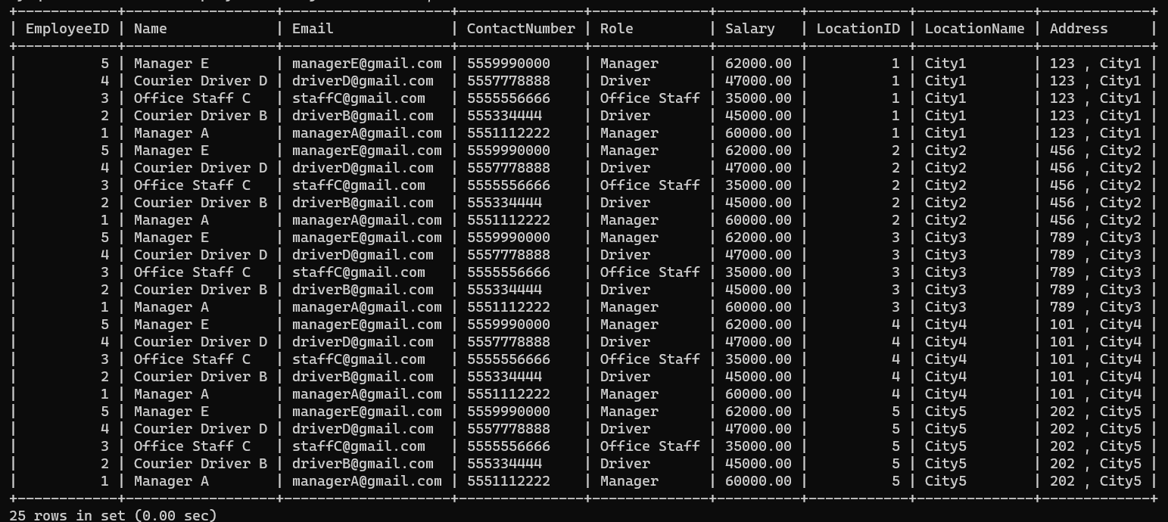

38)

Select * from courier left join user as sender on courier.sendername = sender.name;



39)

Select * from courier left join user as receiver on courier.receivername = receiver.name;



42) select l.locationid, l.locationname, sum(p.amount), as totalpayments from location l left join payment p on l.locationid = p.locationid group by l.locationid;

43)



44)

SELECT * from employee where role="Manager";

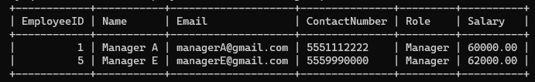

45)

mysql> select * from payment inner join courier on payment.courierid = courier.courierid inner join courier as samelocation on courier.senderaddress = samelocation.senderaddress and courier.courierid <> samelocation.courierid;

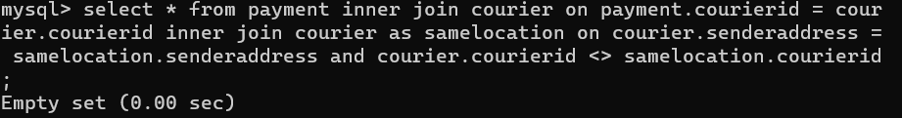

46)

SELECT CourierID,TrackingNumber,SenderName,SenderAddress,ReceiverName,ReceiverAddress,

Weight,Status,DeliveryDate FROM Courier WHERE SenderAddress IN (SELECT SenderAddress FROM Courier GROUP BY SenderAddress HAVING COUNT(*) > 1);

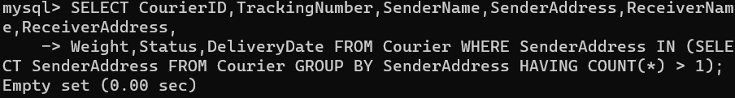

49)

select * from courier where weight > (select avg(weight) from courier);

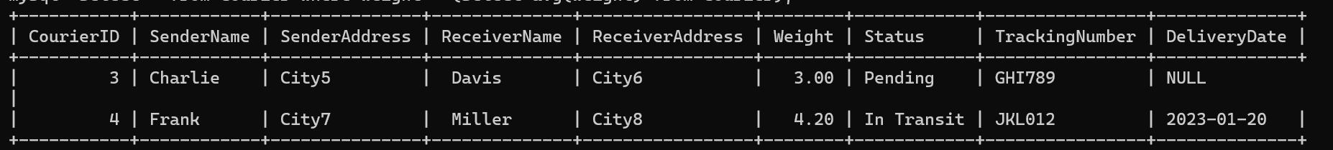

50)

select name from employee where salary> (select avg(salary) from employee) ;

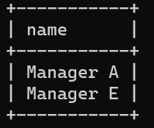

51)

select sum(cost) from courierservices where cost < (select max(cost ) from

-> courierservices);

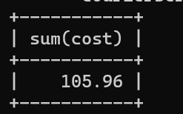

52)

mysql> select * from courier where status in ('in Transit','Delivered');

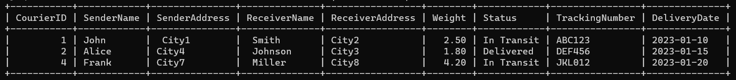

53)

select l.locationid, l.locationname, l.address, max(p.amount) as maxamount

-> from location l join payment p on l.locationid = p.locationid

-> group by l.locationid having max(p.amount) is not null;

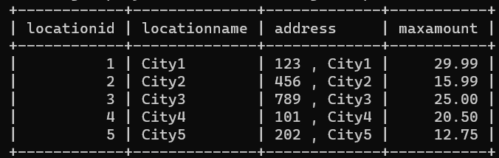

54)

