**EXPERIMENT - 2**

**AIM** **:**

Write queries to implement DDL commands – Create, Alter, Truncate and Drop

**THEORY :**

In this experiment we will see the implementation and functioning of DDL commands - Create, Alter, Truncate and Drop on a table.

DDL stands for Data Definition Language. It is used to define the database schema. DDL is a set of SQL commands used to create, modify, and delete database structures but not data.

List of DDL commands:

* [CREATE](https://www.geeksforgeeks.org/sql-create/): used to create the database or its objects (like table, index, function, views, store procedure, and triggers).
* [ALTER](https://www.geeksforgeeks.org/sql-alter-add-drop-modify/)**:**used to alter the structure of the database.
* [TRUNCATE](https://www.geeksforgeeks.org/sql-drop-truncate/)**:** used to remove all records from a table, including all spaces allocated for the records are removed.
* [DROP](https://www.geeksforgeeks.org/sql-drop-truncate/): used to delete objects from the database.

**CODE:**

**Query** : Create a table using DDL commands

**Syntax** :

MariaDB [student]> create table STUDENT (ROLLno INT(5), NAME VARCHAR(18), BRANCH VARCHAR(10),SEM INT(1), PHONE INT(10));

**Output** :

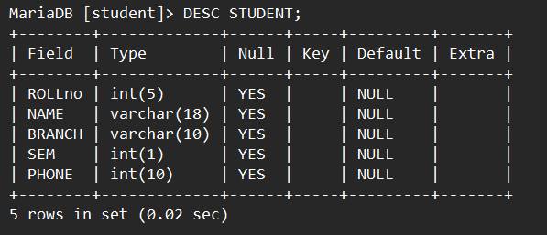

**Query** : Add new column to the existing table using DDL commands

**Syntax** :

MariaDB [student]> ALTER TABLE STUDENT

-> ADD EMAIL VARCHAR (50);

**Output** :

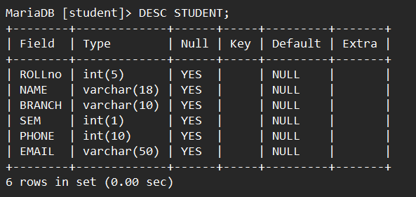

**Query** : Remove existing records from the table using DDL commands

**Syntax** :

MariaDB [student]> TRUNCATE STUDENT;

**Output** :

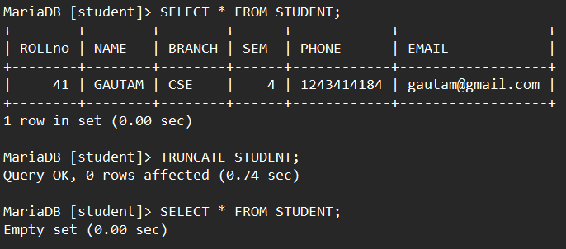

**Query** : Delete the table using DDL commands

**Syntax** :

MariaDB [student]> DROP TABLE STUDENT;

**Output :**

