EXPERIMENT – 4

**AIM :**

Write queries to implement DML commands – Select, Insert, Update and Delete

**THEORY :**

In this experiment we will see the implementation and functioning of DML commands - Select, Insert, Update and Delete on a table.

DML stands for Data Manipulation Language. It deals with the manipulation of data present in the database. It is the component of the SQL statement that controls access to data and to the database.

List of DML commands:

* SELECT: used to retrieve data from the database.
* INSERT : used to insert data into a table.
* UPDATE: used to update existing data within a table.
* DELETE : used to delete records from a database table.

# PROCEDURE :

**CREATING TABLES:**

# SYNTAX:

CREATE TABLE DEPOSIT (ACTNO VARCHAR (5), CNAME VARCHAR (18), BNAME VARCHAR (18), AMOUNT DECIMAL (8,2), ADATE DATE);

CREATE TABLE BRANCH (BNAME VARCHAR (18), CITY VARCHAR(18));

CREATE TABLE CUSTOMERS (CNAME VARCHAR (19), CITY VARCHAR (18));

CREATE TABLE BORROW (LOANNO VARCHAR (5), CNAME VARCHAR (18), BNAME VARCHAR(18), AMOUNT DECIMAL (8,2));

**OUTPUT:**

1. **DEPOSIT:** A picture containing text, screenshot, font, number

   Description automatically generated
2. **BRANCH:**

1. **CUSTOMERS:**

1. **BORROW:**

**INSERT COMMAND:**

**QUERY(i) :** Insert values into DEPOSIT table

# SYNTAX:

INSERT INTO DEPOSIT VALUES (100, 'ANIL', 'VRCE', 1000.00, '1995-03-01');

INSERT INTO DEPOSIT VALUES (101, 'SUNIL', 'AJNI', 5000.00, '1996-01-04') INSERT INTO DEPOSIT VALUES (102, 'MEHUL', 'KAROLBAGH', 3500.00, '1995-11-17');

INSERT INTO DEPOSIT VALUES (104, 'MADHURI', 'CHANDNI', 1200.00, '1995-12-17');

INSERT INTO DEPOSIT VALUES (105, 'PRAMOD', 'M.G.ROAD', 3000.00, '1996-03-27');

INSERT INTO DEPOSIT VALUES (106, 'SANDIP', 'ANDHERI', 2000.00, '1996-03-31');

INSERT INTO DEPOSIT VALUES ('107', 'SHIVANI', 'VIRAR', 1000.00, '1995-09-05'); INSERT INTO DEPOSIT VALUES ('108', 'KRANTI', 'NEHRUPLACE', 5000.00,

'1995-07-02');

INSERT INTO DEPOSIT VALUES ('109', 'MINU', 'POWAI', 7000.00, '1995-08-10');

**QUERY(ii) :** Insert values into BRANCH table

# SYNTAX:

INSERT INTO BRANCH VALUES ('VRCE', 'NAGPUR'); INSERT INTO BRANCH VALUES ('AJNI', 'NAGPUR'); INSERT INTO BRANCH VALUES ('KAROLBAGH', 'DELHI'); INSERT INTO BRANCH VALUES ('CHANDNI', 'DELHI');

INSERT INTO BRANCH VALUES ('DHARAMPETH', 'NAGPUR'); INSERT INTO BRANCH VALUES ('M.G.ROAD', 'BANGLORE'); INSERT INTO BRANCH VALUES ('ANDHERI','BOMBAY'); INSERT INTO BRANCH VALUES ('VIRAR', 'BOMBAY');

INSERT INTO BRANCH VALUES('NEHRUPLACE', 'DELHI'); INSERT INTO BRANCH VALUES('POWAI', 'BOMBAY');

**QUERY(iii) :** Insert values into CUSTOMERS table

# SYNTAX:

INSERT INTO CUSTOMERS VALUES ('ANIL', 'CALCUTTA');

INSERT INTO CUSTOMERS VALUES ('SUNIL', 'DELHI');

INSERT INTO CUSTOMERS VALUES ('MEHUL', 'BARODA');

INSERT INTO CUSTOMERS VALUES ('MANDAR', 'PATNA');

INSERT INTO CUSTOMERS VALUES ('MADHURI', 'NAGPUR');

INSERT INTO CUSTOMERS VALUES ('PRAMOD', 'NAGPUR');

INSERT INTO CUSTOMERS VALUES ('SANDIP', 'SURAT');

INSERT INTO CUSTOMERS VALUES ('SHIVANI', 'BOMBAY');

INSERT INTO CUSTOMERS VALUES ('KRANTI', 'BOMBAY')

INSERT INTO CUSTOMERS VALUES ('NAREN', 'BOMBAY');

**QUERY(iv) :** Insert values into BORROW table

# SYNTAX:

INSERT INTO BORROW VALUES ('201', 'ANIL', 'VRCE', 1000); INSERT INTO BORROW VALUES ('206', 'MEHUL', 'VRCE', 5000);

INSERT INTO BORROW VALUES ('311', 'SUNIL', 'DHARAMPETH', 3000); INSERT INTO BORROW VALUES ('321', 'MADHURI', 'ANDHERI', 2000); INSERT INTO BORROW VALUES ('375', 'PRAMOD', 'VIRAR', 8000); INSERT INTO BORROW VALUES ('481', 'KRANTI', 'NEHRU PLACE', 3000);

# SELECT COMMAND:

**QUERY(i) :** List all data from table DEPOSIT.

**SYNTAX:** SELECT * FROM DEPOSIT;

# OUTPUT:

**QUERY (ii):** List all data from table BORROW.

**SYNTAX:** SELECT * FROM BORROW;

# OUTPUT:

**QUERY (iii):** List all data from table CUSTOMERS.

**SYNTAX:** SELECT * FROM CUSTOMERS;

# OUTPUT:

**QUERY (iv):** List all data from table BRANCH.

**SYNTAX:** SELECT * FROM BRANCH;

# OUTPUT:

**QUERY (v):** Give account no and amount of depositors.

**SYNTAX:** SELECT ACTNO, AMOUNT FROM DEPOSIT;

# OUTPUT:

**QUERY (vi):** Give cname and account no. of depositors.

**SYNTAX:** SELECT CNAME, ACTNO FROM DEPOSIT;

# OUTPUT:

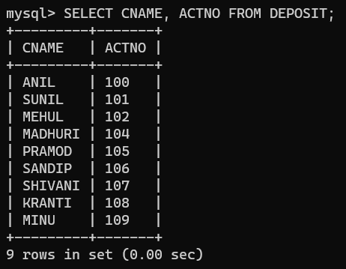

**QUERY (vii):** Give names of customers.

**SYNTAX:** SELECT CNAME FROM CUSTOMERS;

# OUTPUT:

**QUERY (viii):** Give names of branches.

**SYNTAX:** SELECT BNAME FROM BRANCH;

# OUTPUT:

**QUERY (ix):** Give names of borrowers.

**SYNTAX:** SELECT CNAME FROM BORROW;

# OUTPUT:

**QUERY (x):** Give names of customers living in city NAGPUR.

**SYNTAX:** SELECT CNAME FROM CUSTOMERS WHERE CITY = ‘NAGPUR’;

# OUTPUT:

**UPDATE COMMAND:**

**QUERY(i) :** Give 10% interest to all depositors.

**SYNTAX:** UPDATE DEPOSIT SET AMOUNT = 1.1 * AMOUNT;

# OUTPUT:

**QUERY (ii):** Give 10% interest to all depositors having branch VRCE.

**SYNTAX:** UPDATE DEPOSIT SET AMOUNT = 1.1 * AMOUNT WHERE BNAME = ‘VRCE’;

# OUTPUT:

**QUERY (iii):** Give 10% interest to all depositors living in NAGPUR.

**SYNTAX:** UPDATE DEPOSIT SET AMOUNT = 1.1 * AMOUNT WHERE CNAME IN (SELECT CNAME FROM CUSTOMER WHERE CITY = 'NAGPUR');

# OUTPUT:

**QUERY (iv):** Change the deposit of VRCE branch to 1000 and change the branch as VRCE_AMBAZARI.

**SYNTAX:** UPDATE DEPOSIT SET AMOUNT = 1000, BNAME = 'VRCE_AMBAZARI' WHERE BNAME = 'VRCE';

# OUTPUT:

**QUERY (v):** Change the living city of VRCE branch borrowers to NAGPUR.

**SYNTAX:** UPDATE CUSTOMERS SET CITY = 'NAGPUR' WHERE CNAME IN (SELECT CNAME FROM BORROW WHERE BNAME = 'VRCE');

# OUTPUT:

**QUERY (vi):** Transfer Rs 10 from account of Anil to the account of Sunil.

# SYNTAX:

UPDATE DEPOSIT SET AMOUNT = AMOUNT - 10 WHERE CNAME = 'ANIL'; UPDATE DEPOSIT SET AMOUNT = AMOUNT + 10 WHERE CNAME = 'SUNIL';

# OUTPUT:

**QUERY (vii):** Add Rs 100 to account of all those depositors who are having highest deposit amount in their respective branches.

**SYNTAX:** UPDATE DEPOSIT D1 SET D1.AMOUNT = D1.AMOUNT + 100 WHERE (D1.BNAME, D1.AMOUNT) IN (SELECT D2.BNAME, MAX(D2.AMOUNT) FROM (SELECT * FROM DEPOSIT) D2 GROUP BY D2.BNAME);

# OUTPUT:

**QUERY (viii):** Add Rs 10 to the amount of all depositors having deposit higher than the average deposit.

**SYNTAX:** UPDATE DEPOSIT D1 SET D1.AMOUNT = D1.AMOUNT + 10 WHERE D1.AMOUNT > (SELECT AVG(D2.AMOUNT) FROM (SELECT * FROM DEPOSIT) D2);

# OUTPUT:

**QUERY (ix):** Add Rs 100 to deposit of ANIL and assign it to SUNIL.

# SYNTAX:

UPDATE DEPOSIT SET AMOUNT = AMOUNT + 100 WHERE CNAME = 'ANIL';

UPDATE DEPOSIT D1 SET D1.AMOUNT = (SELECT D2.AMOUNT FROM (SELECT * FROM DEPOSIT) D2 WHERE D2.CNAME = 'ANIL') WHERE D1.CNAME = 'SUNIL';

# OUTPUT:

**QUERY (x):** Assign to the deposit of ANIL the maximum deposit from VRCE branch.

**SYNTAX:** UPDATE DEPOSIT D1 SET D1.AMOUNT = (SELECT MAX(D2.AMOUNT) FROM (SELECT * FROM DEPOSIT) D2 WHERE D2.BNAME = ‘VRCE_AMBAZARI) WHERE D1.CNAME = 'ANIL';

# OUTPUT:

**DELETE COMMAND:**

**QUERY(i) :** Delete branches having average deposit more than 5000.

**SYNTAX:** DELETE FROM BRANCH WHERE BNAME IN (SELECT BNAME FROM DEPOSIT WHERE AMOUNT < 5000);\

# OUTPUT:

**QUERY (ii):** Delete customers from Bombay city.

**SYNTAX:** DELETE FROM CUSTOMERS WHERE CITY = 'BOMBAY';

# OUTPUT:

**QUERY (iii):**Delete depositors having deposit less than 500.

**SYNTAX:** DELETE FROM DEPOSIT WHERE AMOUNT < 500;

# OUTPUT:

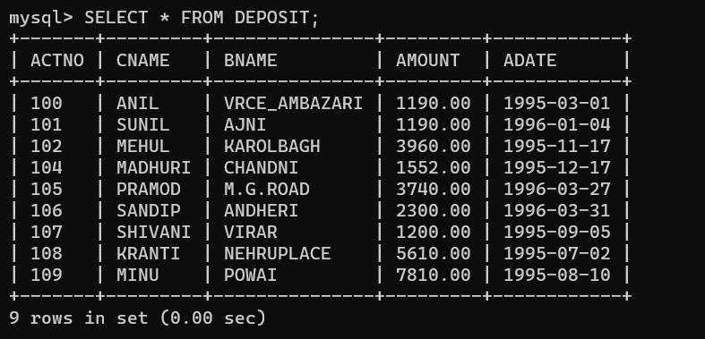

**QUERY (iv):** DELETE BORROWERS HAVING LOAN MORE THAN 10000.

**SYNTAX:** DELETE FROM BORROW WHERE AMOUNT > 10000;

# OUTPUT:

**QUERY (v):** Delete borrowers having loan more than 1000 and branch KAROLBAGH.

**SYNTAX:** DELETE FROM BORROW WHERE AMOUNT > 1000 AND BNAME = 'KAROLBAGH';

# OUTPUT:

**QUERY (vi):** Delete the names of those depositors of VRCE BRANCH who live in city BOMBAY.

**SYNTAX:** DELETE FROM DEPOSIT WHERE BNAME = 'VRCE_AMBAZARI' AND CNAME IN (SELECT CNAME FROM CUSTOMERS WHERE CITY = 'BOMBAY');

# OUTPUT:

**QUERY (vii):** Delete borrowers having branch CHANDNI.

**SYNTAX:** DELETE FROM BORROW WHERE BNAME = 'CHANDNI'**;**

# OUTPUT:

**QUERY (viii):** Delete borrowers of branches having loan less than 1000.

**SYNTAX:** DELETE FROM BORROW WHERE CNAME IN (SELECT CNAME FROM BORROW WHERE AMOUNT < 1000);

# A picture containing text, screenshot, font Description automatically generatedOUTPUT:

**QUERY (ix):** Delete deposit of SUNIL.

**SYNTAX:** DELETE FROM DEPOSIT WHERE CNAME = 'SUNIL';

# OUTPUT:

**QUERY (x):** Delete branches having deposit from NAGPUR.

**SYNTAX:** DELETE FROM BRANCH WHERE CITY = 'NAGPUR';

# OUTPUT:

