

Ark Robotics
Yunhao Cao
Gidon Gautel
Gourav Mohanan
Skanda Nadig

Introduction and Background
This report details the start-up thesis and technical background of Ark Robotics (AR). At its core, AR is a company focused on autonomous inspection of crewed space stations and other high-value, high-risk space assets. We provide this service through a sensor-equipped CubeSat capable of autonomously navigating around a space structure, ensuring full sensor-coverage at acceptable fuel cost. We use nitrogen cold-gas thrusters to navigate our spacecraft, a commodity readily available and frequently resupplied to any crewed space station.
The key motivation for this service is the current exorbitant operational cost of space station inspection and monitoring. Astronauts currently spend between 40 and 140 hours per year conducting extravehicular activity (EVAs) on the International Space Station (ISS). The vast majority of these hours spent are for inspection and servicing purposes, detracting from value-added activities such as conducting science experiments. With an amortized cost of astronaut time of $100,00 per hour, and 2 or more astronauts conducting each EVA, this results in between $8m to $28m of direct cost spent on non-value-added activities per year, and an estimated $20m to $50m in total annual cost when accounting for opportunity cost (see Appendix 2.1). As the ISS is decommissioned and commercial space stations are launched to replace it, this problem will not go away. We will automate EVA activity to deliver cost-savings to NASA and commercial operators, allowing astronauts to focus all of their time on value-added activities, increasing operator ROI.
To address this problem, we specifically propose to provide the following service:
- Full coverage path planning and autonomous execution of trajectories to fully sense space station exteriors
- Autonomous detection of anomalies on the space station exterior
This report proceeds by reviewing related work, current and future competitors in Section 2. Section 3 provides a system overview, detailing the environment driving our requirements, our hardware, and our software and autonomy stack. Section 4 provides a more detailed analysis of our coverage path planning and controls approach, as well as providing a performance analysis of the current implementation. Section 5 concludes. Additionally, please note that additional analyses and details are provided in an Appendix in Section 6.

Related Work and Market Research
Discuss other relevant state-of-the-art approaches, which may come from research labs or other startups.
Properly cite and attribute all outside sources, alternative approaches, and related work.
Highlight differences between your approach and how it fills a gap.

Current Approaches
Space-station external inspection is currently conducted almost entirely by humans via EVA, however, is heavily assisted by an array of robotic systems. More specifically, Table 2.1 provides a full overview of these systems, and their specific role in supporting or partially replacing human EVA activity.
Robotic System | Description
Canadarm2
Dextre
European Robotic Arm
Japanese Experiment Module Remote Manipulator System
Robotic External Leak Locator
GITAI S2 Robotic Arm System
Table 2.1 Overview of Robotic Systems supporting and/or replacing EVA activity
These systems have several key drawbacks.
Firstly, and most importantly, they do not allow full external sensor coverage of the ISS exterior.
Secondly, they are costly to operate. For example, Canadarm2 is manually operated, usually by a team of ground-based operators. While no specific figures are publicly available, it is likely that the annual cost of this operating team runs in the millions of dollars.
Thirdly, while latency is not prohibitive, it is high enough to require careful planning, which slows down operations and increases costs.

Emerging Approaches
A number of emerging approaches exist that will compete with our solution.

Planned Systems for New Space Stations
Table 2.2 provides an overview of the planned systems for external inspection and servicing of emerging space stations.
Station | Planned Systems
Table 2.2 Planner systems on future space stations

Likely Emerging Competitors
In addition to the planned systems detailed above, a number of companies currently exist in the market that have not explicitly stated plans to move into our vertical, but possess capabilities that could make them competitors in future. Table 2.3 provides an overview of these companies and their capabilities.
Company | Planned Capabilities
Table 2.3 Potential competitors and their capabilities

Our Competitive Advantage

System Overview

Assumptions of Operating Environment & Limitations of Deployment
The requirements for our system were driven by the unique environment posed by our use case. Specifically, our system would need the capabilities to:
- Navigate completely and safely the exterior of 3D structures
- Maneuver accurately in a zero-G environment, in a fuel efficient manner
- Use a fuel that is readily available and safe in a crewed high-risk environment
- Have sensors suited for the external inspection of space structures, generating data of high enough fidelity to detect anomalies

Summary of Hardware
Driven by the environmental requirements and constraints, we settled on the following hardware configuration for our platform:
- A 6U CubeSat, capable of 6 DOF through the use of reaction wheels and thrusters
- Nitrogen cold gas thrusters. Nitrogen is readily available on any crewed space station and is regularly resupplied. It is non-explosive and non-flammable, and while posing an asphyxiation risk, protocols are already in place on crewed stations to manage this risk.
- Visual sensors: possible anomalies on the space station exterior include micrometeor impacts, arcing on solar panels, and other visible surface damage. Anomalies should therefore be detectable through an optical sensor suite in the visual band. This said, we are flexible to accommodate additional sensors if needed.
- High-accuracy navigation: We aim to use differential GNSS for positioning relative to the space station (requiring some custom work on a robust positioning system for use in LEO), as well as an IMU, and potentially beacons placed on the space station exterior, should positioning accuracy be insufficient.
We will use a lightweight and standardized cubic form-factor for our platform to reduce launch and material costs.
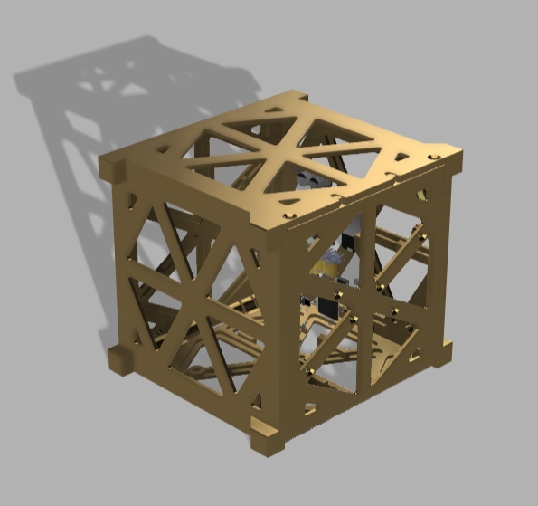
Figure 3.1 Mechanical prototype of structural primitives of the CubeSat
Figure 3.2 provides an exploded view of our complete hardware platform: A 6U cubesat equipped with the necessary structural, power and sensor suite to execute the required mission.
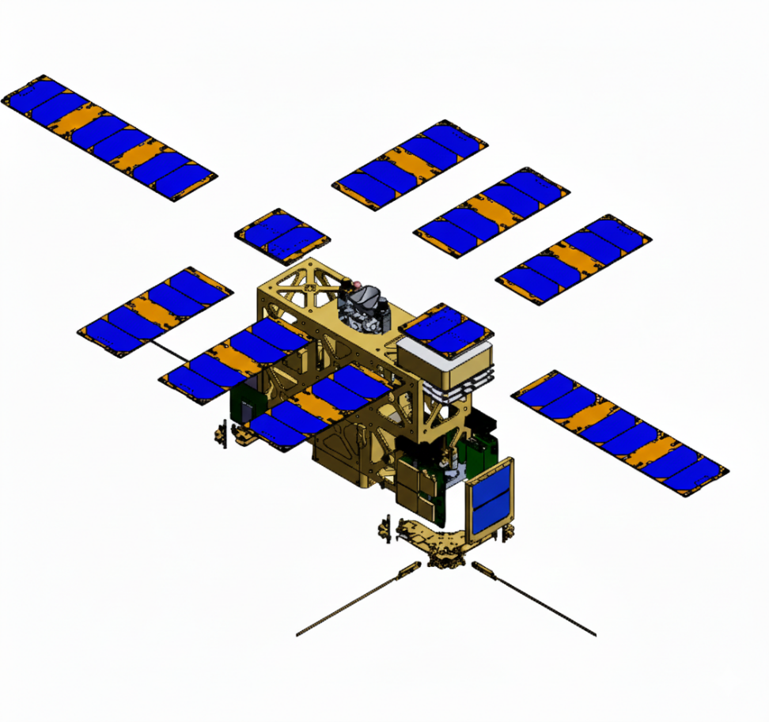
Figure 3.2 Hardware configuration of platform

Summary of Algorithms & Autonomy Stack
The below provides a high-level summary of the core components of our algorithm and autonomy stack. Further details, and analysis of their effectiveness are provided in Section 4.
The software stack is modular which means that each sub-system is its own module running efficient algorithms. The modules are monitored by the master module that controls the execution of modules based on the information set in the configuration file. This modular design makes the system flexible to use and highly customizable. Customization is one of the core requirements for the application of inspection robots and the method of customization has to be kept simple. We have achieved this by designing robust APIs and adaptable modules that enable configuration of the entire system with a single configuration file. The parameters to be added, modified and tuned are all designed and those that may need implementation in the future can also be introduced into the system seamlessly.
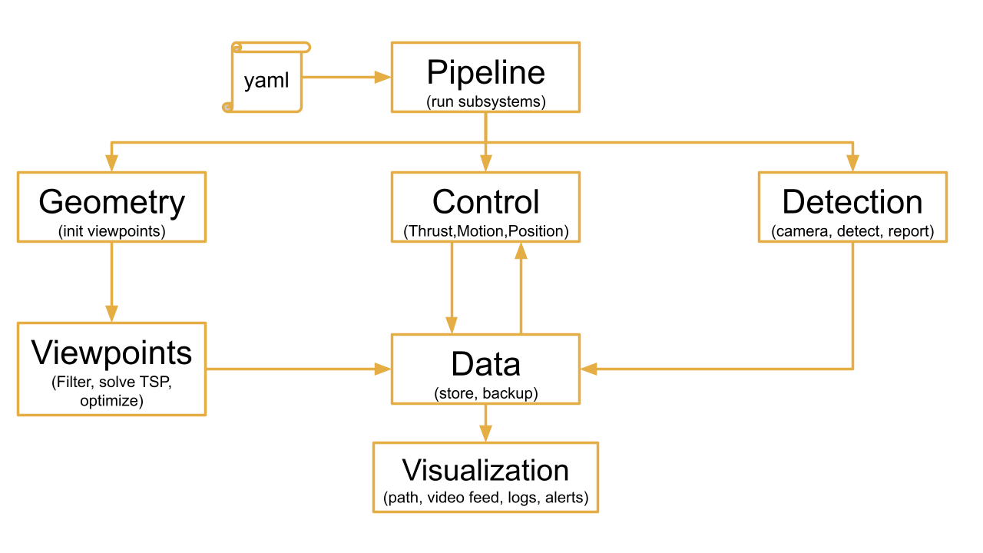
Figure 3.3 Software System Architecture

Coverage Path Planning Algorithm
Our coverage path-planning draws from the high-level approach taken by Apodaca et al. [1], however, has been adapted to our specific use case. Key differences are pointed out throughout the text in Section 4.1. On a high level, the path-planning algorithm takes the following approach:
- The station model is pre-processed into a watertight triangular mesh of appropriate size for the path planning task
- For each triangular face, a viewpoint is generated by projecting a point at a set distance from the normal of the face
- Viewpoints are then reduced in number using a K-means clustering approach
- The viewpoints are passed to a nearest neighbor travelling salesman planner, which produces an ordered set of viewpoints
- For each viewpoint a pointing angle is produced by producing a pointing vector to the closest face
- The viewpoints are passed to an optimizer which produces trajectories between each viewpoint, and may slightly shift the viewpoint within a given tolerance. The optimizer seeks to produce delta-v impulses at each viewpoint that optimize the time to traverse the entire path, and the fuel consumed for the entirety of the trajectory
The path planner is discussed in more detail in Section 4.1.

Control Algorithm
The path planner produces a path whereby the spacecrafts performs single impulses at each viewpoint that allow it to travel to the next viewpoint. However, for simulating our path in Mujoco, a PID controller was implemented, for several reasons:
- A PID controller with continuous control inputs to the thrusters allows for dwell time at viewpoints
- The PID controller allows for course correction in the case of external perturbations
- The traversal time using a PID controller is faster (at the expense of fuel use)
- The primary purpose of the simulation was to confirm that a spacecraft could safely navigate the path without compromising the safety of the station
The implemented controller is described in detail in Section 4.2.

Anomaly Detection
The Anomaly Detection subsystem provides real-time identification of cracks and surface defects using a monocular optical camera and a lightweight deep learning model. The system captures continuous video frames using OpenCV, preprocesses them for consistency, and performs inference using a GPU-accelerated convolutional neural network optimized for low-latency deployment. Detected anomalies such as cracks, surface damages, or small structural discontinuities are localized using bounding boxes and confidence scores, enabling reliable, on-the-fly assessment of structural health.
To maintain real-time performance, the subsystem integrates frame-level optimizations including downsampling, asynchronous GPU inference, and selective processing. This design enables rapid anomaly highlighting without compromising detection accuracy, making the subsystem suitable for embedded platforms, robotics applications, and autonomous inspection systems.

Technical Contributions

Path Planning Pipeline

3D Model Pre-Processing
The first step of the path planning pipeline is to take in a raw 3D model of a space station (or, for that matter, any inspection object of interest), and produce a watertight mesh with a reasonable number of faces that is computationally processable.
We utilized Blender Python scripting in order to allow for repeatability and controllable parameterization of mesh processing. A model of the ISS provided by NASA was fed through the pipeline and the following transformations were applied:
- Mesh Joining: In the case of the ISS model, the model is composed of a collection of smaller objects. These are joined into a single mesh. This unprocessed single mesh is exported for use in our MuJoCo simulation.
- Voxel Remesh: This step ensures that the final mesh is a single, watertight object. The station object is disaggregated into a 3D grid of cubes (voxels), from which an approximate surface is extracted from the occupancy grid. This results in a watertight mesh with no holes or manifold edges. This is useful for later path planning stages, as it prevents the generation of spurious viewpoints, and simplifies collision detection.
- Laplacian Smoothing: Given the fact that voxel remeshing tends to produce irregular or “blocky” surfaces, a Laplacian smoothing step was added to smooth the mesh by moving vertices towards the average of their neighbors.
- Decimation: Blender’s decimate modifier seeks to collapse edges and remove faces that contribute the least to visual shape. This step was added to reduce the total face count and make the model more computationally processable.
- Weld Vertices: Similar to the previous step, welding vertices combines vertices that are within a chosen threshold distance. This step removes duplicate or redundant vertices, cleans up “cracks” and “gaps”, and ensures the mesh is topologically palatable for later geometric operations.
- Triangulation: Later path planning steps count on a triangulated mesh. The resulting mesh of prior steps is therefore transformed to be composed of purely triangular elements.
Each of these steps are tunable via the following variables, implemented in the model pre-processing step:
- Voxel Size
- Smoothing iterations
- Laplacian smoothing factor
- Decimation ratio
- Weld threshold
These parameters were tuned manually until a smooth mesh with sufficient faces to produce meaningful paths, but few enough faces to be computationally feasible on our machines was achieved.
Even with this repeatable processing pipeline, some features, such as very thin solar panels, or thin, geometrically complex trusses, proved too difficult to process in an automated fashion. Therefore, these features were implemented manually in the Blender GUI in the form of singular, voluminous features superimposed on the original mesh. This new mesh was passed through the processing pipeline. A visual flow of the steps for model pre-processing is provided in Figure 4.1.
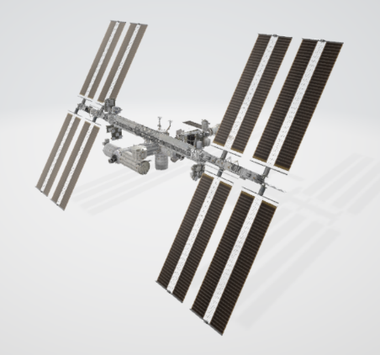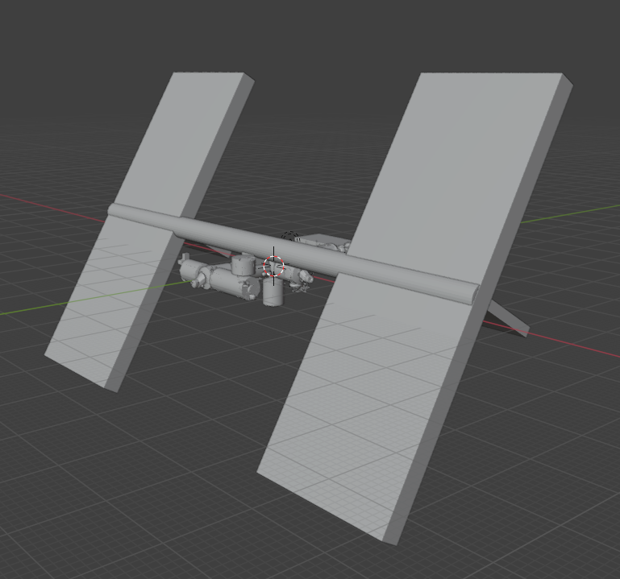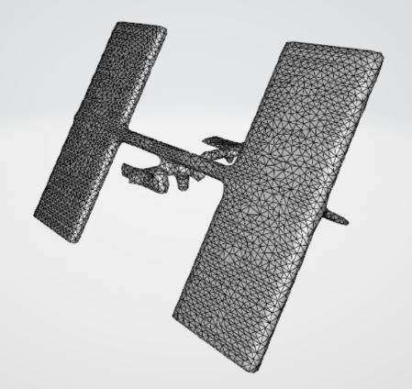
Figure 4.1 Visualization of pre-processing steps

Viewpoint Generation & Clustering
The viewpoint generation step seeks to produce candidate camera positions that are well-aligned with the inspection object. We have implemented two different methods of viewpoint generation.

Fibonacci Sphere Method
To ensure uniform and unbiased coverage of a 3D object during inspection, our system employs the Fibonacci Sphere method to generate a set of evenly distributed viewpoints around the object. This technique is widely used in graphics, robotics, and sampling applications due to its ability to approximate uniform point distributions on a sphere with far less clustering than latitude–longitude or random sampling methods.

Method Overview
The Fibonacci Sphere algorithm leverages properties of the golden angle to generate points on a sphere that naturally avoid clustering. For a desired number of viewpoints N, each point is defined by incrementally stepping around the sphere at an angular separation proportional to the golden angle.

Golden Angle
The golden angle Φ derives from the golden ratio $φ=\frac{1+\sqrt{5}}{2}$, and is defined as:
$$Φ=\frac{2π}{φ^{2}}≈2.399963229 rad$$

Algorithm to Generate the Sphere of Viewpoints
For each index $i∈\left\{0,1,…,N-1\right\}$, the spherical coordinates are constructed as:
$$y_{i}=1-\frac{2i}{N-1}$$
$$r_{i}=\sqrt{1-y_{i}^{2}}$$
$$θ_{i}=i∙Φ$$
The corresponding cartesian coordinates become:
$$x_{i}=r_{i}cos(θ_{i})$$
$$z_{i}=r_{i}sin(θ_{i})$$
Each point $(x_{i}, y,{ z}_{i})$ forms one camera viewpoint.
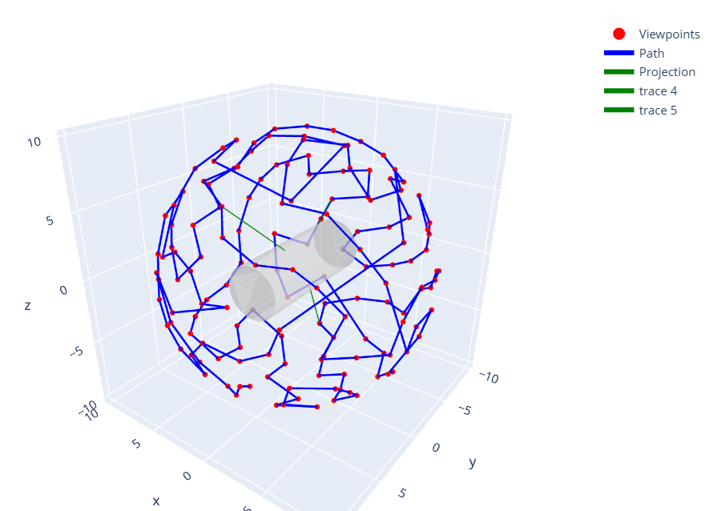
Figure 4.2 Point generation around a 3D model using Fibonacci Sphere Method

Raycasting Method
Viewpoint generation is implemented by stepping away from each triangular face’s centroid along the surface normal. Concretely:
Centroids are calculated from each triangle’s three vertices v_{i1}, v_{i2}, v_{i3} as:
$$c_{i}=\frac{v_{i1}+v_{i2}+v_{i3}}{3}$$
The normal is given by:
$$n_{i}=\frac{(v_{i2}-v_{i1})×(v_{i3}-v_{i1})}{\left\|(v_{i2}-v_{i1})×(v_{i3}-v_{i1})\right\|}$$
Normals are then normalized, which allows for viewpoints to be offset by an arbitrary distance, which is parameterized within our pipeline.
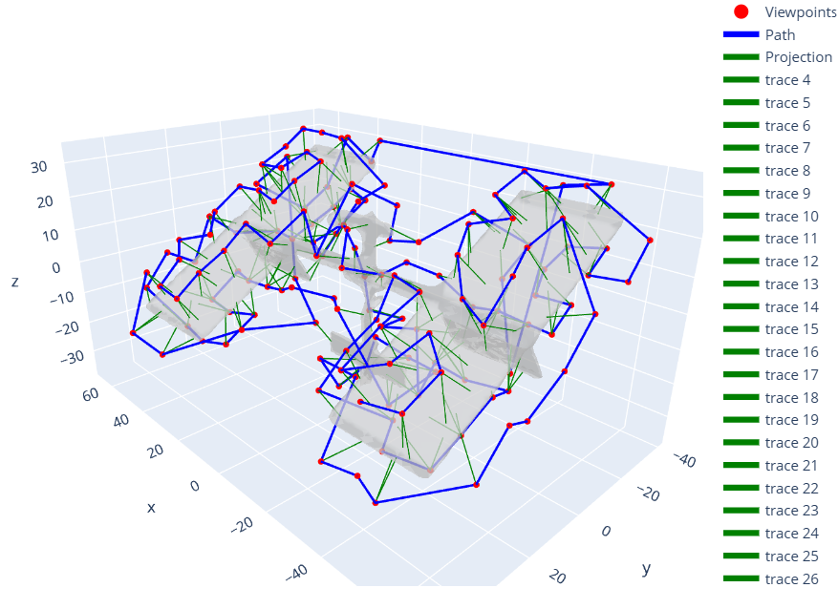
Figure 4.3 Point generation around the space station model using Raycasting method
Because of the previous pre-processing step, our model is watertight, which ensures that normals are consistently outwards from the station body. However, even with the face-reduction steps taken previously, this can still result in thousands of viewpoints, which is impractical. Therefore, a clustering step is added to reduce the number of viewpoints, while maintaining information gain and coverage.
Two clustering approaches of viewpoints were implemented, configurable via our config files in the planning pipeline:
- DBSCAN: Cluster viewpoints according to the density of the viewpoint cloud. DBSCAN is a density-based clustering algorithm that groups together points that are closely packed, marking points in low-density regions as outliers. It works by finding core points (those with a minimum number of neighbors within a set radius, epsilon) and expanding clusters from them, which allows it to find clusters of arbitrary shapes and handle noise effectively
- K-Means: We use the unsupervised machine learning algorithm to partition filtered viewpoints into k distinct, non-overlapping groups (clusters), aiming to make viewpoints within a cluster similar, represented by centroids (cluster means). It's an iterative process that starts by randomly picking k centroids, assigns data points to the nearest centroid, then re-calculates the centroid as the mean of its assigned points, repeating until centroids stabilize. Its goal is to minimize the within-cluster sum of squares (WCSS), creating compact, isolated clusters.

Viewpoint ordering

Collision Avoidance
The straight line paths between ordered viewpoints are not guaranteed to be collision free. To mitigate this, we employ a heuristic collision avoidance system that “repairs” the set of viewpoints {k_{i}} by introducing intermediate waypoints that result in a safe path. The result is a set of waypoints {w_{i}} that produce safe coverage.
The station center is first approximated as the mean of all face centroids. This provides a simple reference point for later calculations.
For each pair of viewpoints, the system samples a parametric number of points along the straight line path between points. We compute relative vectors between sampled points and face centroids. We then compute an outward unit normal from the face, and calculate the signed distances to each face plane. A sampled point is then safe if for any plane if the signed distance is positive and greater than a given margin.
To repair paths with detected collision, we produce waypoints along tangent directions of the straight-line path between viewpoints at the midpoint of the path. Candidate waypoints are produced along four perpendicular tangential directions at set distances, and checked for collision. The waypoint closest to the starting position of the path is chosen. This process is repeated recursively until either the path is safe or the recursion depth (specified in the yaml file) is reached. If no safe waypoint is found, a warning is logged, which requires manual repair.
Figure 4.1 provides an example of the collision avoidance heuristic in action for a simplified “station”. As can be seen, a safe intermediate waypoint is successfully found for a straight-line path that is very obviously a collision with the station.
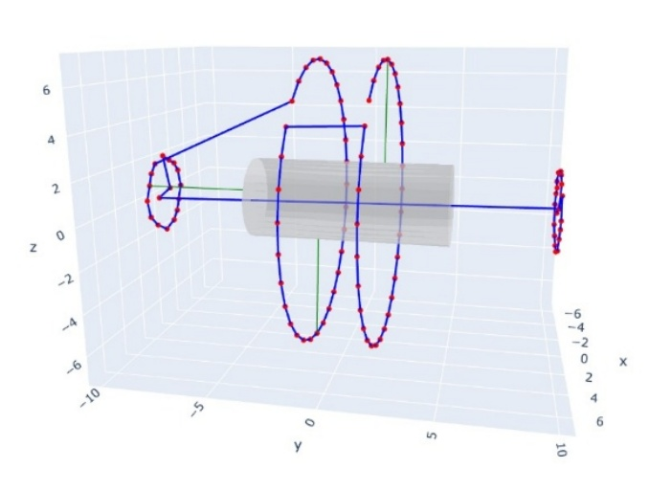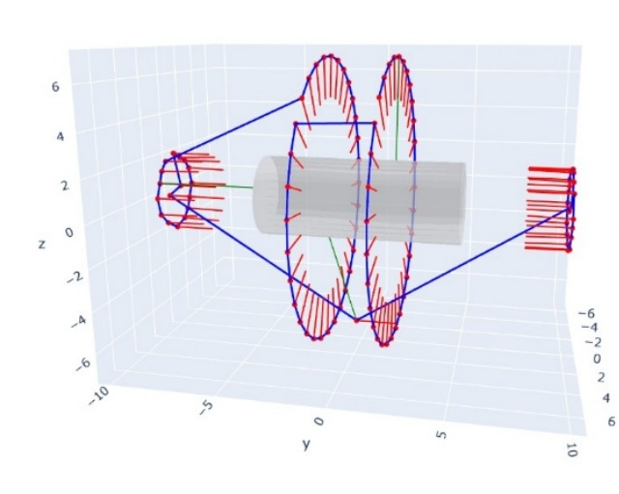
Figure 4.4 Simplified example of the collision avoidance system in action

Pointing Angle Generation
Given an ordered sequence of waypoints around the station, producing corresponding pointing vectors at each waypoint is comparatively simple. Our solution takes in the set of collision free waypoints, as well as the face centroids of the station mesh.
Viewpoints are first classified as real waypoints or intermediate waypoints generated through the collision avoidance process. For real waypoints, the system picks the nearest mesh face centroid and produces a vector pointing at it, by:
- Computing the distance from waypoint w_{i} to all centroids
- Selecting the closest face
- Producing a normalized vector from the waypoint to the centroid of that face
For intermediate waypoints, the pointing angle of the prior waypoint is simply copied.
When pointing angles are passed to the control system of our stack, their respective orientations are converted into quaternion format for simple processing by MuJoCo.

Trajectory Generation & Optimization
At this stage of our path-planning system, we have a set of collision free ordered waypoints, however, the challenge remains to produce a dynamically feasible trajectory that visits each one. One solution is to apply an impulsive maneuver at each waypoint, drifting along the intermediate distance. Impulsive maneuvers can be characterized in terms of the directional delta-v required at each viewpoint, given the dynamic state from the prior maneuver. We want to do this in a manner that minimizes fuel and time cost while performing at a level realistic to the physical system.
The problem statement for trajectory generation is therefore: Produce the set of delta-v’s to reach each viewpoint, minimizing fuel and time cost, subject to viewpoint tolerance, delta-v maximum magnitude, leg-time bounds. We also constrain the speed upon reaching the final viewpoint to be close to zero.
To solve this optimization problem, we employ a simple “free-floater” dynamics model, whereby the spacecraft state is described by:
$$x=\left[\begin{matrix}r \\ v\end{matrix}\right]$$
Where r is position and v is velocity. The continuous dynamics between impulses are then described by:
$$\dot{r}\left(t\right)=v\left(t\right), \dot{ v\left(t\right)=0}$$
At the beginning of each leg between waypoints, k, an impulsive velocity change $∆v_{k}$ is applied for an instantaneous update:
$$v_{k}^{+}=v_{k}+∆v_{k}$$
And over the leg duration, $∆t_{k}$, the state simply evolves as constant-velocity drift:
$$r_{k+1}=r_{k}+v_{k}^{+}∆t_{k}$$
For each leg, k, therefore, the optimizer chooses impulse $∆v_{k}$ and leg duration $∆t_{k}$, according to the objective function and constraints. The decision vector for optimization is therefore a stack of delta-v’s and leg times:
$$x=\left[\begin{matrix}∆v_{0} \\ ∆v_{1} \\ \begin{matrix}… \\ ∆v_{n_{legs}-1} \\ \begin{matrix}∆t_{0} \\ ∆t_{1} \\ \begin{matrix}… \\ ∆t_{n_{legs}-1}\end{matrix}\end{matrix}\end{matrix}\end{matrix}\right]$$
The objective function is then the weighted sum of fuel usage (using squared impulse as a proxy) against total time:
$$J\left(x\right)=\sum_{k=0}^{n_{legs}-1}{\left(w_{fuel}{\left\|∆v_{k}\right\|}_{2}^{2}+w_{time}∆t_{k}\right)}$$
For our base case, $w_{fuel}$ was chosen as 1, and $w_{time}$ as 0.1.
As mentioned, three constraints, implanted to be in the form $g(x)≤0$, are applied to every leg:
- The end of every leg must lie within a radius around the second waypoint (which can be determined using our dynamics model)
- The delta-v at each step cannot exceed a given value
- The final speed on the last leg cannot exceed a given value, close to zero
- The leg duration cannot exceed an upper bound
In code, we used CasADi to formulate the optimization problem, which, summarizing the above, is composed of:
- Our decision vector:$x=\left[\begin{matrix}all ∆v_{k} \\ all ∆t_{k}\end{matrix}\right]$
- Our objective: $f\left(x\right)=J(x)$
- And our constraints $g(x)≤0$
We used the CasADi nlpsol (non-linear program solver) for the in-code implementation.
Finally, the output of the optimization step is the optimal delta-v, $∆v_{k}^{*}$, for each leg, and the optimal time, $∆{vt}_{k}^{*}$, for each leg. These can then be easily processed into a format which is executable for a controller set-up to execute impulsive maneuvers.
In the end, a set of waypoints positions, arrival velocities, and quaternions is exported for direct input into a controller.

Spacecraft Control
For simulation purposes, we employed a PD controller to achieve the given waypoints and pointing angles, rather than a controller that executes the impulsive maneuvers produced in the optimization section above. This was done for practical reasons, allowing us to view trajectory execution in real time, as well as for the reasons listed in the section below. PD control will inevitably lead to increased fuel use, so for a real-life implementation, impulsive control of the trajectory produced through optimization would be the chosen path.

Description
This section describes the low-level controller used to track viewpoint positions and attitude for our space robot. The controller is intentionally lightweight and robust. It is deployed on a 29.5 kg platform equipped with six face-mounted thrusters (each capped at 20 N) and three reaction wheels (each capped at 5 N·m). PD control is adopted for three main reasons:
- Simplicity and robust performance: PD requires few parameters and avoids online optimization.
- Simple Dynamics: Each axis is shaped as an independent second-order system, enabling easy modeling.
- No integral term by design: Under the assumption of negligible constant biases (well-aligned thrusters and wheels), steady-state errors are small enough to be ignored. This also eliminates integral windup under actuator saturation—an issue that does not arise with pure PD.
The control objective is to (i) track position/velocity in world frame using thrusters; (ii) track attitude/angular velocity using reaction wheels, given a reference input vector
$$input=[p, v, θ, w]∈ R^{3+3+4+3}$$
where $p, v∈ R^{3}$ are the desired position and velocity (world frame), $θ∈ R^{4}$ is the desired unit quaternion representing attitude (world frame), and $w∈ R^{3+3+4+3}$ is the desired angular velocity (body frame).

Translational PD (Acceleration)
A critically damped second-order controller is designed independently for each axis. The position and velocity tracking errors are defined as
$$e_{p}=p-p^{*}$$
$$e_{v}=v-v^{*}$$
$$a_{des}=-k_{p}e_{p}-k_{v}e_{v}$$
where $p^{*}$ and $v^{*}$ are the reference position and velocity, $a_{des}$ is the desired acceleration output. For each axis, the closed-loop dynamics are modeled as a standard second-order system
$\ddot{x}+\frac{k_{v}}{m}\dot{x}+\frac{k_{p}}{m}x=0$ , $\left\{\begin{aligned}k_{p}=mw_{n}^{2} \\ k_{v}=2mζw_{n}\end{aligned}\right.$, where for critical-damped, $ζ{=w}_{n}=1$
with $m=25kg$, this yields ${\text{k}}_{\text{p}}=25$ and ${\text{k}}_{\text{v}}=50$.

Attitude PD (Quaternion Error)
Similar to the translational PD controller, we define the angular-velocity error as
$${\text{e}}_{\text{w}}=w-w^{*}$$
where $w^{*}$ is the reference angular velocity. The attitude error is first expressed as a quaternion error
$$e_{q}=q^{*}⨀q^{-1}$$
where $q^{*}$ is the reference quaternion, $⨀$ denotes the quaternion (Hamilton) product, and $q^{-1}$ is the conjugate of current quaternion. We then map the quaternion error to a 3-D attitude error vector via
$$e_{R}=2q_{v}$$
where $q_{v}∈ R^{3}$ is the vector part of quaternion $q$. Finally, the PD type torque feedback law
$$τ=-K_{R}e_{R}-K_{w}e_{w}$$
is implemented.
This PD controller is simulated in MuJoCo with a control frequency of 500 Hz. The burn time of each thruster is accumulated as
$$T=N∆t$$
where N is the number of simulation steps (frames) during which the thruster is active, and $∆t$ is the time step of each frame, for the purpose of overall fuel consumption evaluation.

Fuel Consumption With PID

Hardware

Top-Level Requirements

Structure
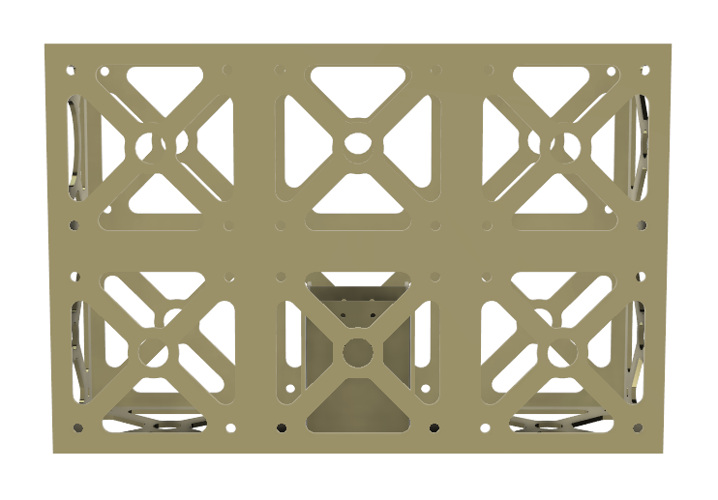

ADCS

CDH

Power & Propulsion

Sensing
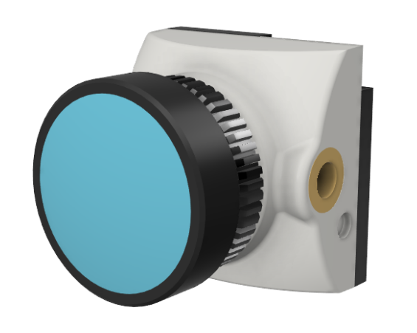

Anomaly Detection
The Anomaly Detection subsystem is responsible for identifying cracks, dents, and other surface defects on metallic structures using an optical camera. For this proof-of-concept, we use a Logitech 1080p HD webcam to capture real-time video of the surface and apply a combination of classical computer vision (OpenCV) and deep learning-based segmentation to detect anomalies.

System Architecture
$$I_{t}→F_{t}→X_{t}→M_{t}→O_{t}$$
Where:
- $I_{t}$ = raw image at time t
- $F_{t}$ = filtered/clean frame
- $X_{t}$ = normalized, resized model input
- $M_{t}$ = model output mask (probability of crack/damage)
- $O_{t}$ = final overlay visualization
The detection model returns bounding boxes and segmentation masks overlaid on the live video stream.

Pre-processing Pipeline
Before detection, the frame is enhanced to highlight small cracks:
- Grayscale conversion
- Contrast-Limited Adaptive Histogram Equalization (CLAHE)
- Gaussian smoothing to reduce noise
- Edge-enhancing filters (e.g., Sobel or Canny)
- Edge Feature Extraction:
$$E_{t}=∇F_{t}=\sqrt{{\left(\frac{∂F_{t}}{∂x}\right)}^{2}+{\left(\frac{∂F_{t}}{∂y}\right)}^{2}}$$

Crack Detection Model
We use a lightweight UNet-based semantic segmentation model trained or adapted for surface defect detection (e.g., MVTec AD or similar dataset). This model outputs a probability mask:
$$M_{t}\left(x,y\right)=P\left(crack \right| X_{t}(x,y))$$
A pixel is classified as a crack if:
$$M_{t}\left(x,y\right)> τ, where the default value of τ=0.5$$

Post-processing and Bounding Box Extraction
The probability mask is thresholded, cleaned and converted into bounding boxes.

Experiments
The detection subsystem was tested independently in the real world on primarily metal surfaces to simulate the body of the space station. The best candidates for real world testing were domestic cars since the type of damage and frequency of occurrence favoured our requirements for testing. The anomaly detection system was evaluated on a custom dataset consisting of optical camera images of metal and composite surfaces with artificially introduced cracks, scratches, dents, and corrosion patterns. Data was collected using a 1080p USB webcam under controlled indoor lighting. The detection pipeline ran on a Lenovo Legion Y520 (Intel i7-7700HQ CPU, NVIDIA GTX 1050 Ti GPU) with Python 3.10, PyTorch, and OpenCV.
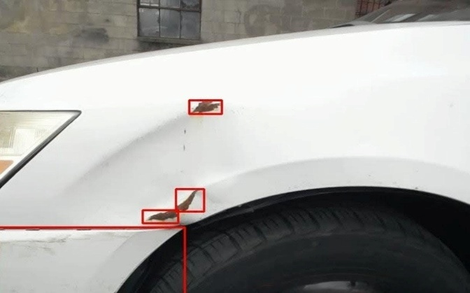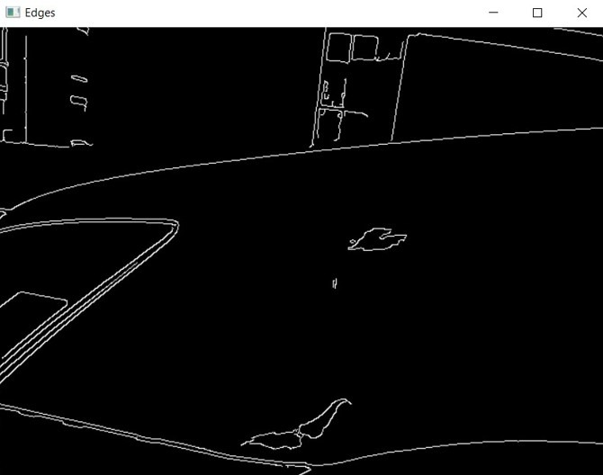
Figure 4.5 Example result of the crack detection system on a terrestrial vehicle

Results

Path Planning Results
Our pipeline is highly parameterized, with parameters within the modelling pre-processing and clustering steps resulting in significant variance in the resulting path and trajectory. This fact is addressed in Section 5. We therefore present results for a base case with the following key set-up values:
Model Pre-Processing:
- Voxel size: 1.2
- Smoothing iterations: 5
- Smoothing lambda: 0.3
- Decimation ratio: 0.9
- Weld threshold: 1.3
Clustering:
- method: kmeans
- Number of clusters: 150

Coverage

Travelling Time & Fuel Consumption
Travelling time is simple to calculate using the pre-existing impulsive dynamics developed for the optimization stage. Fuel consumption, similarly, is easy to calculate, as the delta-v’s for the trajectory can be plugged into the rocket equation. As we are using nitrogen thrusters, a specific impulse of approximately 70 can be assumed.
$$∆v=I_{sp}g_{0}ln⁡\left(\frac{m_{0}}{m_{f}}\right)$$
Where $I_{sp}$ is the specific impulse of the thrusters, $g_{0}$ is Earth’s gravitational constant, $m_{0}$ is the starting mass before a maneuver, and $m_{f}$ is the final mass after the maneuver.
The base case travel time for a full ISS inspection is 45 minutes, and fuel use is 1.5kg. These are both well within achievable limits. Additionally, given the considerable time required for pre-breathing, donning, and other procedures for current astronauts, the inspection time of 45 minutes offers a vast improvement over astronaut-conducted inspection.

Simulation

Anomaly Detection
In live testing, the subsystem reliably identifies:
- Linear cracks down to 1 to 2 mm
- Surface dents and pits
- Abrasion and discoloration regions
Latency on the GTX 1050 Ti averages:
- Preprocessing: 2 to 4 ms
- Inference: 25 to 40 ms
- Postprocessing: 5 to 10 ms
- Total: 32 to 55 ms, yielding 18 to 30 FPS
These results demonstrate that the proposed detection pipeline is well-suited for fast, reliable surface anomaly inspection in real-world robotics and automation environments.

Areas to Improve

Conclusion

Appendix

Cost & Revenue Analysis

NASA. 2023. International Space Station 3D Model. Available Online: https://science.nasa.gov/resource/international-space-station-3d-model/ [last accessed: 11/28/2025]

