**Task 1:**

**Create a GitHub repository and demonstrate branching, pull requests, and code reviews.**

**Response:**

**Branching:**

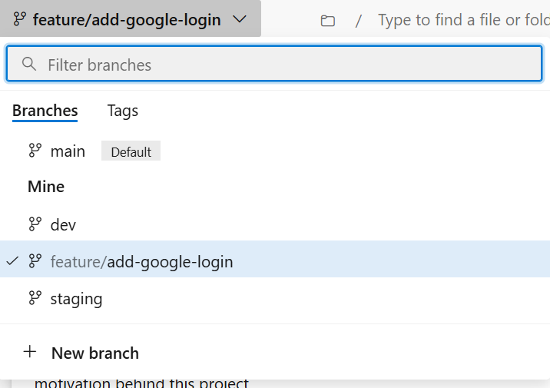

**PR:**

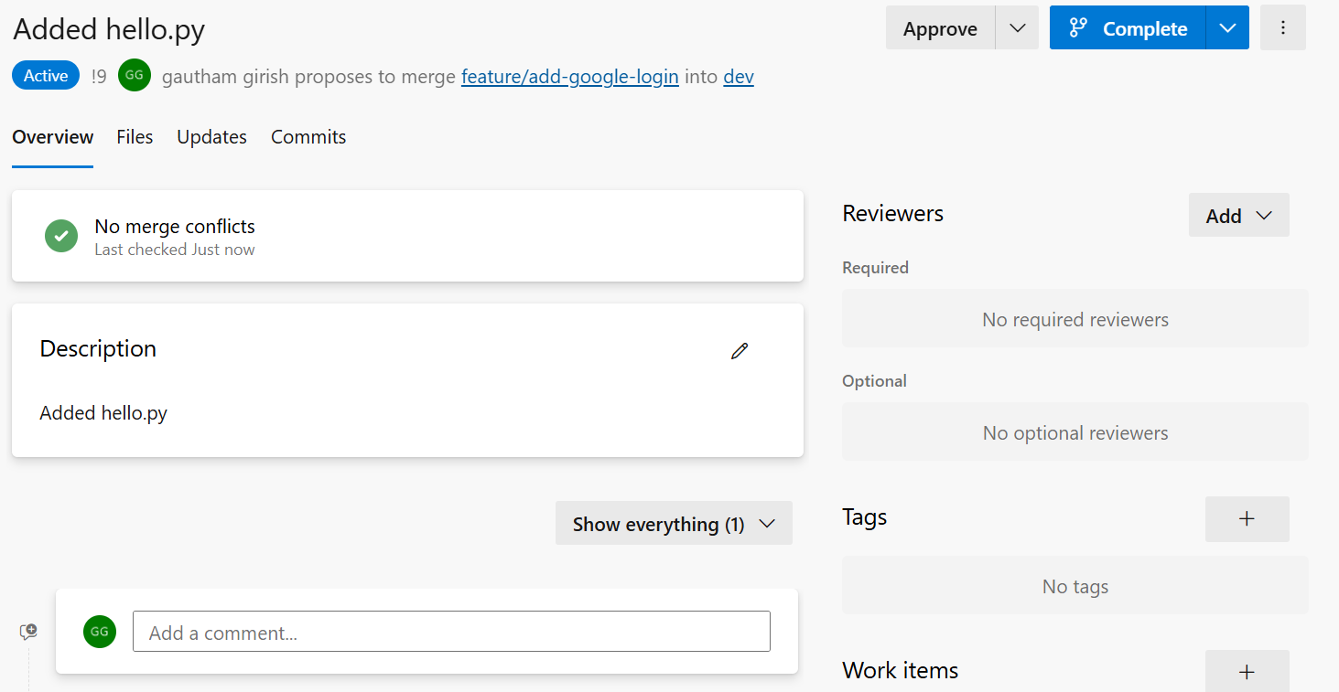

**Code Review:**

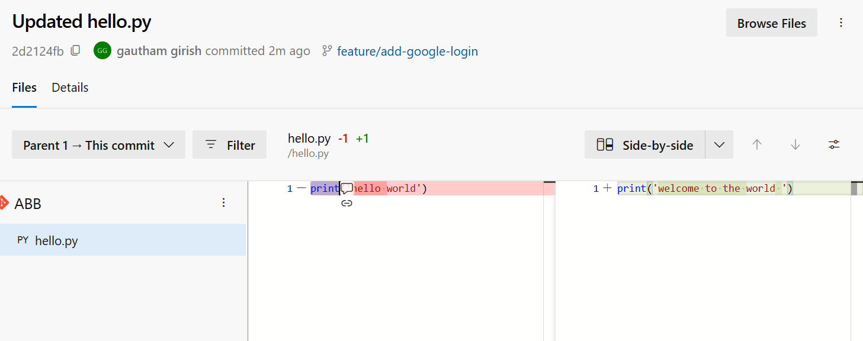

**Task 2,3,4**

|  |
| --- |
| Set up a CI pipeline in Azure DevOps for a sample .NET/Node.js application. Include unit testing and artifact publishing. |
| Extend the CI pipeline to deploy the application to Azure App Service or AKS, with approval gates for production. |
| Create a multi-stage pipeline for deployments across Dev, Test, and Prod environments with specific configurations. |

**Response:**

Please refer the the ci.yml and cd.yml files in the task-2,3,4 folder for pipeline configuration files.

Environments:

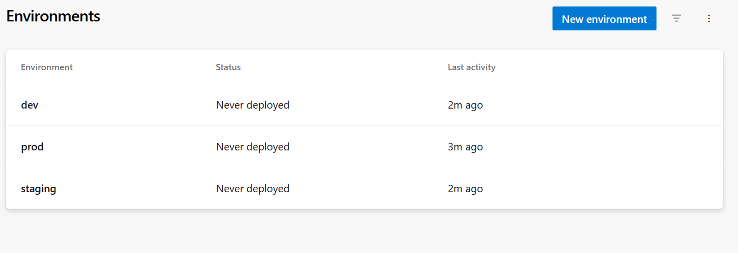

Approval gates:

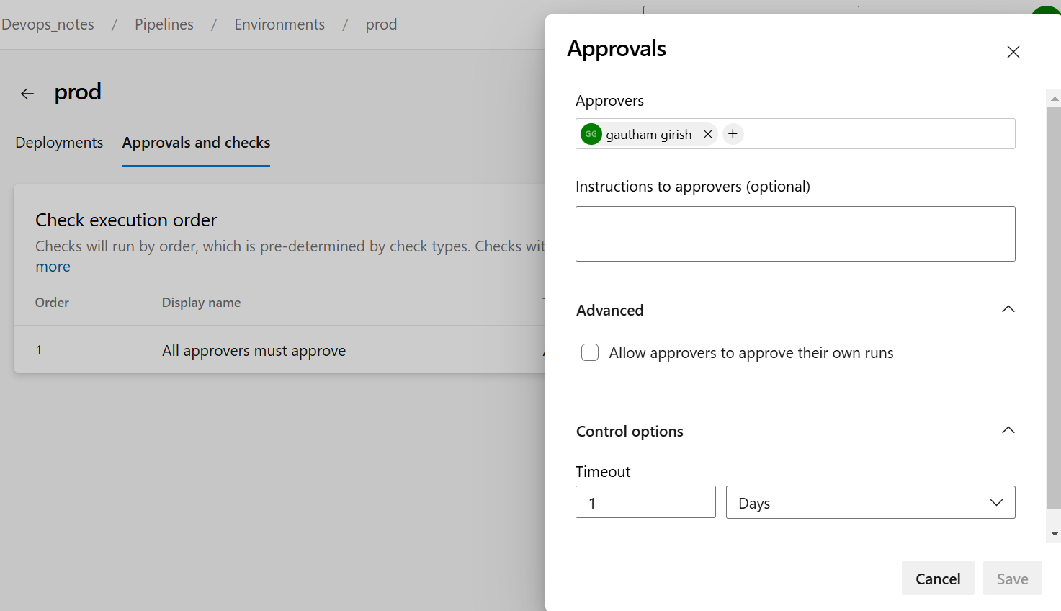

**Task 5:**

**Write a Terraform script to provision an AKS cluster with Azure Monitor enabled.**

Please refer to task-5 folder aks-main.tf file.

To apply the file execute below commands:

terraform init

terraform validate

terraform plan aks-main.tf

terraform apply aks-main.tf

**Task 6**

**Retrieve secrets from Azure Key Vault within a CI/CD pipeline and use them during deployment.**

Please refer task-6 folder

**Task 7**

**Create a Dockerfile for a sample application, build the image, and push it to Azure Container Registry (ACR).**

Please refer to the Dockerfile in the task-7 folder and execute the commands below for build and push.

az acr login --name abb

docker tag sample-app:latest abb.azurecr.io/sample-app:latest

docker push abb.azurecr.io/sample-app:latest

docker push abb.azurecr.io/sample-app:latest

**Task 8**

Please refer task-8 folder for required files

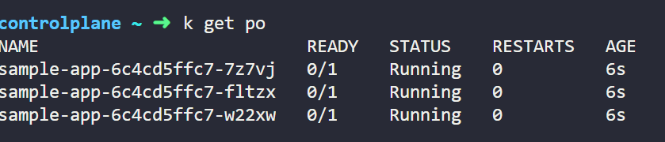

**Task 11**

**Write a KQL query in Log Analytics to analyze application logs for error patterns over the last 24 hours.**

AppLogs

| where TimeGenerated >= ago(24h)

| where LogLevel == "Error" or Message contains "error" or Message contains "exception"

| project TimeGenerated, LogLevel, Message, Source

| order by TimeGenerated desc

**Task 14**

**Debug a failing Azure DevOps pipeline with errors in environment variable configuration.**

Please refer task-14 folder for required files

